**Assignment TP1: Rapid Prototyping**

This assignment is realized by David Feng (10250) and Kenza Kettani (10279).

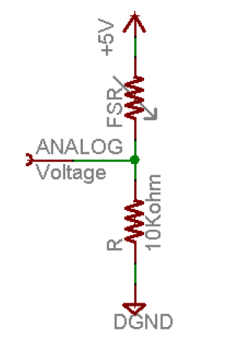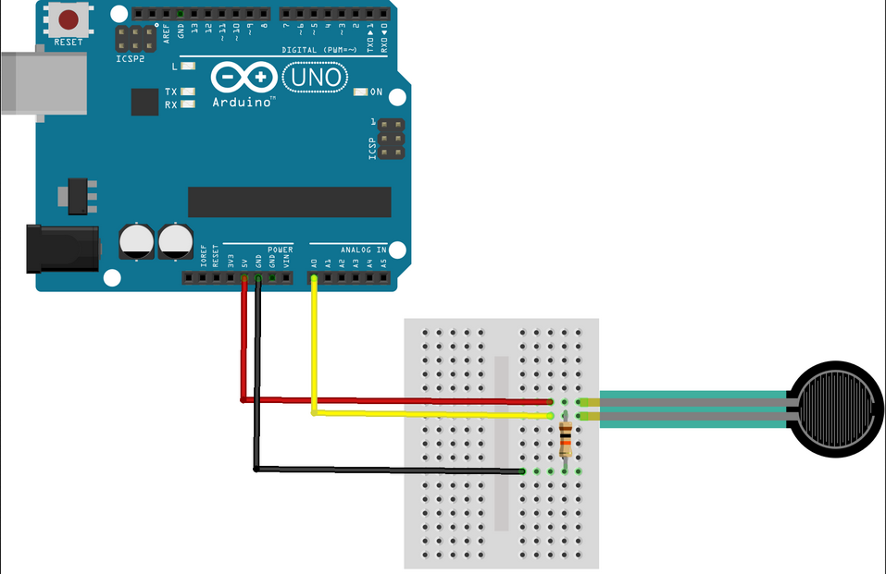

We have chosen a force sensitive resistor (FSR) as sensor in this circuit and we used a 10 KOhm resistance.

1. Measurement setup:  
   After the construction of the circuit, it is necessary to stack several elements to have a sufficient weight. We have chosen a EWA2 loud speaker, XiaoMi Note 3 smartphone, an ashtray and a cup.
2. We use the program that we created before in the exercise 6. And we use the processing software to save the data   
     
   100 measurements  
   Mean value  
   random error

