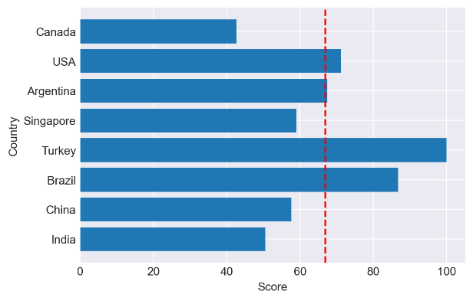

Indicator weight map

在此前的模型中，我们分析了……（待填充），但是考虑到各个国家与地区在经济发展、塑料垃圾生产与排放以及人均塑料管理不善的不同，我们根据此前制定的全球一次性塑料减少量的指标，给不同国家制定不同的标准，尽可能实现公平解决这一全球性问题。具体的模型与实现步骤如下。

In our previous model, we analyzed the issue of global plastic waste（写前两个模型所解决的问题）. We took into account the various differences in economic growth, production and discharge of plastic waste, and mismanagement of plastic across different countries and regions. Based on the established global indicator for reducing disposable plastic usage, we have set different standards for various countries to address this issue in a fair and equitable manner. The specific model and implementation steps are as follows.

1. 层次分析法——计算出各个指标的权重
2. TOPSIS熵权法——结合指标与权重对各个国家进行打分
3. 根据打分以确定各个国家一次性塑料减少量的指标

​

1. Hierarchical Analysis Method (AHP) for determining the weights of the selected indicators including 'GDP', 'Garbage discharged into the ocean per capita', 'Waste plastic production per capita', 'Poor management of plastic waste per capita', and 'GDP per capita'. The weights of each evaluation index calculated by AHP are shown in the figure above（根据图片标号更改）
2. Topsis Entropy Method for scoring each country based on the combination of the indicators and their weights. The countries being evaluated are 'India', 'China', 'Brazil', 'Turkey', 'Singapore', 'Argentina', 'USA', and 'Canada'.

The Topsis Entropy Method calculates the scores of each country by combining the indicators and their weights. The method involves determining an ideal solution and an anti-ideal solution, which represents the best and worst possible outcomes, respectively. The scores of each country are then calculated based on the difference between each country's performance and the ideal solution, as well as the difference between each country's performance and the anti-ideal solution. The final scores take into account both the relative importance of each indicator and the performance of each country.

In order to make the final scores more generalizable, a comprehensive consideration of the above indicators was taken into account in the selection of the countries being evaluated. The final outcome of the analysis provides a comprehensive evaluation of the potential for reducing disposable plastic in the selected countries, which can be used to evaluate the reduction efforts and provide data support for policy making.