Dear editors,

The WB images in main figures lack relevant bands images, which we’re sorry for that. Therefore, we repeated the WB experiments from Figure 2 & Figure 5G recently, and the repeated results are as shown below with relevant bands. Also, we’ve zipped these raw files in WB_220608.zip.

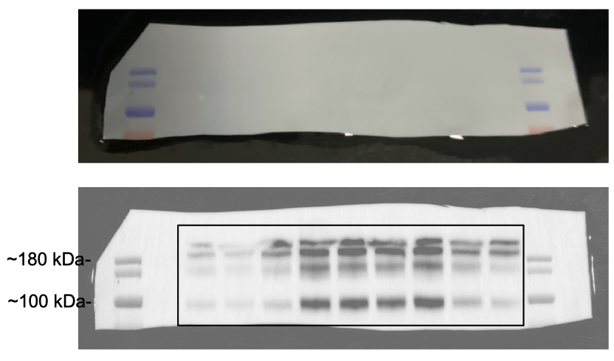

Figure 3C APP repeated

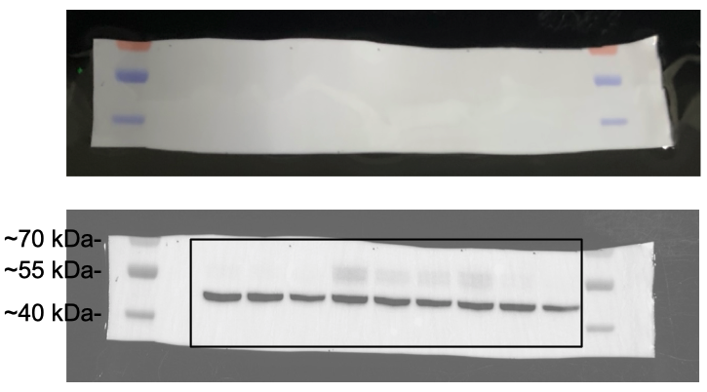

Figure 3C β-actin repeated

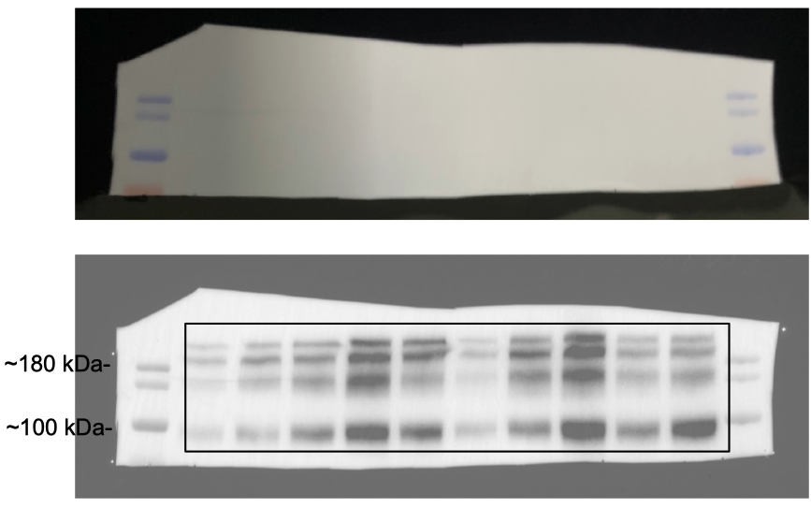

Figure 6G APP repeated

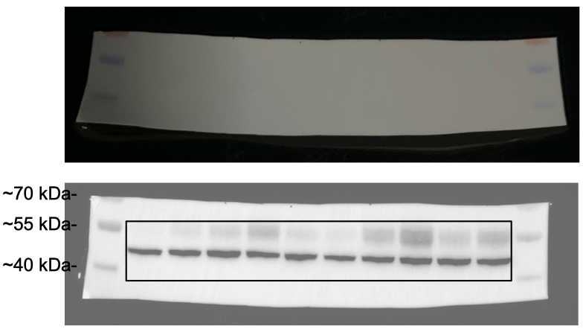

Figure 6G β-actin repeated

Protein ladder we used:

<https://www.thermofisher.cn/order/catalog/product/26619?SID=srch-srp-26619>

