# Storm Intersection Forecast Tool

# End User Manual v1.3

# *Contact:*

### *Charles Bussy-Virat ( cbv@umich.edu )*

### *Dorina Twigg ( dtwigg@umich.edu )*

Overview

The Storm Intersection Forecast Tool (SIFT) is an interactive visualization application developed to help operational planning for the CYGNSS satellite constellation. SIFT uses the Spacecraft Orbital Characterization Kit (SpOCK) to predict CYGNSS satellite and wind speed measurement (specular point) locations and displays them alongside key weather information and other information of interest.

## Getting Started

#### Installing SIFT

SIFT is available on Windows (64 Bit) and Mac OSX, and a \*NIX version is coming soon.

To install SIFT, please refer to the document INSTALL\_windows or INSTALL\_mac, depending on your platform.

SIFT is written in Python 2.7.10 and a full listing of python package dependencies for SIFT can be found in Appendix II.

SIFT is optimized for a screen resolution of 1920x1080. Lesser resolution will rely on the use of the scroll bars in order to see the entire SIFT display.

#### SIFT Directory Structure

The SIFT root directory is further divided into five folders in order to better group the various input/output files generated for and by SIFT. This section describes the purpose/contents of each subdirectory within the SIFT root directory.

* ../code

Contains all SIFT \*.py and SpOCK. Files in this directory should not be altered nor moved, to maintain stable operation.

* ../demo\_input

Contains SIFT inputs for demo runs. Files in this directory should

not be altered, but additional demo packages can be stored here if desired.

* ../input\_sift

Contains all SpOCK output to be used as input to SIFT. Input packages will

automatically be named according to the start/end date of the package. Each input

package contains five folders at the ../input\_sift/<input\_package>/input/ level, namely spock\_in, gsCoverage, sat\_positions, spec\_positions, and storm\_forecasts. These folders contain the various files generated by SpOCK which serve as input to SIFT.

* ../output\_sift

Contains any screenshots or reports generated by SIFT during normal operation. Like

input\_sift, this directory contains subfolders automatically named according to the

start/end date of the input package that was running when the output was generated.

* ../doc

Contains the installation files and this user manual.

In addition to these five directories, there is a log file named sift.log which logs info, warnings, and errors during normal SIFT operation.

#### SIFT Propagator: SpOCK

SpOCK[[1]](#footnote-1) is the tool that runs in the background to predict the trajectories of the CYGNSS constellation and the positions of the specular points. SpOCK is a highly accurate orbit propagator using comprehensive modeling of the perturbing forces acting on a spacecraft, in particular atmospheric drag. This allows for an accurate prediction of the CYGNSS and GPS satellite trajectories. From the positions and velocities of the two constellations, SpOCK then derives the locations of the specular points. SpOCK also computes the coverage of ground stations by the CYGNSS observatories to predict when the wind speed measurements can be transmitted to the ground. SpOCK is written in C and supports parallelism, which makes it well suited for constellation analysis.

The positions of the CYGNSS satellites and the specular points, as well as the coverage of ground stations outputted by SpOCK are used as inputs by SIFT.

SIFT was designed so that users have the least amount of work to run it. This implies less flexibility, though. In particular, users can’t change the way SpOCK runs in the background.

For example, the users may want to change parameters such as adding a ground station, changing the elevation mask, or modifying propagation parameters (attitude of the satellites for example). If users wish to do so, they can contact cbv@umich.edu .

#### Normal SIFT Operation

Under normal SIFT operations, the end user will specify an analysis interval start/end and SIFT will automatically invoke SpOCK to generate necessary input files as well as download relevant storm forecasts.

To run SIFT in this way, open a Terminal window (or a Cygwin Terminal window if the platform is Windows), navigate to ../code and execute:

./sift.py

A prompt should appear asking for an analysis start date and an analysis end date.

Likewise, you will be prompted for your Joint Typhoon Warning Center (JTWC) website credentials. Hitting ‘enter’ for JTWC login and password will still allow SIFT to run, however there will be no storm predictions available alongside the CYGNSS satellite projections. In order to create a JTWC account contact:

IT help, contact:

Angelo Alvarez, CISSP

System Administrator, Joint Typhoon Warning Center (JTWC)

email: [angelo.alvarez@navy.mil](mailto:angelo.alvarez@navy.mil) (NIPR)

phone: 808.471.3645

Science or organizational help, contact:

Robert (Bob) Falvey

Director, Joint Typhoon Warning Center (JTWC)

email: [robert.falvey@navy.mil](mailto:robert.falvey@navy.mil)

After creating an account, SIFT is able to access to: <https://pzal.ndbc.noaa.gov/atcf_storms/storms/>

Upon successful authentication, SpOCK begins the necessary propagation for the specified analysis interval. Note: this process may take some time depending on the length of time in the interval. Once complete, SIFT automatically begins the storm forecast download and parses forecasts for storms relevant to the interval specified. When complete, the prepared SIFT visualization appears.

Note: In order to quickly re-run past visualizations, SpOCK is only invoked if no folder for the requested analysis interval exists in ../input\_sift. If there was a problem during execution and certain SpOCK output files are not available on your local machine, you need to delete the appropriate folder in ../input\_sift in order to force SpOCK to re-run.

#### SIFT Data Sources

SIFT relies on the following sources of information:

* SpOCK - propagator for all satellite information and specular point positions
* NOAA Storm Tracks (<https://manati.star.nesdis.noaa.gov/TC_cone_info/>) - for all Atlantic Basin storm forecasts
* JTWC Storm Tracks (<https://pzal.ndbc.noaa.gov/atcf_storms/storms/>) - for all other storm forecasts
* NORAD TLEs (<https://www.celestrak.com/NORAD/elements/>) - for GPS satellite TLEs
* SpaceTrack TLEs (<https://www.space-track.org>) - for CYGNSS TLEs

## screenshot_2017-05-02T22-10-43.pngUsing SIFT

#### Inputs Section

The leftmost column of the main SIFT screen constitutes the ‘inputs’ section of the application. In this section various components can be added to the main visualization such as sub-satellite traces, specular point traces, ground station elevation masks and storm forecast trajectories. This section also contains the main controls for operating SIFT i.e. play, pause etc.

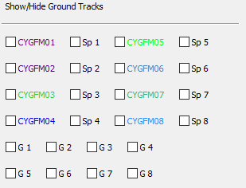

At the top of the inputs section ground tracks and specular point tracks for each satellite can be toggled on/off individually. Additionally, there are toggle boxes for a special version of specular point tracks which show specular point gain as line thickness. **Note: Displaying specular point gain results in a significantly slower simulation. The recommendation is to narrow down the analysis window as much as possible before engaging specular point gain, or to use the gain option only when not animating.**

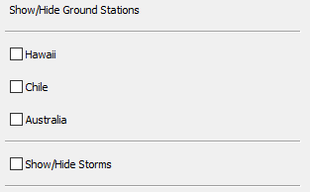

Below the ‘Show/Hide Ground Tracks’ section are the ‘Show/Hide Ground Stations’ controls. Here users can select which ground station 5 degree elevation masks they wish to see projected on the main display. Users can also select to display interpolated storm forecast tracks here as well, which will appear as long as there is a storm forecast within the analysis interval.

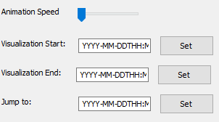

Next in the input section are the ‘Visualization’ controls. These options allow the user to speed up or slow down the animation speed, change the beginning/end points of the analysis interval, and jump to a time anywhere in between those beginning/end points. The appropriate format for all three visualization time text fields is ‘YYYY-MM-DDTHH:MM:SS’. Note that all input times must fall within the ‘global’ analysis interval that was specified during SIFT startup.

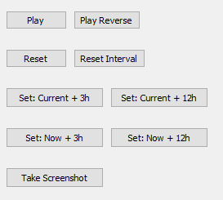

At the bottom of the Inputs section are additional visualization controls as well as analysis interval hot buttons, useful for quickly setting the analysis beginning/end times on the fly.

* Play/Pause - starts/pauses the animation
* Play Reverse - plays the animation backwards
* Reset - Sets the analysis time and satellite positions back to beginning of analysis interval
* Reset Interval - Sets analysis interval to maximums determined at SIFT startup
* Current + 3h - Sets analysis interval to current analysis time - current analysis time + 3h
* Current + 12h - Same as above but + 12h
* Now + 3h - Sets analysis interval to real-time - real-time + 3h
* Now + 12h - Sets analysis interval to real-time - real-time + 12h
* Take Screenshot - Stores screenshot in ‘../output\_sift/<run\_dir>/screenshots

#### Visualization Section

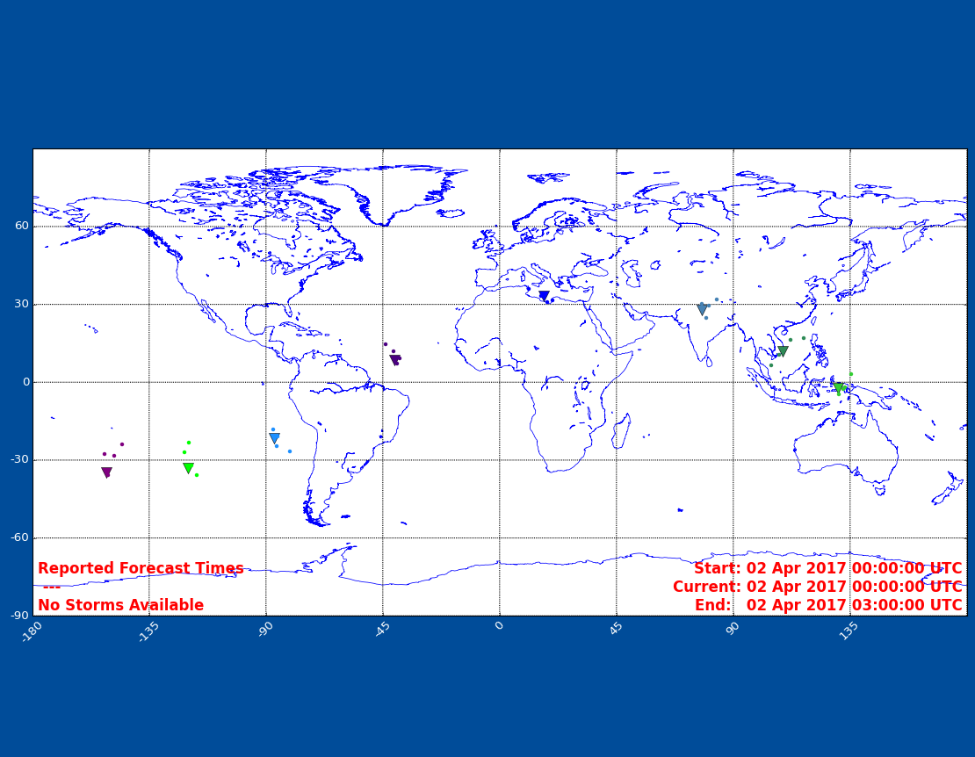

The center column of the main SIFT screen is the ‘visualization’ section of the application. This section is a map that displays all CYGNSS satellite and specular point locations, information about the analysis interval as well as a list of storms that exist in the current analysis interval.

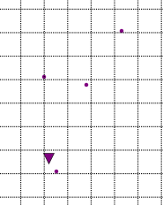

Shown above is a zoomed in image of one of the satellites shown in the ‘visualization’ section. The satellite location at a given moment in time is represented by the inverted triangle icon. Associated with the inverted triangle are four small circles of the same color - these circles represent the specular point measurements being made by the associated satellite. **Note: the**

**thickness of the specular point circle does not represent the surface area over which**

**actual wind speed measurements are made.**

#### Outputs Section

The rightmost column of the main SIFT screen is the ‘outputs’ section of the application. It shows information about the next ground station overpass for each satellite as well as satellite headings and information about how to read information encoded in the visualization section (i.e. specular point gain, storm trajectory and type etc.)

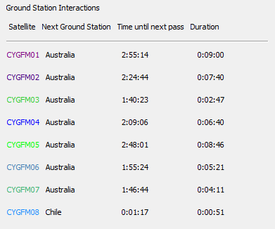

The topmost area of the ‘outputs’ section shows upcoming ground station interactions for all satellites provided there will be an interaction before the end of the analysis interval. Each line represents one satellite and the satellites are color-coded to match the satellite icons in the visualization section. Information provided includes the next ground station the satellite will pass over, how long until that overpass occurs and how long that overpass will last for.

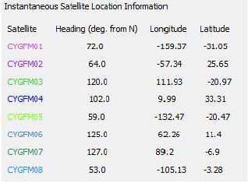

Below the ground station interactions portion of the output GUI is the Instantaneous Satellite

Location Information. In this section the current timestep by timestep location and heading of

each individual CYGNSS satellite can be seen.

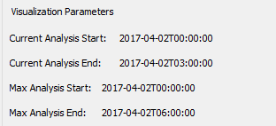

The middle area of the ‘outputs’ section shows information about the current analysis interval and the maximum analysis interval defined at SIFT start up. Note that when choosing new visualization start/end times (in the ‘inputs’ section) the must fall inclusively between the ‘Max Analysis Start’ and ‘Max Analysis End’.

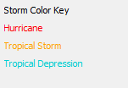

At the bottom of the ‘outputs’ section is a simple storm color code reference, showing a different color for each of three major storm types of interest. An expanded key is available in the SIFT toolbar described below.

#### Application Toolbar Options

At the top of the main SIFT window there are four drop down menus: File, View, Generate, and Help. The File menu contains additional application operation functions, such as a button to close the application. View offers various zoom options for the visualization pane of the application, allowing users to change the map area of focus.

In addition to the several zoom presets, users can specify their own zoom settings by editing ../input\_sift/user\_zoom.txt. **Note: These user-created zoom settings *will* persist between SIFT runs and can be cleared by simply removing the associated entry from zoom\_settings.txt in the SIFT root directory.** Values entered in ‘user\_zoom.txt’ must be whole numbers with latitude in +/-deg N 0-90, and longitude in +/-deg E, 0-180. (The first three lines of this file are ignored.)

Generate offers several reports which can be generated by SIFT. Reports are stored in the appropriate subdirectory of ../output\_sift/.

● Ground Station Interaction Report - A report designed to provide users with a quick

overview of when ground station overpasses will occur on a per satellite basis

● Overpass Report - A report designed to report specular point samples

within any specified lat/lon grid and time window. The header of the CSV file produced is:

CYGFM0#, TIME,LAT\_SPEC, LON\_SPEC, HEADING, GAIN, NAME\_GPS, NUM\_PRN, SCIENCE\_MODE\_Y/N

(Note: The GAIN column is in terms of ‘LOW, MEDIUM, and HIGH’)

Help provides expanded functionality or additional information about items available on the GUI. The Help menu is where users will find an expanded color key for all storm types forecasted by NOAA and the JTWC.

SIFT Log

In addition to the various on-screen inputs/outputs described above there is a sift.log file located in the SIFT root directory. The purpose of this file is to capture SIFT events while the software is executing. Events are logged at one of five levels, namely info, debug, warning, error, critical shown here in increasing order of severity. The log file can be used to review SIFT regular use errors (i.e. if an analysis time is requested that is outside the analysis interval for that SIFT run an event will be logged) as well as SpOCK execution issues. All standard error output is written to the log file in the case of a crash allowing users to easily retrieve error codes and information for bug report submission.

### Appendix I: Full listing of information encoding in SIFT

The following information encodings in SIFT are listed in the format: graphical attribute - physical quantity or significance

**Satellite/Specular Points**

Icon Color (inverted triangle for satellite, small circle for specular) - Associated satellite number

Line thickness (when plotting specular gain) - Specular gain, consult gain key (under Help >

Specular Gain Trace Key)

**Storms**

Circle Size - Storm size, calculated as circle of radius maximum 34 kt winds

Circle Color - Storm Type, consult color key (under Help > Storm Forecast Color Key)

Circle Color (darkened) - Indicates current storm position

Circle Color (lightened) - Indicates future forecasted position

### Appendix II: Python packages required for SIFT

wxPython

calendar

numpy

getpass

sys

os

glob

datetime

time

fileinput

setuptools

subprocess

matplotlib

mpl\_toolkits.basemap

name\_package

collections

itertools

operator

math

scipy

bisect

logging

ctypes

pprint

pandas

getpass

urllib2

ssl

urllib

base64

bs4

re

requests

1. Bussy-Virat, C., Getchius, J., & Ridley, A. (2018). The Spacecraft Orbital Characterization Kit and its Applications to the CYGNSS Mission. In 2018 Space Flight Mechanics Meeting (p. 1973). [↑](#footnote-ref-1)