**WOKVX-21414 ‘Pharmacological Action’ and Qualifiers fields are not indexed while searching in MeSH Thesaurus**

**SUMMARY**

This document helps in solving the bug WOKVX-21414.

**PROBLEM**

The fields: ‘See Also’, ‘Qualifiers’, ‘Pharm. Action’ and ‘Previous Indexing’. They have been indexed for the thesaurus which they are within. So if we type one of the above fields while searching in MeSH Thesaurus, the thesaurus which contains the field should be returned. On the contrary, none of them is returned.

WOKVX-21414: <http://edclinuxqa22.isinet.com:8080/browse/WOKVX-21414>

**CAUSE**

Every thesaurus is represented by an entry in Search Aid Database. An entry consists of many fields. Whether a field need to be indexed depends upon its field template in template.xml.

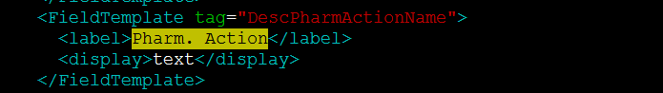

The “Pharm. Action” field template has no “<index />” flag, so the “Pharm. Action” field won’t be indexed.

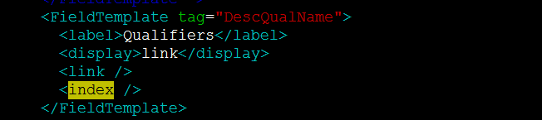

The “Qualifiers” field will be indexed for its thesaurus because its template has “<index />” flag. Why can’t we get the thesaurus by searching its “Qualifiers” field since this field has been indexed?

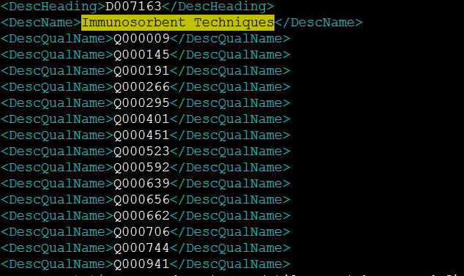

Look at the file desc_qual_2006_entry.xml. The thesaurus “Immunosorbent Techniques” has some qualifier fields. The values of these qualifier fields-Q000009, Q000145, Q000191 and so on, will be indexed for the thesaurus “Immunosorbent Techniques”. When we search Q000706, the thesaurus “Immunosorbent Techniques” will be returned. But Q000706 is just the Unique ID of the qualifier “statistics & numerical data”. The name of the qualifier isn’t indexed for the thesaurus that contains this qualifier. So we can’t get any thesaurus if we search the qualifier name “statistics & numerical data”.

The cases of ‘See Also’ and ‘Previous Indexing’ are the same as ‘Qualifiers’.

**SOLUTION**

For the field ‘Pharm. Action’, we just need to add “<index />” flag to its field template.

**PROPOSAL**

For the field ‘See Also’, ‘Qualifiers’ and ‘Previous Indexing’, I suggest executing the command “gbsa_link” prior to the command “gbsa_index”.

The field templates of ‘See Also’, ‘Qualifiers’ and ‘Previous Indexing’ have “<index />” flag and “<link />” flag at the same time and the values of these fields are all Unique IDs of qualifiers. The command “gbsa_link” gets the entry ID by the Unique ID. When we execute the “gbsa_index” command later, we can get the entry by the entry ID, and then find the qualifier name from the entry. So we can index the qualifier name for thesaurus.

To allow the command “gbsa_index” to find thesaurus name from the entry, we have to modify the function build_index() in gbsa_index.c

The disadvantage of this proposal: As a result of “gbsa_link”, the entry ID replaces the Unique ID as the values of these fields. We can’t index the Unique IDs of the qualifiers for the thesaurus which contains the qualifiers any more.