# Technical Report

**Technical Report for Real-time Anomaly Detection in Video Surveillance**

## Introduction

The increasing use of surveillance cameras in the United States, driven by technology and security concerns, has led to a reliance on human operators for monitoring and anomaly detection. However, human operators have limitations such as fatigue and distraction. To address this, real-time automatic anomaly detection in video surveillance is crucial. This system can continuously monitor and promptly respond to unusual activities, enhancing security by detecting crimes like shootings, shoplifting, assault, and robbery. Furthermore, it serves as an early threat detection tool, identifying suspicious events like robbery, unusual vehicle movements, etc. Rapid anomaly detection enables quicker responses from security personnel and law enforcement, reducing the risk of danger or damage.

## Data Preprocessing

Preprocessing video data for real-time anomaly detection in video surveillance involves several steps to ensure that the data is prepared, cleaned, and transformed in a way that facilitates accurate anomaly detection. Here are the key steps:

* 1. **Data Collection:** Gather video data from surveillance cameras, which can be in the form of video streams or recorded footage. Ensure that the data is timestamped to maintain temporal information.
  2. **Frame Extraction:** To work with video streams, extract individual frames from the video to process them individually.
  3. **Removing duplicate frames:** Eliminate identical frames to reduce redundancy. This will significantly decrease the number of frames to process.
  4. **Data Normalization:** Normalize the extracted features to have consistent scales and distributions. This step is crucial for ensuring that different features are treated equally during anomaly detection.
  5. **Data Splitting:** Splitting the data into training, and testing datasets. So that we can train the model with these datasets.

## Data Analysis

* 1. **Temporal Analysis:** Analyze the temporal behavior of objects or regions of interest across multiple frames. Detect anomalies by identifying deviations from typical object behavior over time.
  2. **Thresholding:** Set appropriate thresholds for anomaly scores or probabilities to classify detected anomalies as genuine or false positives.
  3. **Model Updating:** Periodically update the background models, feature extraction methods, and anomaly detection algorithms to adapt to changing environmental conditions and maintain accuracy.
  4. **Evaluation and Fine-tuning:** Continuously evaluate the performance of the anomaly detection system and fine-tune parameters and algorithms to minimize false positives and improve detection accuracy.

## Notification and Logging

* 1. **Alert Generation:** Generate alerts or notifications when anomalies are detected. This may involve sending alerts to security personnel or triggering other actions to address the anomaly. Some ways are through email, message through subscripted phone, and notification through application.
  2. **Logging and Storage:** Log the detected anomalies and associated information for future analysis and auditing. Store the preprocessed video data, anomalies, and alerts for reference and evidence.

## Methodology

* **I3D (Inflated 3D ConvNet)**
  + 3D Convolutional Layers: I3D uses 3D convolutional layers that operate on video data, capturing spatial and temporal features simultaneously.
  + Inflated Weights: Initializing the 3D convolutional layers with 2D convolutional filters pretrained on large-scale image classification datasets. These pretrained weights helps in transfer learning and faster convergence.
  + Two-Stream Architecture: I3D typically employs two parallel streams of networks: one for RGB frames and another for optical flow. This enables the model to analyze both frame content and motion patterns.
* **LIME**
  + Model Agnostic: LIME is model-agnostic, meaning it can be used with any machine learning model, whether it's a decision tree, neural network, random forest, or any other model. It does not rely on the model's internal structure.
  + Local Interpretability: LIME focuses on explaining the prediction of a single instance or a small group of instances. It doesn't provide global explanations for the entire model.
  + Human-Readable Explanation: The local model's coefficients or rules can be interpreted by humans, providing insights into why the model made a particular prediction for a given instance.

**Figure 1: Example of the Lime model**

## Proposed Approach

**Figure 2: The flow diagram of proposed anomaly detection [1]**

## In Figure 2, we change C3D model to I3D model to extract features for each video segment. In addition, for the feature extraction part, we are using the pre-calculated I3D and then we build train a fully connected neural network to calculate the ranking loss between the highest score instances in the positive bag (containing anomaly) and the negative bag (containing no anomaly)

## Preprocessing

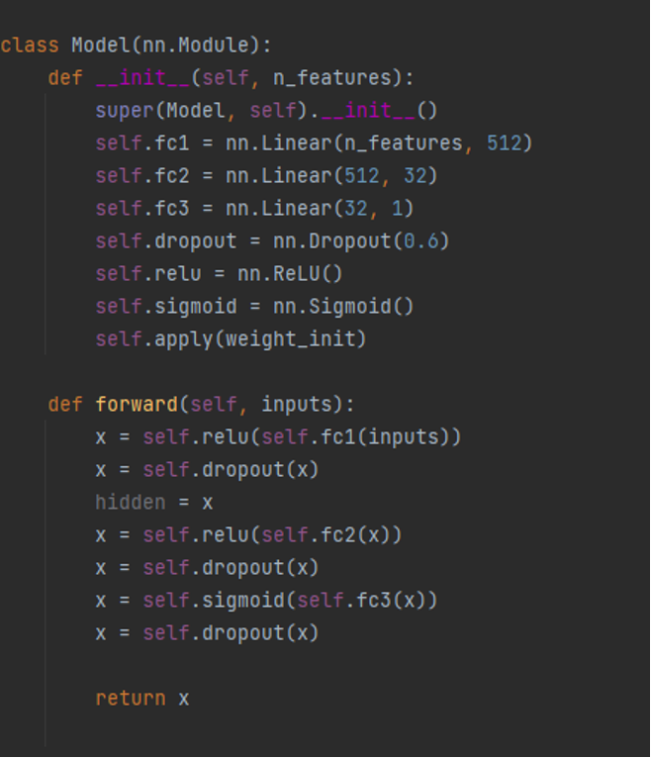

## Figure 3: Custom Dataset class

## In Figure 3, we create a custom dataset class to load the training and testing dataset.

1. **Model**

## 

## Figure 4: Fully connected neural network to compute the ranking loss

## In Figure 4, we create a neural network model using the nn. Module base class. This model consists of several fully connected layers (linear layers) along with activation functions and dropout layers.

## Figure 5: Training function

## In Figure 5, we create a training loop for a neural network model. We use two data loaders, nloader and aloader to train the model.

## Conclusion

In conclusion, this paper has underscored the critical importance of real-time anomaly detection in video surveillance systems, emphasizing its role in enhancing societal security. We have discussed the significance of early threat detection, scalability, reduced false positives, proactive response, and emergency notification as key objectives in the context of this technology.

## References

[1] https://[www.crcv.ucf.edu/projects/real-world](http://www.crcv.ucf.edu/projects/real-world)