 | INTERNATIONAL TELECOMMUNICATION UNION

ITU-T | G.723.1
TELECOMMUNICATION  STANDARDIZATION SECTOR  OF ITU | Annex A  (11/96)

SERIES G: TRANSMISSION SYSTEMS AND MEDIA
Digital transmission systems – Terminal equipments – Coding of analogue signals by methods other than PCM

Dual rate speech coder for multimedia communications transmitting at 5.3 and 6.3 kbit/s
Annex A: Silence compression scheme

ITU-T Recommendation G.723.1 – Annex A
(Previously CCITT Recommendation)

ITU-T G-SERIES RECOMMENDATIONS
TRANSMISSION SYSTEMS AND MEDIA

INTERNATIONAL TELEPHONE CONNECTIONS AND CIRCUITS | G.100–G.199
INTERNATIONAL ANALOGUE CARRIER SYSTEM
GENERAL CHARACTERISTICS COMMON TO ALL ANALOGUE CARRIER-TRANSMISSION SYSTEMS | G.200–G.299
INDIVIDUAL CHARACTERISTICS OF INTERNATIONAL CARRIER TELEPHONE SYSTEMS ON METALLIC LINES | G.300–G.399
GENERAL CHARACTERISTICS OF INTERNATIONAL CARRIER TELEPHONE SYSTEMS ON RADIO-RELAY OR SATELLITE LINKS AND INTERCONNECTION WITH METALLIC LINES | G.400–G.449
COORDINATION OF RADIOTELEPHONY AND LINE TELEPHONY | G.450–G.499
TRANSMISSION MEDIA CHARACTERISTICS | G.600–G.699
DIGITAL TRANSMISSION SYSTEMS
TERMINAL EQUIPMENTS | G.700–G.799
General | G.700–G.709
Coding of analogue signals by pulse code modulation | G.710–G.719
Coding of analogue signals by methods other than PCM | G.720–G.729
Principal characteristics of primary multiplex equipment | G.730–G.739
Principal characteristics of second order multiplex equipment | G.740–G.749
Principal characteristics of higher order multiplex equipment | G.750–G.759
Principal characteristics of transcoder and digital multiplication equipment | G.760–G.769
Operations, administration and maintenance features of transmission equipment | G.770–G.779
Principal characteristics of multiplexing equipment for the synchronous digital hierarchy | G.780–G.789
Other terminal equipment | G.790–G.799
DIGITAL NETWORKS | G.800–G.899
General aspects | G.800–G.809
Design objectives for digital networks | G.810–G.819
Quality and availability targets | G.820–G.829
Network capabilities and functions | G.830–G.839
SDH network characteristics | G.840–G.899
DIGITAL SECTIONS AND DIGITAL LINE SYSTEM | G.900–G.999
General | G.900–G.909
Parameters for optical fibre cable systems | G.910–G.919
Digital sections at hierarchical bit rates based on a bit rate of 2048 kbit/s | G.920–G.929
Digital line transmission systems on cable at non-hierarchical bit rates | G.930–G.939
Digital line systems provided by FDM transmission bearers | G.940–G.949
Digital line systems | G.950–G.959
Digital section and digital transmission systems for customer access to ISDN | G.960–G.969
Optical fibre submarine cable systems | G.970–G.979
Optical line systems for local and access networks | G.980–G.999
For further details, please refer to ITU-T List of Recommendations.
ITU-T RECOMMENDATION G.723.1 – Annex A

silence compression scheme

Source
Annex A to ITU-T Recommendation G.723.1, was prepared by ITU-T Study Group 15 (1993-1996) and was approved under the WTSC Resolution No. 1 procedure on the 8th of November 1996.

FOREWORD
ITU (International Telecommunication Union) is the United Nations Specialized Agency in the field of telecommunications. The ITU Telecommunication Standardization Sector (ITU-T) is a permanent organ of the ITU. The ITU-T is responsible for studying technical, operating and tariff questions and issuing Recommendations on them with a view to standardizing telecommunications on a worldwide basis.
The World Telecommunication Standardization Conference (WTSC), which meets every four years, establishes the topics for study by the ITU-T Study Groups which, in their turn, produce Recommendations on these topics.
The approval of Recommendations by the Members of the ITU-T is covered by the procedure laid down in WTSC Resolution No. 1 (Helsinki, March 1-12, 1993).
In some areas of information technology which fall within ITU-T’s purview, the necessary standards are prepared on a collaborative basis with ISO and IEC.

NOTE
In this Recommendation, the expression “Administration” is used for conciseness to indicate both a telecommunication administration and a recognized operating agency.

© ITU 1997
All rights reserved. No part of this publication may be reproduced or utilized in any form or by any means, electronic or mechanical, including photocopying and microfilm, without permission in writing from the ITU.
CONTENTS
Page
A.1 Introduction 1
A.2 Description of the VAD 2
A.2.1 Adaptation enable flag computation 2
A.2.2 Inverse filtering 3
A.2.3 Filtered energy computation 3
A.2.4 Noise level computation 3
A.2.5 Threshold computation 4
A.2.6 The VAD decision 4
A.2.7 VAD hangover addition 4
A.2.8 VAD initialization 4
A.3 General description of the CNG 4
A.4 Description of the CNG encoder part 6
A.4.1 Computation of the frame autocorrelation function 6
A.4.2 Computation of the current frame type Ftypt 7
A.4.3 Quantization of the average energy 8
A.4.4 Computation and coding of SID parameters 9
A.4.5 Computation of the CNG excitation 10
A.4.6 Interpolation of LSPs and update 11
A.4.7 COD-CNG initialization 11
A.5 Description of the decoder part 11
A.5.1 Description of DEC-CNG 12
A.5.2 Frame erasure concealment with regards to the CNG 13
A.5.3 DEC-CNG initialization 14
A.6 Bit stream packing 14
A.7 Glossary 14
A.8 Bit-exact, fixed-point C source code 15
Recommendation G.723.1 – Annex A
Silence compression scheme
(Geneva, 1996)

A.1 Introduction
This Annex describes the silence compression system that has been designed for the G.723.1 speech coder. Silence compression techniques are used to reduce the transmitted bit rate during silent intervals of speech. Systems allowing discontinuous transmission are based on a Voice Activity Detection (VAD) algorithm and a Comfort Noise Generator (CNG) algorithm that allows the insertion of an artificial noise during silence periods. This feature is necessary to avoid noise modulation introduced when the transmission is switched off: if the background acoustic noise that was present during active periods abruptly disappears, this very unpleasant noise modulation may even reduce the intelligibility of the speech.
The purpose of the VAD is to reliably detect the presence or absence of speech and to convey this information to the CNG algorithm. Typically, VAD algorithms base their decisions on several successive frames of information in order to make them more reliable and to avoid producing intermittent decisions. The VAD is constrained to operate on the same 30 ms speech frames which will subsequently either be encoded by the speech coder or filled with comfort noise by the comfort noise generator. The output of the VAD algorithm is passed to the CNG algorithm.
The largest difficulty in the detection of speech is the presence of any of a diverse range of background noise conditions. The VAD must be able to detect speech even in very low signal-to-noise ratio conditions. It is impossible to distinguish between speech and noise using simple level detection techniques when parts of the speech utterance are buried below the noise. The distinction between these conditions can only be made by taking into consideration the spectral characteristics of the input signal. In order to do this, the VAD incorporates an inverse filter, the coefficients of which are derived during noise-only periods by the CNG. All further details of the VAD are included in A.2.
The purpose of the CNG algorithm is to create a noise that matches the actual background noise with a global transmission cost as low as possible. At the transmitting end, the CNG algorithm uses the activity information given by the VAD for each frame, then computes the encoded parameters needed to synthesize the artificial noise at the receiving end. These encoded parameters compose the Silence Insertion Descriptor (SID) frames, which require less bits than the active speech frames and are transmitted during inactive periods.
The main feature of this CNG algorithm is that the transmission of SID frames is not periodic: for each inactive frame, the algorithm makes the decision of sending a SID frame or not, based on a comparison between the current inactive frame and the preceding SID frame. In this way, the transmission of the SID frames is limited to the frames where the power spectrum of the noise has changed.
During inactive frames, the comfort noise is synthesized at the decoder by introducing a pseudo-white excitation into the short-term synthesis filter. The parameters used to characterize the comfort noise are the LPC synthesis filter coefficients and the energy of the excitation signal. At the encoder, for each SID frame the algorithm computes a set of LPC parameters and quantizes the corresponding LSPs using the coder LSP quantizer on 24 bits. It also evaluates the excitation energy and quantizes it with 6 bits. This yields encoded SID frames of 4 bytes including the 2 bits for bit rate and DTX information.
A notable feature of this CNG algorithm is the method used to evaluate the spectrum of the ambient noise for each SID frame. It takes into account the local stationarity or non-stationarity of the input signal.
Finally, the excitation corresponds to the higher bit rate excitation of the G.723.1 codec. Since the fixed excitation has a rather poor spectrum, the long-term excitation is also used in order to obtain a better white-noise-type of excitation. The algorithm randomly chooses the codes of the long-term parameters (delays and gains) and the fixed codebook parameters (grid, pulse positions and signs). For every two subframes, it computes the gain of the fixed excitation to achieve a global energy derived from the transmitted SID energy.
The computation of the excitation needs to be performed both at the encoder and at the decoder to keep both parts synchronized.
At the receiver, to simplify the procedure, the harmonic postfilter is switched off during comfort noise generation since the generated noise is not a voiced signal.
The results of the tests on the VAD/DTX/CNG scheme as described in this Annex will be published at a later date as an appendix to Annex A to Recommendation G.723.1.

A.2 Description of the VAD
This subclause describes the Voice Activity Detector (VAD) used in the G.723.1 speech coder. The function of the VAD is to indicate whether each 30 msec frame produced by the speech encoder contains speech or not. The VAD decision at frame t is labelled as Vadt and is the input to the COD-CNG block that computes Ftypt, as described in A.3 and Figure A.1. The performance of the VAD algorithm is characterized by the amount of audible speech clipping and the percentage of speech activity it indicates.
The VAD is basically an energy detector. The energy of the inverse filtered signal is compared with a threshold. Speech is indicated whenever the threshold is exceeded. The threshold is computed by a two-step procedure. First, the noise level is updated based on its previous value and the energy of the filtered signal. Second, the threshold is computed from the noise level via a logarithmic approximation.
Hangover is a term describing the practice of declaring the first few frames of silence following a speech burst to still be speech. It is used to eliminate low level speech clipping. Hangover is only added to speech bursts which exceed a certain duration to avoid extending noise spikes.

A.2.1 Adaptation enable flag computation
An adaptation enable flag, denoted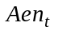 for the current frame t, is used to be sure that the VAD noise level is adapted only when speech is not present. It is based on the fact that the background noise or the silence is neither a voiced signal nor a sine wave:
– Voiced/Unvoiced detection:
The open loop pitch delays of the preceding and current frame are used to test voicing. Let us note 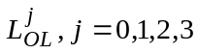 those four values. The minimum delay 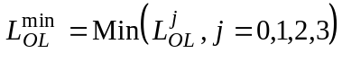 is first computed. The counter 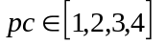 indicating how many delays 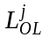lie in the neighborhood of a multiple of 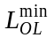 (±3) is evaluated. If pc is equal to 4 the signal is considered as voiced.
– Sine wave detection : (already present COM 15-255 Contribution)
The following sine wave detector is included in the LPC analysis of the G.723.1 encoder:
Let 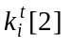 be the second reflection coefficient computed by the Durbin recursion for each subframe 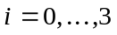 of frame t.
If 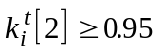 for at least 14 of the 15 last values, then a sine wave is detected (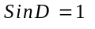). In the other case, 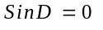.
– Compute the adaptation enable flag:
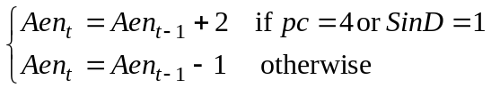
Aen_{t} is bounded into 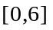.

A.2.2 Inverse filtering
The input signal frame, 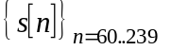, is inverse filtered by a FIR filter 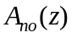 with coefficients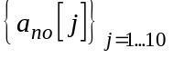. This filter is calculated by the CNG block and provides an estimation of the LPC filter associated to the current background noise.
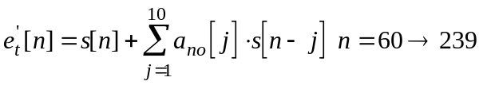 (A-1)
where 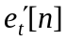 is the inverse filtered signal.

A.2.3 Filtered energy computation
The energy, Enrt, is computed from the inverse filtered signal of the current frame by:
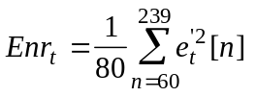 (A-2)

A.2.4 Noise level computation
The noise level at frame t, Nlevt, is updated based on its previous value and on the previous energy,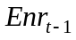 and on the adaptation enable flag Aen_{t}. This update procedure is characterized by slow attack and fast decay. The dynamic range of the noise level at frame t is limited to the range 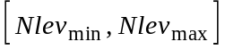.
1) If 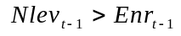then the noise level is first clipped:
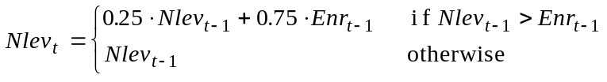 (A-3)
2) Then 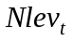 is increased, if adaptation is enabled, otherwise it is decreased by a small amount:
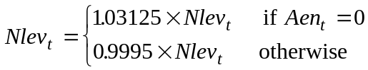 (A-4)
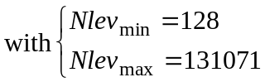

A.2.5 Threshold computation
The relationship between the noise level at frame t, Nlevt, and the threshold, Thr, is defined by logarithmic approximation and defined by the following formula:
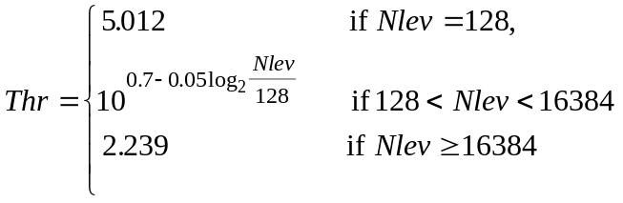 (A-5)

A.2.6 The VAD decision
The VAD decision is based on the comparison between the threshold, Thr, and the current energy, Enrt.
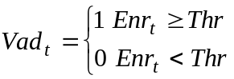 (A-6)

A.2.7 VAD hangover addition
A hangover of 6 frames is added only in the case of speech bursts (Vadt = 1) larger or equal than 2 frames.

A.2.8 VAD initialization
All static variables of the VAD algorithm are initialized to zero, except the following variables:
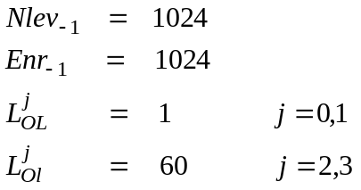 (A-7)

A.3 General description of the CNG
The algorithm is divided into two blocks situated at the encoder and the decoder, that will be called respectively COD-CNG and DEC-CNG. At the encoder (see Figure A.1), the COD-CNG block uses the autocorrelation function of the speech signal computed for each 60 samples subframe, the past excitation samples and LSPs from the preceding frame.
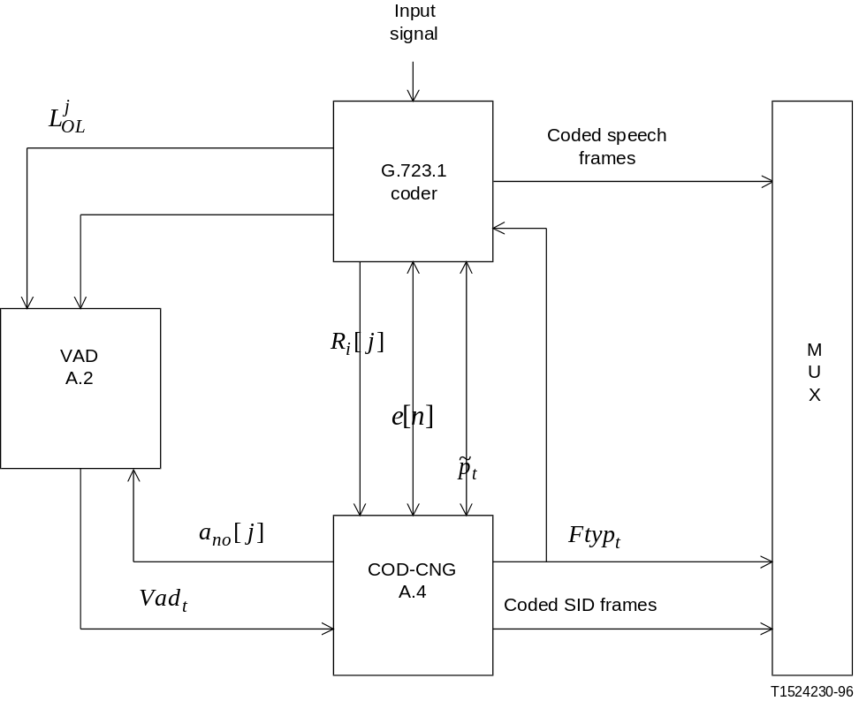
Figure A.1/G.723.1
Block diagram of the encoder with VAD/CNG
For inactive frames, COD-CNG computes the CNG excitation samples in order to synchronize the local decoder of the encoder with the distant decoder.
Because of the predictive coding of the LSPs in the G.723.1 scheme, a similar input/output with update is done for LSP parameters during inactive frames.
COD-CNG outputs the encoded SID frames and the final decision 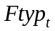 (Frame type of frame t) as one of the three values, 0, 1, or 2 corresponding to untransmitted frame, active speech frame or SID frame, respectively.
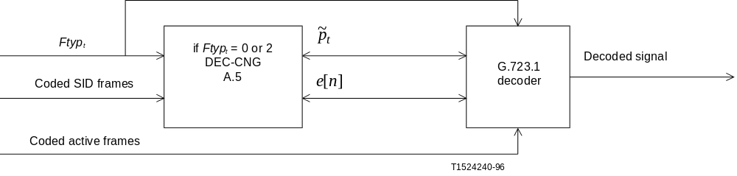
Figure A.2/G.723.1
Block diagram of the decoder with VAD/DTX
At the receiver (see Figure A.2), the DEC-CNG block processes only inactive speech frames, for which the input information is equal to 0 or 2 (untransmitted/SID). DEC-CNG decodes the SID frames and both for SID and untransmitted frames, computes the current LSPs and excitation using the same method as COD-CNG.
Then the G.723.1 decoder synthesizes the comfort noise using the CNG excitation and LSPs.

A.4 Description of the CNG encoder part
For each frame of 240 samples (active or inactive), the COD-CNG block processes the data coming from the VAD and the coder, produces the information and the coded SID frame according to the procedure depicted by Figure A.3 and detailed in A.4.1 to A.4.7.

A.4.1 Computation of the frame autocorrelation function

File: COD_CNG.C | Procedure: Update_Acf() | Update autocorrelation function
For every frame t (active or inactive), the autocorrelation coefficients (calculated in the encoder as described in 2.4 of Recommendation G.723.1) 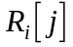, j = 0 to 10 of the four subframes indexed by i = 0 to 3 are summed. The cumulated autocorrelation function of the current frame t, is given by:
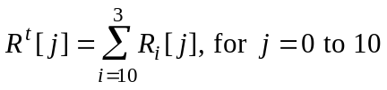 (A-8)
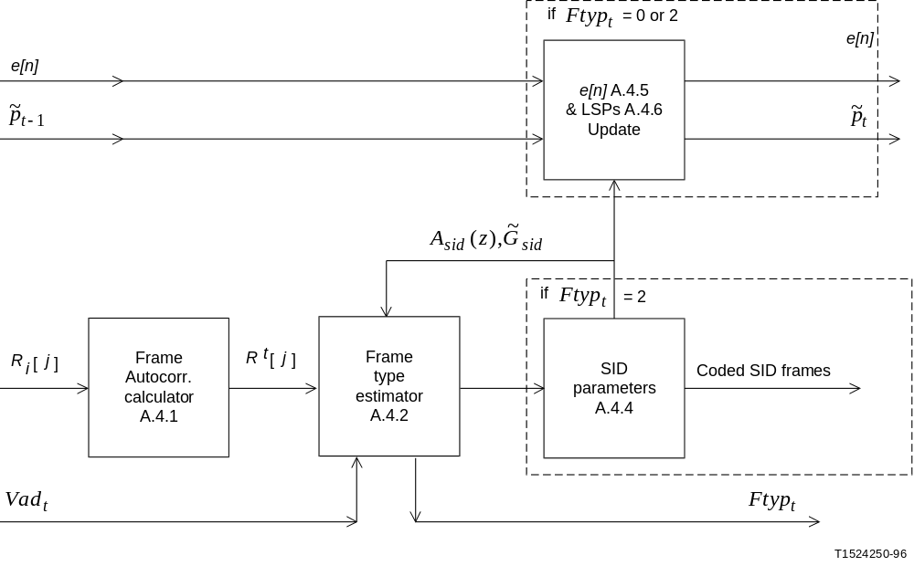
Figure A.3/G.723.1
Block diagram of the CNG at the encoder part

A.4.2 Computation of the current frame type Ftypt

File: COD_CNG.C | Procedure: Cod_Cng() | COD_CNG main body
File: COD_CNG.C | Procedure: LpcDiff() | Itakura distance comparison
File: LPC.C | Procedure: Durbin() | Levinson-Durbin recursion
If the current frame t is an active speech frame (Vad_{t}=1), then = 1 and no other processing is performed.
In the other case, the decision SID/untransmitted frame is taken according to the following procedure:
The LPC filter 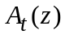of the current frame t is calculated by the Durbin procedure (see 2.4 of Recommendation G.723.1) using 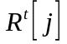 as input. The coefficients of are noted at[j], j=1 to 10. The Durbin procedure also provides the residual energy 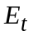, that will be used as an estimate of the frame excitation energy.
Then the current frame type 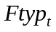is determined in the following way:
• If the current frame is the first inactive frame of the inactive zone, the frame is selected as SID frame, the variable 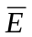which reflects the energy sum is taken equal to , and the number of frames involved in the summation, kE, is initialized to 1:
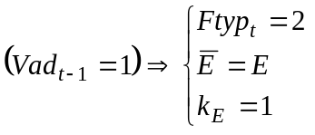 (A-9)
• Else, if the current filter is significantly different from the preceding SID filter, or if the current excitation energy significantly differs from the preceding SID energy, then the frame is selected as SID ( = 2).
• Otherwise, if the current frame is not the first of an inactive period, and if the current LPC filter and the excitation energy are similar to the SID ones, the frame is not transmitted ( = 0).
The LPC filters and energies are compared according to the following methods:
Comparison of the LPC filters
The current LPC filter and SID filter are considered as significantly different if the Itakura distance between the two filters exceeds the given threshold, which is expressed by:
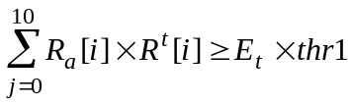 (A-10)
where Ra[j], j = 0 to 10 is a function derived from the autocorrelation of the coefficients of the SID filter, given by :
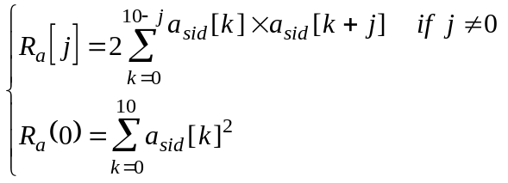 (A-11)
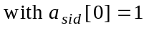
A value of 1.2136 is used for thr1.
Comparison of the energies
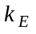being first incremented up to the maximum value 3, the sum the frame energies 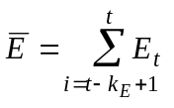is calculated.
Then is quantized, using the 6-bit pseudo-logarithmic quantizer described in A.4.3. The coded gain index GIndt is compared to the previous coded SID gain index 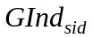. If the difference exceeds the threshold thr2=3, the two energies will be considered as significantly different.

A.4.3 Quantization of the average energy

File: UTIL_CNG.C | Procedure: Qua_SidGain() | Quantize Sid Gain
File: UTIL_CNG.C | Procedure: Dec_SidGain() | Decode Sid Gain
The quantization procedure operates on the sum of the energies , and the decoding provides a gain, which corresponds to the decoded value of the average energy square root.
A scaling factor 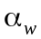 = 2.70375 is introduced to take into account the effect of windowing and bandwidth expansions present in the subframes autocorrelation functions 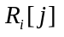
The value used at the input of the gain quantizer is:
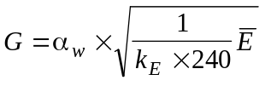, bounded in [0, 352].
The quantizer is a pseudo-log one, that divides [0, 352] into three segments indexed isg = 0 to 2 of length N[isg] = 16, 16, 32 with the associated resolutions 2, 4 and 8.
Let Gisg [j], j = 0 to N[isg]-1 be the decoded values for segment isg. Those values are given by:
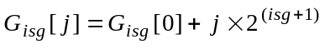 (A-12)
The procedure uses 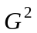 to calculate the index isg of the segment which contains G and the index is of Gisg ( is) the closer to G.
The current quantization index is given by:
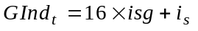 (A-13)
The decoding is performed using the following formula:
(A-14)
where 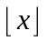denotes the greatest integer ≤ x.

A.4.4 Computation and coding of SID parameters

File: COD_CNG.C | Procedure: Cod_Cng() | COD_CNG main body
File: COD_CNG.C | Procedure: ComputePastAvFilter() | Computes past average filter
File: COD_CNG.C | Procedure: LpcDiff() | Itakura distance comparison
File: COD_CNG.C | Procedure: CalcRc() | Compute function RC from LPC
File: LPC.C | Procedure: Durbin() | Levinson-Durbin recursion
File: LSP.C | Procedure: AtoLsp() | Converts LPC coefficients into LSP
File: LSP.C | Procedure: Lsp_Qnt() | LSP quantization
File: LSP.C | Procedure: Lsp_Inq() | LSP inverse quantization
When the current frame is a SID frame, the SID parameters are calculated and quantized. Notice that those parameters will serve in making the SID decision for the next inactive frames up to the next SID frame.
Computation of SID LPC filter [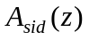] and update of VAD LPC filter [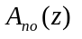]
First, the past average LPC filter 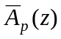 built from the three frames preceding the current one is estimated, using the Durbin procedure with the following autocorrelation function as input:
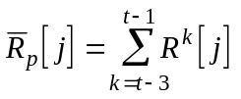, for j = 0 to 10 (A-15)
the autocorrelation functions R^{k}[ j] being the cumulated ones calculated by (A-8).
The past average LPC filter coefficients are denoted 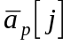, j = 1 to 10.
The VAD noise LPC filter used in A-2 is then updated with 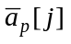 but only when the adaptation enable flag Aen_{t} allows it:
(A-16)
Then 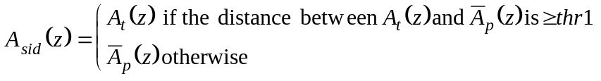 see eq. (A-10)
The distance between the current LPC filter 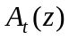and the average past LPC filter is computed in the same manner as in A.4.2.
The coefficients 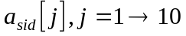 of the new SID LPC filter are LSP converted and the LSPs are quantized using the encoder LSP 24-bit quantization procedure (see 2.5 of Recommendation G.723.1). The decoded value will be called 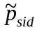.
SID gain
The quantized value of the SID gain is given by:
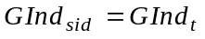 (A-17)
and the decoded value is denoted 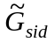.

A.4.5 Computation of the CNG excitation

File: UTIL_CNG.C | Procedure: Calc_Exc_Rand() | Computation of the excitation
File: UTIL_CNG.C | Procedure: random_number() | Random number generation
File: UTIL_CNG.C | Procedure: distG() | Used to select excitation Gain
File: UTIL_LBC.C | Procedure: Sqrt_lbc() | Square root
File: UTIL_LBC.C | Procedure: Rand_lbc() | Pseudo-random sequence
The update of the excitation signal is performed both for SID frames and for untransmitted frames.
First, let us define the target excitation gain 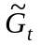 as the square root of the average energy that must be obtained for the current frame t synthetic excitation. is calculated using the following smoothing procedure:
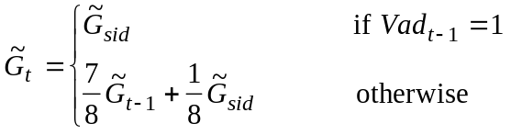 (A-18)
The 240 samples of the frame are divided into two blocks of 120 samples, each block comprising two subframes of 60 samples.
For each block, the CNG excitation samples are synthesized using the following algorithm:
First the LTP parameters of the two subframes are selected:
• The pitch lag for the first subframe is randomly chosen in the interval [123, 143].
• The two subframes gain vector indices are randomly chosen into [0, 49], which corresponds to the first 50 vectors of the 170 entries gain codebook.
• The second subframe lag offset is taken equal to 0 for the first block, and 3 for the second block.
Next, the fixed codebook vectors of the two subframes are built by random selection of the grid, the pulses signs and positions, corresponding to the higher rate fixed excitation pattern.
Then a unique fixed excitation gain is computed for the two subframes of the block.
The adaptive excitation vector on the current block is noted 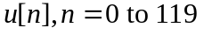 and the fixed excitation 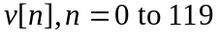.
The fixed excitation gain is obtained by calculating the value Gf that yields a block average energy the closest to the target energy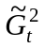:
select Gf such that 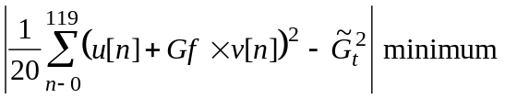 (A-19)
Notice that Gf can take a negative value.
Let us define 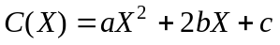such that:
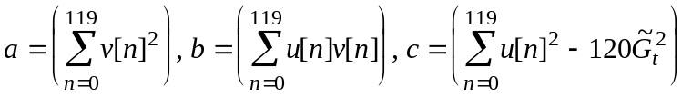
The equation 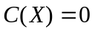 is then studied:
If the discriminant is ≤ 0 then 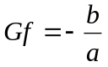 is selected, else the two roots are calculated and the one with the lowest absolute value is selected.
Then Gf is bounded: Gf ≤ 5000
Finally the block CNG excitation is built, using:
(A-20)

A.4.6 Interpolation of LSPs and update

File: COD_CNG.C | Procedure: Cod_Cng() | COD_CNG main body
File: LSP.C | Procedure: Lsp_Int() | LSP Interpolator
Both for SID frames and for untransmitted frames, the interpolated sets of LPC coefficients are calculated using 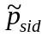 and the previous LSP vector 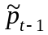provided to COD-CNG.
The LSP update is also performed: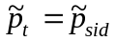.

A.4.7 COD-CNG initialization
The following initialization must be performed on the frame autocorrelation functions, the target excitation gain, VAD information, and seed of the random generator used to compute the CNG excitation:
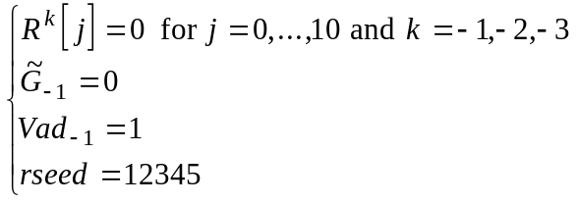
No initialization is needed for the other static variables of COD-CNG.

A.5 Description of the decoder part
At the receiving end, DEC-CNG processes SID frames and untransmitted frames to produce the synthesized comfort noise.
The procedures developed to deal with frame erasures are described next.

A.5.1 Description of DEC-CNG

File: DEC_CNG.C | Procedure: Dec_Cng() | DEC_CNG main body
File: UTIL_CNG.C | Procedure: Calc_Exc_Rand() | Computation of the excitation
File: UTIL_CNG.C | Procedure: random_number() | Random number generation
File: UTIL_CNG.C | Procedure: distG() | Used to select excitation Gain
File: UTIL_LBC.C | Procedure: Sqrt_lbc() | Square root
File: UTIL_LBC.C | Procedure: Rand_lbc() | Pseudo-random sequence
File: LSP.C | Procedure: Lsp-Inq() | LSP inverse quantization
File: LSP.C | Procedure: Lsp_Int() | LSP Interpolator
File: UTIL_CNG.C | Procedure: Qua_SidGain() | Quantize Sid Gain
File: UTIL_CNG.C | Procedure: Dec_SidGain() | Decode Sid Gain

Figure A4 provides a general description of the comfort noise generation at the decoder part.
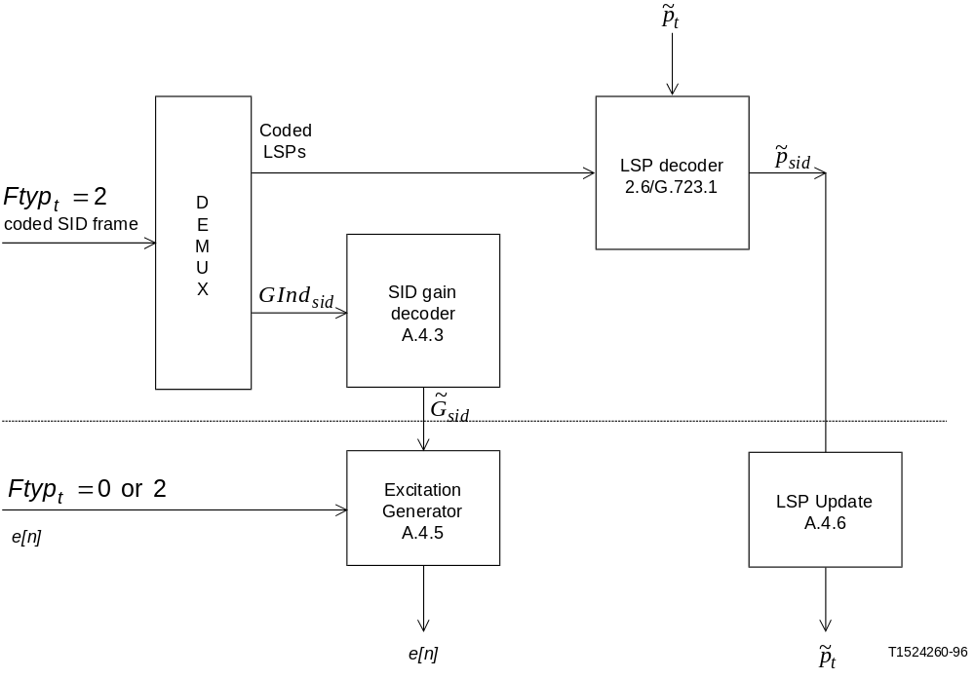
Figure A.4/G.723.1
Block diagram of the CNG at the decoder part
When the decoder receives an SID frame, DEC-CNG decodes the SID parameters.
Both in case of SID and untransmitted frames, the module DEC-CNG uses the decoded SID parameters to compute the LSPs and the excitation of the comfort noise that will be synthesized by the decoder synthesis module.
The CNG type of frame information (for frame t) provided at the receiver is the same as the value computed by COD-CNG at the encoder.
• When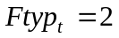, the parameters of the SID frame are decoded: 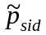for the LSPs and 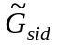 for the decoded gain.
• When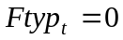,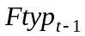 is tested to verify that the SID information has not been erased (see A.5.2). If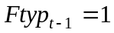, an energy term Enr, that has been calculated by the G.723.1 decoder during the processing of the last valid frame is quantized and decoded using the same procedure as the average energy in 3.1 of Recommendation G.723.1 except that there is no scaling factor 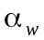. The decoded value is the restored .
Then, in both cases, the CNG excitation is calculated according to the procedure described in COD-CNG in A.4.5. The new LSP vector, , is used to compute the interpolated LPC coefficients, and the LSP updating is performed: 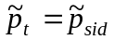

A.5.2 Frame erasure concealment with regards to the CNG

File: DECOD.C | Procedure: Decod() | Frame decoding
When a frame erasure is detected by the decoder, the erased frame type depends on the preceding frame type:
– if the preceding frame was active, then the current erased frame is considered as active,
– else if the preceding frame was either an SID frame or an untransmitted frame, the current erased frame is considered as untransmitted:
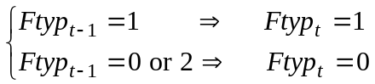 (A-21)
If an untransmitted frame has been erased, no error is then introduced.
If a SID frame is erased, there are two possibilities:
• If it is not the first SID frame of the current inactive period, then the previous SID parameters are kept.
• If it is the first SID frame of an inactive period, a special protection has been taken:
As stated in A5.1, this case is detected by the fact that 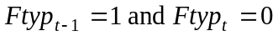.
This combination of events does not imply that the preceding frame was a good active frame: several frames up to the preceding one may have been erased. What is certain is that the last good frame was an active frame, that the present frame was not erased, and that the SID frame supposed to provide information for the current untransmitted frame is lost.
To recover the SID information, DEC-CNG uses parameters provided by the G.723.1 decoder main part:
• The LSPs of the last valid active frame are used for .
• The energy term Enr calculated by the decoder during the the residual interpolation procedure (see 3.10.2 of Recommendation G.723.1) over the 120 last excitation samples of
the last valid active frame is used to recover, according to the method described in A.5.1.
Finally, to avoid de-synchronization of the random generator used to compute the excitation, the pseudo-random sequence reset is performed at each active frame, both at the encoder and coder part: rseed = 12345.

A.5.3 DEC-CNG initialization
Only the following variables must be initialized:
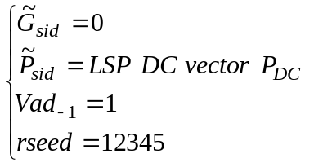

A.6 Bit stream packing
Table A.1 shows the bit stream of the SID frames according to the notations used in clause 4 of Recommendation G.723.1.
Table A.1/G.723.1
Bit packing for SID frames
Transmitted octets | PARx_By, ...
1 | LPC_B5 ... LPC_B0, VADFLAG_B0, RATEFLAG_B0
2 | LPC_B13 ... LPC_B6
3 | LPC_B21 ... LPC_B14
4 | GAIN_B5 ... GAIN_B0, LPC_B23, LPC_B22

A.7 Glossary

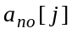 | noise LPC filter coefficients
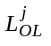 | preceding frame and current frame open loop pitch delays
pc | pitch delays counter for voicing estimation
Aen_{t} | adaptation enable flag
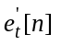 | noise-inverse filtered input signal for frame t
Enrt | noise-inverse filtered input signal energy for frame t
Nlevt | noise level at frame t
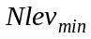 | minimum bound on Nlevt
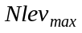 | maximum bound on Nlevt
Thr | adapted threshold for VAD decision
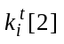 | second reflection coefficient for subframe i in frame t

SinD | sine wave detection flag (1: sine detected, 0: else)
e[n] | decoded combined excitation vector
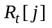 | autocorrelation function for subframe i, j = 0,1,...,10
thr2 | threshold for energies distance
Ra[j] | modified autocorrelation of LPC coefficients
Gindsid | SID gain index
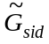 | decoded SID gain
G | excitation gain used at the SID quantizer input
Gindt | gain index for frame t
isg | SID gain quantizer segment index
N[isg] | SID gain quantizer segment length
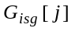 | gain decoded values of segment isg, j=0,1, ..., N[isg]-1
is | gain index relative to the segment
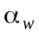 | energy scaling factor
asid | SID LPC coefficient vector
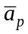 | past average LPC filter coefficients
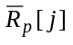 | sum of past autocorrelation functions
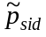 | decoded SID LSP vector
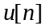 | adaptive codebook excitation vector
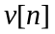 | fixed codebook excitation vector
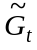 | target excitation gain for excitation synthesis
a, b, c | coefficients of energy minimization equation
C(X) | energy minimization equation
Gf | fixed codebook gain for CNG excitation synthesis
rseed | random generator seed

A.8 Bit-exact, fixed-point C source code
All details of the silence compression algorithm are included as part of bit-exact, fixed-point ANSI C source code. In the event of any discrepancy between the above descriptions and the C source, the C source code is presumed to be correct. This C source code is a part of the code distributed by the ITU-T as Recommendation G.723.1.

ITU-T RECOMMENDATIONS SERIES
Series A Organization of the work of the ITU-T
Series B Means of expression
Series C General telecommunication statistics
Series D General tariff principles
Series E Telephone network and ISDN
Series F Non-telephone telecommunication services
Series G Transmission systems and media
Series H Transmission of non-telephone signals
Series I Integrated services digital network
Series J Transmission of sound-programme and television signals
Series K Protection against interference
Series L Construction, installation and protection of cables and other elements of outside plant
Series M Maintenance: international transmission systems, telephone circuits, telegraphy, facsimile and leased circuits
Series N Maintenance: international sound-programme and television transmission circuits
Series O Specifications of measuring equipment
Series P Telephone transmission quality
Series Q Switching and signalling
Series R Telegraph transmission
Series S Telegraph services terminal equipment
Series T Terminal equipment and protocols for telematic services
Series U Telegraph switching
Series V Data communication over the telephone network
Series X Data networks and open system communication
Series Z Programming languages

It should be noted that test conditions were not sufficiently severe for mobile conditions.

