 | INTERNATIONAL TELECOMMUNICATION UNION

ITU-T | G.729
TELECOMMUNICATION  STANDARDIZATION SECTOR  OF ITU | Annex B  (11/96)

SERIES G: TRANSMISSION SYSTEMS AND MEDIA
Digital transmission systems – Terminal equipments – Coding of analogue signals by methods other than PCM

Coding of speech at 8 kbit/s using conjugate structure algebraic-code-excited linear-prediction (CS-ACELP)
Annex B: A silence compression scheme for G.729 optimized for terminals conforming to Recommendation V.70

ITU-T Recommendation G.729 – Annex B
(Previously CCITT Recommendation)

ITU-T G-SERIES RECOMMENDATIONS
TRANSMISSION SYSTEMS AND MEDIA

For further details, please refer to ITU-T List of Recommendations.
INTERNATIONAL TELEPHONE CONNECTIONS AND CIRCUITS | G.100–G.199
INTERNATIONAL ANALOGUE CARRIER SYSTEM
GENERAL CHARACTERISTICS COMMON TO ALL ANALOGUE CARRIER-TRANSMISSION SYSTEMS | G.200–G.299
INDIVIDUAL CHARACTERISTICS OF INTERNATIONAL CARRIER TELEPHONE SYSTEMS ON METALLIC LINES | G.300–G.399
GENERAL CHARACTERISTICS OF INTERNATIONAL CARRIER TELEPHONE SYSTEMS ON RADIO-RELAY OR SATELLITE LINKS AND INTERCONNECTION WITH METALLIC LINES | G.400–G.449
COORDINATION OF RADIOTELEPHONY AND LINE TELEPHONY | G.450–G.499
TRANSMISSION MEDIA CHARACTERISTICS | G.600-G.699
DIGITAL TRANSMISSION SYSTEMS
TERMINAL EQUIPMENTS | G.700–G.799
General | G.700–G.709
Coding of analogue signals by pulse code modulation | G.710–G.719
Coding of analogue signals by methods other than PCM | G.720–G.729
Principal characteristics of primary multiplex equipment | G.730–G.739
Principal characteristics of second order multiplex equipment | G.740–G.749
Principal characteristics of higher order multiplex equipment | G.750–G.759
Principal characteristics of transcoder and digital multiplication equipment | G.760–G.769
Operations, administration and maintenance features of transmission equipment | G.770–G.779
Principal characteristics of multiplexing equipment for the synchronous digital hierarchy | G.780–G.789
Other terminal equipment | G.790–G.799
DIGITAL NETWORKS | G.800–G.899
General aspects | G.800–G.809
Design objectives for digital networks | G.810–G.819
Quality and availability targets | G.820–G.829
Network capabilities and functions | G.830–G.839
SDH network characteristics | G.840–G.899
DIGITAL SECTIONS AND DIGITAL LINE SYSTEM | G.900–G.999
General | G.900–G.909
Parameters for optical fibre cable systems | G.910–G.919
Digital sections at hierarchical bit rates based on a bit rate of 2048 kbit/s | G.920–G.929
Digital line transmission systems on cable at non-hierarchical bit rates | G.930–G.939
Digital line systems provided by FDM transmission bearers | G.940–G.949
Digital line systems | G.950–G.959
Digital section and digital transmission systems for customer access to ISDN | G.960–G.969
Optical fibre submarine cable systems | G.970–G.979
Optical line systems for local and access networks | G.980–G.999
ITU-T RECOMMENDATION G.729 – Annex B

A silence compression scheme for G.729 optimized for terminals conforming to Recommendation v.70

Summary
Annex B to G.729 defines a voice activity detector and comfort noise generator for use with G.729 or Annex A optimized for V.70 DSVD applications.

Source
Annex B to ITU-T Recommendation G.729, was prepared by ITU-T Study Group 15 (1993-1996) and was approved under the WTSC Resolution No. 1 procedure on the 8th of November 1996.

FOREWORD
ITU (International Telecommunication Union) is the United Nations Specialized Agency in the field of telecommunications. The ITU Telecommunication Standardization Sector (ITU-T) is a permanent organ of the ITU. The ITU-T is responsible for studying technical, operating and tariff questions and issuing Recommendations on them with a view to standardizing telecommunications on a worldwide basis.
The World Telecommunication Standardization Conference (WTSC), which meets every four years, establishes the topics for study by the ITU-T Study Groups which, in their turn, produce Recommendations on these topics.
The approval of Recommendations by the Members of the ITU-T is covered by the procedure laid down in WTSC Resolution No. 1.
In some areas of information technology which fall within ITU-T’s purview, the necessary standards are prepared on a collaborative basis with ISO and IEC.

NOTE
In this Recommendation, the expression “Administration” is used for conciseness to indicate both a telecommunication administration and a recognized operating agency.

INTELLECTUAL PROPERTY RIGHTS
The ITU draws attention to the possibility that the practice or implementation of this Recommendation may involve the use of a claimed Intellectual Property Right. The ITU takes no position concerning the evidence, validity or applicability of claimed Intellectual Property Rights, whether asserted by ITU members or others outside of the Recommendation development process.
As of the date of approval of this Recommendation, the ITU had/had not received notice of intellectual property, protected by patents, which may be required to implement this Recommendation. However, implementors are cautioned that this may not represent the latest information and are therefore strongly urged to consult the TSB patent database.

© ITU 1997
All rights reserved. No part of this publication may be reproduced or utilized in any form or by any means, electronic or mechanical, including photocopying and microfilm, without permission in writing from the ITU.
CONTENTS
Page
B.1 Introduction 1
B.2 General description of the VAD/DTX/CNG algorithms 1
B.3 Detailed description of the VAD algorithm 2
B.3.1 Parameter extraction 4
B.3.2 Initialization of the running averages of the background noise characteristics 4
B.3.3 Generating the long-term minimum energy 5
B.3.4 Generating the difference parameters 5
B.3.5 Multi-boundary initial voice activity decision 6
B.3.6 Voice activity decision smoothing 7
B.3.7 Updating the running averages of the background noise characteristics 8
B.4 Detailed description of the DTX/CNG algorithms 9
B.4.1 Description of the DTX algorithm 9
B.4.2 SID evaluation and quantization 11
B.4.3 SID bit stream description 13
B.4.4 Non-active encoder/decoder (CNG) description 13
B.4.5 Frame erasure concealment with regards to the CNG 15
B.5 Bit-exact description of the silence compression scheme 15
B.5.1 Organization of the simulation software 16

Recommendation G.729 – Annex B
A silence compression scheme for G.729 optimized for terminals conforming to Recommendation v.70
(Geneva, 1996)

B.1 Introduction
This annex provides a high level description of the Voice Activity Detection (VAD), Discontinuous Transmission (DTX), and Comfort Noise Generator (CNG) algorithms. These algorithms are used to reduce the transmission rate during silence periods of speech. They are designed and optimized to work in conjunction with Recommendation V.70. Recommendation V.70 mandates the use of Annex A/G.729 (G.729A) speech coding methods. However, when it is desirable, the full version of Recommendation G.729 can also be used to improve the quality of the speech. The algorithms are adapted to operate with both the full version of Recommendation G.729 and Annex A/G.729. This description is for the full version of Recommendation G.729, the only difference for Annex A is indicated in B.3.1.1. A block diagram of a silence compression speech communication system is depicted in Figure B.1.
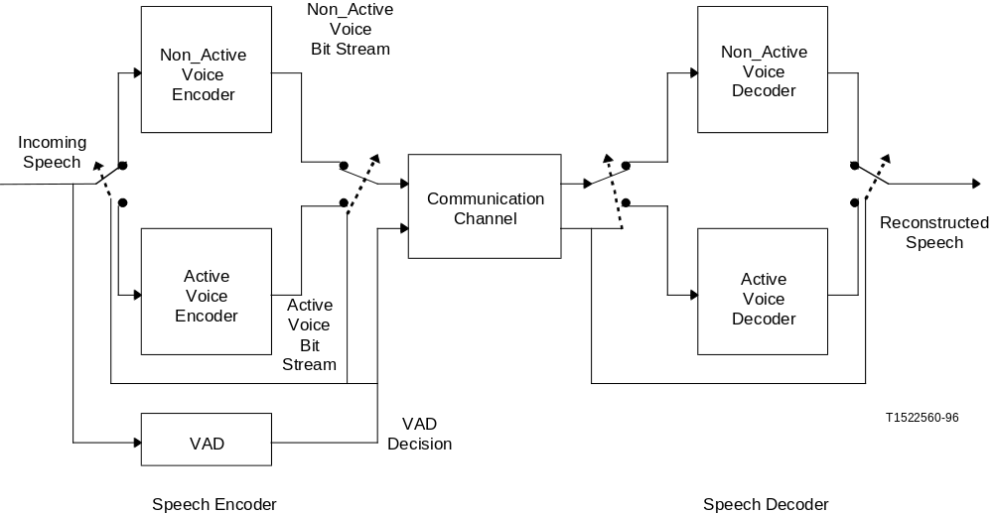
Figure B.1/G.729
Speech communication system with VAD

B.2 General description of the VAD/DTX/CNG algorithms
The VAD algorithm makes a voice activity decision every 10 ms in accordance with the frame size of the G.729 speech coder. A set of difference parameters is extracted and used for an initial decision. The parameters are the full band energy, the low band energy, the zero-crossing rate and a spectral measure. The long-term averages of the parameters during non-active voice segments follow the changing nature of the background noise. A set of differential parameters is obtained at each frame. These are a difference measure between each parameter and its respective long-term average.
The initial voice activity decision is obtained using a piecewise linear decision boundary between each pair of differential parameters. A final voice activity decision is obtained by smoothing the initial decision.
The output of the VAD module is either 1 or 0, indicating the presence or absence of voice activity respectively. If the VAD output is 1, the G.729 speech codec is invoked to code/decode the active voice frames. However, if the VAD output is 0, the DTX/CNG algorithms described herein are used to code/decode the non-active voice frames. Traditional speech coders and decoders use comfort noise to simulate the background noise in the non-active voice frames. If the background noise is not stationary, a mere comfort noise insertion does not provide the naturalness of the original background noise. Therefore it is desirable to intermittently send some information about the background noise in order to obtain a better quality when non-active voice frames are detected. The coding efficiency of the non-active voice frames can be achieved by coding the energy of the frame and its spectrum with as few as fifteen bits. These bits are not automatically transmitted whenever there is a non-active voice detection. Rather, the bits are transmitted only when an appreciable change has been detected with respect to the last transmitted non-active voice frame.
At the decoder side, the received bit stream is decoded. If the VAD output is 1, the G.729 decoder is invoked to synthesize the reconstructed active voice frames. If the VAD output is 0, the CNG module is called to reproduce the non-active voiced frames.

B.3 Detailed description of the VAD algorithm
A flowchart of the VAD operation is given in Figure B.2. The VAD operates on frames of digitized speech. The frames are processed in time order and are consecutively numbered from the beginning of each conversation/recording.
At the first stage, four parametric features are extracted from the input signal. Extraction of the parameters is shared with the active voice encoder module and the non-active voice encoder for computational efficiency. The parameters are the full and low-band frame energies, the set of Line Spectral Frequencies (LSF) and the frame zero crossing rate.
If the frame number is less than N_{i}, an initialization stage of the long-term averages takes place, and the voice activity decision is forced to 1 if the frame energy from the LPC analysis is above 15 dB (see equation B.1). Otherwise, the voice activity decision is forced to 0. If the frame number is equal to N_{i}, an initialization stage for the characteristic energies of the background noise occurs.
At the next stage a set of difference parameters are calculated. This set is generated as a difference measure between the current frame parameters and running averages of the background noise characteristics. Four difference measures are calculated:
• a spectral distortion;
• an energy difference;
• a low-band energy difference;
• a zero-crossing difference.
The initial voice activity decision is made at the next stage, using multi-boundary decision regions in the space of the four difference measures. The active voice decision is given as the union of the decision regions and the non-active voice decision is its complementary logical decision. Energy consideration, together with neighbouring past frames decisions, are used for decision smoothing.
The running averages have to be updated only in the presence of background noise, and not in the presence of speech. An adaptive threshold is tested, and the update takes place only if the threshold criterion is met.
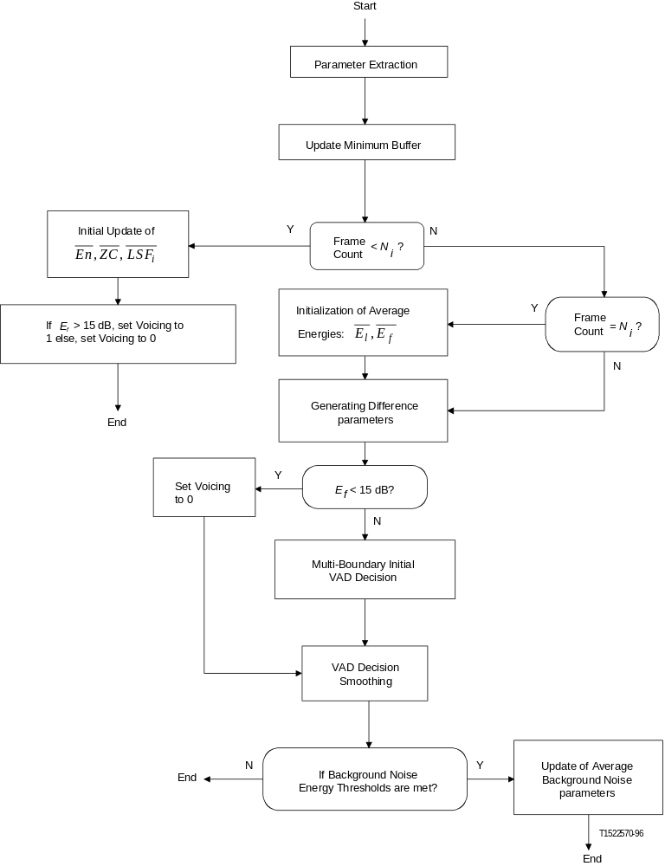
Figure B.2/G.729
VAD flowchart

B.3.1 Parameter extraction
For each frame a set of parameters is extracted from the speech signal. The parameters extraction module can be shared between the VAD, the active voice encoder and the non-active voice encoder. The basic set of parameters is the set of autocorrelation coefficients, which is derived similarly to Recommendation G.729 (see 3.2.1). The set of autocorrelation coefficients will be denoted by:
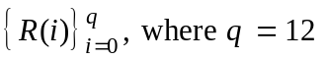

B.3.1.1 Line Spectral Frequencies (LSF)
A set of linear prediction coefficients is derived from the autocorrelation and a set of 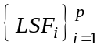, where p = 10, is derived from the set of linear prediction coefficients, as described in 3.2.3/G.729 or A.3.2.3/G.729.

B.3.1.2 Full band energy
The full band energy E_{f} is the logarithm of the normalized first autocorrelation coefficient 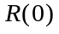:
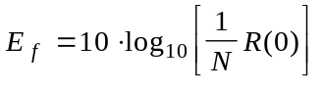 (B.1)
where 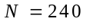is the LPC analysis window size in speech samples.

B.3.1.3 Low band energy
The low band energy E_{l} measured on 0 to 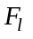 Hz band, is computed as follows:
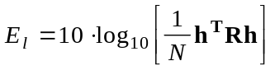 (B.2)
where h is the impulse response of an FIR filter with cutoff frequency at 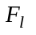 Hz,  is the Toeplitz autocorrelation matrix with the autocorrelation coefficients on each diagonal.

B.3.1.4 Zero crossing rate
Normalized zero-crossing rate 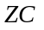 for each frame is calculated by:
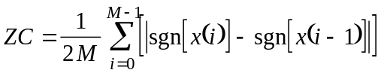 (B.3)
where 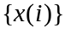 is the pre-processed input signal (see 3.1/G.729) and 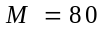.

B.3.2 Initialization of the running averages of the background noise characteristics
For the first 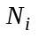 frames, the spectral parameters of the background noise, denoted by 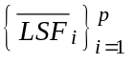 are initialized as an average of the 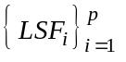 of the frames. The average of the background noise zero-crossings, denoted by 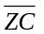 is initialized as an average of the zero crossing rate 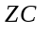 of the frames.
The running averages of the background noise energy, denoted by 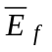, and the background noise low-band energy, denoted by 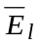, are initialized as follows. First, the initialization procedure uses
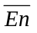, defined as the average of the frame energy 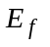 over the first frames. These three averaging (, , and) include only the frames that have an energy 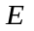 greater than 15 dB. Second, the initialization procedure continues as follows:
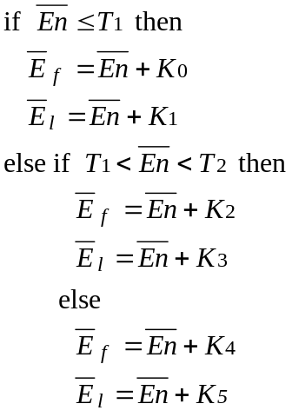
See Table B.1 for constant values.

B.3.3 Generating the long-term minimum energy
A long-term minimum energy parameter, E_{min}, is calculated as the minimum of E_{f} over N₀ previous frames. Since N₀ is relatively large, E_{min} is calculated using stored values of the minimum of E_{f} over short segments of the past.

B.3.4 Generating the difference parameters
Four difference measures are generated from the current frame parameters and the running averages of the background noise.

B.3.4.1 The spectral distortion 
The spectral distortion measure is generated as the sum of squares of the difference between the current frame 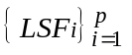 vector and the running averages of the background noise :
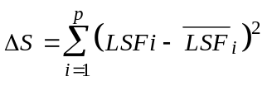 (B.4)

B.3.4.2 The full-band energy difference 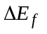
The full-band energy difference measure is generated as the difference between the current frame energy, E_{f}, and the running average of the background noise energy, 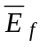:
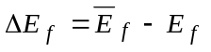 (B.5)

B.3.4.3 The low-band energy difference 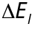
The low-band energy difference measure is generated as the difference between the current frame low-band energy, E_{l}, and the running average of the background noise low-band energy, 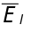:
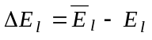 (B.6)

B.3.4.4 The zero-crossing difference 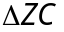
The zero-crossing difference measure is generated as the difference between the current frame zero-crossing rate, ZC, and the running average of the background noise zero-crossing rate, 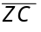:
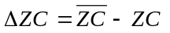 (B.7)

B.3.5 Multi-boundary initial voice activity decision
The initial voice activity decision is denoted by I_{VD}, and is set to 0 ("FALSE") if the vector of difference parameters lies within the non-active voice region. Otherwise, the initial voice activity decision is set to 1 ("TRUE"). The fourteen boundary decisions in the four-dimensional space are defined as follows:
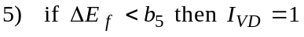
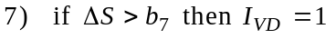
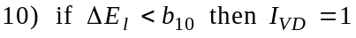
If none of the fourteen conditions is "TRUE" I_{VD} = 0. See Table B.1 for constant values.
Table B.1/G.729
Table of constants
Name | Constant | Name | Constant
N_{i} | 32 | N₁ | 4
N₀ | 128 | N₂ | 10
K₀ | 0 | T₁ | 671088640
K₁ | -53687091 | T₂ | 738197504
K₂ | -67108864 | T₃ | 26843546
K₃ | -93952410 | T₄ | 40265318
K₄ | -134217728 | T₅ | 40265318
K₅ | -161061274 | T₆ | 40265318
a₁ | 23488 | b₁ | 28521
a₂ | -30504 | b₂ | 19446
a₃ | -32768 | b₃ | -32768
a₄ | 26214 | b₄ | -19661
a₅ | 0 | b₅ | -30802
a₆ | 28160 | b₆ | -19661
a₇ | 0 | b₇ | 30199
a₈ | 16384 | b₈ | -22938
a₉ | -19065 | b₉ | -31576
a₁₀ | 0 | b₁₀ | -17367
a₁₁ | 22400 | b₁₁ | -27034
a₁₂ | 30427 | b₁₂ | 29959
a₁₃ | -24576 | b₁₃ | -29491
a₁₄ | 23406 | b₁₄ | -28087

B.3.6 Voice activity decision smoothing
The initial voice activity decision is smoothed (hangover) to reflect the long-term stationarity nature of the speech signal. The smoothing is done in four stages.
A flag indicating that hangover has occurred is defined as 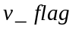. It is set to zero each time before the voice activity decision smoothing is performed. Denote the smoothed voice activity decision of the frame, the previous frame and frame before the previous frame by 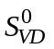, 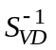 and 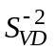, respectively. is initialized to 1, and is initialized to 1. For start 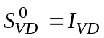. The first smoothing stage is:
For the second smoothing stage define a Boolean parameter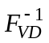 and a smoothing counter 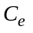. 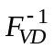 is initialized to 1 and is initialized to 0. Denote the energy of the previous frame by 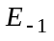. The second smoothing stage is:
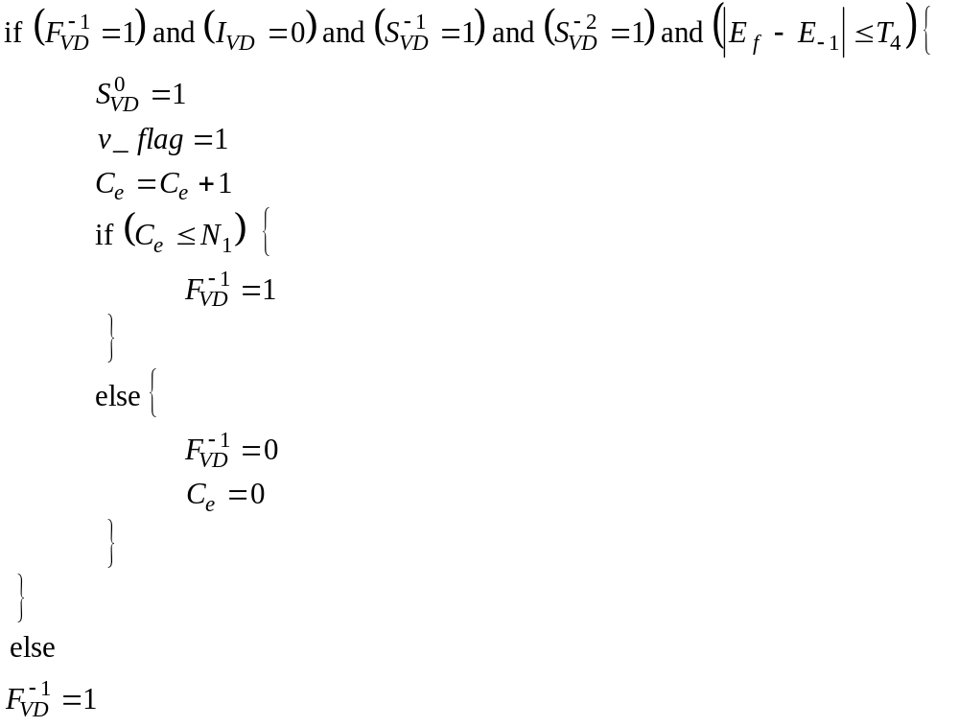
For the third smoothing stage define a noise continuity counter C_{s}, which is initialized to 0. If 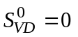 then C_{s} is incremented. The third smoothing stage is:
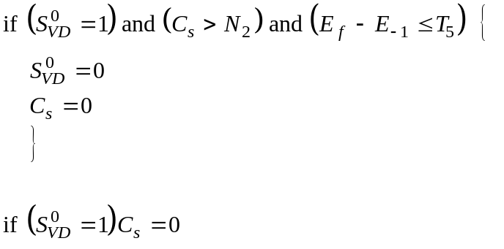
In the fourth stage, a voice activity decision is made if the following condition is satisfied:

B.3.7 Updating the running averages of the background noise characteristics
The running averages of the background noise characteristics are updated at the last stage of the VAD module. At this stage, the following condition is tested and the updating takes place if the following condition is met:
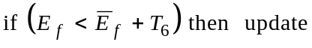
The running averages of the background noise characteristics are updated using a first order Auto-regressive (AR) scheme. Different AR coefficients are used for different parameters, and different sets of coefficients are used at the beginning of the recording/conversation or when a large change of the noise characteristics is detected.
Let 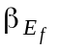 be the AR coefficient for the update of , 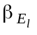 be the AR coefficient for the update of 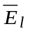, 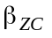 be the AR coefficient for the update of 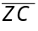 and 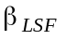 be the AR coefficient for the update of 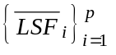. The total number of frames where the update condition was satisfied is counted by C_{n}. Different set of the coefficients , , , and is used according to the value of C_{n}.
The AR update is done according to:
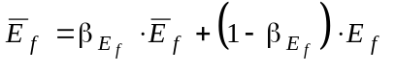
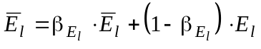 (B.8)
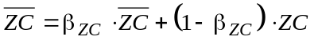
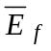 and C_{n} are further updated according to:
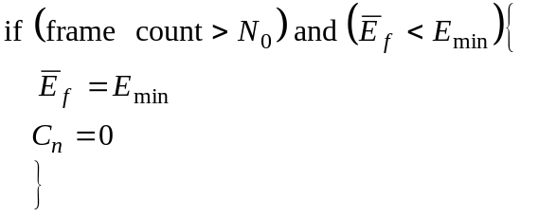

B.4 Detailed description of the DTX/CNG algorithms
The DTX/CNG algorithms provide continuous and smooth information about the non-active voice periods, while keeping a low average bit rate.

B.4.1 Description of the DTX algorithm
For each non-active voice frame, the DTX module decides if a set of non-active voice update parameters ought to be sent to the speech decoder, by measuring the changes in the non-active voice signal. Absolute and adaptive thresholds on the frame energy and the spectral distortion measure are used to obtain the update decision. If an update is needed, the non-active voice encoder sends the information needed to generate a signal which is perceptually similar to the original non-active voice signal. This information is comprised of an energy level and a description of the spectral envelope. If no update is needed, the non-active voice signal is generated by the non-active decoder according to the last received energy and spectral shape information of a non-active voice frame.
However, a minimum interval of N_{min} = 2 frames is required between two consecutive SID frames i.e. if a spectral or level change has occurred n < N_{min} frames after a SID frame, the SID emission is delayed.
Situated at the transmitting end, the DTX module receives from the VAD module the active/non-active voice information, and from the encoder modules the autocorrelation function of the speech signal computed for each 80 sample frame and the past excitation sample. For each frame, the DTX decision 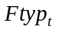 (Frame type for frame numbered t) is output as one of the three values, 0, 1, or 2 corresponding to untransmitted frame, active speech frame or SID frame, respectively, according to the following procedure:

B.4.1.1 Store the frame autocorrelation function
For every frame t (active or inactive), the autocorrelation coefficients of the current frame t, including the bandwidth expansion and noise correction (see the G.729 description) are retained in memory. The set of frame t autocorrelations will be denoted 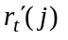, for j = 0 to 10.

B.4.1.2 Computation of the current frame type
If the current frame t is an active speech frame (Vad_{t} = 1), then the current frame type 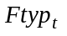 = 1 and the normal speech encoder processing continues.
In the other case, a current LPC filter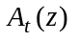 calculated over N_{cur} = 2 previous frames including the current one t is first evaluated:
The N_{cur} autocorrelation functions are summed:
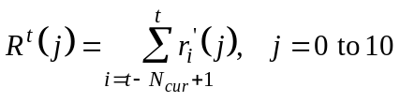 (B.9)
and 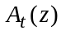 is calculated by the Levinson-Durbin procedure (see the G.729 description) using 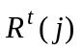 as input. The coefficients of this filter will be noted a_{t}(j), j = 0 to 10. The Levinson-Durbin procedure also provides the residual energy 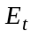, that will be rescaled and used as an estimate of the frame excitation energy.
Then the current frame type 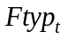is determined in the following way:
• If the current frame is the first inactive frame of the inactive zone, the frame is selected as SID frame. The variable 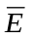which reflects the energy sum is taken equal to E_{t}, and the number of frames involved in the summation, k_{E}, is initialized to 1:
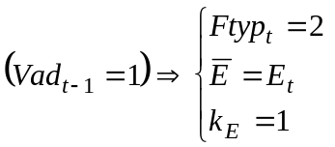 (B.10)
• For the other frames, the algorithm compares the preceding SID parameters to the current ones: if the current filter is significantly different of the preceding SID filter, or if the current excitation energy significantly differs from the preceding SID energy, the flag flag_chang is set to 1, else it does not change.
• The counter count_fr indicating how many frames are elapsed since the previous SID frame is incremented. If its value is greater than N_{min}, the emission of a SID frame is allowed. Then if flag_chang is equal to 1, a SID frame is sent. In all other cases, the current frame is untransmitted:
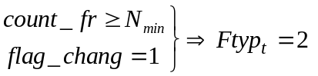 (B.11)
Otherwise: 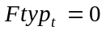
In case of a SID frame, the counter count_fr and the flag flag_chang are re-initialized to 0.
LPC filters and energies are compared according to the following methods:

B.4.1.3 Comparison of the LPC filters
The previous SID LPC filter will be noted 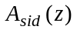 and its coefficients 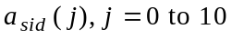 (the evaluation of this filter is described in B.4.2.2). The current and previous SID-LPC filters are considered as significantly different if the Itakura distance between the two filters exceeds a given threshold, which is expressed by:
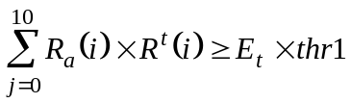 (B.12)
where R_{a}(j), j = 0 to 10 is a function derived from the autocorrelation of the coefficients of the SID filter, given by:
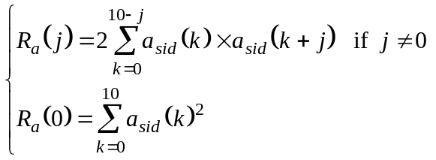 (B.13)
A value of 1.20226 is used for thr1.

B.4.1.4 Comparison of the energies
The sum the frame energies is calculated, k_{E} being first incremented up to the maximum value Ng = 2:
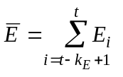 (B.14)
Then is quantized, using the 5-bits logarithmic quantizer described in B.4.2.1. The decoded log-energy E_{q} is compared to the previous decoded SID log-energy 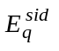. If the difference exceeds the threshold thr2=2 dB, the two energies will be considered as significantly different.

B.4.2 SID evaluation and quantization
The Silence Insertion Descriptor (SID) is comprised of the quantized frame excitation energy (i.e. the current quantized excitation energy 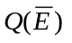for the SID frames) and the quantized LSPs corresponding to the estimated SID-LPC filter. Four indices make up the SID frame. One index describes the energy and three indices describe the spectrum portion of the SID frame.

B.4.2.1 Energy quantization
The quantization of the energy 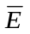is performed as follows. First, a scaling factor α_{w} = 0.125 is introduced that takes into account the effect of windowing and bandwidth expansions present in the subframes autocorrelation functions 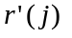.
The value used at the input of the gain quantizer is:
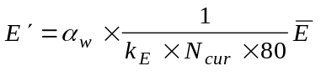 (B.15)
The energy term 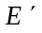 is quantized with a 5-bit non-uniform quantizer in the logarithmic domain in the range of −12 dB to 66 dB. A uniform step size of 2 dB is used between 16 dB and 66 dB. A step size
of 4 dB is used in the range of −4 dB to 16 dB. Below −4 dB, a single step size of 8 dB is used giving a quantization level of −12 dB. The quantization is straightforward and does not need the storage of a quantizer table.
Notice that since the energy comparison (B.4.1.4) is performed with decoded energies, the quantization of the energy is done for all non-active voice frames.

B.4.2.2 SID-LPC filter estimation and quantization
The SID-LPC filter estimation takes into account the local stationarity or non-stationarity of the noise at the SID frame neighbourhood.
First, a past average filter 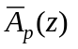 built from N_{p} frames preceding the current SID one is calculated, using the following autocorrelation sum as input of the Levinson-Durbin procedure:
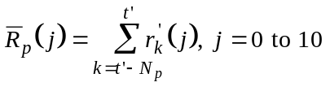 (B.16)
The number of frames involved in the summation has been fixed to N_{p} = 6.
The frame number varies in 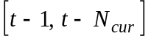, depending on the rest of the Euclidian division of the current frame number t by N_{cur}.
The SID-LPC filter is then obtained with:
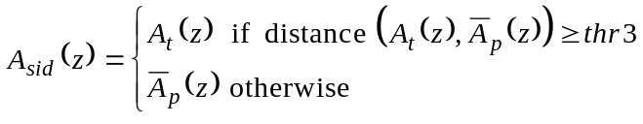 (B.17)
The threshold value thr3 is fixed to 1.12202 and the distance between the current LPC filter and the past average one is calculated in the same manner as in B.4.1.3 (see equation B.12).
Then the SID-LPC filter is transformed to the LSF domain for quantization. The LSFs are quantized by a two-stage switched predictive vector quantization ("VQ") with 5 and 4 bits each. The quantization of the LSF vector entails the determination of the best three indices. The first index is that of the predictor. The last two indices are each taken from a different vector table, as it is done in a two stage vector quantization. The overall quantization procedure follows the one given in 3.2.4/G.729 with the following modifications:
1) The second 4th order MA predictor used in Recommendation G.729 is modified as a linear combination of the first and second MA predictors as follows:
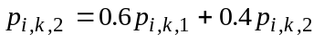 (B.18)
where
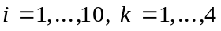
2) The first stage VQ quantization is similar to the one used in Recommendation G.729. However, only a portion of the first table of the quantizer is used. The relevant subset entries of the table are stored in an auxiliary lookup table with 32 address indices. Moreover, a delayed decision quantization is used by keeping few candidates as inputs to the second stage.
3) The candidates from the first stage in conjunction with those of the second stage are used by the second stage VQ. The second stage VQ quantization is different from the one used in Recommendation G.729. A full VQ is used as compared to the split VQ of
Recommendation G.729. Only a portion of the second stage tables is used as well. The relevant subset entries are stored in another lookup table with two 16 address entries. The combination of the predictor, a vector from the first stage and a vector from the second stage, leading to the minimum distortion in the weighted mean square error sense, is chosen as the LSF descriptor.

B.4.3 SID bit stream description
The bit stream related to the transmission of an SID frame is described in Table B.2. The bit stream related to the transmission of an active frame is defined in Table 8/G.729. The bit stream ordering is reflected by the order in the table. For each parameter the Most Significant Bit (MSB) is transmitted first.
Table B.2/G.729
Parameter description | Bits
Switched predictor index of LSF quantizer | 1
First stage vector of LSF quantizer | 5
Second stage vector of LSF quantizer | 4
Gain (Energy) | 5

B.4.4 Non-active encoder/decoder (CNG) description
At the decoder part, the comfort noise is generated by introducing a pseudo-white excitation signal of controlled level into interpolated LPC filters, in the same manner than the decoder produces active speech by filtering the decoded excitation. The excitation level and LPC filters are obtained from the previous SID information. The subframes interpolated LPC filters are obtained by using the SID-LSPs as current LSPs and performing the interpolation with the previous frame LSPs as done for active frames in Recommendation G.729.
The pseudo-white excitation ex(n) is a mixture between an excitation of the same type as the active speech one 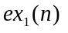 and a white Gaussian excitation 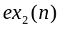.
The G.729 excitation is composed of an adaptive excitation with a small gain and an ACELP fixed excitation, which improves the transition between active and non-active voice frames. The addition of a Gaussian excitation allows the generation of a whiter signal.
Since the encoder and decoder need to keep synchronized during non-active voice periods, the excitation generation is performed on both sides, for SID frames and for untransmitted frames.
First, let us define the target excitation gain 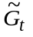 as the square root of the average energy that must be obtained for the current frame t synthetic excitation. is calculated using the following smoothing procedure, where 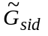 is the SID gain derived for the decoded SID gain:
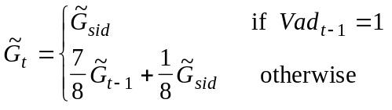 (B.19)
The 80 samples of the frame are divided into 2 subframes of 40 samples. For each subframe, the CNG excitation samples are synthesized using the following algorithm.
A pitch lag is randomly chosen in the interval [40,103].
Next, the fixed codebook vector of the subframe is built by random selection of the grid, the pulses signs and positions, according to the G.729 ACELP code structure.
An adaptive excitation signal of unity gain is then calculated, noted 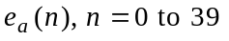. The selected subframe fixed excitation will be noted 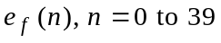.
The adaptive and fixed gains Ga and Gf are then computed in order to yield a subframe average energy equal to 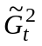, which is expressed by:
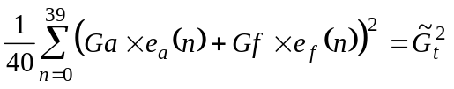 (B.20)
Notice that Gf can take a negative value.
Let us define 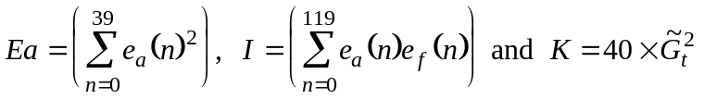
Due to the ACELP excitation structure 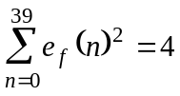
If we fix randomly the adaptive gain Ga, then equation B.19 becomes a second order equation on the fixed gain Gf:
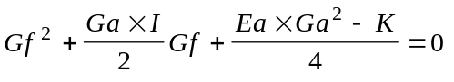 (B.21)
A constraint may be imposed on Ga to be sure that this equation has a solution. Furthermore it is desirable to forbid the use of large adaptive gains. For this, the adaptive gain Ga will be randomly chosen in:
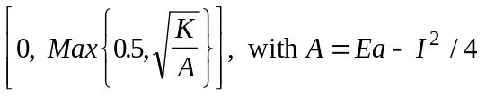 (B.22)
The root of equation B.20 that has the lowest absolute value is selected for Gf.
Finally the G.729 excitation is built, using:
(B.23)
The method of deriving the composite excitation signal ex(n) is as follows:
Let 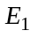 be the energy of , 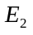 be the energy of . has a unit variance and a zero mean. Let 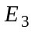 be the cross-energy between and .
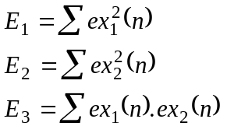 (B.24)
where the summation is over the subframe size.
Let α and β be the scale proportion of and used in the mixture excitation respectively. α is set to be 0.6. β is found as the solution to the following quadratic equation:
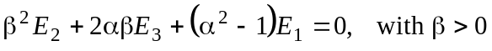 (B.25)
If no solution is found for β, it is set to 0 and α to 1.
The CNG excitation 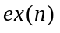 becomes:
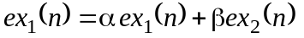 (B.26)

B.4.5 Frame erasure concealment with regards to the CNG
When a frame erasure is detected by the decoder, the erased frame type depends on the preceding frame type:
– if the preceding frame was active, then the current frame is considered as active;
– else if the preceding frame was either a SID frame or an untransmitted frame, the current erased frame is considered as untransmitted:
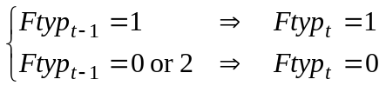 (B.27)
If an untransmitted frame has been erased, no error is then introduced.
If a SID frame is erased, there are two possibilities:
• If it is not the first SID frame of the current inactive period, then the previous SID parameters are kept.
• If it is the first SID frame of an inactive period, a special protection has been taken.
Notice first that this case is detected by the fact that 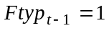 and 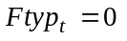.
This combination of events does not imply that the preceding frame was a good active frame: several frames up to the preceding one may have been erased. What is certain is that the last good frame was an active frame, that the present frame was not erased, and that the SID frame supposed to provide information for the current untransmitted frame is lost.
To recover the SID information, the CNG module uses parameters provided by the G.729 decoder main part:
• the LSPs of the last valid active frame are used for the SID-LPC filter;
• an energy term is calculated on the excitation signal by the decoder during the processing of all valid active voice frames. To recover the missing SID gain , the energy term of the last valid active frame is quantized with the SID gain quantizer and decoded.
Finally to avoid de-synchronization of the random generator used to compute the excitation, the pseudo-random sequence reset is performed at each active frame, both at the encoder and decoder parts.

B.5 Bit-exact description of the silence compression scheme
The silence compression scheme is simulated in 16-bit fixed-point ANSI-C code using the same set of fixed-point basic operators defined in Table 11/G.729. The ANSI-C code constitutes an integral part of this Recommendation reflecting the bit-exact, fixed-point description of the silence compression scheme. In the event of any discrepancy between the printed text of this Recommendation and the C source, the C-source code is presumed to be correct.

B.5.1 Organization of the simulation software
Same as 5.2/G.729.
The Annex B ANSI-C software modules are listed in Table B.3. Refer to the read.me file provided with the software for more details.
Table B.3/G.729
G.729 Annex B ANSI-C module names | Description
Vad.c | VAD
Dtx.c | DTX Decision
Qsidgain.c | SID Gain Quantization
QsidLSF.c | SID-LSF Quantization
Calcexc.c | CNG Excitation Calculation
Dec_sid.c | Decode SID Information
Miscel.c | Miscellaneous Calculations
G.729 Annex B ANSI-C.h file names | Description
Vad.h | Prototype and Constants
Dtx.h | Prototype and Constants
Sid.h | Prototype and Constants
Miscel.h | Prototype and Constants

ITU-T RECOMMENDATIONS SERIES
Series A | Organization of the work of the ITU-T
Series B | Means of expression
Series C | General telecommunication statistics
Series D | General tariff principles
Series E | Telephone network and ISDN
Series F | Non-telephone telecommunication services
Series G | Transmission systems and media
Series H | Transmission of non-telephone signals
Series I | Integrated services digital network
Series J | Transmission of sound-programme and television signals
Series K | Protection against interference
Series L | Construction, installation and protection of cables and other elements of outside plant
Series M | Maintenance: international transmission systems, telephone circuits, telegraphy, facsimile and leased circuits
Series N | Maintenance: international sound-programme and television transmission circuits
Series O | Specifications of measuring equipment
Series P | Telephone transmission quality
Series Q | Switching and signalling
Series R | Telegraph transmission
Series S | Telegraph services terminal equipment
Series T | Terminal equipments and protocols for telematic services
Series U | Telegraph switching
Series V | Data communication over the telephone network
Series X | Data networks and open system communication
Series Z | Programming languages

