#0: Preparation for Algorithm and Interview

Problem and Answer

面试中的常见误区:

做过的题(或者简单的题)肯定能过; 算法想出来了就能过; 代码写出来了就能过

面试官眼中的求职者: 你可能是他未来的同事

● 你的代码看起来舒服么: TA需要多少时间Review你的代码）

● 你的Coding习惯好么: TA不会在未来疲于帮你DEBUG，你不会动不动就搞出SEV

● 你的沟通能力好么: TA和你交流费劲么

面试考察的编程基本功

程序风格（缩进，括号，变量名）

Coding习惯（异常检查，边界处理）

沟通（让面试官时刻明白你的意图）

测试（主动写出合理的Testcase）

Implement strStr()

For a given source string and a target string, you should output the first index(from 0) of target string in source string. If target does not exist in source, just return -1.

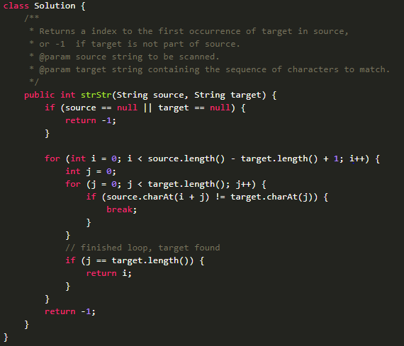

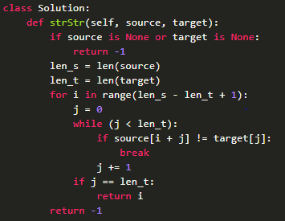

Note:

1, This might be the first problem, which used to test whether you meet the benchmark or not. So no need to use KMP, for loop is OK.

2, coding style issue: use readable name for variables, like source and target. Don’t use str1 or str2.

Use blank row to separate logic block to make it clear. Even if…return…can be written in one line, we still need to use two lines.

3, For a problem, the algorithm is important but the abnormal cases and edge check are also important.

Eg, S1==NULL or S2==NULL

4, communication: try to communicate with interviewer: repeat the question after you hear it to make sure, like duplicates? Sorted?; communicate how you think about it and the way you want to solve it; give some test cases if possible.

Given a set of distinct integers, return all possible subsets. Elements in a subset must be in non-descending order. The solution set must not contain duplicate subsets.

Example: If S = [1,2,3], a solution is: [ [3], [1], [2], [1,2,3], [1,3], [2,3], [1,2], []]

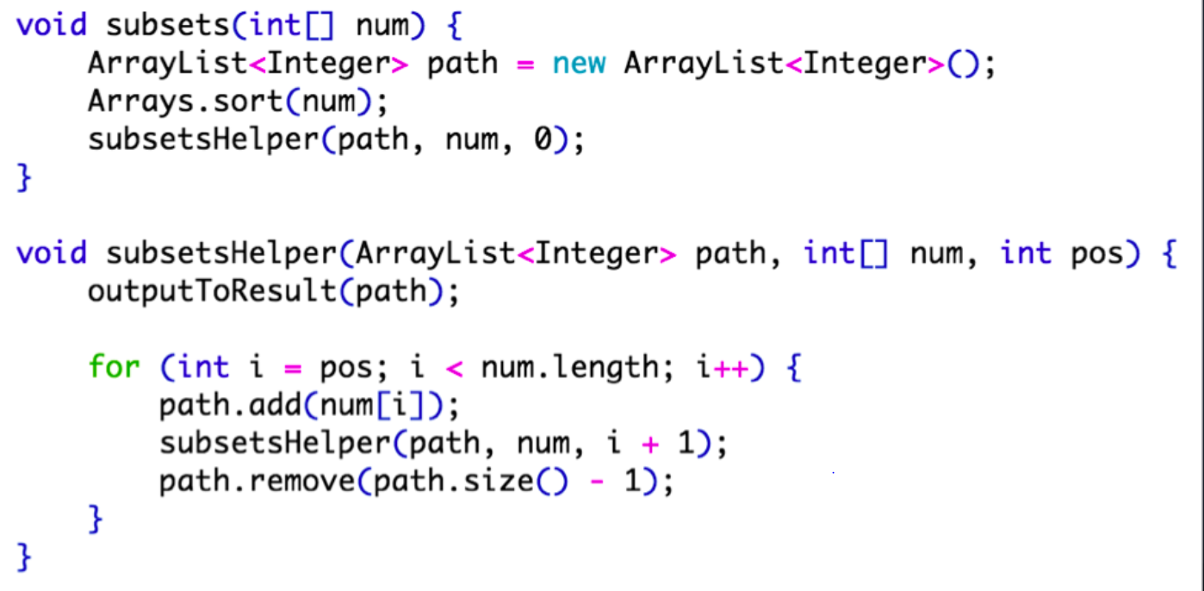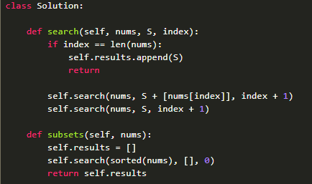

Given a collection of integers that might contain duplicates, nums, return all possible subsets (the power set). Each element in a subset must be in non-descending order. The ordering between two subsets is free. The solution set must not contain duplicate subsets.

Input: [1,2,2] Output: [ [2], [1], [1,2,2], [2,2], [1,2], [] ]

1. 与Subsets有关，先背下Subsets的模板

2. 既然要求Unique的，就想办法排除掉重复的。

3. 哪些会重复？如{1, 2(1), 2(2), 2(3)}，规定{1, 2(1)}和{1, 2(2)}重复，{1, 2(1), 2(2)}和{1, 2(2), 2(3)}重复

4. 得出规律：我们只关心取多少个2，不关心取哪几个。

5. 规定必须从第一个2开始连续取（作为重复集合中的代表），如必须是{1, 2(1)}不能是{1, 2{2})

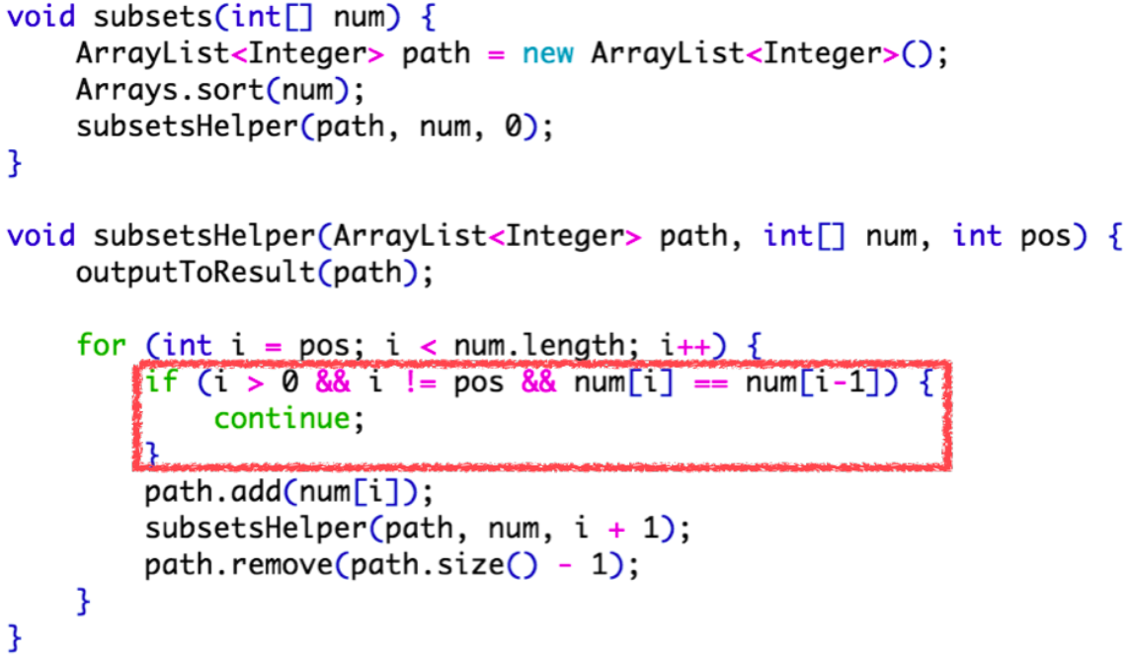

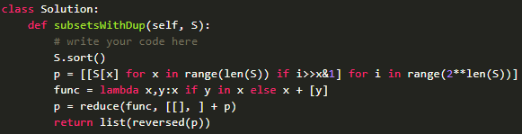

排列组合模板总结

使用范围: 几乎所有的搜索问题

根据具体题目要求进行改动

● 什么时候输出

● 哪些情况需要跳过

适用该模板的题目

Combination Sum

Letter Combination of a Phone Number

Palindrome Partitioning

Restore IP Address

...

Given a list of numbers, return all possible permutations.

You can assume that there is no duplicate numbers in the list.

For nums = [1,2,3], the permutations are:

[ [1,2,3], [1,3,2], [2,1,3], [2,3,1], [3,1,2], [3,2,1] ]

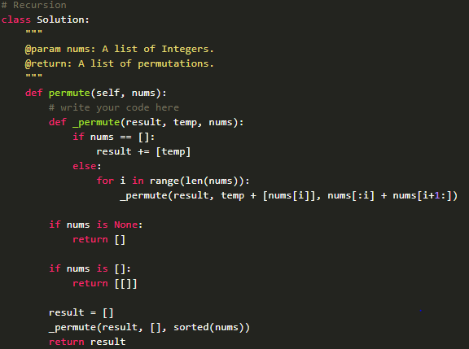

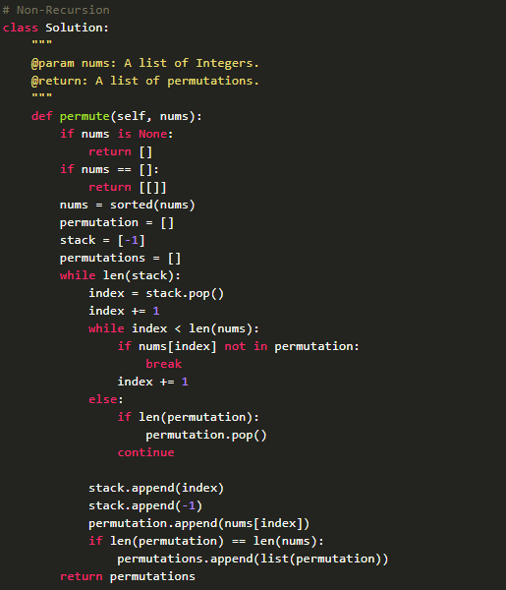

Given a list of numbers with duplicate number in it. Find all unique permutations.

For numbers [1,2,2] the unique permutations are: [ [1,2,2], [2,1,2], [2,2,1]]

