#3: Subset & Permutation & Combination

Problem and Answer

Subsets

Given a set of distinct integers, return all possible subsets

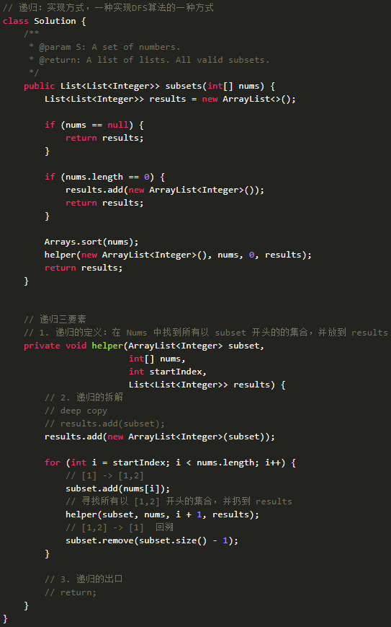

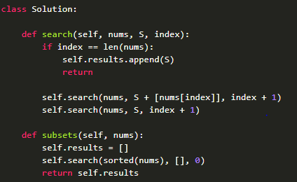

Subsets II

Given a collection of integers might contain duplicates, nums, return all possible subsets (the power set).

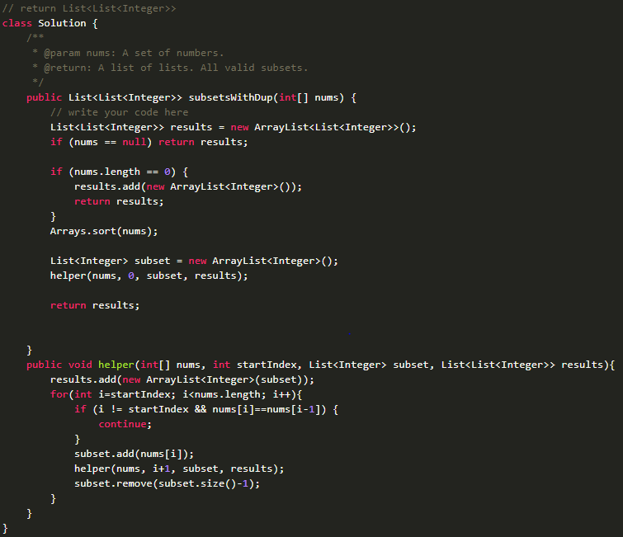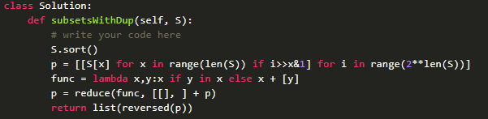

Permutations

Given a list of numbers, return all possible permutations.

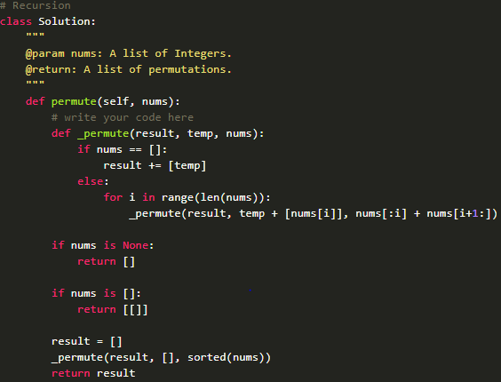

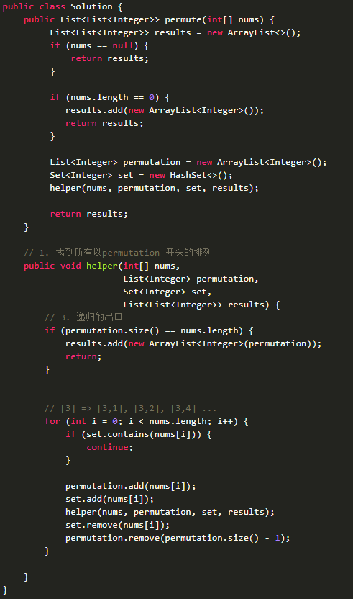

Permutations II

Given a list of numbers with duplicate number in it. Find all unique permutations.

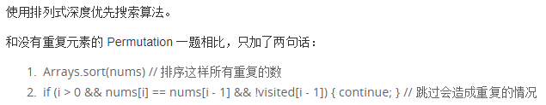

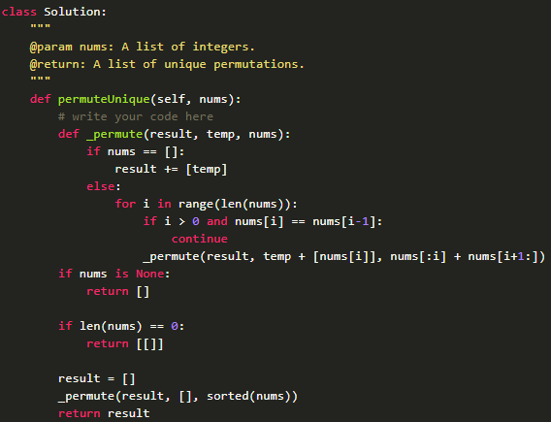

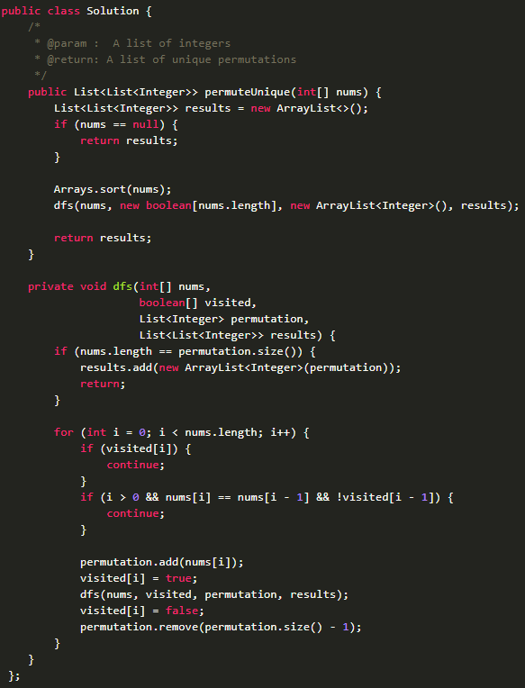

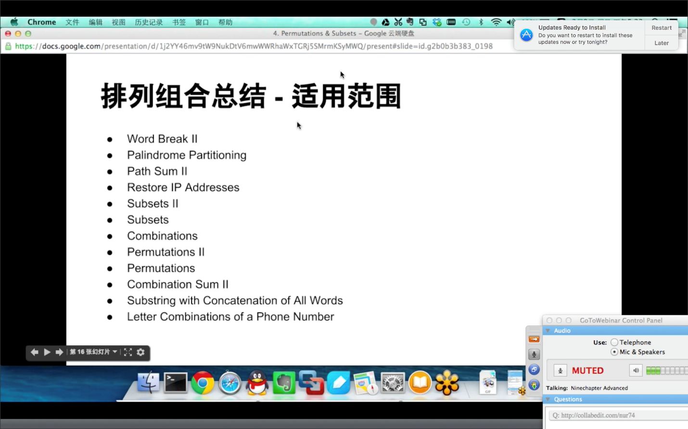

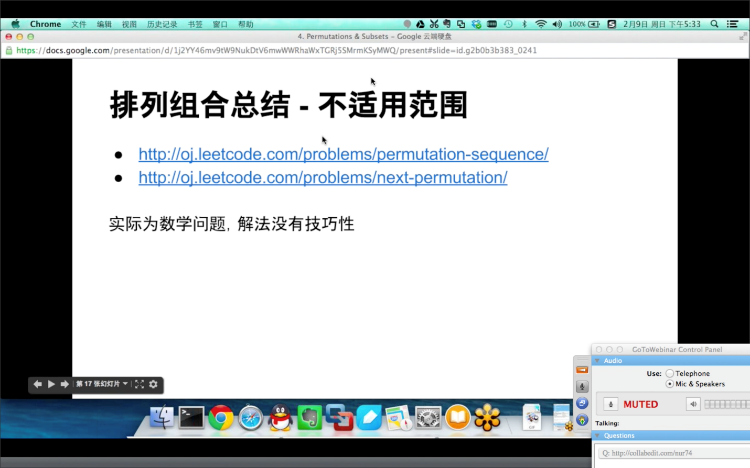

N-Queens

The n-queens puzzle is the problem of placing n queens on an n×n chessboard such that no two queens attack each other. Given an integer n, return all distinct solutions to the n-queens puzzle. Each solution contains a distinct board configuration of the n-queens' placement, where 'Q' and '.' both indicate a queen and an empty space respectively.

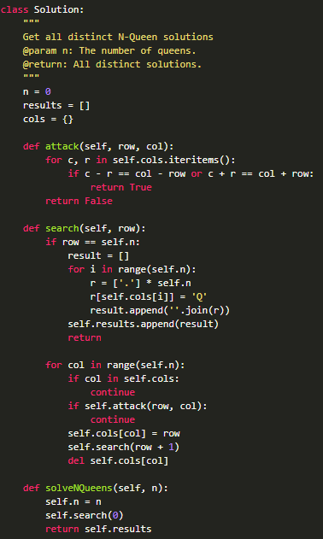

If A(a,b) and B(c,d) are on the same diagram:

OR relation: a+b = c+d or a-b = c-d

To be clear, separate different functions