#5: linked list

Problem and Answer

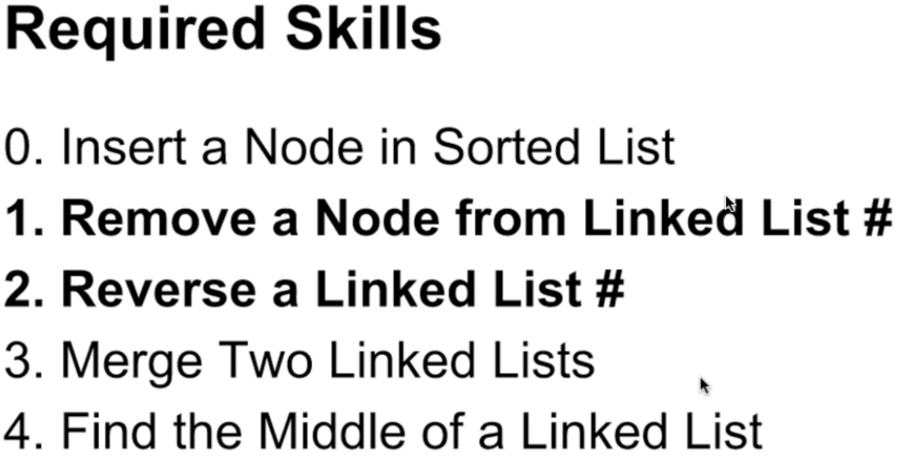

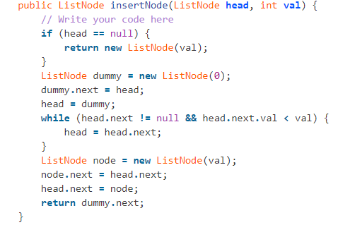

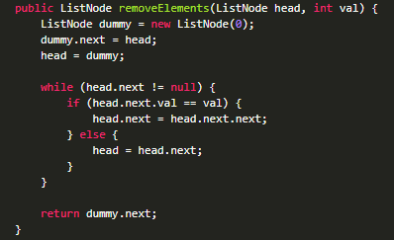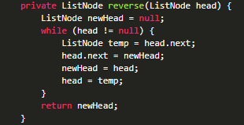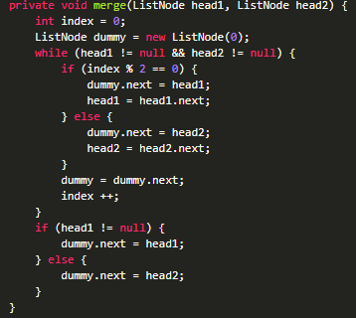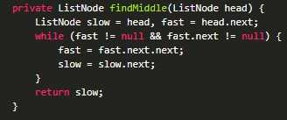

Application:

Remove Duplicates from Sorted List

Remove Duplicates from Sorted List II

Reverse Linked List

Reverse Linked List II

Merge Two Sorted Lists

Partition List

Insert Node in Sorted Linked List

Insert into a Cyclic Sorted List

Insertion Sort List

Sort List

Reorder List

Linked List Cycle

Linked List Cycle II

Merge k Sorted Lists

Copy List with Random Pointer

Convert sorted list to balanced bst

Remove Nth Node From End of List

middle of linked list