***Product Backlog***

User Stories:

1. **Destination and Airline:** This is the travel Itinerary Planner’s Website. On the First page, Customers can input the**destination(city and country)** to determine where they want to go and also they can input the city **denatured and arrival with the number of people and the class in the flight**. Classes separate by Economy, Bussiness, and First. It will depend on the APIs. So they can get the flight details from the departure to arrival. And only the destination will show on the**PLANNER**page(2nd page)
2. **Date**: Customers also can choose the date of their travel plan, From the start and the end of their trip.
3. **Activities Preference:**Customer can choose the preference of their activities on the travel destination, Indoor or Outdoor, WildLife or History, if Customers are not interested in these activities preference, they can choose “others”. If they don’t choose anyone the activities will be recommended randomly.
4. **Recommendation and Planner:**We can recommend the activities depending on Customers’ date(different seasons, long or short trip) or Customers’ class of the flight and budget plan(cheap, moderate, or expensive). We can also recommend the hotels by their choices(cheap, moderate, or expensive/highest rate/Popular)
5. **The Details of your Trip:**Then,**the accommodation details** and **the local transportation situation of destination**, **the flight details**will show on the**PLANNER**page(2nd page), also **with their budget.** (under the line of Destination) They also will show on the itinerary( Email version / PDF document)
6. **Generating an Itinerary:**When Customer clicks the **“search for plan” Button, all of the information of the first page**will store in the Itinerary and show on the second page by generating the details of above things.
7. **Sending the Itinerary:**On the Second page, **Allowing users to input their email address, and click the “get your Itinerary” button,**System will send the Itinerary by emailing customer, Customer will get their Itinerary.
8. **Transfer to PDF document:**When clicking the “Transfer to PDF” Button, All information will transfer to the PDF version and download automatically
9. **Activities show off separately(day by day): With separate modules, The activities will be recommended on the daily module with the date. One page just has three modules and there have a triangle button if you click and will show the next days’ activities.**
10. **The activities will be represented by URL and the title is the keywords.(you can separate to morning/afternoon/evening or some activities will run several days)**

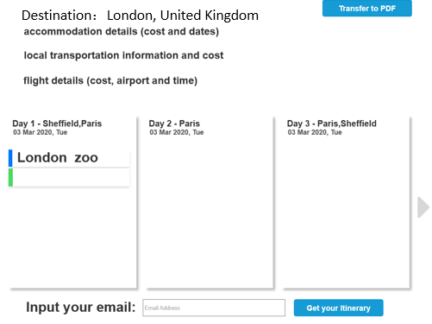

**Introduction and background**

**In today’s world, travelling has played an important role in people’s life. Travelling is an interesting experience where tourists from various ages can have fun, adventure and discovery for new places around the world. However, planning for a trip it is no easy task with the increasing number of airlines companies, hotels, attractions and activities in recent years. A considerable amount of time is required to gather information from different sources in order to make travel Itinerary plan. Nonetheless, the advancement of technology makes this task by using different kinds of websites and applications such as travel itinerary planner. Travel itinerary planner is a website help design and plans users’ memorable vacations. Based on the user input, which includes destination, arrival and departure dates, activities preferences, the system automatically constructs day-by-day itinerary. The Itinerary will include information about airlines and accommodations details, local transportation information, as well as famous attractions and activities to enjoy during the trip, combined with the price of each of them. The final budget for the trip will be calculated to the user. Another important feature, the system will generate a PDF copy of the itinerary and it will be sent to the user via email.**