**Team management & communication**

**Team management:**

We sperate the project to the two main parts which are Front-End Part and Back-End Part. And Front-End Part have two subtasks:Prototype Design and Front-End Programming. In the Back-End Part, there have several subtasks: Logic Functions Programming.

We tried Scrum Management during the period of Agile development. And we have two scrum masters and one product owner to push the project. And the other three teammates belong to Dev scrum group who are focus on developing and testing. So, Runmin Zhang was responsible for managing the Front-end and Basic functions. And Areej Alosaimi was responsible for managing the Back-end and Logic programming. As a product owner, Yanghao Zhou managed the team communication and communicated with the Client to determine the demands. Meanwhile, the Dev Scrum Team can receive the help and the information from scrum masters.

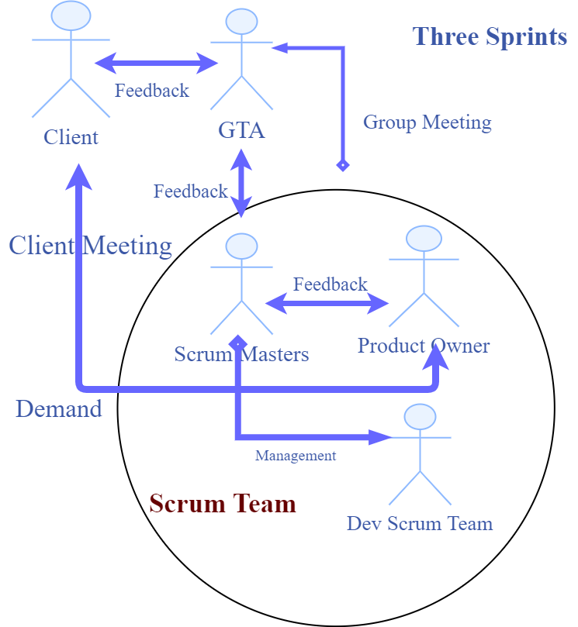

Figure: Team Management

For improving the the efficiency of teamwork, we followed the principle of Agile developmnet and we decided to download three software or platforms:Git (you must register the Github account firstly), Trello (about Agile), Slack (Sharing the important information) to help to manage the teamwork. So we using the Wechat or WhatsApp to communicate with each other, make a discussion on the team project and upload some project materials. We also use Gitlab to upload and share the materials or code, and the Slack to manage and plan the Group meeting.

Furthermore, We use Trello to realize the Agile development. These tool promoted thee Implementation of the scrum method and the scrum method separate the work to several sprints. A sprint is a short, time-boxed work period when a scrum team works to finish the seperated part. Sprints are so important in agile methodologies, and it let our team to solve lots of questions and challenges quickily. With the sprints that break down big, complex projects into bite-sized pieces, travel itinerary planner is built in a series of iterations. So every iteration will cost about 4 weeks, and we finished one demo of two parts and let the website contains basic functions and work better. Then we continued to extend the functions and solve the problems.

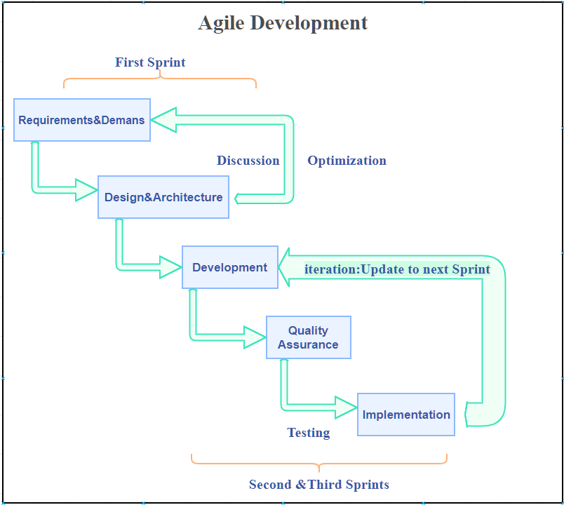

Figure: Agile Development

Our work division is that Runmin Zhang and Yanghao Zhou focused on the Front-End Part and Areej, Conglei Tan, Feng Xiang, Shuang Chen will be resposible for Back-End Part.

**Tasks Distribution:**

Task decomposition was so important and work distribution is that:

**Team Scrum Master:** Areej Alosaimi

**Project Implement:**

**Documantation:**

**Team Scrum Master:** Runmin Zhang

**Project Implement:** Runmin Zhang do some research about travel planner, and learn python flask. Build the framework for our system. According to UI interface, using bootstrap I design the first page. User can input email address, travel dates, interests destination city. Also, I build classes for places of interests, and plane. Then use form to convert those information to backend. According to the information user input, retrieve data from google. Then get json file from google and amadue. I parase data with plane, restaurant, and activities into all related classes. According to the rates, then rank those in a descending order. Generate a simple travel Planner for users. Also, I implement the function that generate the pdf files and download automatically in local storage. I implement the function send email to users. Then return those data to the result page. I try catch all the bugs in our system.

**Documantation: Setups, and the part of completed and uncompleted features, and the APIs Guide**

**Product Owner:** Yanghao Zhou

**Project implementation:**

**Documantation:**

**Dev Team: Shuang Chen, Feng Xiang, Conglei Tan**

**Shuang Chen:**

**Project implementation:**

The original collaborative division of tasks was back-end to create and use a database, but later considered that the data can be directly accessed through API, our program does not need to use the database to store the data, so my job changed from the database to data analysis, the json data is parsed with python and then displayed on the front end. Then, we found that flight API cannot choose class, and the activity API cannot get the price, so I  also search and try to call the appropriate flight API with class and activity API with price.

**Documantation:**

**Feng Xiang:**

**Project implementation:**

In this project, I was mainly responsible for the realization of traffic query and navigation function, in which the traffic navigation part mainly used the Google navigation API, which can find the traffic navigation between two places through the geographical information of places, including walking and bus.In our travel recommendations, users will be provided with a daily itinerary, and the daily arrangement of transportation between locations needs to be part of our exported travel plan

**Documantation:**

**Conglei Tan**

**Project implementation:**

**Documantation:**

**Team Communication:**

Agile project management attaches importance to **face-to-face communication**, which is the best way to transmit information. And the second principle is **believing that the planning cannot be precisely estimated** so that we must keep the flexible product backlog. The third priciple is that we must **clarify the ability of the teammates and believe that there are no unachievable tasks.** So that we can finish the effective work distribution. For the effective communication, so we managed a Group Meeting every week and there is the figure of our team communication and management.

During the period of working, we met so many problems and challeges on the team projects. There have three sprints in the period of project programming. So we divided the project to three iteration, For every week’s meeting time, we collected some questions and problems we have met to ask for help from GTA and the Supervisor. And in the every sprint, we had a presentation of travel itinerary planner to our Clients.

**On Week 1:**

**Communication and Challenges:**Firstly, we need to make a decision to choose the programming language and Framework. There are different opinions for this decision, The chanllenge is that some teammates thought Java is suitable for organize the Website Framework, the others thought Python is light and easy to use. Then we listed some advantages and disadvantages for these two languages. Furthermore we started a public vote to make a decision, And before voting we discussed three choices: Programme Language Choice, Framework Choice, Algorithm about Recommender System in a off-line group meeting. The voting is a suitable method to maintain a better teamwork and make a better decision. And for framework, we must have some experiments and choose the better one and it was flexible.

**On Week 2-4, which is sprint 1:**

**Communication:** When the project named travel itinerary planner was in development, The whole team thought we must construct the front-end structure and then allocate each subtasks to the teammates who are resposible to Back-end programming. So Yanghao Zhou started to design the prototype and then Runmin Zhang began to coding the front-end part. And we established a wechat group to communicate with each other and share the information. Also, we used the Slack and Trello to keep the Agile Development and share any idea to each other. Areej and the dev team: Shuang Chen, Feng Xiang, Conglei Tan discussed about the Back-end design.

**Challenges:**

1. When Yanghao Zhou designed the prototype, he thought about the essential functions and transferred them to the website prototype, we met a challenge that the project manager should take care of the feasibility of prototype design and the demand of the client. So he decided to arrange a offline group meeting before the GTA’s meeting to talk about the questions of design. When Yanghao Zhou finished the design, he share the ideas with Runmin Zhang and Runmin Zhang try to coding for the framework of front-end part. On the second week, they finished the initial front-end part and the team of back-end part started to allocate the subtasks to each other.
2. 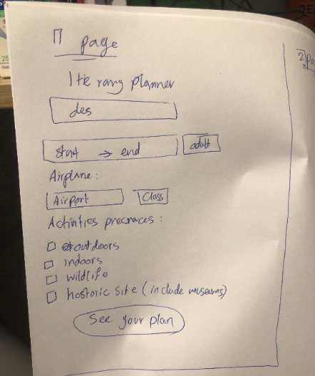And we still could not find the useful APIs or Data to collected, for instance, the budget of flight or hotel. We ask for GTA and GTA thought we should use machine learning to predict the information of budget. So in the begin of programming, we met a difficult challenge on data selecting and how to manage the data: we were doubtful about where can we to collect the data, and what kind of data can we choose. And because if we collected the data of flights, hotel, and activities which were all historical information, we could not determine the travel information on the future. So there had two choices, First choice was that we found the APIs to convey the data into the website, and second Choice was that we should use the tools of machine learning to do logistic regression to predict the future informaiton. Above all, It made us be doubtful.

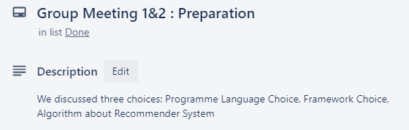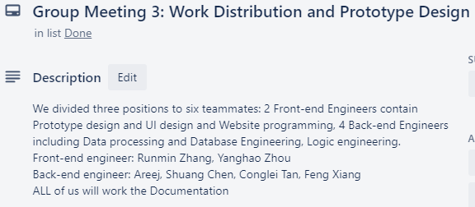**The meeting minutes of week 2-4:**

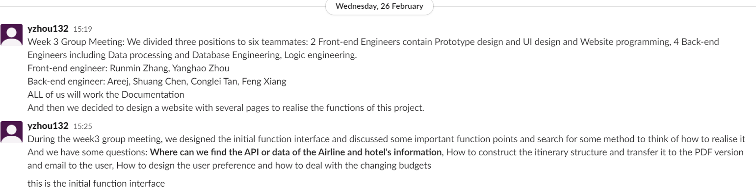

**On Week 5-7, which is sprint 2:**

**Communication:**Last week’s challenges all overcame, not only because of the communication with client but also team effort and skills. We communicated with each other on the Wechat group effectively, when we started to focus on the whole architecture of travel planner realized and logic functions design. It is difficult to persuade the other people to change their idea, so we need to let the scrum master Areej lead us to effectively come up with a solution. And the product owner continued to convey the flexible demands by completing the user stories. Dev Group continued to give feedback to scrum master, and back-end scrum master discussed the questions with front-end scrum master and PM. Before communicating, each of our team members must collect useful information and share the information in the WeChat group, so that everyone's understanding of the logic function is on the same channel. As we all know, communication is to convey information and opinions clearly and clearly, and at the same time, we made sure that the other teammates have received the content of the transmission. This is very similar to the network protocol handshake. And Dev Group also tried the unit testing in this sprint and gave feedback to each other.

**The records of the Group Meeting**



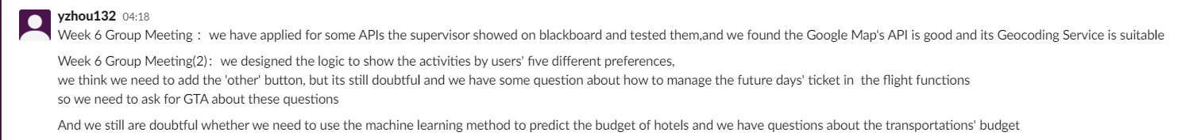

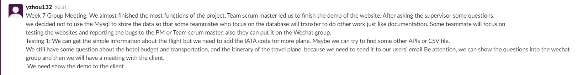

**On Week 8-10, which is sprint 3:**

**Communication:** When we finished the software demo of Travel Itinerary Planner, Team scrum masters suggest that we can build the own branch and add some new planned functions to the demo separately and then merge them finally. And the planned functions are based on the requirements and suggestions of the client. We continued to communicate by Wechat Group and we uploaded the files into the Gitlab. Meanwhile, we had the meeting online with Client and GTA to check how about we had done and showed the demo to them to know whether we need to add new functions. And the product owner and Dev group began the final testing. Scrum masters began to review the work and divided the tasks of documentation. Because of the google docs, we can discuss and modify the documentation online and share our idea effectively. Furthermore, we actively put forward our own opinions and made a document that satisfied everyone’s requirement.

**Challenges:** In the final sprint, we finished the demo last week so we started to build a new branch. Meanwhile, because of the motivation of the teammates, there were some duplication of work happened. So, scrum masters communicated with Dev Group and the product owner keep the information updated. We solved this problem and completed the project in advance.

**Sample of Communication**

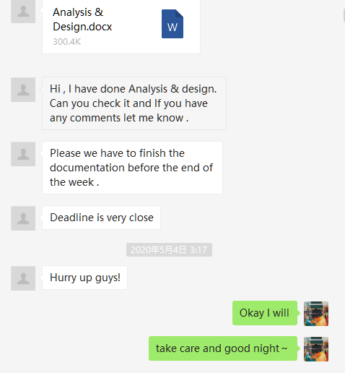We shared the information and documentations finished in the group, and the scrum master push the progress of the documentation writing.

And the two figures below are the meeting minutes of week 8 and 9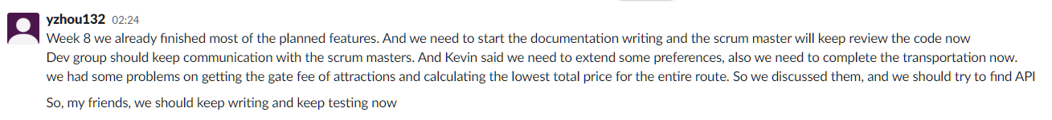

//Week9 meeting minutes.

Planned & Completed Features:

Our planned and completed features were.

1. Inputting the arrival (Recognizing to the destination)and departure place.
2. Determining the number of passengers and the classes in the flight.
3. Choosing the date of the travel plan from the start to the end of the trip
4. Choosing the preferences user want and recommend related activities.
5. Recommending the minimum price of the preferred flight to the user.
6. Recommending the minimum price of a suitable hotel for the user.
7. Recommending the high rating attraction in the destination.
8. Showing the flight’s details(cost, airport and time)on the itinerary.
9. Showing the accommodation's details(cost, airport and time)on the itinerary.
10. Showing the local transportation information and cost. And the distance between the places.
11. Generating the every day’s planning contains recommended activities, restaurants, rating, and addresses and showing on the travel itinerary planner, as well as transportation information.
12. Allowing the itinerary to be converted to a PDF document.
13. Allowing the users to input the email and sending the travel itinerary planner to users by email.

Uncompleted Features:

1. Getting the gate fee of attractions and Calculating the lowest total price for the entire route

Reason: Because there is no ticket price or cost of related attractions in used API and we are difficult to find the APIs which have the budget of attraction or other activities.

1. Voice input

Reason: Because the Client said that it is not necessary to implement it. At the same time, it involves speech processing, which is more difficult. If you use the API to complete the speech input, it will require some payments. We have implemented Text Input because the text itself can convey enough information and it is more efficient than voice.

Conclusion

Above all, Let’s discuss what we learnt from this module. In this module, we understood the important roles of the Agile Development and the product design process. And we learned to adapt the Scrum method of Agile Development to ensure the completion of the project.

At the same time, we have learnt these general skills:

1. Designing and implementing the website of the new field.
2. Software development process.
3. Managing the risk and time.
4. Learning the skills of the effective communication and using reliable tools to communicate.
5. How to manage a small team by Agile management like scrum.
6. Sharing useful information and progress in time.
7. Submitting the commits continuously
8. Testing and modifying. After each sprint, thinking about how to improve the work, and implement specific improvements to the next sprint.
9. Learning to summarize and review.
10. Learning to ask effective questions. And being able to solve problems through communication and practice.

Moreover, We knew how to understand and balance the time management between several courses’ tasks. Because we are a team of six people, each person's course and the proficiency of Coding are different. So we decide to arrange the work distribution by teammates’ preference. Moreover, because the team size is relatively small, so the budget for communication is relatively low. And under the pressure of COVID 19, we encouraged each other and became each other's strength. Although we realized and practised, some communication problems inevitably appeared. Trough these lessons, we understood why we need to use the Slack, Trello and Gitlab to keep the clear, effective and controllable process.

Everyone has learned relevant knowledge from the work what they are good at, and we also know how to design and complete a WEB program about travel itinerary planner. This project also improves our ability to solve real-world problems while learning time management and risk management. Not only have we gained related knowledge and the skills of communication, self-management and organization, but also we have gained friendship.

So, then we talk about the challenges we met and how we solved them. The project went well and everyone was united, however, there still were some challenges during the period of working. We started to be a little tired to understand the knowledge and communicate with each other firstly because we all are not native speakers of the English language. Then through the several months’ English communication, we became good friends and communicated with teammates proficiently. Finally, We began to understand the major value of communication which is to solve the information gap. So that communication will be a tool to maintain high efficiency.

Meanwhile, every teammate had different opinions on the prototype design at first. Then we realized the importance of the function of scrum master and product manager. So we decided to let the PM and scrum master design the preliminary hand-writing prototype and then had a group meeting with other teammates to discuss the prototype and let it be better. Therefore, as the project progresses, we organized weekly meetings within the group to kept the information flowing and reduced duplication of work. We all think this is a good decision.

Then we had the challenge of the data collecting and APIs selection. When we realized that problem, we began to actively reflect this problem to Supervisor and GTA, and at the same time, we were also thinking about which method is better to collect and save data. Also, everyone retrieved and tested the APIs and teammates cooperated to send useful information to the group in time. The product owner understood the demands of the client and then feedbacked the demands of the client to the team. Furthermore, a large number of conference discussions are conducted until the appropriate API is selected. Understanding the demands of the client and improving the development team's understanding of the logic of the demands is an important part of effective agile development.

When we were coding the project in every sprint, we had some challenges in some user stories. For instance, we were doubtful about the transportations part and the budget part, Some user stories were technically difficult, some user stories were somewhat logically confused. At this time, the development team actively reflects the problems to the scrum masters. Then, the scrum masters began to communicate with the product owner, and then the product owner and the scrum master thought the idea of code design scheme which were reliable and feasible. Of course, product owner and scrum masters discussed these challenges with Client. So that the logic of these part became more and more clear. After solving the problems of logic confusion, the development team and scrum masters started to work together to finish these user stories easily. So communication is an essential skill in agile development and teamwork.

We are honoured to be a team and solved real-life problems together. We are also very grateful that the supervisor and GTA of this course are so kind and professional. Under the influence of the coronavirus, they are still so dedicated and considerate for students. Also, they were actively communicating with us and helped us to solve the challenges. And we are also very grateful to each other in this group, everyone is brave, especially the teammates who returned to the motherland and still struggling for the project in the midnight, Thank you all and best wishes.