**Contents**

**1. Introduction1**

1.1 Introduciton and Background1

1.2 Objective1

1.3 Team name and list of members 1

**2. Product Backlog2**

**3. Analysis & Design3**

3.1 System Architecture3

3.2 Use Case Diagrams4

3.3 Sequence Diagrams5

3.4 Activity Diagrams5

3.5 Description of Processes6

**4. Evidence of Testing8**

4.1 Test Plan8

4.2 Test Documentation8

4.3 Test Results11

**5. Teamwork13**

5.1 Team Management 14

5.2 Task Distribution 5

5.3 Team Communication5

**6. Project Completion4**

6.1 Planned & Completed Features5

6.2 Uncompleted Features5

**7. Screenshots of relevant pages 4**

**8. Conclusion 4**

**Appendix4**

User Guide5

Setup Guide5

Used APIs5

1. **Introduction**

# **Introduction and Background**

In today’s world, travelling has played an important role in people’s life. Travelling is an interesting experience where tourists from various ages can have fun, adventure and discovery for new places around the world. However, planning for a trip is no easy task with the increasing number of airline companies, hotels, attractions and activities in recent years. A considerable amount of time is required to gather information from different sources in order to make a travel itinerary plan. In the traditional planning process, tourists need to search in every airline, hotel and activities websites and find out about the price and level of service. Then make comparison between many sources of information to find the best option suit theirs need. It is very difficult and tedious process which may not produce the desirable itinerary plan. Nonetheless, the advancement of technology has revolutionized people’s lives and makes this task easier by using different kinds of websites and applications such as travel itinerary planner. Travel itinerary planner is a website that helps design and plan users' memorable vacations. Based on the user input, which includes destination, arrival and departure dates, activities preferences, the system automatically constructs day-by-day itinerary. The Itinerary will include information about airlines and accommodation details, local transportation information, as well as famous attractions and activities to enjoy during the trip, combined with the price of each of them. The final budget for the trip will be calculated to the user. Another important feature is the system will generate a PDF copy of the itinerary and it will be sent to the user via email. Such website will help to solve already discussed problems with traditional planning process besides saving time and reduce the effort and for travellers to choose their own tourism program and enjoy pleasant vacation.

# **Objectives**

The objective of the project is to build a website which is able to build an itinerary automatically for the user which includes the following features:

* Flight information (airline name, class, cost, flight duration, departure and arrival airport, departure date and time as well as arrival date and time)
* Accommodation information (name of the hotel, address, cost, contact information)
* Two activities per day that the user can participate in the destination city. The activity contains (name, rating and address).
* One suggested restaurant per day combined with (restaurant name, rating and address).
* Transportation information (transportation type, price, average travel distance and time).

This website is able to provide allotted time for the activities, restaurant as well as transportation which will help the travellers to arrange theirs time accordingly.

* Calculate the total budget for the user which will be kept to the minimum.
* Download the itinerary as PDF.
* Send the itinerary as PDF to the user by email.

It is worth noting that there are many features which consider out of the scope such as:

* Provide a list of popular tourist destinations.
* Add supporting information for the selected destination (currency, language as we as weather).
* Provide booking and payment services for flights, hotels, transportation, activities and attractions.

Implementing these features in future will help to improve the user experience because in the traditional planning process, the traveller facing difficulty to make sure to find reservations for flights, hotels, transportation, activities and attractions in desired destination in selected dates. Due to the limited time for the development of the travel planner website, it was difficult to implement these features on our website.

# **Team name and list of members**

**Team Name: 0 Error 0 Warning**

|  |  |  |  |
| --- | --- | --- | --- |
| **Name** | **Position** | **Name** | **Position** |
| Areej Alosaimi | Team Scrum Leader | Conglei Tan | Dev team |
| Runmin Zhang | Team Scrum Leader | Xiang Feng | Dev team |
| Yanghao Zhou | Product Owner | Shuang Chen | Dev team |

# **Product Backlog**

This is the table of user storie for this project. The important principle of Agile is believing that the planning cannot be precisely estimated so that we must keep the flexible product backlog.

|  |  |  |  |  |
| --- | --- | --- | --- | --- |
| **Product Backlog for Travel Itinerary Planner** | | | |  |
| **Task ID** | **Story** | **Estimate** | **Priority** | **Sprint** |
| 1 | As a user, I want to input the destination and the departure place to determine the flight with the number of people in the flight on the first page. | 4 | 1 | 1 |
| 2 | As a user, I want to choose the date of my travel plan, From the start and the end of my trip on the first page. | 4 | 2 | 1 |
| 3 | As a user, I want to choose the preference of the recommended activities on the travel destination, just like attractions or gallery. If I have no idea to choose anyone, random planning is also fine. | 4 | 3 | 1 |
| 4 | As a user, I want the travel itinerary planner to recommend a suitable flight which has an appropriate price. And I want to know the flight information contains the price and the flight name, date, the duration of the flight, and the departure and arrival airport information. | 7 | 4 | 2 |
| 5 | As a traveller, I want to know the hotel details on the destination by the recommendation of the travel itinerary planner. And I want the appropriate budget. | 10 | 5 | 2 |
| 6 | As a traveller, I want to let the travel itinerary planner recommend me every day’s allocation which contains recommended activities, restaurants, rating, and addresses.etc | 15 | 6 | 2 |
| 7 | As a traveller, I want to know the details of the transportation on the destination by the recommendation of the travel itinerary planner. And I want to know the details of transportation. For instance, the type, budget, the average distance between two sceneries, and the time consumed. | 12 | 7 | 3 |
| 8 | As a user, I want to input the email address and the website can email me the generated travel itinerary planning which contains compulsory information. | 6 | 8 | 3 |
| 9 | As a user, I want to download the generated travel itinerary planning by pdf document through just clicking one button. | 3 | 9 | 3 |

**Estimate：**Estimate is the man-hours which measure the effort required to complete.

**Priority:** Priority is means the User Stories’ Priority based on risks, benefits, costs and estimates and it makes sure the task which has the high priority will be completed first.

# **Analysis & Design**

* 1. **System Architecture**

The system architecture consists of the complete method used for the recognition of each segment of a web entity such as its various dimensions, facets, interface and so on. It is an important component because it helps define the requirement quota upon which a web application is based and aligned with. The main advantage of system architecture is that it projects all functions, features and operations in a system for clear visibility, also it plays a prominent role in data interchange, which in our case is travel information.

Keeping in view the requirements for this project, a robust architecture opted. The user communicates with the web application server via the browser. A front-end presentation layer is displayed to the user. This communicates with the back-end application layer via RESTful APIs. The user selection determines the parameters for the requests. The back-end communicates with various 3rd party web services to retrieve data and apply transformations according to the business logic of the system. The data once processed is displayed in a rational manner to the user via the presentation layer. The user can then request the data via email which is sent to him via a 3rd part web service.

Figure 3.1 The system architecture

* 1. **Use Case Diagrams**

UML diagrams serve the purpose of representation of any particular process or function occurring within an application. It has a number of diverse categories, among which the least complex are use-case diagrams which help project the pattern of interactions that the user has which the system. These fragments are broken down into ‘actions’ and naturally, users are regarded as the actors within the interactive process.

In this application, travel features are addressed by taking into assessment the various dimensions entailed; passengers or travellers are kept updated with the locations, destinations, arrival and departure times as well as the particular services available at their specified time slot.

In this application, the options available to the user lie in the selection of trip duration, trip destination, activities and the number of travelling passengers. The system processes the user provided options to generate a travel plan. The data processed by the system is provided by 3rd party web services which are compiled by the system to create a sequential and understandable interface which is viewed by the user. The user can opt to receive the plan as PDF which is sent by the system using a 3rd party service.

Figure 3.2 Use Case Diagrams

* 1. **Sequence Diagrams**

A sequence diagram is also used to display interactive elements, but it does so through a specific focus on the application’s travel planner components and while doing so in a conjecture of the time sequence involved in the entire process. It takes into account all elements and functions but does so within the time frame in which they occur. Thus, sequence diagrams use a temporal template for the representation of interactions between the objects of the travel application and the time units involved. Sequence diagrams are important for the logical representation of individual cases of processes occurring within one travel function or plan, which means that it is an important display for case representations. It commences from the user’s request of travel data, his provision of information according to his requirements, the generation of appropriate information in the form of a pdf file and then the passing on of the file back to the user.

Figure 3.3 Sequence Diagrams

* 1. **Activity Diagram**

Activity diagrams are the most essential type of UML diagrams because they are well-suited for the creation of business models. It is important and preferred in business process representations because it does so in a perfectly aligned flow. It encompasses the features of other diagrams (as mentioned before it), thus it possesses the capacity to represent operations in both sequential and comparative or parallel forms. The value of these diagrams for business modelling is drawn from the fact that they are able to project consumption, usage, and user preferences through their functional representations and define the relationship between these facets while doing so. Although these diagrams are thorough, the emphasis does not lie on the commencement and ending of an activity, rather all the fragments upon which the activity is consistent on and their association to one another.

The travel parameters opted by the user once finalized are passed to the system, the system fetches the data from the 3rd party web services and runs iterations to generate the optimum values. The values once complied are either displayed or sent to the user via email based on the user’s choice.

Figure 3.4 Activity Diagram

* 1. **Description of Processes**

1. **User Interface**

* Bootstrap, JQuery1.4.2, Bootstrap-datetimepicker

1.1 Bootstrap is used to design for interface carving.

1.2 JQuery and Bootstrap-datetimepicker are used for date selection effects.

1. **Data Transfer**

* Form, Http(Post), jinja2, JSON

2.1 Form is used to transfer user input information (destination, travelers, Activity Preference, date and so on), then use Post method into back-end.

2.2 jinja2 is used to render information when back-end transfer data (list, dictionary(JSON) and so on) to front-end.

1. **Data Processing（API）**

* Key APIs: Google Maps, Amadeus, Opencage; HttpRequests, HttpResponses;

1. After getting the user input information, use response object to accept the return value of HttpRequests. Amadeus provides the flight response; Opencage provides the detailed place response, Google Maps provides detailed direction response. Google also provides the detailed response of activities(hotel, restaurants and so on).
2. Use Model.py file to package the JSON files.(Store activities into a Class)
3. Select the data the system use, then use JSON(dictionary) to transfer data to front-end.
4. Use google photo API to show images for user.
5. Recommend user 2 activities, a restaurant and a hotel a day
6. Use Google direction API to generate the itinerary.

**Key methods are as followed:**

|  |  |  |
| --- | --- | --- |
| method | return | File |
| get_attraction() | Restaurant and Activities information | Activities.py |
| internal_server_error() | Catch all bugs | App.py |
| send_email() | Send user email | QQSend.py |
| get_location() | Get ITIA code for airport | Locations.py |
| get_flight() | Get flight information | Flight.py |
| get_travel_line() | Get activities a day | Activities.py |
| calculate_time_distance() | Get time and distance between activities | transportation.py |
| get_hotel() | Get hotel information | hotel.py |

1. **Generate pdf & Send Email**

* Html2canvas, JsPdf, SMTP Protocol

When generate the final itinerary, use JsPdf and Html2canvas to transfer the result page into pdf and automatically download to local storage.

Through SMTP protocol to use a third party verification to send email.

# **Evidence of Testing**

* 1. **Test plan**

The test procedure of our group team can be divided into three stages in accordance with time. Our first sprint is from 2 to 4 week and weeks 5-7, 8-10 are the second and third sprint in turn.In order to ensure that the testing process goes smoothly,the test developers usually queried and learned the various functions in the project functionality in the API document.Besides, in general, sprint cycles are divided into two categories:Feature Sprint and Release Sprint.To be specific, feature sprint mainly involves the development of new features and various types of testing.In comparison to the feature sprint, release sprint becomes a little more complicated.At first, release sprint needs to determine the function of new version combined with the plan.Secondly,our test developer s test the new functions.

**The responsibilities of tester**

In agile software development, the responsibilities of testers have three main aspects:

**Define Quality：**This should be the basic duty of software testers in the objective of the agile tests encourage testers how to communicate with the developers, mutual Communication set quality requirements for product function defect

**Communication :** agile process emphasizes the Communication of team developers often focus on the important function and novel, testers should seize the details, looking for the missing in the design of feel. In addition, developers use unit tests to ensure the basic quality of the product, and testers can use Acceptance tests to identify inconsistencies between customer needs and actual results

**Feedback:** The agile process emphasizes simplicity and efficiency. The tester needs to feedback the current quality problems of the product in time. In this way, the team can start to solve it immediately. If the traditional process is to summarize the status once a week, the agile process requires daily quality issues to be summarized. In our project, the internal test report will be displayed on the internal site in the form of a web page. Every team member can get it at any time. In addition, our test framework provides Self-assistant Test: By clicking on a specific use case in the test case list, developers can reproduce the defect without interrupting the tester's work.

**Estimate acceptance test time**

In general, our first sprint is from 2 to 4 week and weeks 5-7, 8-10 are the second and third sprint in turn.There is a week of free time between iterations for developers to learn and review the knowledge and techniques used in the project, as well as for testers to record problems encountered during testing

Design test cases and prepare test data for 2 days

Load the data set and record for 1 day

Perform tests and communicate with developers for 2 days

In total: 5 days

|  |  |
| --- | --- |
| Serial-number | Test data |
| 1 | Place of departure: Beijing  Destination:Paris  Number of travelers:2  Date of departure:2020/05/21  Date of arrival:2020/05/23 |
| 2 | Place of departure:XXXX(This place actually does not exist on earth)  Destination:Paris  Number of travelers:2  Date of departure:2020/05/21  Date of arrival:2020/05/23 |
| 3 | Place of departure:XXXX(This place actually does not exist on earth)  Destination:YYYY(This place actually does not exist on earth)  Number of travelers:2  Date of departure:2020/05/21  Date of arrival:2020/05/23 |
| 4 | Place of departure:Beijing  Destination:XXXX(This place actually does not exist on earth)  Number of travelers:2  Date of departure:2020/05/21  Date of arrival:2020/05/23 |
| 5 | Place of departure:Beijing  Destination:Paris  Number of travelers:2  Date of departure:No data is filled  Date of arrival:2020/05/23 |
| 6 | Place of departure:Beijing  Destination:Paris  Number of travelers:2  Date of departure:2020/05/21  Date of arrival:No data is filled |
| 7 | Place of departure:Beijing  Destination:Paris  Number of travelers:2  Date of departure:No data is filled  Date of arrival:No data is filled |
| 8 | Place of departure:Beijing  Destination:Paris  Number of travelers:10  Date of departure:2020/05/21  Date of arrival:2020/05/23 |

All test cases are based on the user stories.In our user stories,there are nine tasks to complete for software developers.In addition to this, as a rule of thumb,testing usually accounts for about a third of a project's development time.For example,if a project is estimated to take 30 days to develop,test developers need to spend ten days to test the program.Below is how much time each test case takes.

* 1. **Test Documentation**

There are five test cases to complete and below is the concrete description about the test cases.

**First Sprint:**

**Test Case1**

**Test Scenario:** Users are able to input destination and departure place, the number of travelers and the departure date and arrival date of flight.In addition, users are supposed to input all data.

**Prerequisites:** None

**Priority:** High

**Test data:**

Our test group collected sevel test datasets to test the function and each set of test data represents a test of the origin and destination of the flight, the number of visitors and the departure and arrival dates.

**Test Procedure**

Our test developers just need to input the test data, and then click the button” Search for plan”.

**Expected Results**

The first set of test data:Successfully searches for data and can jump to the next page.

The second set of test data:Unable to successfully search for data and can jump to 404 page

The third set of test data:Unable to successfully search for data and can jump to 404 page

The fourth set of test data:Unable to successfully search for data and can jump to 404 page

The fifth set of test data:Unable to successfully search for data and can jump to 404 page

The sixth set of test data:Unable to successfully search for data and can jump to 404 page

The seventh set of test data:Unable to successfully search for data and can jump to 404 page

The eighth set of test data:Successfully searches for data and can jump to the next page

**Test Case2**

**Test Scenario:** Users need to input their own preference of activity.

**Prerequisites:** None

**Priority:** High

**Test data**

Our test group collected sevel test datasets to test the preference of activity.These dataset includes one, two and all preferences of activity.

|  |  |
| --- | --- |
| Serial-number | Test data |
| 1 | Only one preference of activity is inputted:Art |
| 2 | Two preference of activity are inputted:Art and Gallery |
| 3 | All preference of activity are inputted: |
| 4 | No data is filled |

**Test Procedure**

Our test developers just need to input the test data, and then click the button” Search for plan”.

**Expected Results**

The first set of test data:Successfully searches for data and can jump to the next page.

The second set of test data:Successfully searches for data and can jump to the next page

The third set of test data:Successfully searches for data and can jump to the next page

The fourth set of test data:Unable to successfully search for data and can jump to 404 page

**Second sprint**

**Test Case3**

**Test Scenario:** User inputs his/her email in the box and the button ‘send’ can be clicked

**Prerequisites:** Travelers need to fill in information about their flights and activities

**Priority:** High

**Test data**

Since our mailbox sending function supports different mailbox formats,test developers need to test all of them.

|  |  |
| --- | --- |
| Serial-number | Test data |
| 1 | Gmail:xxxx@gmail.com |
| 2 | QQ:xxxx@qq.com |
| 3 | 163:xxxx@qq.com |
| 4 | No mailbox is filled |

**Test Procedure**

Test developer only input different mailbox formats and click the button ”Send”

**Expected Results**

The first set of test data:Successfully send the email to the user.

The second set of test data:Successfully send the email to the user

The third set of test data:Successfully send the email to the user

The fourth set of test data:Unable to send the email to the user

**Test Case4**

**Test Scenario:** User can click the button called “PDF” and generate a pdf document

**Prerequisites:** Travelers need to fill in information about their flights and activities

**Priority:** High

**Test data:**

|  |  |
| --- | --- |
| Serial-number | Test data |
| 1 | User has clicked the button called “PDF” |
| 2 | User has not clicked the button called “PDF” |

**Expected Results:**

The first set of test data:A PDF document is successfully generated

The second set of test data:A PDF document is not successfully generated

**Third sprint**

**Test case5**

**Test Scenario:** system can show the details of transportation,including budget, distance, and price of tickets according to the user's choice on the second page.In addition to this,system is able to divide the transportation into more detailed steps,including which departure stop to walk, what is the arrival stop for each step, transit ways, time cost and distance for each step.

**Prerequisites:** Travelers need to fill in information about their flights and activities.

**Priority:** High

**Test data:**

Our test group tries to input the correct data in the web page.

|  |  |
| --- | --- |
| Serial-number | Test data |
| 1 | Place of departure: Beijing  Destination:Paris  Number of travelers:2  Date of departure:2020/05/21  Date of arrival:2020/05/23 |
| 2 | Place of departure: Paris  Destination:London  Number of travelers:2  Date of departure:2020/05/22  Date of arrival:2020/05/24 |

**Expected Results**

The first set of test data: Web page successfully shows the details of flight transportation and urban transport.

The second set of test data: Web page successfully shows the details of flight transportation and urban transport.

* 1. **Test Results**

These test results are the results from test cases above.

Function test case results in the first sprint.

|  |  |  |
| --- | --- | --- |
| Task Case | Function test case | Pass/Fail |
| 1 | Can users input the destination and departure place, the number of people as well and departure date and arrival date of flight? | All of the test data are passed |
| 2 | Can the user input the preference of activity and the web can show the information the user | All of the test data are passed |

Function test case results in the second sprint

|  |  |  |
| --- | --- | --- |
| Task Case | Function test case | Pass/Fail |
| 3 | User1.User can input the mailbox  2.system can send the email to user | All of the test data are passed |
| 4 | User User can click the button called “PDF” and  generate a pdf document | All of the test data are passed |

Function test case results in the third sprint.

|  |  |  |
| --- | --- | --- |
| Task Case | Function test case | Pass/Fail |
| 5 | Syst System can show the details of flight  transportation and divide the urban  transportation into several steps | All of the test data are passed |

# **Teamwork**

* 1. **Team management**

The scrum is the practical method for team management and promote a team to keep motivation and high efficiency.[1] The scrum team normally contain three roles which are Team Scrum Master, Product Owner, Developer. So, for adapting the project, the team management will use the scrum framework and separate the team to

Sperating the project to the two main parts which are Front-End Part and Back-End Part. And the Front-End Part has two subtasks:Prototype Design and Front-End Programming. In the Back-End Part, there are several subtasks for Logic Functions Programming. So, for adapting the project, the team management will use the scrum framework and separate the team to two scrum master, a product onwer, and a Dev team contains three persons.

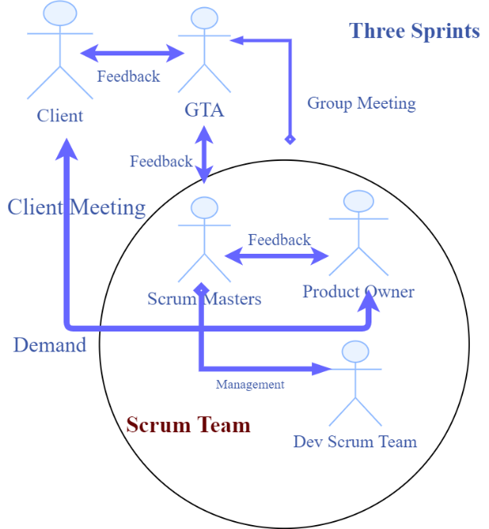

Figure5.1: Team Management

The scrum masters and product owner pushed the project’s progress and keep the effective implement in each sprint. And the Dev development group were focused on developing and testing. And firstly, each member in this team showed its previous knowledge and skills. So, after the discusstion, Runmin Zhang was responsible for Scrum master to manage the Front-end and Basic functions. And Areej Alosaimi as scrum master too and she was responsible for managing the Back-end and Logic programming. As a product owner, Yanghao Zhou managed the team communication and communicated with the Client to determine the demands. Meanwhile, Xiang Feng and Shuang Chen, Conglei Tan were belong to the Dev Scrum Team which focus on developing and testing, and they can receive the help and the information from scrum masters and product owner.

For improving the the efficiency of teamwork, we followed the principle of Agile development and we decided to utilize several tools to manage team and keep the team communicaiton: **Git** (you must register the Github account firstly), **Trello** (about Agile), **Slack** (Sharing the important information) to help to manage the teamwork. So we use **Wechat** or **WhatsApp** to communicate with each other in the daily life, make a discussion on the team project and upload some project materials. We also use **Gitlab** to upload and share the materials or code, and the **Google Hangout** to manage and plan the Group meeting.

Furthermore, these tools promoted the Implementation of the scrum method and the scrum method separated the work to several sprints. A sprint is a short, time-boxed work period when a scrum team works to finish the separate part. Sprints are so important in agile methodologies, and it lets our team solve lots of questions and challenges quickly. With the sprints that break down big, complex projects into bite-sized pieces, travel itinerary planner is built in a series of iterations. [3] So every iteration will cost about 3 weeks, and there were three sprints in the period of project programming. So we divided the project into three iterations and decided to finish the initial demo. Then the team were continued to extend the functions and solve the problems.

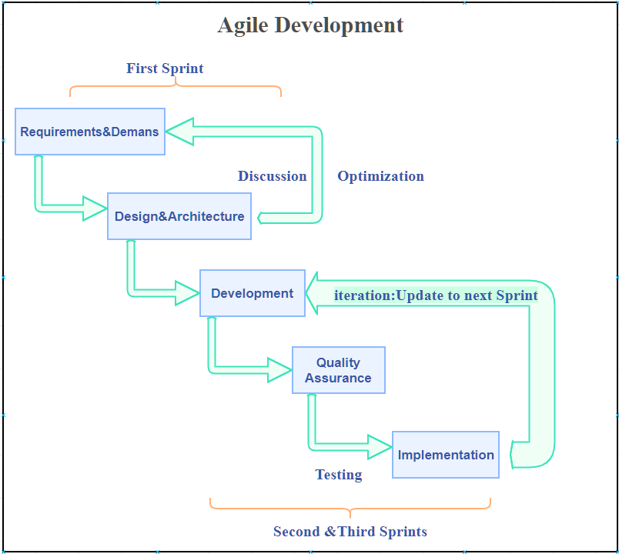

Figure 5.2: Agile Development

* 1. **Tasks Distribution**

The team must clarify the ability of the teammates and believe that there are no unachievable tasks so that every team member can work effectively.

Team Scrum Master: Runmin Zhang , Areej Alosaimi

Product Owner: Yanghao Zhou

Development team: Xiang Feng, Conglei Tan, Shuang Chen

|  |  |  |
| --- | --- | --- |
| **Name:** Runmin Zhang  **Position:** Team Scrum master  **Document:**   * Setup guide * Description of processes   **Code:**   * Build the basic architecture of the system. * Build the first version of index page * Parse some JSON information and Package the activities and plane information * Generate pdf files * Send information to users through email * Generate a basic itinerary for user | Areej Alosaimi  **Position:** Team Scrum master  **Document:**  **Code:** | Yanghao Zhou  **Position:** Product Owner  **Document:**   * Documentation Management * Teamwork part * Project Completion * Product Backlog * Conclusion * Documentation Layout   **Code:**   * Build the first version of index page * Package data into class * Transfer data from front-end to back-end * Prototype Design |
| **Name:** Xiang Feng  **Position:** Dev team member  **Document:**  **Code:** | **Name:** Conglei Tan  **Position:** Dev team member  **Document:**  **Code:** | **Name:** Xiang Feng  **Position:** Dev team member  **Document:**  **Code:** |

* 1. **Team Communication**

Agile project management attaches importance to face-to-face communication, which is the best way to transmit information. For effective communication, the product owner managed a Group Meeting every Wedneday before the GTA Meeting and it was flexible.

During the period of working, we met so many problems and challenges on the team projects. For every week’s meeting time, we collected some questions and problems we have met to ask for help from GTA and the Supervisor. And in every sprint, we had a presentation of a travel itinerary planner to our Clients.

**On Week 1:**

**Communication and Challenges:** The team had the initial meeting to decide the schedule of regular group meeting and share the previous knowledge and experiences. So that we can make good position distribution and work distribution. Based on everyone's’ preference, we chose the Scrum framework to manage the team and finished the position and work distribution. And meanwhile, the team utilized some tools to share useful information. The challenge is the different opinions for the decision for the first week’s task. Some teammates thought Java is suitable for organizing the Website Framework, the others thought Python is light and easy to use. Then every team member listed some advantages and disadvantages for these two languages. Furthermore, product owner started a public vote to make a decision, And before voting the team manage twice meetings to discussed three choices: Programme Language Choice, Framework Choice, Algorithm about Recommender System in an off-line group meeting. So the challenge overcame. Voting is a suitable method to maintain better teamwork and make a better decision.

**On Week 2-4, which is sprint 1:**

**Communication:** Using tools like Slack and Trello to manage Agile Development and Communication. Team members shared useful information into the Slack and Wechat Group. And product owner manages the product backlog on Trello and record the Meeting minutes on Slack. The scrum masters focused on Gitlab management. Every team members kept the information synchronized by sharing the files and links into the group or Slack. If we had questions, the product owner and scrum masters will collect them and ask for GTA or Client. Then, the team received the feedback and modified the Backlog and teamwork. When the product owner was working on the Backlog and the prototype design, the scrum master needed to communicate with him. And product owner shared the basic demo into the Wechat Group to collect the suggestions and transfer the feedback to the prototype design. And the scrum masters and Dev team were concentrated on the front-end programming and first sprint’s user stories design and programming. If someone have questions or problems, other teammates were glad to help him or her. The team tried to manage the common time to work together and determined the structure of the entire project as soon as possible.

**Meeting minutes of Team Communication in first sprint**

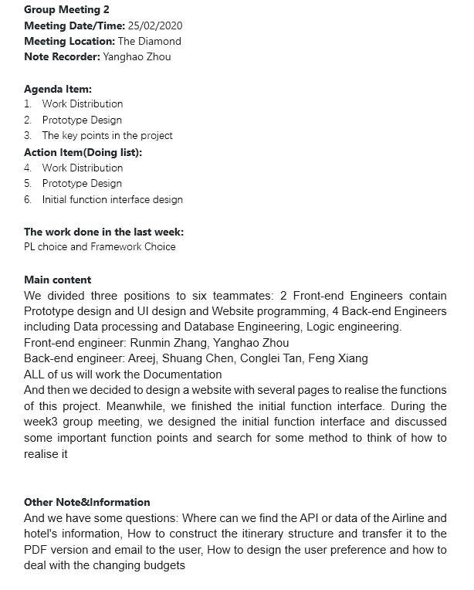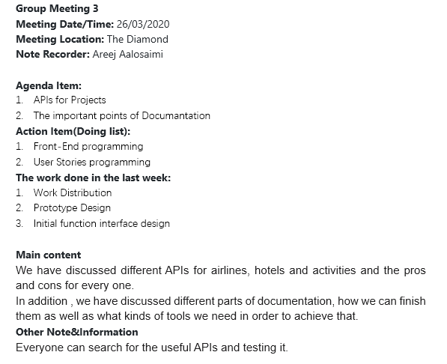

**On Week 5-7, which is sprint 2:**

**Communication:**

The team communicated with each other on the Wechat group effectively. When we started to focus on the second sprint’s user stories realization and logic functions design, sometimes, It was difficult to persuade the other people to change their idea, so that the scrum master Areej and Runmin leaded the Dev team to effectively come up with a coding solution. And by discussion, we chose the optimal solution to realize the user stories which is the main body of the travel itinerary planner. And meanwhile, the product owner continued to convey the flexible demands by completing the user stories. Dev Group continued to give feedback to scrum masters. Before communicating, each of our team members must collect useful information and share the information in the WeChat group, so that everyone's understanding of the user stories and logic function is on the same channel. As we all know, communication is to convey information and opinions clearly and clearly, and at the same time, we made sure that the other teammates have received the content of the transmission. This is very similar to the network protocol handshake. And Dev Group also tried the unit testing in this sprint and gave feedback to each other.

**Meeting minutes of Team Communication in second sprint**

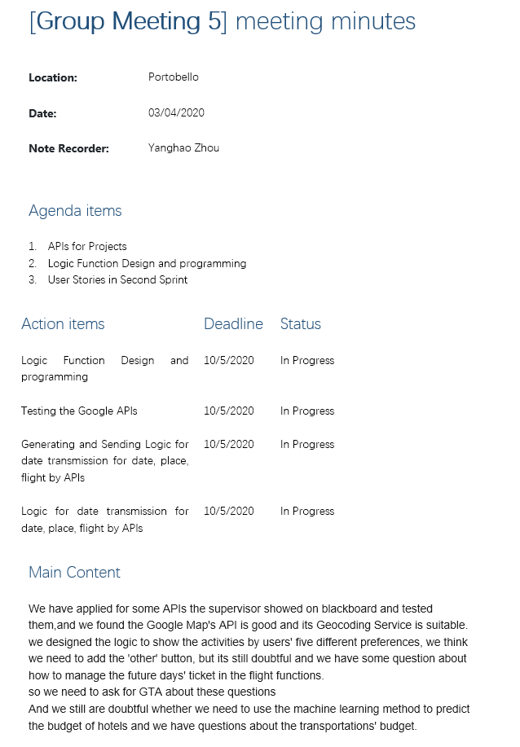 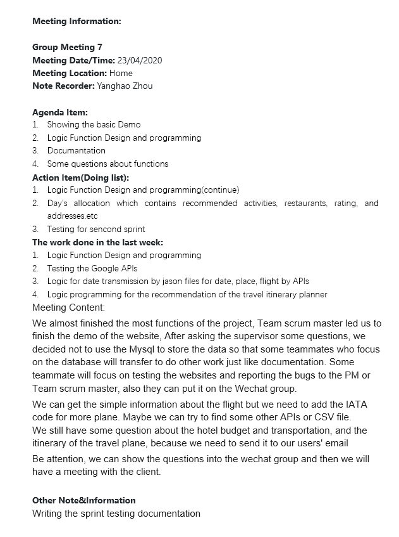

**On Week 8-10, which is sprint 3:**

**Communication:** Not only because of the communication but also team effort, the software demo of Travel Itinerary Planner almost finished on the 8th week. Team scrum masters suggested that we can build our own branch and add some new planned functions to the demo separately and then merge them finally. And the planned functions are based on the requirements and suggestions of the client. The team continued to communicate by Wechat Group and we uploaded the files into Gitlab. Meanwhile, we had the meeting online with Client and GTA to check how we had done and showed the demo to them to know whether we need to add new functions. And the product owner and Dev group began the final testing. Scrum masters began to review the work and divided the tasks of documentation. Because of the google docs, the whole team can discuss and modify the documentation online and share the ideas effectively. Furthermore, we actively put forward our own opinions and made a document that satisfied everyone’s requirement. All the teammates were trying to write the documentation and were collaborated to finish the documentations. When someone finished, he or she would share into the Wechat Group and other teammates could review or check it and give suggestions.

**Challenges:** In the final sprint, we finished the demo last week so we started to build a new branch. Meanwhile, because of the motivation of the teammates, there was some duplication of work. So, scrum masters communicated with Dev Group and the product owner kept the information updated. We solved this problem and completed the project in advance.

**Meeting minutes of Team Communication in third sprint**

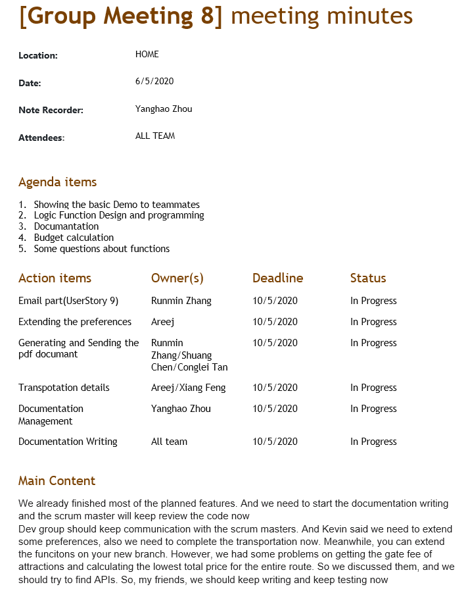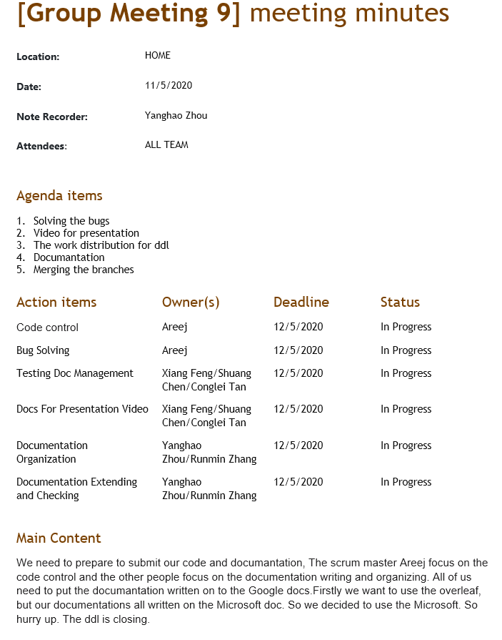

# **Project Completion**

# **Planned & Completed Features**

**Planned and completed features were:**

1. Inputting the arrival (Recognizing to the destination)and departure place.
2. Determining the number of passengers and the classes in the flight.
3. Choosing the date of the travel plan from the start to the end of the trip
4. Choosing the preferences user want and recommend related activities.
5. Recommending the minimum price of the preferred flight to the user.
6. Recommending the minimum price of a suitable hotel for the user.
7. Recommending the high rating attraction in the destination.
8. Showing the flight’s details(cost, airport and time)on the itinerary.
9. Showing the accommodation's details(cost, airport and time)on the itinerary.
10. Showing the local transportation information and cost. And the distance between the places.
11. Generating the every day’s planning contains recommended activities, restaurants, rating, and addresses and showing on the travel itinerary planner, as well as transportation information.
12. Allowing the itinerary to be converted to a PDF document.
13. Allowing the users to input the email and sending the travel itinerary planner to users by email.

# **Uncompleted Features**

1. Getting the gate fee of attractions and Calculating the lowest total price for the entire route

**Reason:** Because there is no ticket price or cost of related attractions in used API and we are difficult to find the APIs which have the budget of attraction or other activities.

Voice input

**Reason:** It involves speech processing, which is more difficult. If you use the API to complete the speech input, it will require some payments. We have implemented Text Input because the text itself can convey enough information and it is more efficient than voice. And the client said this feature was not the necessary to develop and the text input was enough.

# **Screenshots of relevant pages**

# **Conclusion**

Above all, Let’s discuss what we learnt from this module. In this module, we understood the important roles of Agile Development and the product design process. And we learned to adapt the Scrum method of Agile Development to ensure the completion of the project. At the same time, we learned how to manage time and how to be friends with time. We knew how to understand and balance the time management between several courses’ tasks. Because we are a team of six people, each person's course and the proficiency of Coding are different. So we decided to arrange the work distribution by teammates’ preference. Moreover, because the team size is relatively small, so the budget for communication is relatively low. And under the pressure of COVID 19, we encouraged each other and became each other's strength. Although we realized and practised, some communication problems inevitably appeared. Through these lessons, we understood why we need to use Slack, Trello and Gitlab to keep the process clear, effective and controllable. Everyone has learned relevant knowledge from the work they are good at, and we also know how to design and complete a WEB program about travel itinerary planner. This project also Improves our ability to solve real-world problems while learning time management and risk management. Not only have we gained related knowledge and the skills of communication, self-management and organization, but also we have gained friendship.

So, then we talk about the challenges we met and how we solved them. The project went well and everyone was united, however, there still were some challenges during the period of working. We started to be a little tired to understand the knowledge and communicate with each other firstly because we all are not native speakers of the English language. Then through the several months’ English communication, we became good friends and communicated with teammates proficiently. Finally, We began to understand the major value of communication which is to solve the information gap. So that communication will be a tool to maintain high efficiency.

Meanwhile, every teammate had different opinions on the prototype design at first. Then we realized the importance of the function of scrum master and product manager. So we decided to let the PM and scrum master design the preliminary hand-writing prototype and then had a group meeting with other teammates to discuss the prototype and let it be better. Therefore, as the project progresses, we organized weekly meetings within the group to keep the information flowing and reduce duplication of work. We all think this is a good decision.

Then we had the challenge of the data collecting and APIs selection. When we realized that problem, we began to actively reflect this problem to Supervisor and GTA, and at the same time, we were also thinking about which method is better to collect and save data. Also, everyone retrieved and tested the APIs and teammates cooperated to send useful information to the group in time. The product owner understood the demands of the client and then feedbacked the demands of the client to the team. Furthermore, a large number of conference discussions are conducted until the appropriate API is selected. Understanding the demands of the client and improving the development team's understanding of the logic of the demands is an important part of effective agile development.

When we were coding the project in every sprint, we had some challenges in some user stories. For instance, we were doubtful about the transportations part and the budget part, Some user stories were technically difficult, some user stories were somewhat logically confused. At this time, the development team actively reflects the problems to the scrum masters. Then, the scrum masters began to communicate with the product owner, and then the product owner and the scrum master thought of the idea of a code design scheme which was reliable and feasible. Of course, product owner and scrum masters discussed these challenges with Client. So that the logic of these parts became more and more clear. After solving the problems of logic confusion, the development team and scrum masters started to work together to finish these user stories easily. So communication is an essential skill in agile development and teamwork.

We are honoured to be a team and solve real-life problems together. We are also very grateful that the supervisor and GTA of this course are so kind and professional. Under the influence of the coronavirus, they are still so dedicated and considerate to students. Also, they were actively communicating with us and helped us to solve the challenges. And we are also very grateful to each other in this group, everyone is brave, especially the teammates who returned to the motherland and are still struggling for the project at midnight, Thank you all and best wishes.

# **Bibliography**

[1] Juyun Cho, Richard Huff, and David Olsen. "MANAGEMENT GUIDELINES FOR SCRUM AGILE SOFTWARE DEVELOPMENT PROCESS." Issues in Information Systems 12.1 (2011): 213-23. Web.

[2] Vanderjack, Brian. The Agile Edge : Managing Projects Effectively Using Agile Scrum. First ed. New York: Business Expert, 2015. Portfolio and Project Management Collection. Web.

[3] During, Beatrice. "Sprint Driven Development: Agile Methodologies in a Distributed Open Source Project (PyPy)." Extreme Programming And Agile Processes In Software Engineering, Proceeding 4044 (2006): 191-95. Web.

# **Appendices**

# **User Guide**

1. **Searching for plan**

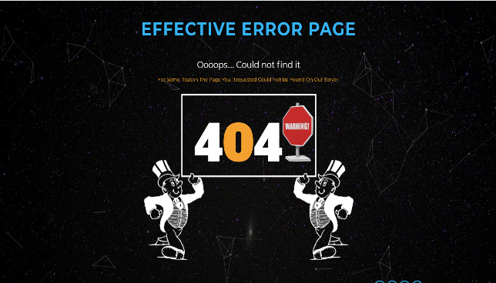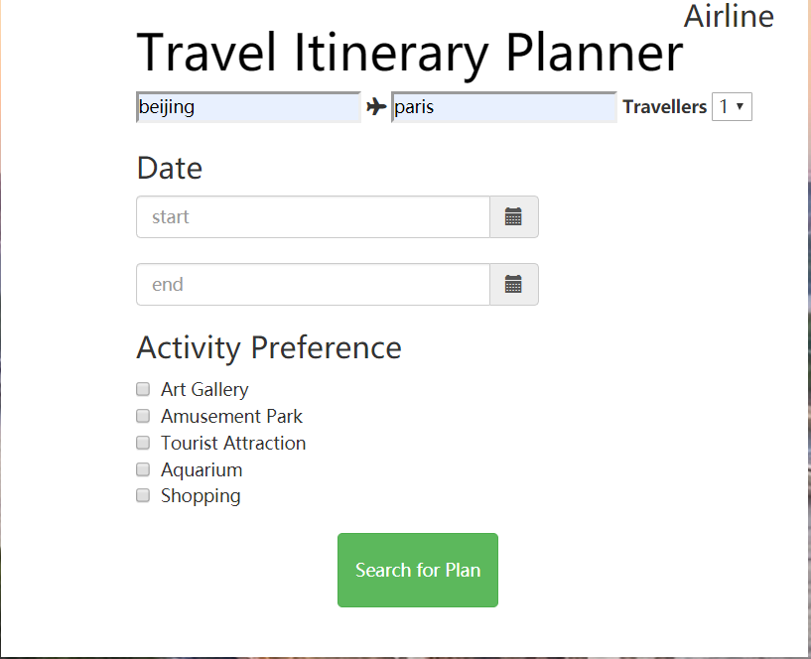For the first time user, it is easy to browse our website. There are several items filled by users,such as place, number of passengers and date. Firstly, the user should fill in the place of origin and destination. In the next step, the number of travelers are supposed to be selected. By the way, only 1 to 5 can be selected by the users. Thirdly, accordingly, travelers have to choose their departure and return dates.In the next, travels need to select their own activity preference. In detail, the user can only select one item, such as art gallery. Certainly, the user can select two or more items. For example, the traveler not only likes shopping but tourist attraction.In this case, this user is able to tick these two boxes. Finally, the users should click the “Search for plan” button to search for information they need.If the user do not fill any data or the information does not exist, the web page will redirect to a 404 page.

1. **Information display page**

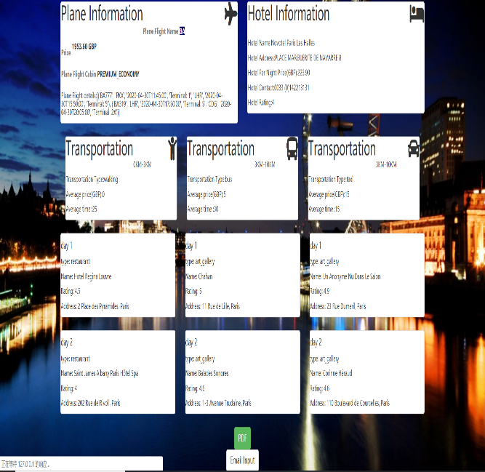There is a good example for users to understand what information they will receive.

The user has filled in the following information: from Beijing to Paris; two travelers and the class of cabin is economy class; from 2020/04/30 to 2020/05/02, art gallery and tourist attraction.

It is obvious that the screen shows the plane information and hotel information to user. In detail, the plane information includes the name of airline and price.The hotel information includes the hotel’s name, price, contact number and rating. Below these two information board, the transportation information has been showed in front of the users. In the end of the screen, this tourism website system usually recommend daily schedule to users according to their own activity preference.

1. **Getting the PDF**

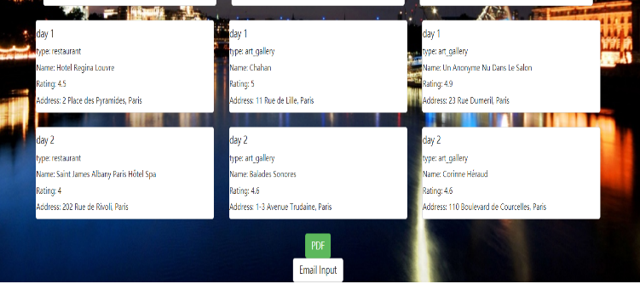The user maybe need the copy of their trip plan. They just click the PDF button and the browser automatically downloads the PDF about the the journey. Therefore, the user is able to save the file and make it available for later review.

1. **Sending the email**

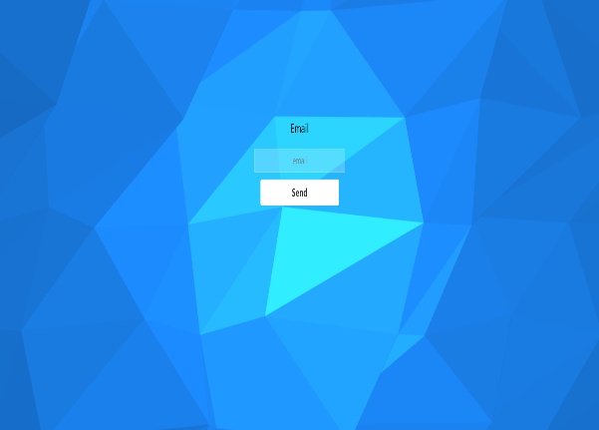For some users, it is convenient to send information to their mailbox. In this case, they just click the “Email input” button and the web page will redirect to the “Email-Send” web page.

In this stage, the user is required to write their mailbox. In particular, our website various of mailbox,such as QQ, Google and so on.

In the end, the user click the “Send” button and web page will send the information to user via email.

# **Setup Guide**

* 1. **About the product**

At present, many people will choose to travel to reduce their pressure, based on such requirements, our system is to help all passengers plan a travel route.

* 1. **Key Benefits**

We can help users who are not familiar with that places of interest to generate a Travel Itinerary Planner. While the ticket information will be also contained in our Itinerary information.

* 1. **System Requirements**

Windows 7, Windows 8, windows 10, Mac

* 1. **Installing**

JetBrains PyCharm to install our system.

* 1. **Starting Up**

Install all packages the system needs. The key packages are Amadeus, opencage, googlemapes. Pip install those packages

* 1. **Uninstalling**

Uninstall the system in PyCharm

* 1. **Backing Up**

No

* 1. **Registering the product**

No

* 1. **Frequently Asked Questions**

**1. Why we cannot travel in China?**

Because our system use google Api to fetch information, while google cannot be used in China, So we cannot help you to get generate travel itinerary.

**2. why we need to wait a long time in getting our itinerary?**

Because when we fetch information from google, every time we get 15 pieces of data, our program will sleep for 2 seconds and proceed to the next batch of data.

**3. why sometimes we cannot get information from that places.**

There are two reasons. The first reason is that the places you search for may not contain tourist attractions with that keyword. The second reason is that there are few tourist attractions, but you want to spend more time there. Since we will recommend 2 tourist attractions to you every 1 day, you may be able to visit all the attractions in 1 week, but you will stay there for more than one week. You only need to adjust your local travel time to get the relevant data

# **Used API**

**Amadeus：**

client.shopping.flight_offers_search.get(  
 originLocationCode=start_place_code,  
 destinationLocationCode=end_place_code,  
 departureDate=start_date,  
 adults=traveller)

input: start Code, end Code, start data, traveler

output: response

response = client.shopping.hotel_offers.get(latitude=latitude, longitude=longitude)

input: latitude, longitude

output: response

**opencage:**

result = geocoder.geocode(place, no_annotations='1') # Geo-coding Service API key

input: start place

output: response

**googlemapes:**

directions_result = gmaps.directions(origin=[sequence.latitude, sequence.longitude],  
 destination=[line_sequence[sindex+1].latitude,  
 line_sequence[sindex+1].longitude],  
 mode="transit")

input: start place latitude, longitude; end place latitude, longitude. Mode

output: response

response = gmaps.places_nearby(location=[latitude, longitude], radius=10000, type=type)

input: radius latitude, longitude type

# **Examples of Meeting Minutes**

