ISYE 6740, Summer 2021, Homework 3

100 points

# Density estimation: Psychological experiments (50 points).

In *Kanai, R., Feilden, T., Firth, C. and Rees, G., 2011. Political orientations are correlated with brain structure in young adults. Current biology, 21(8), pp.677-680.*, data are collected to study whether or not the two brain regions are likely to be independent of each other and considering diﬀerent types of political view **For this question; you can use the proper package for histogram and KDE; no need to write your own.** The data set n90pol.csv contains information on 90 university students who participated in a psychological experiment designed to look for relationships between the size of diﬀerent regions of the brain and political views. The variables amygdala and acc indicate the volume of two particular brain regions known to be involved in emotions and decision-making, the amygdala and the anterior cingulate cortex; more exactly, these are residuals from the predicted volume, after adjusting for height, sex, and similar body-type variables. The variable orientation gives the students’ locations on a ﬁve-point scale from 1 (very conservative) to 5 (very liberal). Note that in the dataset, we only have observations for orientation from 2 to 5.

1. (10 points) Form the 1-dimensional histogram and KDE to estimate the distributions of amygdala and acc, respectively. For this question, you can ignore the variable orientation. Decide on a suitable number of bins so you can see the shape of the distribution clearly. Set an appropriate kernel bandwidth *h > 0*.

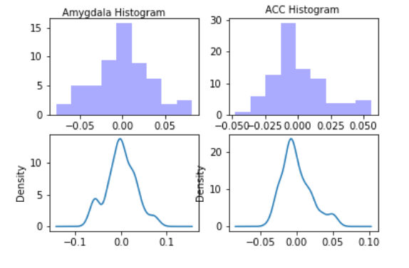

1. (10 points) Form 2-dimensional histogram for the pairs of variables (amygdala, acc). Decide on a suitable number of bins so you can see the shape of the distribution clearly.

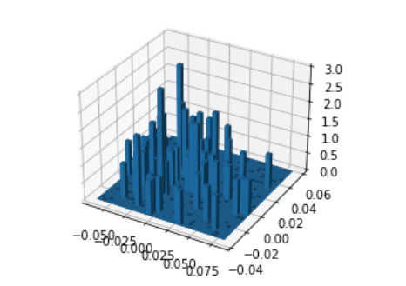

1. (10 points) Use kernel-density-estimation (KDE) to estimate the 2-dimensional density function of (amygdala, acc) (this means for this question, you can ignore the variable orientation). Set an appropriate kernel bandwidth *h >* 0.

Please show the two-dimensional KDE (e.g., two-dimensional heat-map, two-dimensional contour plot, etc.)

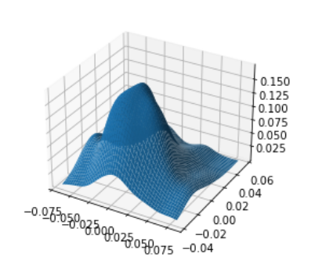

Please explain based on the results, can you infer that the two variables (amygdala,

acc) are likely to be independent or not?

Ttest_indResult(statistic=0.001643592891298308, pvalue=0.9986904437484719)

Two variable are independent in my view. They are well distributed evenly over their range.

1. (10 points) We will consider the variable orientation and consider conditional distributions. Please plot the estimated conditional distribution of amygdala conditioning on political orientation: *p*(amygdala orientation = *c*), *c* = 2*, . . . ,* 5, using KDE. Set an appropriate kernel bandwidth *h >* 0. Do the same for the volume of the acc: plot *p*(acc orientation = *c*), *c* = 2*, . . . ,* 5 using KDE. (Note that the conditional distribution can be understood as ﬁtting a distribution for the data with the same orientation. Thus you should plot 8 one-dimensional distribution functions in total for this question.)

Now please explain based on the results, can you infer that the conditional distribution of amygdala and acc, respectively, are different from *c* = 2*, . . . ,* 5? This is a type of scientific question one could infer from the data: Whether or not there is a difference between brain structure and political view.

Now please also ﬁll out the *conditional sample mean* for the two variables:

Remark: As you can see this exercise, you can extract so much more information from density estimation than simple summary statistics (e.g., the sample mean) in terms of exploitable data analysis.

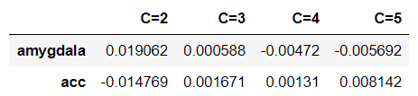

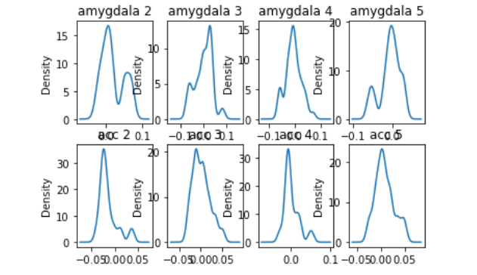

For amygdala, seems they are decreasing a little bit when C get bigger.

For ACC, there are no significant change in my view

1. (10 points) Again we will consider the variable orientation. We will estimate the conditional *joint* distribution of the volume of the amygdala and acc, conditioning on a function of political orientation: *p*(amygdala*,* acc orientation = *c*), *c* = 2*, . . . ,* 5. You will use two-dimensional KDE to achieve the goal; et an appropriate kernel band- width *h >* 0. Please show the two-dimensional KDE (e.g., two-dimensional heat-map, two-dimensional contour plot, etc.).

Please explain based on the results, can you infer that the conditional distribution of two variables (amygdala, acc) are different from *c* = 2*, . . . ,* 5? This is a type of scientific question one could infer from the data: Whether or not there is a difference between brain structure and political view.

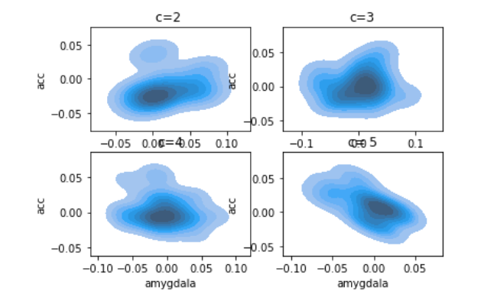

# Implementing EM for MNIST data-set (50 points).

Implement the EM algorithm for fitting a Gaussian mixture model for the MNIST hand- written digits data-set. For this question, we reduce the data-set to be only two cases, of digits “2” and “6” only. Thus, you will ﬁt GMM with *C* = 2. Use the data file data.mat or data.dat. True label of the data are also provided in label.mat and label.dat.

The matrix images is of size 784-by-1990, i.e., there are totally 1990 images, and each column of the matrix corresponds to one image of size 28-by-28 pixels (the image is vector- ized; the original image can be recovered by map the vector into a matrix).

First use PCA to reduce the dimensionality of the data before applying to EM. We will put all “6” and “2” digits together, to project the original data into 4-dimensional vectors.

Now implement EM algorithm for the projected data (with 4-dimensions).

1. (10 points) Write down detailed expression of the E-step and M-step in the EM algo- rithm (hint: when computing *7 i*, you can drop the (2*π*)*n/* factor from the numerator and denominator expression, since it will be canceled out; this can help avoid some numerical issues in computation).

*k*

E_step:

M_step:

1. (16 points) Implement EM algorithm yourself. Use the following initialization

initialization for mean: random Gaussian vector with zero mean

initialization for covariance: generate two Gaussian random matrix of size *n*-by- *n*: *S* and *S*, and initialize the covariance matrix for the two components are

Σ = *SST*

+ *In*, and Σ = *SST*

+ *In*, where *In* is an identity matrix of size

*n*-by-*n*.

Plot the log-likelihood function versus the number of iterations to show your algorithm is converging.

Here is mean log-likelihood plot:

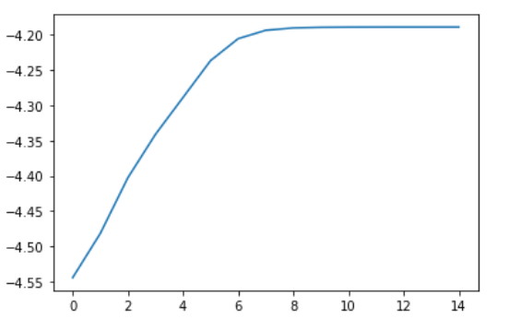

1. (12 points) Report, the fitted GMM model when EM has terminated in your algorithms as follows. Report the weights for each component, and the mean of each component, by mapping them back to the original space and reformat the vector to make them into 28-by-28 matrices and show images. Ideally, you should be able to see these means corresponds to some kind of “average” images. You can report the two 4-by-4 covariance matrices by visualizing their intensities (e.g., using a gray scaled image or heat map).

Weight is [0.51344711 0.48655289]

Mean image:

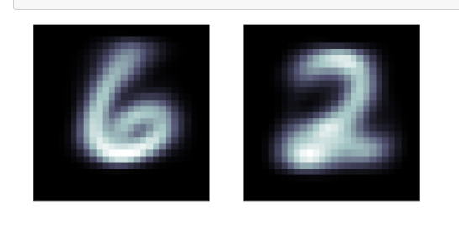

Covariance matrix correction matrix:

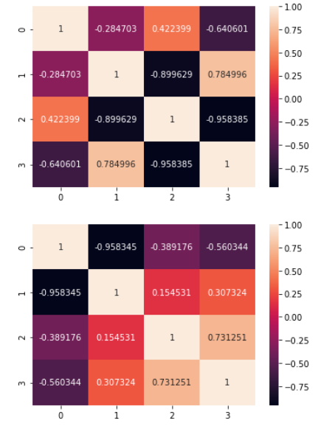

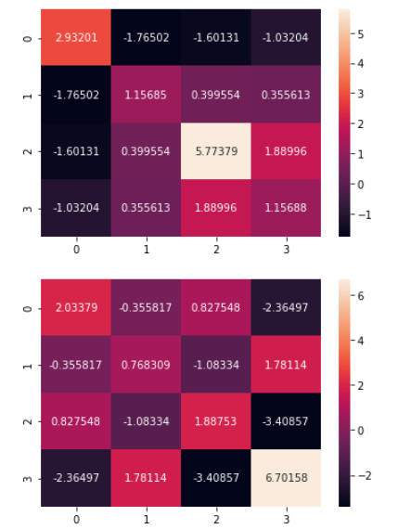

1. (12 points) Use the tau *i* to infer the labels of the images, and compare with the true labels. Report the mis-classiﬁcation rate for digits “2” and “6” respectively. Perform *K*-means clustering with *K* = 2 (you may call a package or use the code from your previous homework). Find out the mis-classiﬁcation rate for digits “2” and “6” respectively, and compare with GMM. Which one achieves the better performance?

*k*

Miss fit:

EM: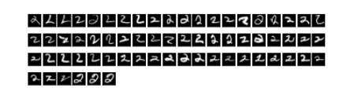

1. Mean: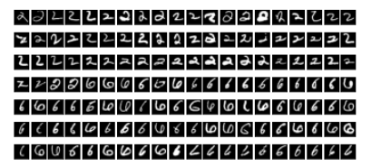

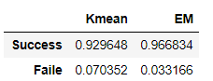

Both of them are pretty good, but Em has better performance.