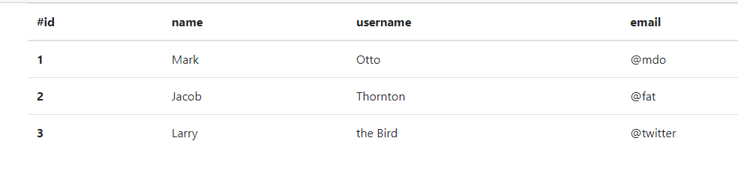

(I am sorry that I do not know JavaScript programming, so I could not apply the Fetch commend. Below HTML table is updated manually)

[

{

"id": 1,

"name": "Mark",

"username": "Otto",

"email": "Mark@mdo",

},

{

"id": 2,

"name": "Jacob",

"username": "Thornton",

"email": "Jacob@fat",

},

{

"id": 3,

"name": "Larry",

"username": "the Bird",

"email": "Larry@twitter",

}

]