Assignment 4

Purdue University Northwest
4/12/2026
Fengyuan Liu

Table of Contents
I. Introduction 2
II. Methodology 3
1. Environment Setup 3
2. Reinforcement Learning Algorithms 4
3. Training Process 4
III. Results 5
IV. Analysis 8
1. Why SARSA is Safer 8
2. Why Q-learning is More Aggressive 8
3. Convergence Behavior 8
V. Conclusion 9

- Introduction
In this project, we model a simplified routing problem in a global data center network using a grid world environment. Each cell in the grid represents a node, and the agent must find an optimal path from a source node to a destination node.
The objective is to:
- Minimize routing delay (modeled as step cost)
- Avoid high-penalty zones (representing congested or failed nodes)
We implement and compare two reinforcement learning algorithms:
- Q-learning (off-policy)
- SARSA (on-policy)
The goal is to analyze their behavior and performance under the same environment.

- Methodology
- Environment Setup
The environment is modeled as an $n×m$grid world:
- Start state: top-left corner $\left(0 , 0\right)$
- Goal state: bottom-right corner $\left(n-1,m-1\right)$
- Some cells are designated as danger zones, which incur high penalties
Reward Design:
- Normal step: -1
- Reaching goal: +100
- Entering danger zone: -100
This reward structure encourages:
- Short paths (fewer steps)
- Avoidance of risky areas

- Reinforcement Learning Algorithms
Q-learning (Off-policy)
Q-learning updates the Q-value using the maximum possible future reward:
$$Q(s,a)←Q(s,a)+α\left[r+γ\underset{a^{'}}{max⁡}Q(s^{'},a^{'})-Q(s,a)\right]$$
- Assumes the agent will always take the optimal action in the future
- Does not consider exploratory behavior during updates

SARSA (On-policy)
SARSA updates the Q-value using the actual next action taken:
$$Q(s,a)←Q(s,a)+α\left[r+γQ(s^{'},a^{'})-Q(s,a)\right]$$
- Considers the current policy (including exploration)
- Reflects realistic behavior of the agent

- Training Process
Both agents are trained using:
- Learning rate $α=0.1$
- Discount factor $γ=0.95$
- Exploration rate $ϵ=0.1$
- Episodes: 500
An epsilon-greedy policy is used to balance exploration and exploitation.

- Results
After training, the learned paths are extracted from the Q-table. Q-learning typically learns a shorter path. SARSA often learns a safer path, avoiding danger zones
Example observation:
Q-learning may choose paths close to danger zones
SARSA maintains a safer distance
The average reward over the last training episodes shows:
Q-learning achieves higher final reward
SARSA shows more stable and conservative performance
This indicates Q-learning prioritizes optimality, SARSA prioritizes safety.
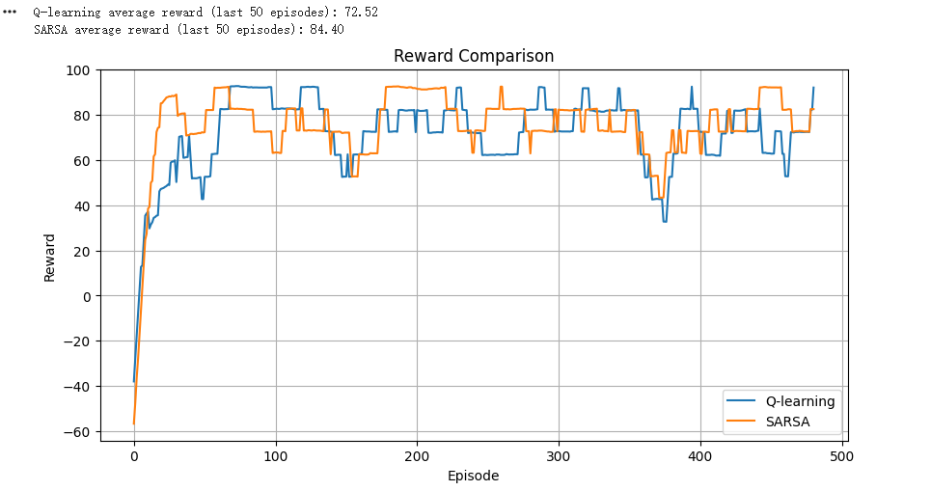
The path visualization confirms:
Q-learning path: shorter but riskier
SARSA path: slightly longer but safer
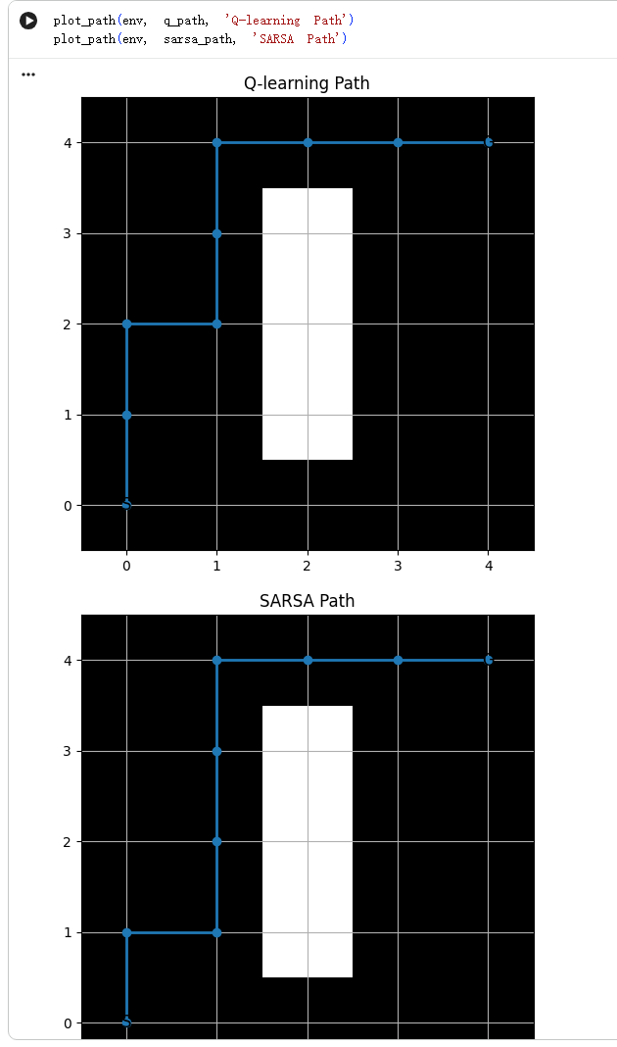
- Analysis
- Why SARSA is Safer
SARSA updates its Q-values based on the actual action taken, including exploratory actions.
This means:
- It accounts for the possibility of entering danger zones during exploration
- It learns policies that are robust under uncertainty
As a result, SARSA tends to avoid high-risk areas.
- Why Q-learning is More Aggressive
Q-learning assumes the agent will always choose the optimal action in the next state.
Therefore:
- It ignores the effect of exploration during learning
- It may learn paths that pass close to danger zones
This makes Q-learning more aggressive but potentially risky during training.
- Convergence Behavior
Q-learning converges to the optimal policy when exploration decreases
SARSA may converge to a suboptimal but safer policy
This reflects the fundamental difference:
Q-learning → optimality-focused
SARSA → safety-aware

- Conclusion
In this project, we compared SARSA and Q-learning in a grid-based routing environment.
Key findings:
- Q-learning learns shorter, more optimal paths but may take risks
- SARSA learns safer, more conservative paths
- The difference arises from their learning strategies:
  - Off-policy vs On-policy
This experiment demonstrates how algorithm design impacts behavior in uncertain environments, especially in safety-critical systems such as network routing.

