1. **Компоновка и элементы управления в WPF**

Задание 1. Измените интерфейс проекта WPF – XmlTaskWPF следующим образом:

добавьте возможность скрывать функциональность под ЭУ Expander;

предложите выбор вывода списка в качестве Компонеты с использованием RadioButtons;

добавьте вывод списка элементов в TreeView, ListBox.

Листинг программы:

using Microsoft.Win32;

using System.IO;

using System;

using System.Windows;

using Task_1.Interfaces;

using Task_1.Share;

using System.Collections.Generic;

using Task_1.Models;

using Microsoft.Extensions.Logging;

using System.Windows.Controls;

namespace Task_1

{

/// <summary>

/// Логика взаимодействия для MainWindow.xaml

/// </summary>

public partial class MainWindow : Window

{

private readonly IXmlWorker _worker;

private readonly ILogger _logger;

public bool IsFileOpened = false;

private string _xmlFilePath;

public MainWindow()

{

InitializeComponent();

_logger = LoggerFactory.Create(builder => builder

.SetMinimumLevel(LogLevel.Information))

.CreateLogger<MainWindow>();

_worker = new XmlDocumentWorker(_logger);

}

private void buttonFindBookByName_Click(object sender, RoutedEventArgs e)

{

var book = _worker.FindBy(textBoxBookName.Text);

PrintBook(book);

}

private void buttonAdd_Click(object sender, RoutedEventArgs e)

{

AddNewBook addNewBook = new AddNewBook();

addNewBook.XmlFilePath = textBlockXMLPathFile.Text;

addNewBook.Show();

_worker.Load(_xmlFilePath);

PrintBooks(_worker.GetAll());

}

private void buttonExit_Click(object sender, RoutedEventArgs e)

{

this.Close();

}

private void buttonDelete_Click(object sender, RoutedEventArgs e)

{

if (!string.IsNullOrEmpty(textBoxDeleteBookName.Text) || !string.IsNullOrWhiteSpace(textBoxDeleteBookName.Text))

{

_worker.Delete(textBoxDeleteBookName.Text);

PrintBooks(_worker.GetAll());

}

}

private void PrintBook(Book book)

{

if (textBlockRB.IsChecked == true)

{

textBlockXmlFileContent.Visibility = Visibility.Visible;

treeViewXmlFileContent.Visibility = Visibility.Collapsed;

listBoxXmlFileContent.Visibility = Visibility.Collapsed;

textBlockXmlFileContent.Text = "Book" + Environment.NewLine;

textBlockXmlFileContent.Text += book?.ToString() ?? "Country not founds";

}

else if (treeViewRB.IsChecked == true)

{

textBlockXmlFileContent.Visibility = Visibility.Collapsed;

treeViewXmlFileContent.Visibility = Visibility.Visible;

listBoxXmlFileContent.Visibility = Visibility.Collapsed;

treeViewXmlFileContent.Items.Add("Book");

treeViewXmlFileContent.Items.Add(book?.ToString() ?? "Country not founds");

}

else if (listBoxRB.IsChecked == true)

{

textBlockXmlFileContent.Visibility = Visibility.Collapsed;

treeViewXmlFileContent.Visibility = Visibility.Collapsed;

listBoxXmlFileContent.Visibility = Visibility.Visible;

listBoxXmlFileContent.Items.Add("Book");

listBoxXmlFileContent.Items.Add(book?.ToString() ?? "Country not founds");

}

}

private void PrintBooks(List<Book> books)

{

if (textBlockRB.IsChecked == true)

{

textBlockXmlFileContent.Visibility = Visibility.Visible;

treeViewXmlFileContent.Visibility = Visibility.Collapsed;

listBoxXmlFileContent.Visibility = Visibility.Collapsed;

textBlockXmlFileContent.Text = "Book" + Environment.NewLine;

foreach (var note in books)

{

textBlockXmlFileContent.Text += note?.ToString();

}

}

else if (treeViewRB.IsChecked == true)

{

textBlockXmlFileContent.Visibility = Visibility.Collapsed;

treeViewXmlFileContent.Visibility = Visibility.Visible;

listBoxXmlFileContent.Visibility = Visibility.Collapsed;

treeViewXmlFileContent.Items.Add("Book");

foreach (var note in books)

{

treeViewXmlFileContent.Items.Add(note?.ToString());

}

}

else if (listBoxRB.IsChecked == true)

{

textBlockXmlFileContent.Visibility = Visibility.Collapsed;

treeViewXmlFileContent.Visibility = Visibility.Collapsed;

listBoxXmlFileContent.Visibility = Visibility.Visible;

listBoxXmlFileContent.Items.Add("Book");

foreach (var note in books)

{

listBoxXmlFileContent.Items.Add(note?.ToString());

}

}

}

private void textBoxBookName_TextChanged(object sender, TextChangedEventArgs e)

{

if (string.IsNullOrEmpty(textBoxBookName.Text))

{

PrintBooks(_worker.GetAll());

}

}

private void buttonOpenFile_Click(object sender, RoutedEventArgs e)

{

var dialog = new OpenFileDialog();

dialog.InitialDirectory = Directory.GetParent(AppContext.BaseDirectory)

.Parent

.Parent

.FullName;

dialog.DefaultExt = ".xml";

dialog.Filter = "Xml documents (.xml)|*.xml";

var result = dialog.ShowDialog();

if (result.HasValue && result.Value)

{

_xmlFilePath = dialog.FileName;

textBlockXMLPathFile.Text = _xmlFilePath;

_worker.Load(_xmlFilePath);

PrintBooks(_worker.GetAll());

}

}

private void textBlockXmlFileContent_MouseMove(object sender, System.Windows.Input.MouseEventArgs e)

{

if (_xmlFilePath != null)

{

_worker.Load(_xmlFilePath);

PrintBooks(_worker.GetAll());

}

}

private void textBlockRB_Checked(object sender, RoutedEventArgs e)

{

if (_xmlFilePath != null)

PrintBooks(_worker.GetAll());

}

private void treeViewRB_Checked(object sender, RoutedEventArgs e)

{

treeViewXmlFileContent.Items.Clear();

if (_xmlFilePath != null)

PrintBooks(_worker.GetAll());

}

private void listBoxRB_Checked(object sender, RoutedEventArgs e)

{

listBoxXmlFileContent.Items.Clear();

if (_xmlFilePath != null)

PrintBooks(_worker.GetAll());

}

}

}

Таблица 1.1 – Входные и выходные данные

|  |  |
| --- | --- |
| Входные данные | Выходные данные |
|  |  |

Анализ результатов:

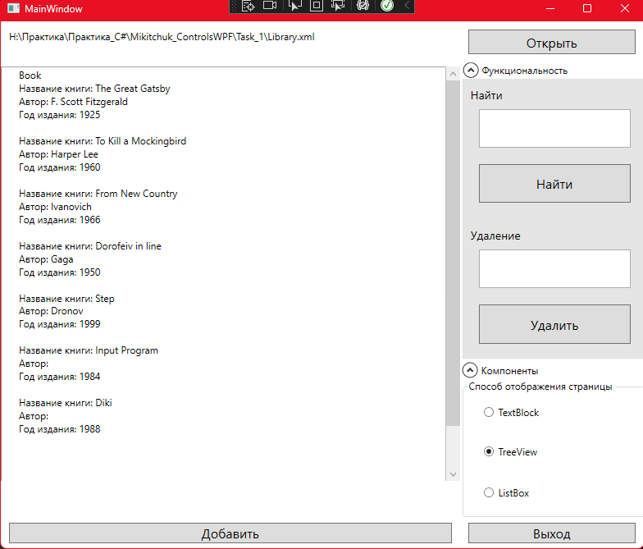

Рисунок 1.1 – Результат работы программы

Источник: собственная разработка