

Web Technology with UI/UX – Assignment 1

Submitted in partial fulfillment of the requirements for the subject
Web Technology with UI/UX

Submitted By:
Fenil Mehta
Enrollment No.: 2502031030046

Department of Information Technology
Aditya Silver Oak Institute of Technology
Silver Oak University
Ahmedabad, Gujarat
Semester 4
Academic Year: 2025–2026

1. Introduction
- This assignment focuses on understanding version control and UI/UX design. The main objective is to create a GitHub repository and organize project files properly.
- Additionally, a website prototype is designed using Figma to understand layout structure, user interface design, and user experience principles.
- The designed prototype will later be converted into a working website using HTML and CSS.

2. Tools Used
- GitHub – repository creation and file management
- Figma – UI design
- Google Chrome – tool access
- MS Word – documentation

3. Task 1: GitHub Repository Setup
- Step 1: Create GitHub Account (Insert Screenshot)
- Step 2: Create Repository named 2502031030011 (Insert Screenshot)
- Step 3: Create folders Assignment_1 and Assignment_2 (Insert Screenshot)
- Step 4: Upload files into respective folders (Insert Screenshot)
- Step 5: Add repository link: https://github.com/your-username/your-repository-name

4. Screenshots of Github:

- Creating Github account
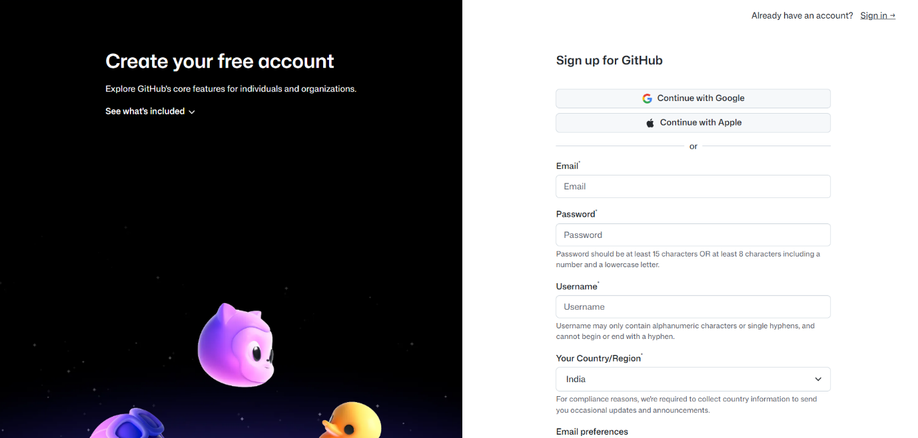

- Folders of assignment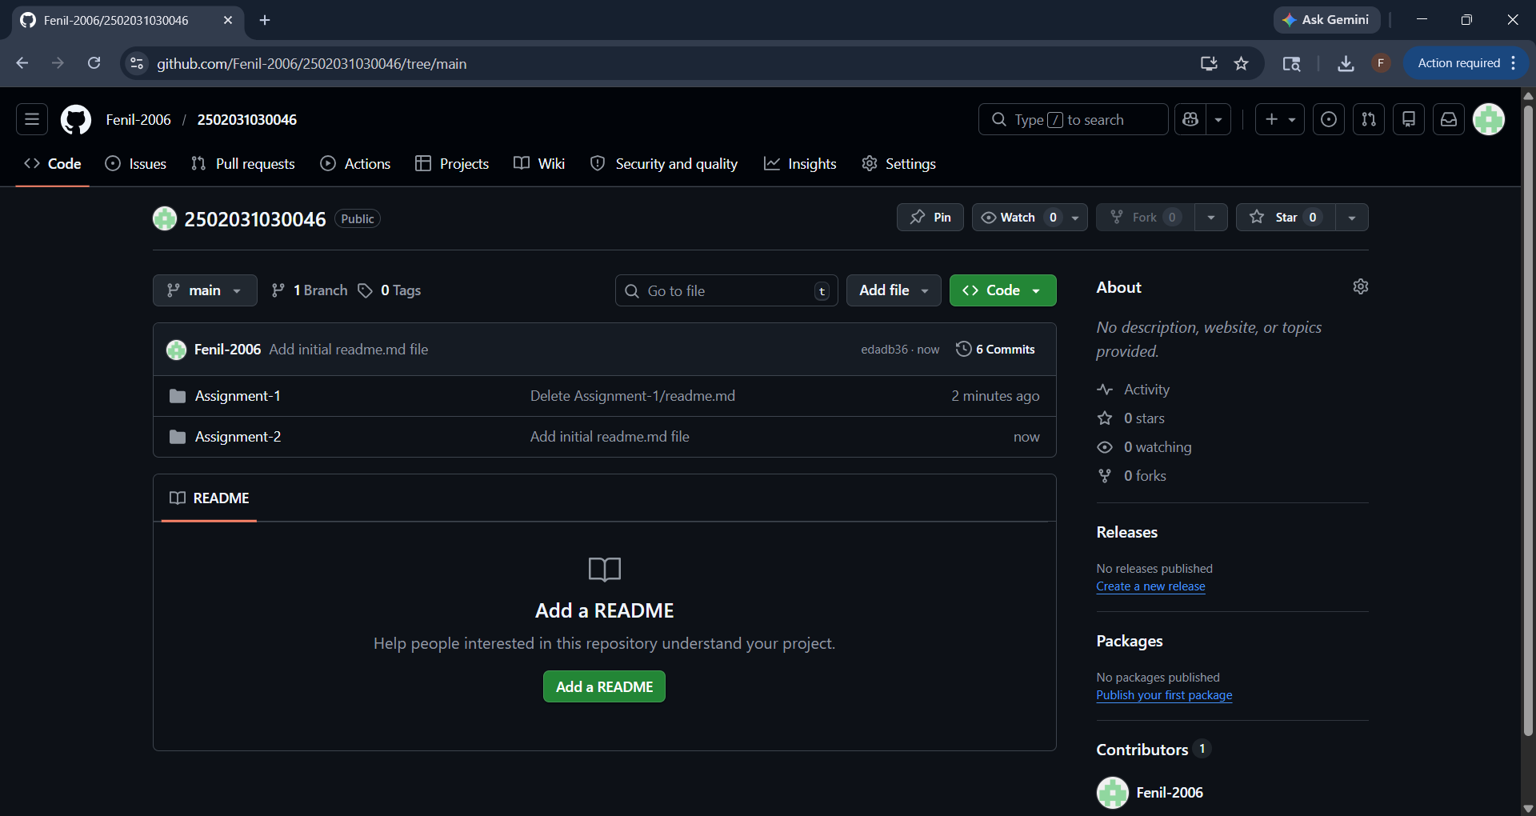

- Files uploaded in folder Assignment 1
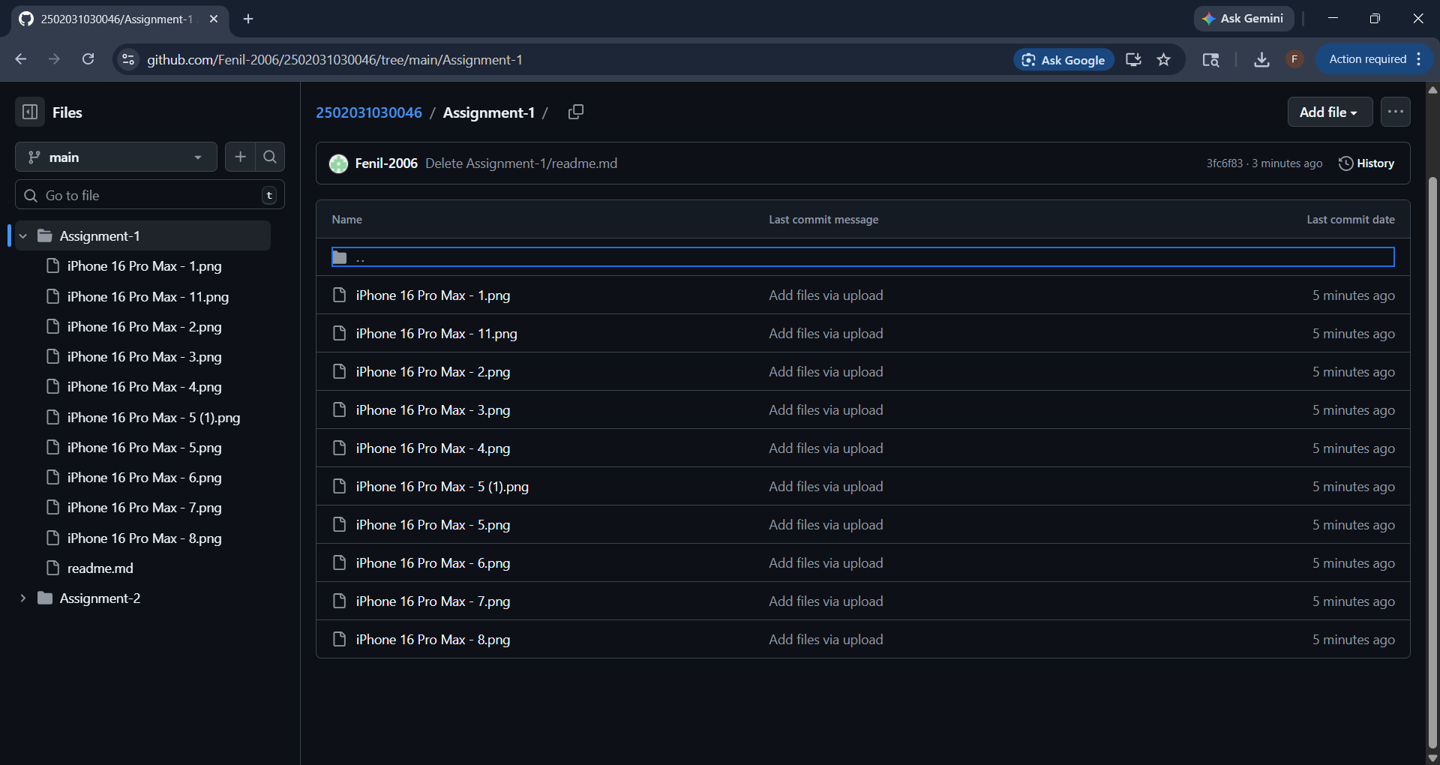

- Repository link: https://github.com/Fenil-2006/2502031030046

4. Task 2: Figma Design

Project Title:
Instagram UI Clone

Project Description
The project is a mobile UI design inspired by Instagram. It focuses on creating a modern, user-friendly interface with clean layout and smooth navigation. The design includes multiple screens that simulate a real-world social media application.

Screens Designed
The following screens were designed in Figma:
- Splash Screen
- Login Screen
- Home Feed Screen
- Stories Section
- Post View Screen
- Reels / Explore Screen
- Chat / Message Screen
- Profile Screen

Design Features
- Dark mode interface for better user experience
- Gradient backgrounds for modern look
- Bottom navigation bar for easy access
- Circular story highlights
- Grid layout for posts and reels
- Clean typography and spacing

5. Screenshots
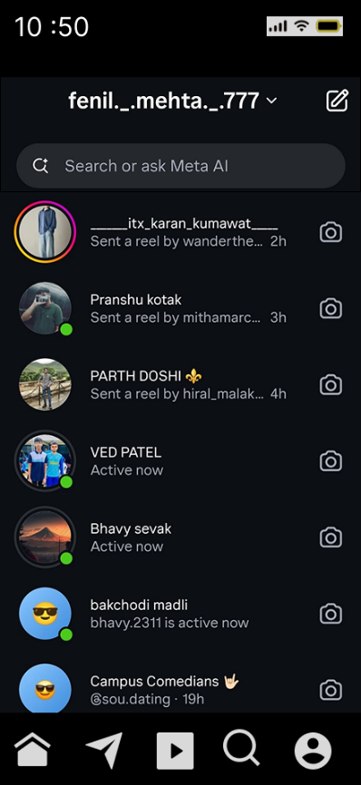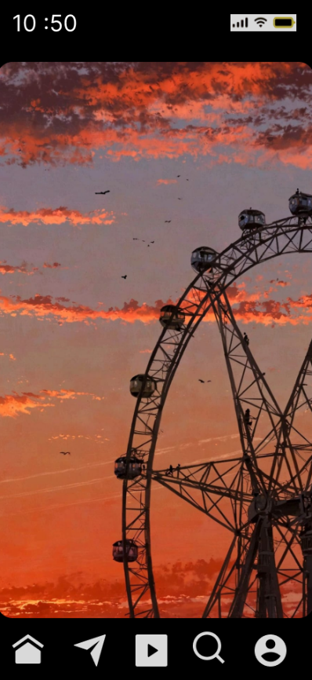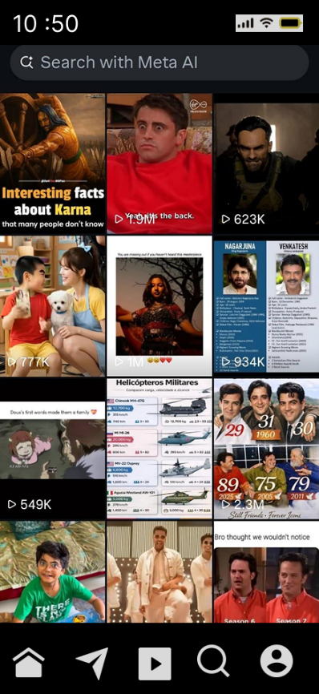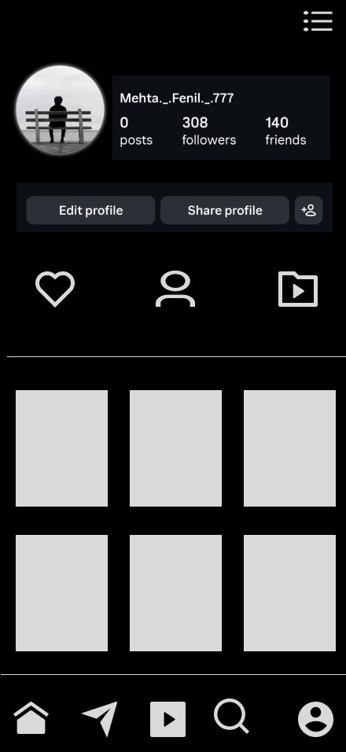

6. Conclusion
This assignment provided practical knowledge about GitHub repository management and UI/UX design. It helped in understanding how to organize project files and create visually appealing user interfaces. The use of Figma improved design skills, and the overall process enhanced understanding of web development workflow.

