**Objective:** To retrieve the customer information, product information and office information for the Mini-Me Toy Car Company using MYSQL with JDBC connection by the user input.

**Classes Created:** I wrote all my code in the main class itself. It shouldn’t be the case and should have taken care of modularity, but I didn’t have any other option. Initially, I tried making different classes for the product, customer, and office information. But I could not connect it, and it was throwing this error. That’s why I went with the single-class approach.

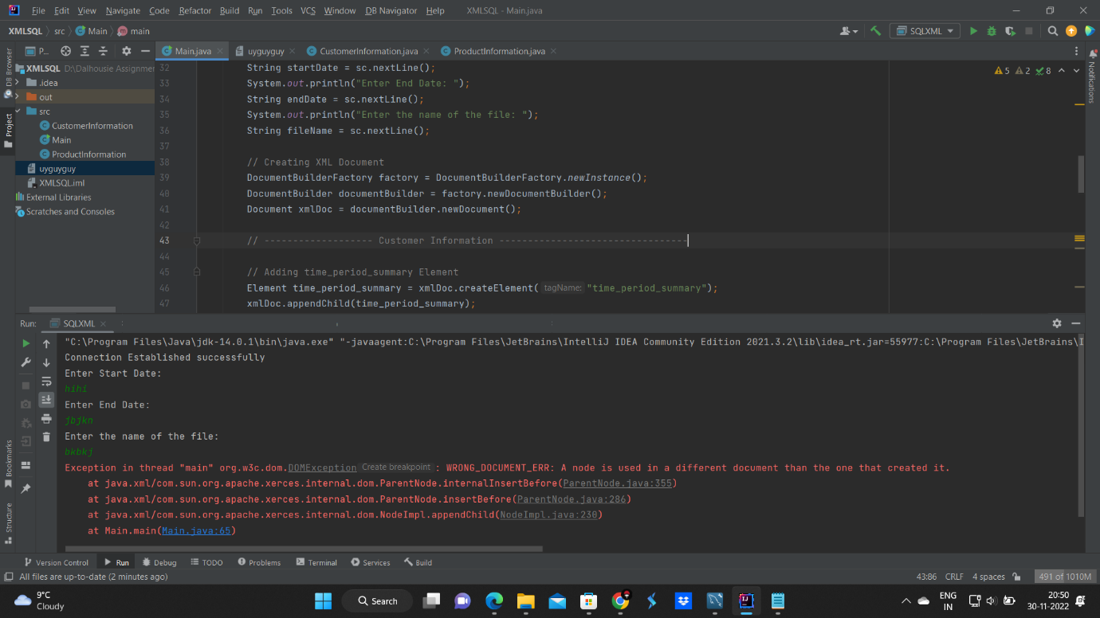

**Approach:** First, I saw the relationship between the table and decided which columns were required, then I joined the table accordingly. I think that’s all. I find it difficult to describe.

**Assumptions**

- Input for Start Date, End Date, and file name cannot be null or string.

- Input for Start Date should be less than End date.

- Input for Start Date and End date cannot be a future date and must be a valid

**Restrictions**

- The code only creates a XML file