Phrase Frequency: Word-Length Grouping
Practical 5 and Practical 6 Code, with Hadoop Log and GUI-Based Analysis

Aim
To present the word-length grouping MapReduce program from Practical 6 and its Combiner/Partitioner extension from Practical 7 together, and to analyse both executions using Hadoop's log files and its web-based GUIs (NameNode UI, ResourceManager UI, and JobHistory Server UI).

Part 1: Practical 6 — Word-Length Grouping (Baseline)

Aim
To group the words of a dataset by their length using MapReduce in Java on Hadoop.

Working
The Mapper reads each line, splits it into words, and for every word emits (word length, word). Hadoop's Shuffle and Sort groups every word that shares the same length under that one key. The Reducer joins all the words for a given length into a single comma-separated line.

PhraseFrequency.java (Practical 6 — baseline)
File location: D:\BIG DATA ANALYSIS\PhraseFrequency.java
import java.io.IOException;
import org.apache.hadoop.conf.Configuration;
import org.apache.hadoop.fs.Path;
import org.apache.hadoop.io.IntWritable;
import org.apache.hadoop.io.Text;
import org.apache.hadoop.mapreduce.Job;
import org.apache.hadoop.mapreduce.Mapper;
import org.apache.hadoop.mapreduce.Reducer;
import org.apache.hadoop.mapreduce.lib.input.FileInputFormat;
import org.apache.hadoop.mapreduce.lib.output.FileOutputFormat;

public class PhraseFrequency {

// Mapper Class
// Emits (word length, word) for every word in the line
public static class LengthMapper
extends Mapper<Object, Text, IntWritable, Text> {

private IntWritable lengthKey = new IntWritable();
private Text word = new Text();

public void map(Object key, Text value, Context context)
throws IOException, InterruptedException {

String[] tokens = value.toString().trim().split("\\s+");

for (String token : tokens) {
if (token.length() > 0) {
lengthKey.set(token.length());
word.set(token);
context.write(lengthKey, word);
}
}
}
}

// Reducer Class
// Groups every word that shares the same length into one comma-separated line
public static class LengthReducer
extends Reducer<IntWritable, Text, IntWritable, Text> {

public void reduce(IntWritable key, Iterable<Text> values,
Context context)
throws IOException, InterruptedException {

StringBuilder grouped = new StringBuilder();
boolean first = true;

for (Text val : values) {
if (!first) {
grouped.append(", ");
}
grouped.append(val.toString());
first = false;
}

context.write(key, new Text(grouped.toString()));
}
}

// Driver Code
public static void main(String[] args) throws Exception {

Configuration conf = new Configuration();
Job job = Job.getInstance(conf, "word length grouping");

job.setJarByClass(PhraseFrequency.class);
job.setMapperClass(LengthMapper.class);
job.setReducerClass(LengthReducer.class);
job.setOutputKeyClass(IntWritable.class);
job.setOutputValueClass(Text.class);

FileInputFormat.addInputPath(job, new Path(args[0]));
FileOutputFormat.setOutputPath(job, new Path(args[1]));

System.exit(job.waitForCompletion(true) ? 0 : 1);
}
}

Input File
File location: D:\BIG DATA ANALYSIS\phrases.txt
my name is sart
Expected output:
2 my, is
4 name, sart

Compile, Package, and Run
cd /d "D:\BIG DATA ANALYSIS"
if not exist build_phrase mkdir build_phrase
for /f "delims=" %i in ('hadoop classpath') do javac -cp "%i" -d build_phrase "D:\BIG DATA ANALYSIS\PhraseFrequency.java"
jar -cf phrasefreq.jar -C build_phrase .

hdfs dfs -mkdir -p /pfinput
hdfs dfs -put "D:\BIG DATA ANALYSIS\phrases.txt" /pfinput
hdfs dfs -rm -r /pfoutput_p6
hadoop jar phrasefreq.jar PhraseFrequency /pfinput /pfoutput_p6

Check Output
hdfs dfs -ls /pfoutput_p6
hdfs dfs -cat /pfoutput_p6/part-r-00000
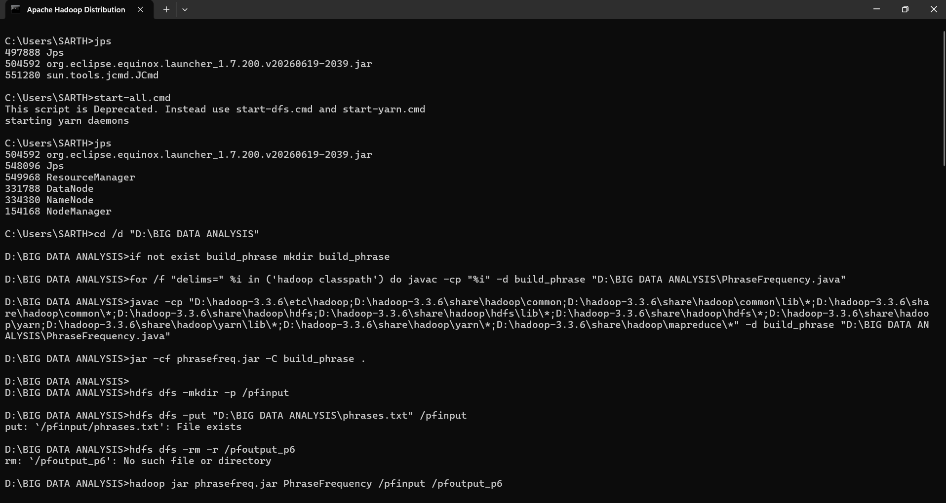
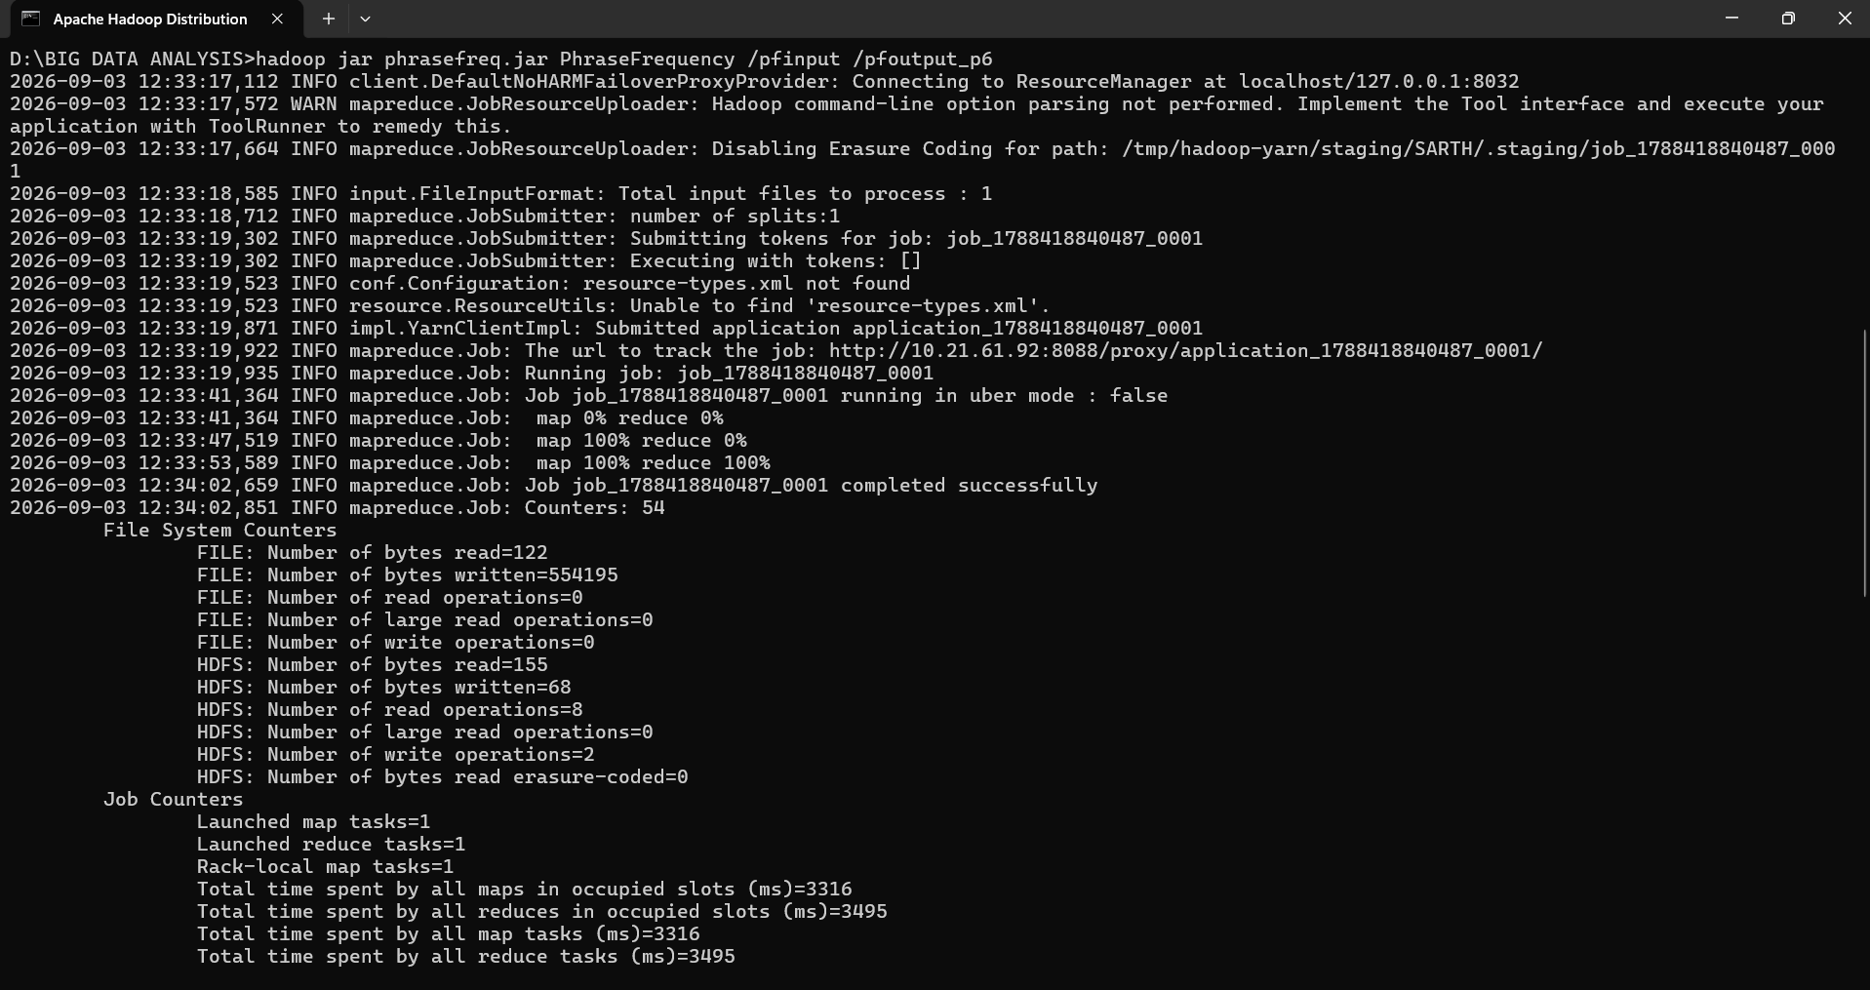

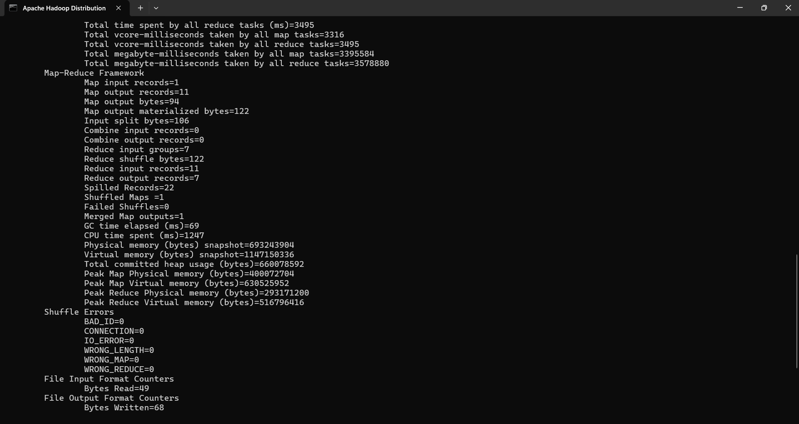
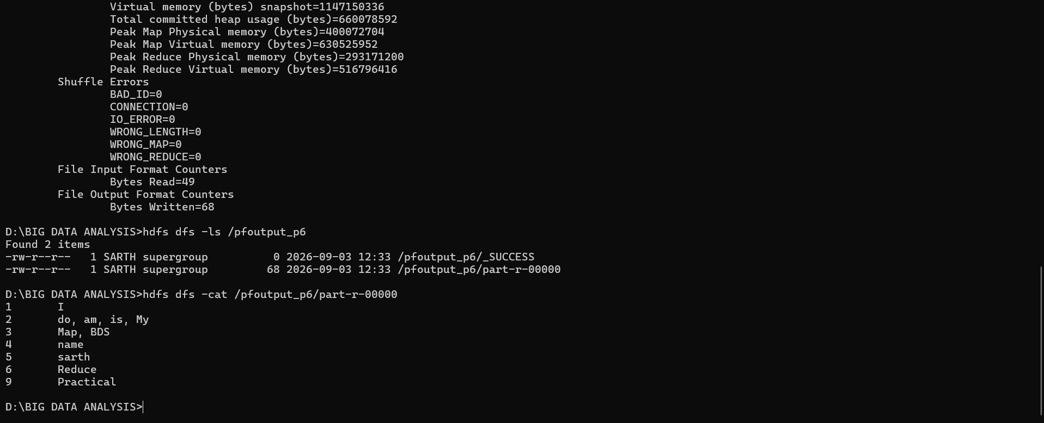

Part 2: Practical 6 — Word-Length Grouping with Combiner and Partitioner

Aim
To extend the Practical 6 program with a Combiner and a custom Partitioner, and to run it with different numbers of Mappers and Reducers on a single node Hadoop cluster.

Working
The Mapper and Reducer keep the same word-length grouping logic as Practical 6. The Combiner reuses the Reducer's logic to pre-join words of the same length on each Mapper's own output before the shuffle, since comma-joining is associative. The custom LengthPartitioner sends a word-length key to reducer (length mod numPartitions), so the same length always lands on the same Reducer regardless of how many Reducers are configured. The driver implements Tool/ToolRunner so the Reducer count can be set from the command line with -D mapreduce.job.reduces=N.

PhraseFrequency.java (Practical 7 — with Combiner and Partitioner)
File location: D:\BIG DATA ANALYSIS\PhraseFrequency.java (updated version)
import java.io.IOException;
import org.apache.hadoop.conf.Configuration;
import org.apache.hadoop.conf.Configured;
import org.apache.hadoop.fs.Path;
import org.apache.hadoop.io.IntWritable;
import org.apache.hadoop.io.Text;
import org.apache.hadoop.mapreduce.Job;
import org.apache.hadoop.mapreduce.Mapper;
import org.apache.hadoop.mapreduce.Partitioner;
import org.apache.hadoop.mapreduce.Reducer;
import org.apache.hadoop.mapreduce.lib.input.FileInputFormat;
import org.apache.hadoop.mapreduce.lib.output.FileOutputFormat;
import org.apache.hadoop.util.Tool;
import org.apache.hadoop.util.ToolRunner;

public class PhraseFrequency extends Configured implements Tool {

// Mapper Class (unchanged from Practical 6)
// Emits (word length, word) for every word in the line
public static class LengthMapper
extends Mapper<Object, Text, IntWritable, Text> {

private IntWritable lengthKey = new IntWritable();
private Text word = new Text();

public void map(Object key, Text value, Context context)
throws IOException, InterruptedException {

String[] tokens = value.toString().trim().split("\\s+");

for (String token : tokens) {
if (token.length() > 0) {
lengthKey.set(token.length());
word.set(token);
context.write(lengthKey, word);
}
}
}
}

// Combiner / Reducer Class (shared logic)
// Joins every word that shares a length into one comma-separated value.
// Safe as a Combiner because string concatenation is associative:
// partial groups formed on each Mapper can be safely merged further
// at the Reducer without changing which words end up under which key.
public static class LengthReducer
extends Reducer<IntWritable, Text, IntWritable, Text> {

public void reduce(IntWritable key, Iterable<Text> values,
Context context)
throws IOException, InterruptedException {

StringBuilder grouped = new StringBuilder();
boolean first = true;

for (Text val : values) {
if (!first) {
grouped.append(", ");
}
grouped.append(val.toString());
first = false;
}

context.write(key, new Text(grouped.toString()));
}
}

// Custom Partitioner
// Routes every word-length key to a reducer using key mod numPartitions,
// so the same length always lands on the same reducer no matter how
// many reducers are configured for the job.
public static class LengthPartitioner extends Partitioner<IntWritable, Text> {

@Override
public int getPartition(IntWritable key, Text value, int numPartitions) {
if (numPartitions <= 1) {
return 0;
}
return Math.abs(key.get()) % numPartitions;
}
}

// Driver Code (Tool/ToolRunner lets -D options set reducer count etc.
// from the command line, e.g. -D mapreduce.job.reduces=2)
@Override
public int run(String[] args) throws Exception {

Configuration conf = getConf();
Job job = Job.getInstance(conf, "word length grouping with combiner and partitioner");

job.setJarByClass(PhraseFrequency.class);
job.setMapperClass(LengthMapper.class);
job.setCombinerClass(LengthReducer.class);
job.setPartitionerClass(LengthPartitioner.class);
job.setReducerClass(LengthReducer.class);
job.setOutputKeyClass(IntWritable.class);
job.setOutputValueClass(Text.class);

FileInputFormat.addInputPath(job, new Path(args[0]));
FileOutputFormat.setOutputPath(job, new Path(args[1]));

return job.waitForCompletion(true) ? 0 : 1;
}

public static void main(String[] args) throws Exception {
int exitCode = ToolRunner.run(new Configuration(), new PhraseFrequency(), args);
System.exit(exitCode);
}
}

Compile, Package, and Run With Varying Reducers
cd /d "D:\BIG DATA ANALYSIS"
if not exist build_phrase2 mkdir build_phrase2
for /f "delims=" %i in ('hadoop classpath') do javac -cp "%i" -d build_phrase2 "D:\BIG DATA ANALYSIS\PhraseFrequency.java"
jar -cf phrasefreq2.jar -C build_phrase2 .

hdfs dfs -rm -r /pfoutput_r1
hadoop jar phrasefreq2.jar PhraseFrequency -D mapreduce.job.reduces=1 /pfinput /pfoutput_r1

hdfs dfs -rm -r /pfoutput_r2
hadoop jar phrasefreq2.jar PhraseFrequency -D mapreduce.job.reduces=2 /pfinput /pfoutput_r2
