Subject:- BDS
Name:- Fenil Chodvadiya
Roll No:- 23BCE048
Practical-3

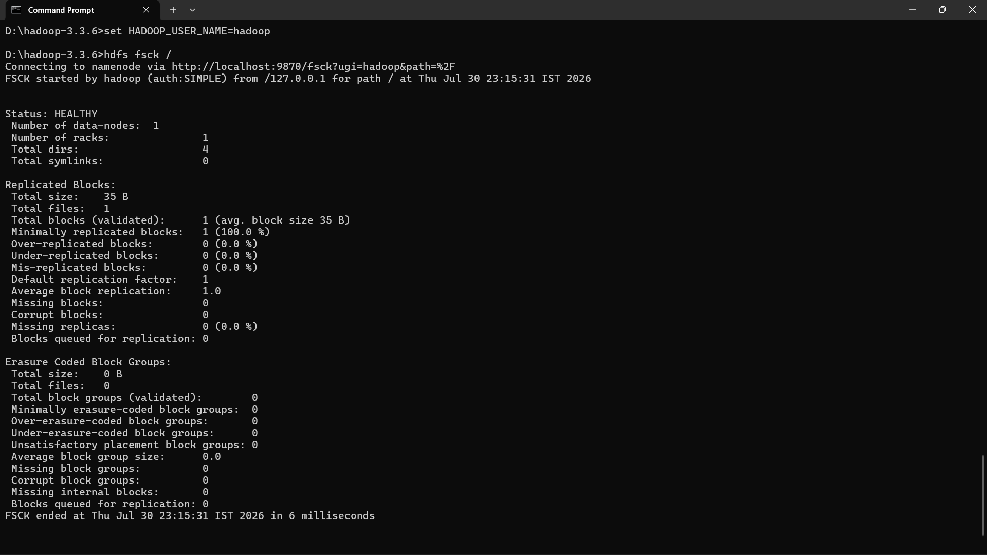

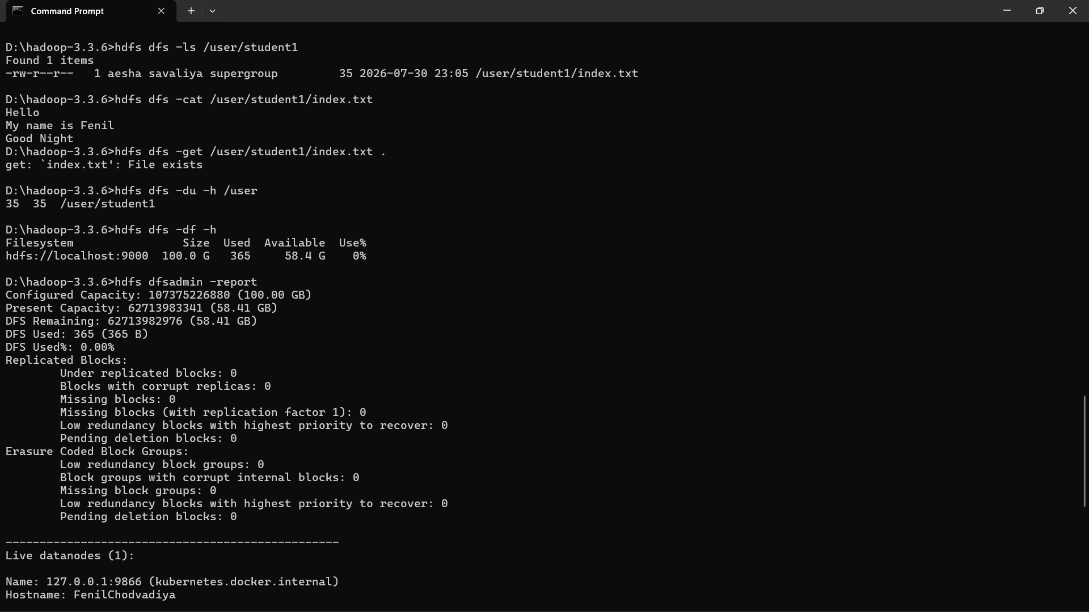

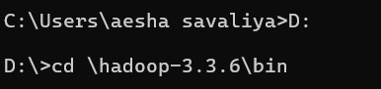

- Hdfs start
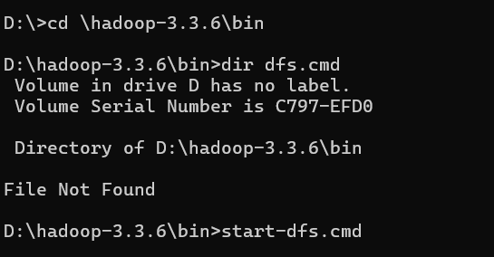

- Yarn start
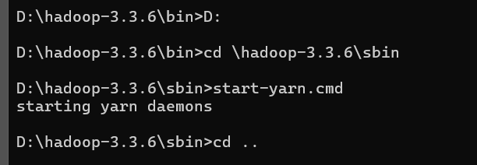

- Jps
show all java node start or not
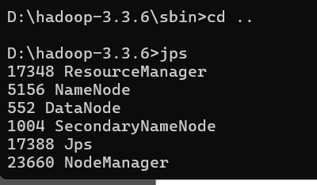

- hdfs dfs -ls /
Displays files and folders in the HDFS root directory.
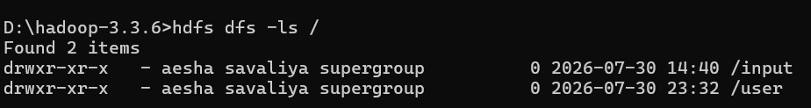

- hdfs dfs -mkdir /user/fenil
Creates a new folder in HDFS.
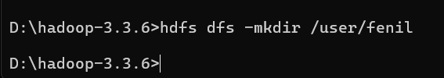

- hdfs dfs -put D:\college_all_sem\4th_Year\BDS\hadoop_pract_4_text.txt /user/fenil/
Copies a file from the local computer to HDFS

- hdfs dfs -cat /user/fenil /hadoop_pract_4_text.txt

Displays the contents of a file stored in HDFS

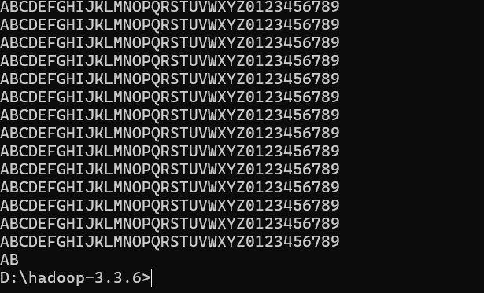

- hdfs dfs -get /user/fenil/hadoop_pract_4_text.txt .
Copies a file from HDFS to the local computer.
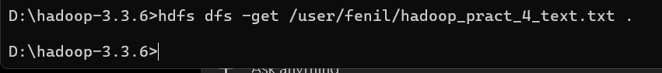

- hdfs dfs -df -h
Displays total HDFS storage, used space, and available space.
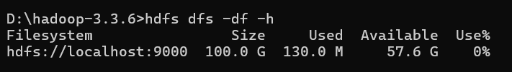

- hdfs dfs -du -h /user
Shows disk usage of files and directories in HDFS
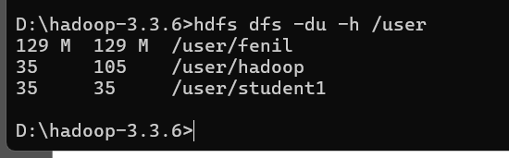

- hdfs dfsadmin -report
Shows information about DataNodes, storage capacity, and cluster health.
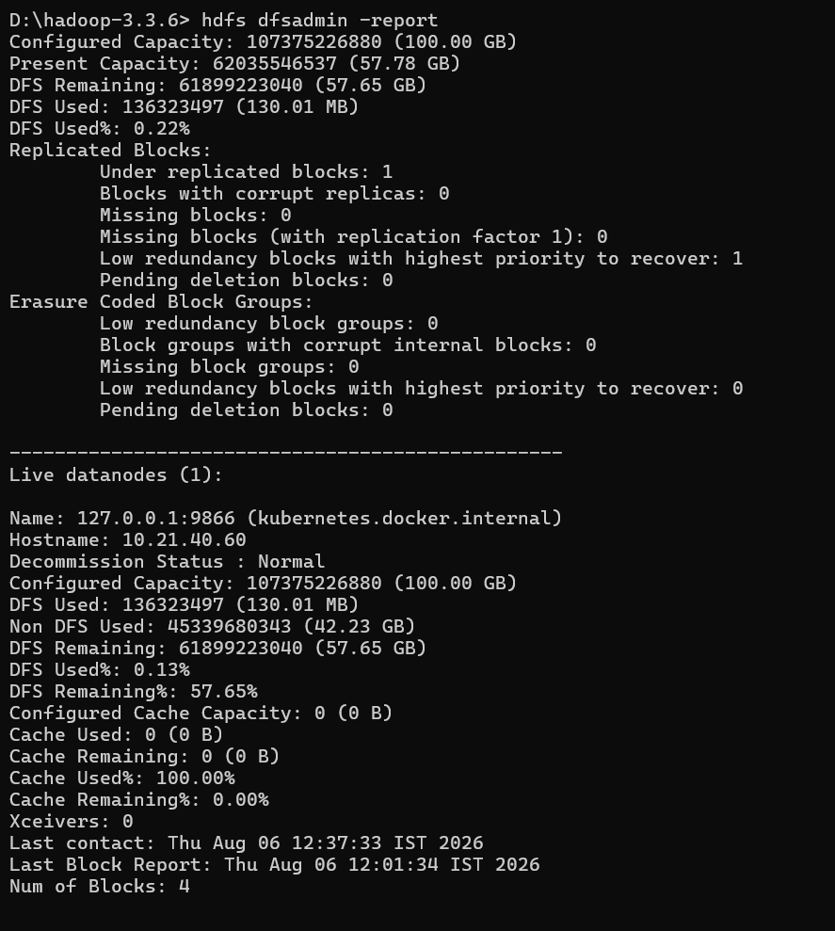

- hdfs fsck /
Checks HDFS for missing, corrupted, or under-replicated blocks.
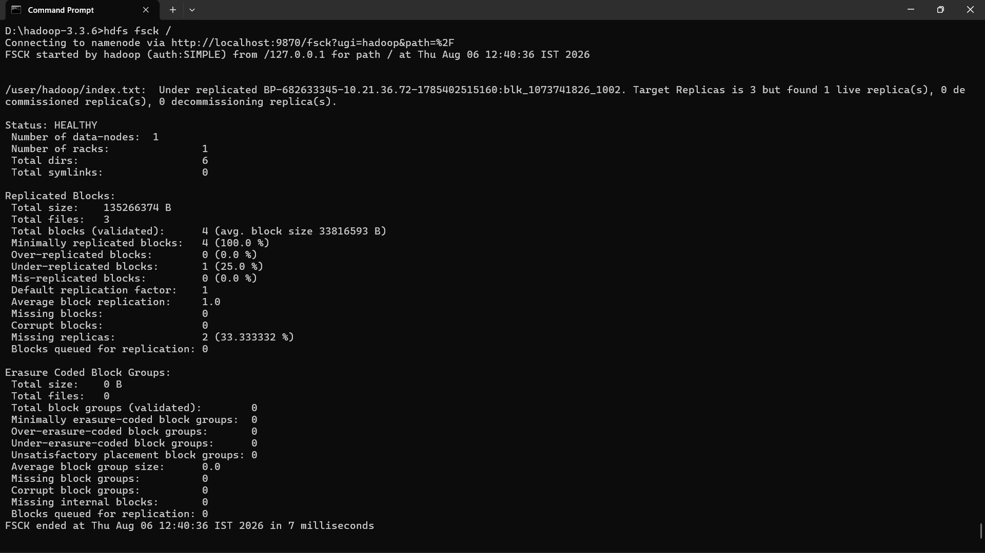

- hdfs dfs -tail /user/fenil/hadoop_pract_4_text.txt
show the last kb of file
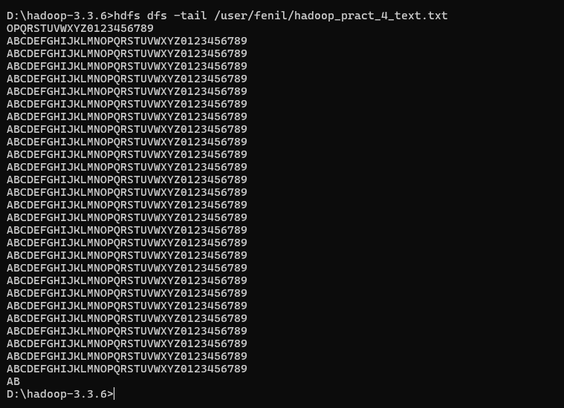
- hdfs fsck / -files -blocks -locations
give blocks locations and stortages
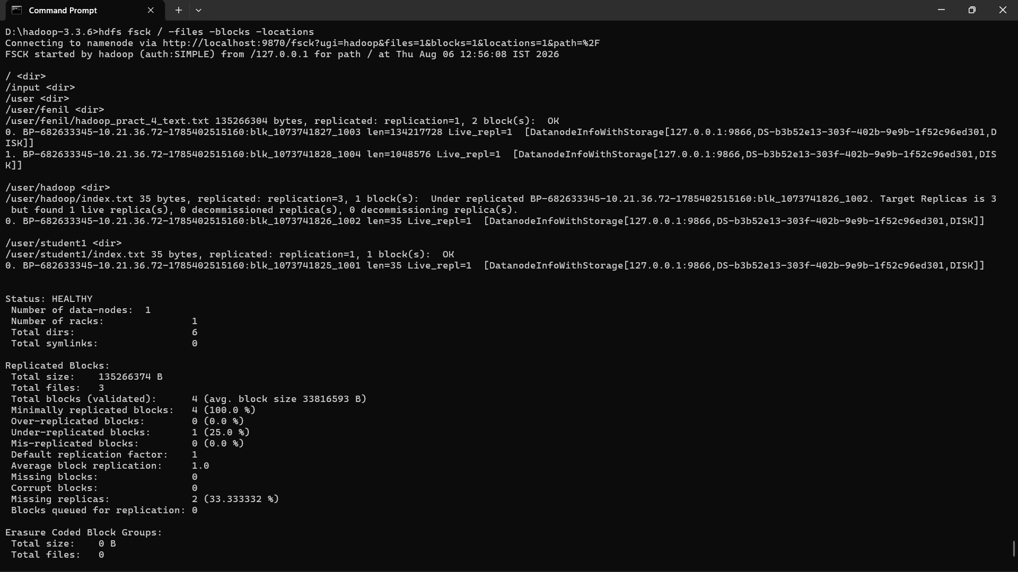

- hdfs dfs -setrep -w 5 /user/fenil/hadoop_pract_4_text.txt
set replica for particular file
