**Program 1 :-** Capture The Packets using Wireshark.

**Step 1:-** Open Wireshark.

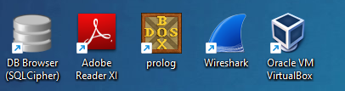

**Step 2:-** Click On Ethernet.

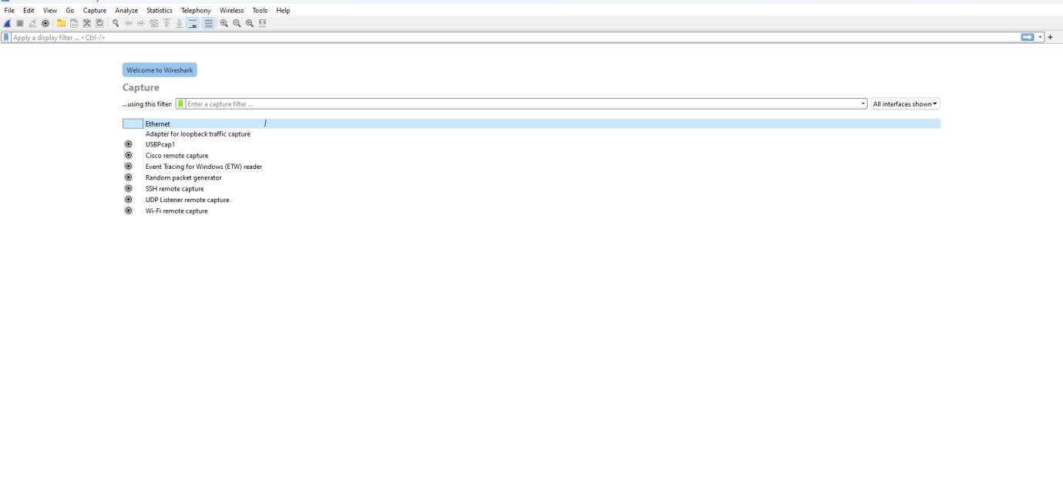

**Step 3:-** Open CMD.

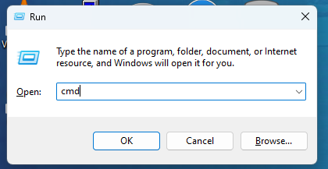

**Step 4:-** Write ipconfig to see our IPv4.

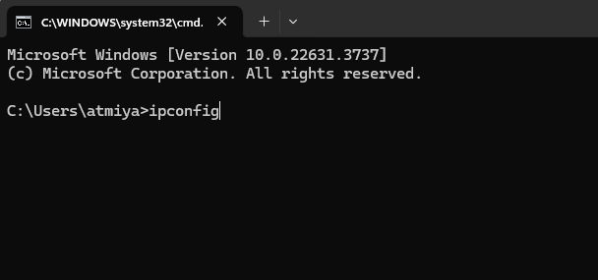

**Step 5:-** Find The IPv4 In our CMD.

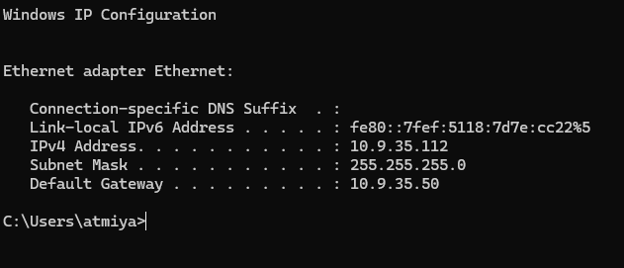

**Step 6:-** Here we see multiple packets are transfer over the internet connection.

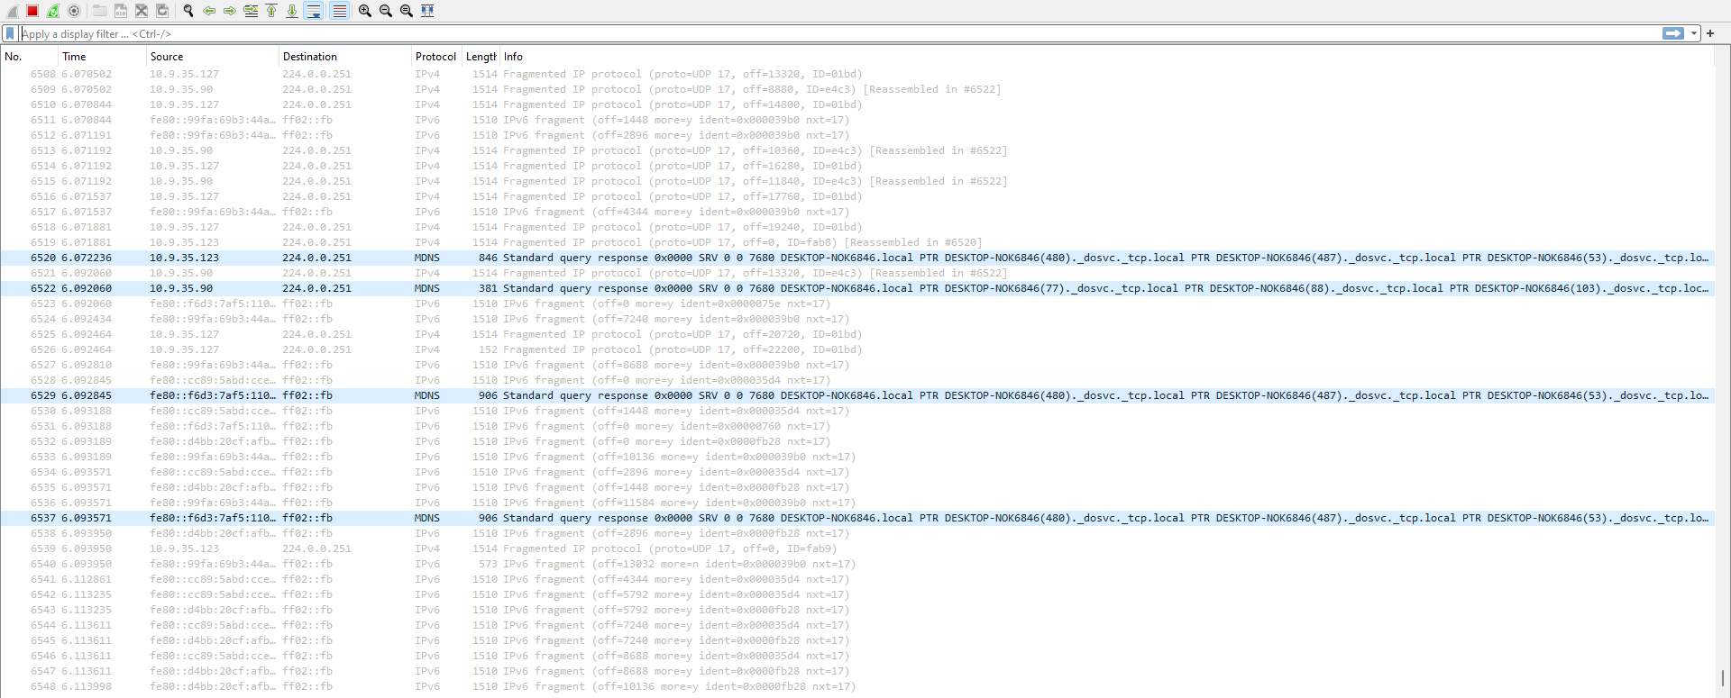

**Step 7:-** Write an ip.addr == “Ip which you want to see”.

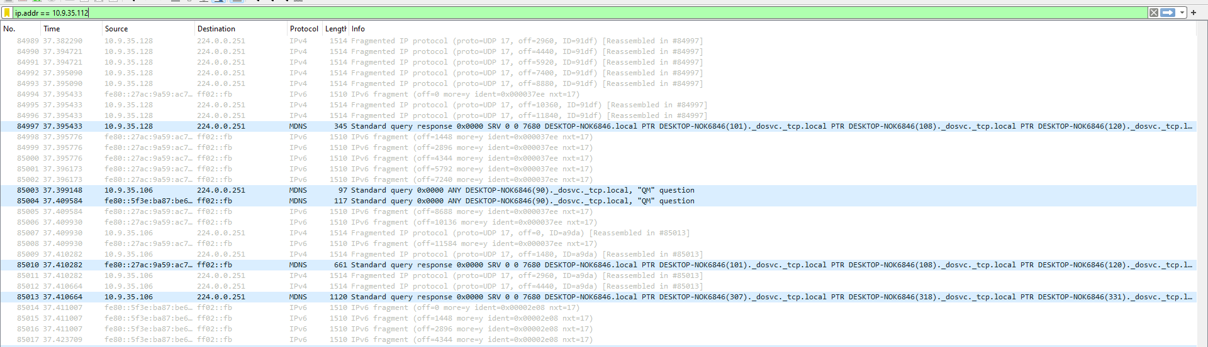

**Step 8:-** Here we see the upper command output.

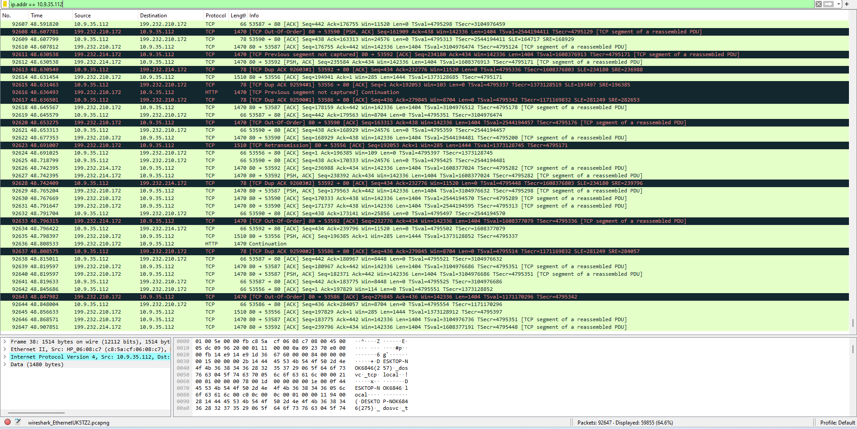

**Step 9:-** Write ip.src == “Ip which you want to see” It shows only source.

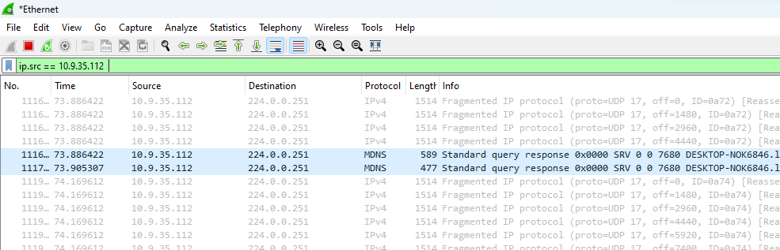

**Step 10:-** Write ip.dst == “Ip which you want to see” it Shows only destination related things.

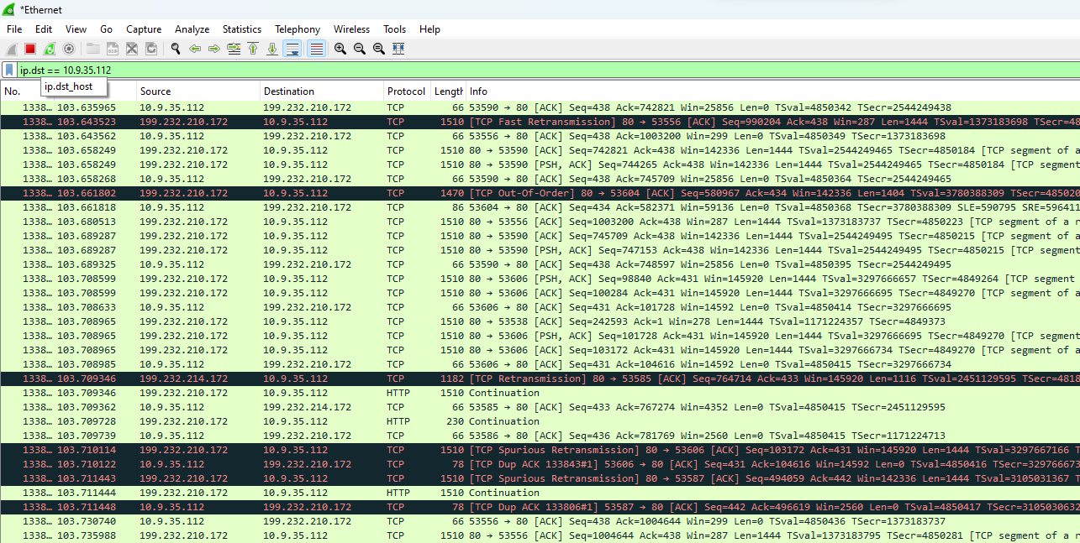

**Step 11:-** Login into the Internet Portal.

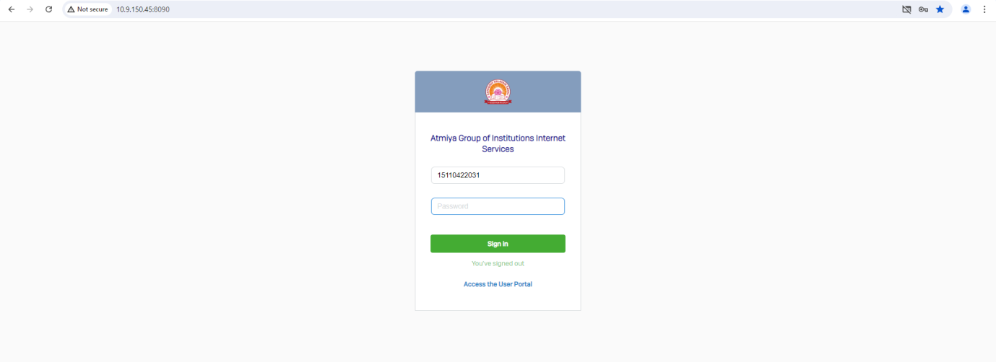

**Step 12:-** Knowingly we mistake in our Password.

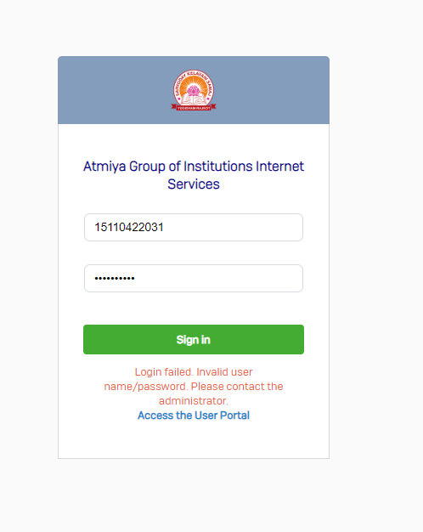

**Step 13:-** Write ip.dst == “IP Address && http” It shows only http traffic.

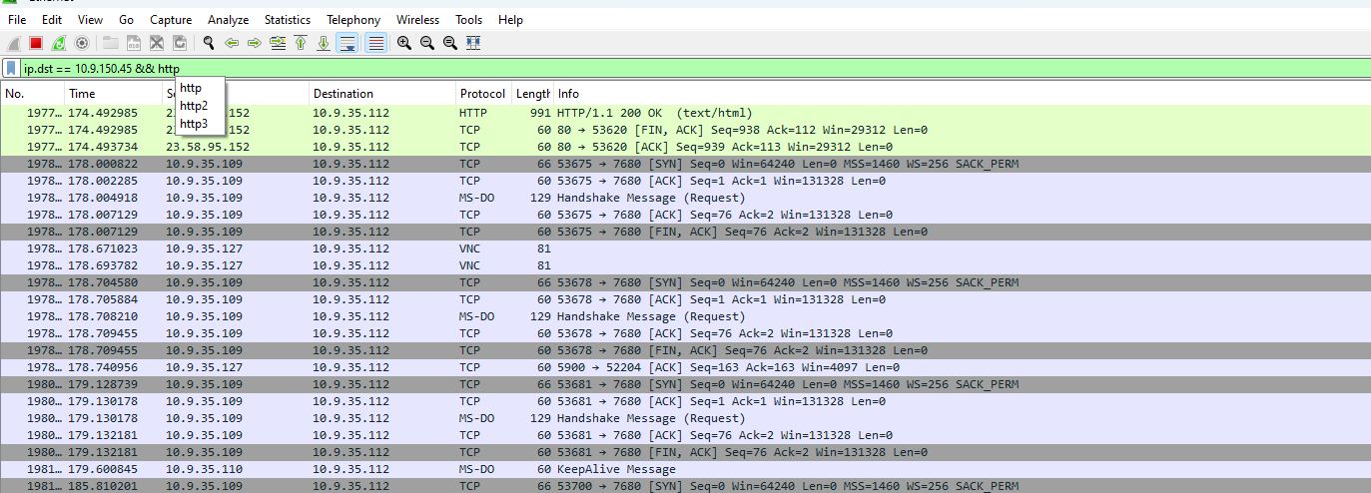

**Step 14:-** This process take some time to run.

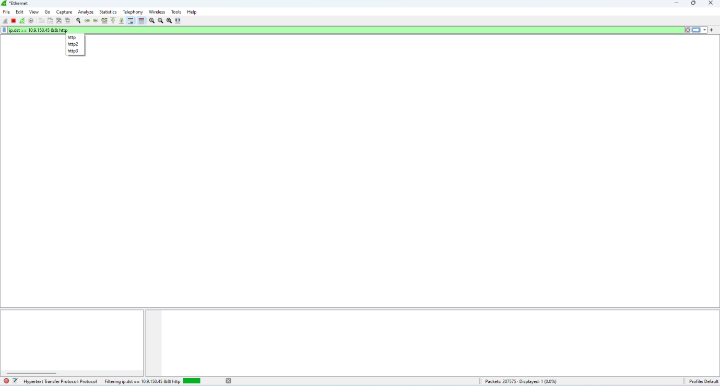

**Step 15:-** Here we see only and only relevant and relative data which we can needed.

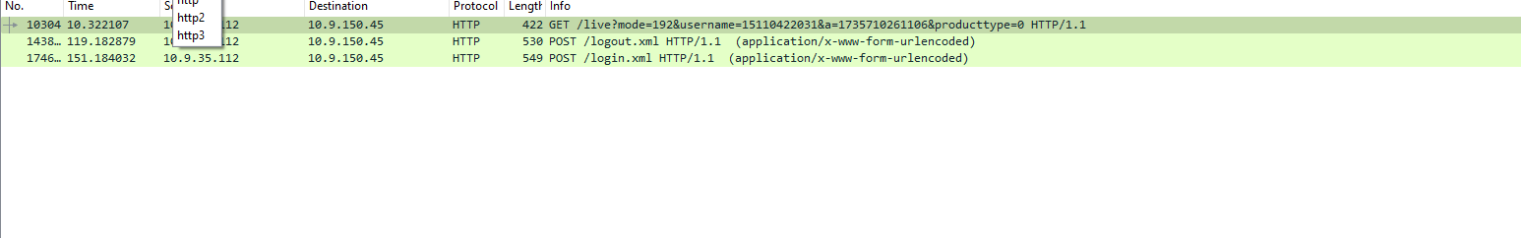

**Step 16:-** Now click on Hypertext transfer Protocol

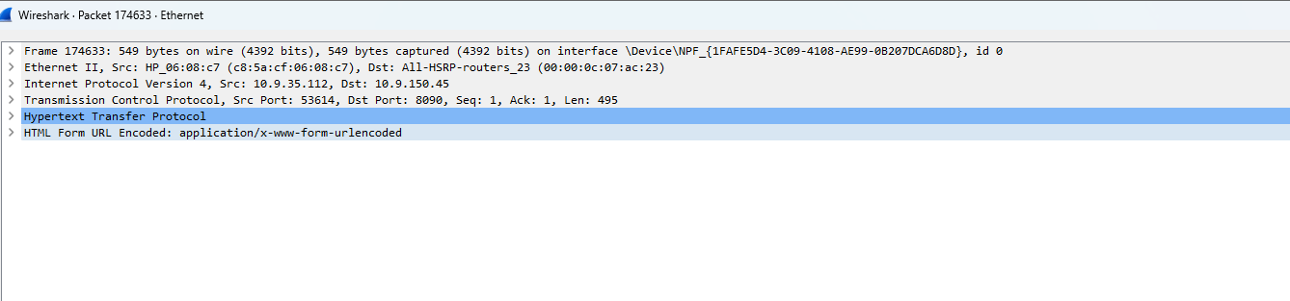

**Step 17:-** This shows our username and password.

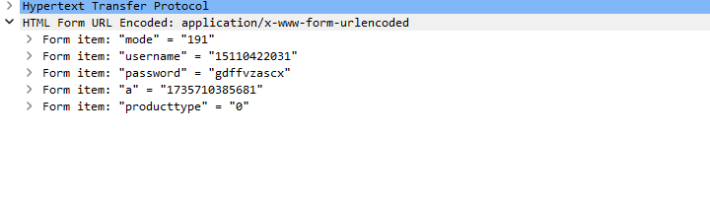

**Step 18:-** Here we see all the details in this image.

