Journal
For subject
DEVELOPMENT OPERATIONS

Performed by
Paghadar Fenil
24ITUOS083
for the partial fulfillment of the requirements for Semester –V’s subject
BACHELOR OF TECHNOLOGY
(INFORMATION TECHNOLOGY)

Dharmsinh Desai University, Nadiad.

Department of Information Technology
Faculty of Technology,
DHARMSINH DESAI UNIVERSITY
NADIAD 387001
October 2026

Index

 | Experiment Title | Page No.
 | Experiment 2: Source Code Version Controlling, Central vs Distributed Version Controlling, Git Workflow, Installing Git and Important Git Commands | 3
 | Experiment 3: Managing Source Code on GitHub using Git | 14
 | Experiment 4: Docker Desktop, Docker and Existing Docker Hub Images | 21
 | Experiment 5: Containerizing an Application using Docker Container | 24
 | Experiment 6: Kubernetes Orchestration with Docker Containers | 26
 | Experiment 7: Jenkins Architecture, Installation and Configuration, and Pipeline Primitives | 30
 | Experiment 8: Creating Jenkins Pipelines and Triggering Based on Events | 37

Experiment-2
Aim: Source Code Version Controlling, Central vs Distributed Version Controlling, Git Workflow, Installing Git and Important Git Commands

Steps to perform Experiment
- Create one folder name as StudentProfileSystem
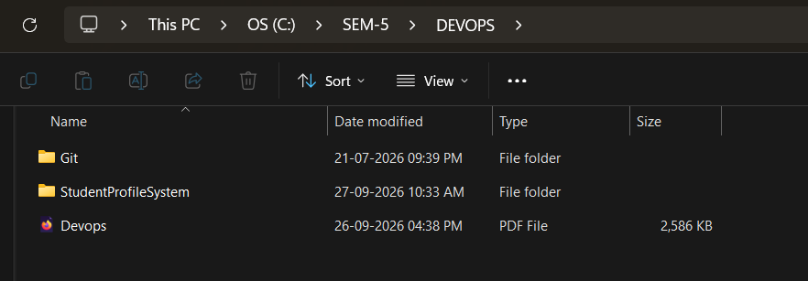
- Open this folder in VS Code
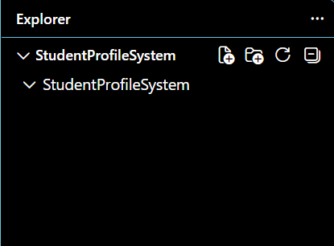
- Open terminal and check the git version //git –version
- Initialize the Git Repository //git init
- Check git status //git status

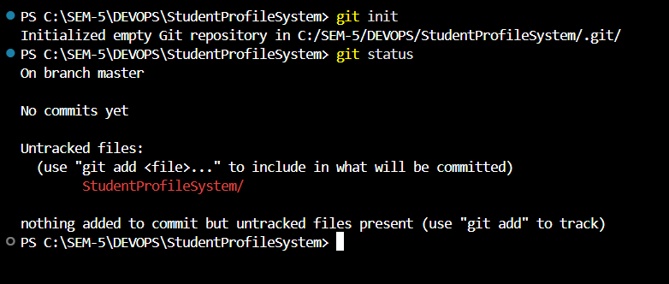
- Create student.py file
- Add student.py to Git //git add student.py
- Commit the file //git commit -m "First Python Program"
- Modify the python file //print ("Welcome to Student Profile System")
- Stage the modified file //git add .
- Commit the modification //git commit -m "Added Welcome Message"

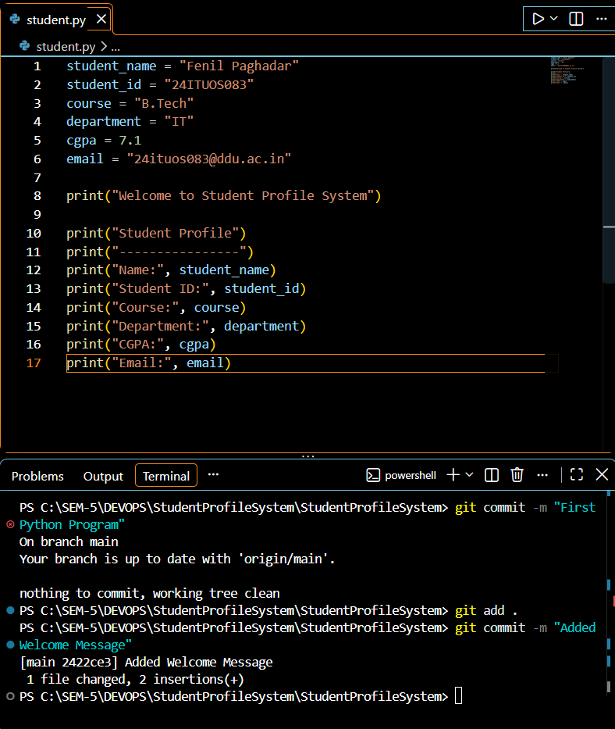

- Create a 'feature' branch //git branch feature
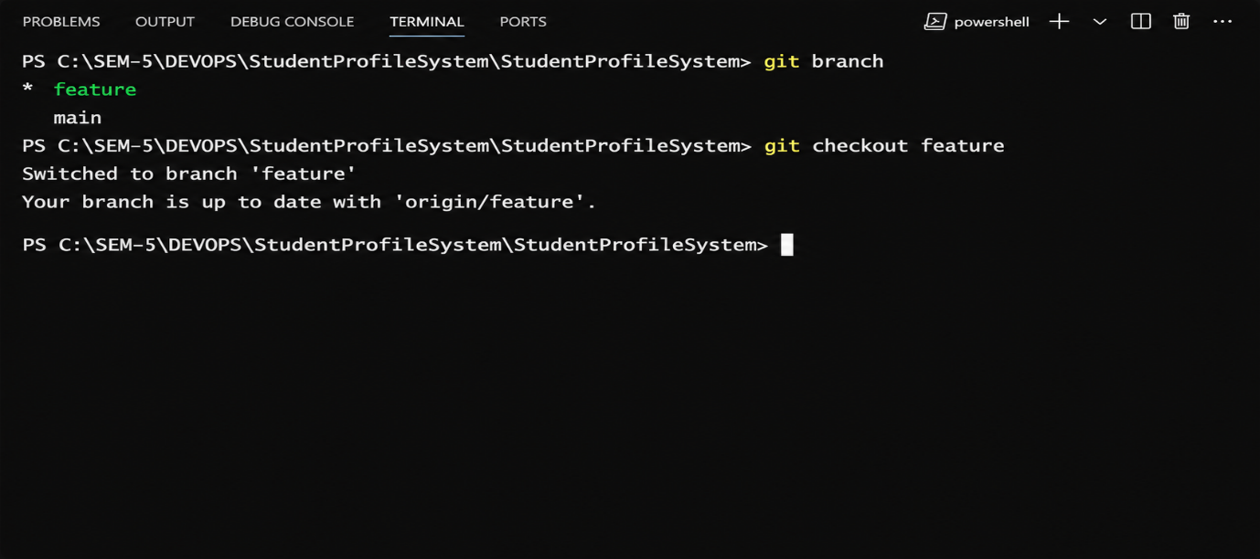
- Switch to the feature branch //git checkout feature
- Modify code and repeat command add & commit
- Merge the feature branch //git checkout main //git merge feature

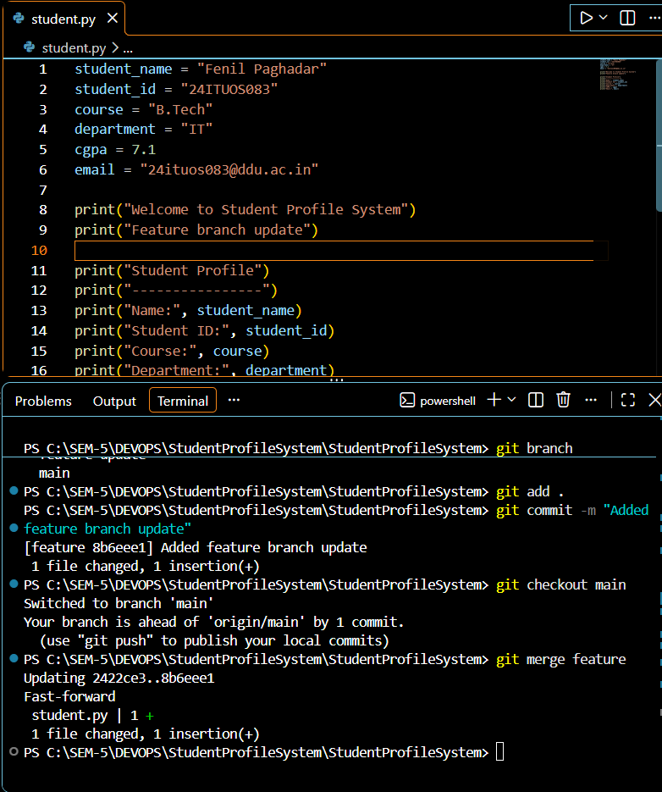
- Create '.gitignore' file
- Modify code and repeat command : add & commit
- Check the final Git status // git status
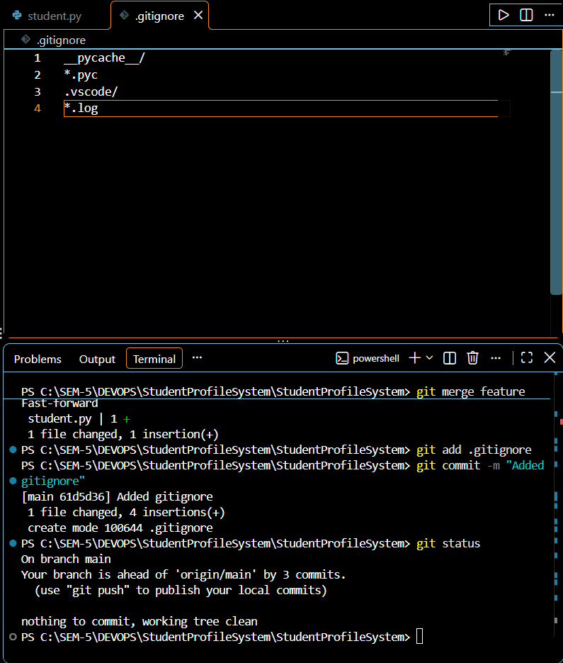
- Open any GitHub repository
- Click Fork
- Under Owner, select GitHub our account
- Create fork
- Verify the Fork

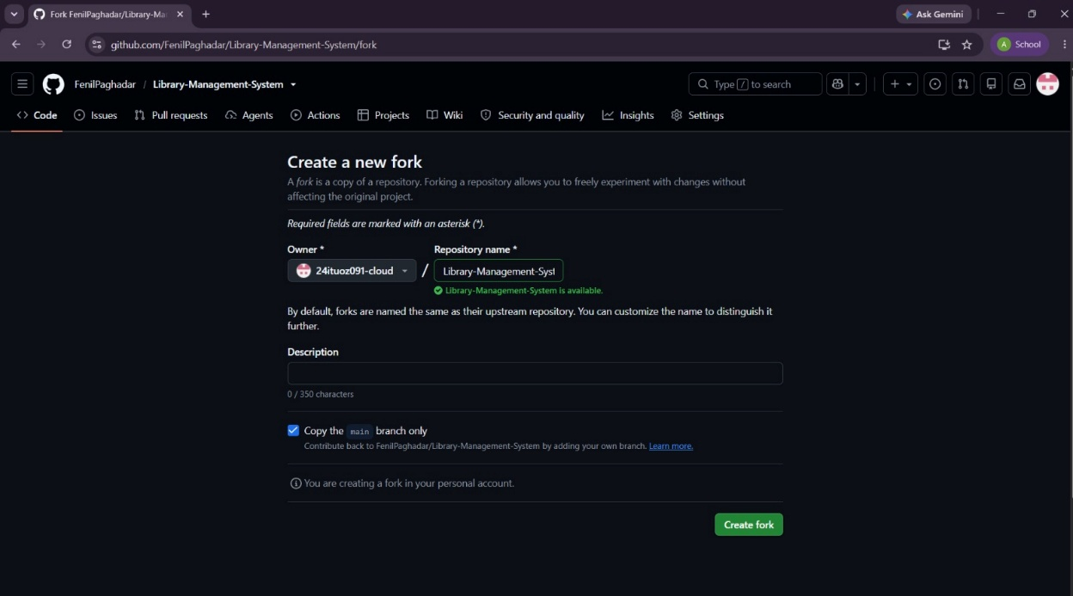
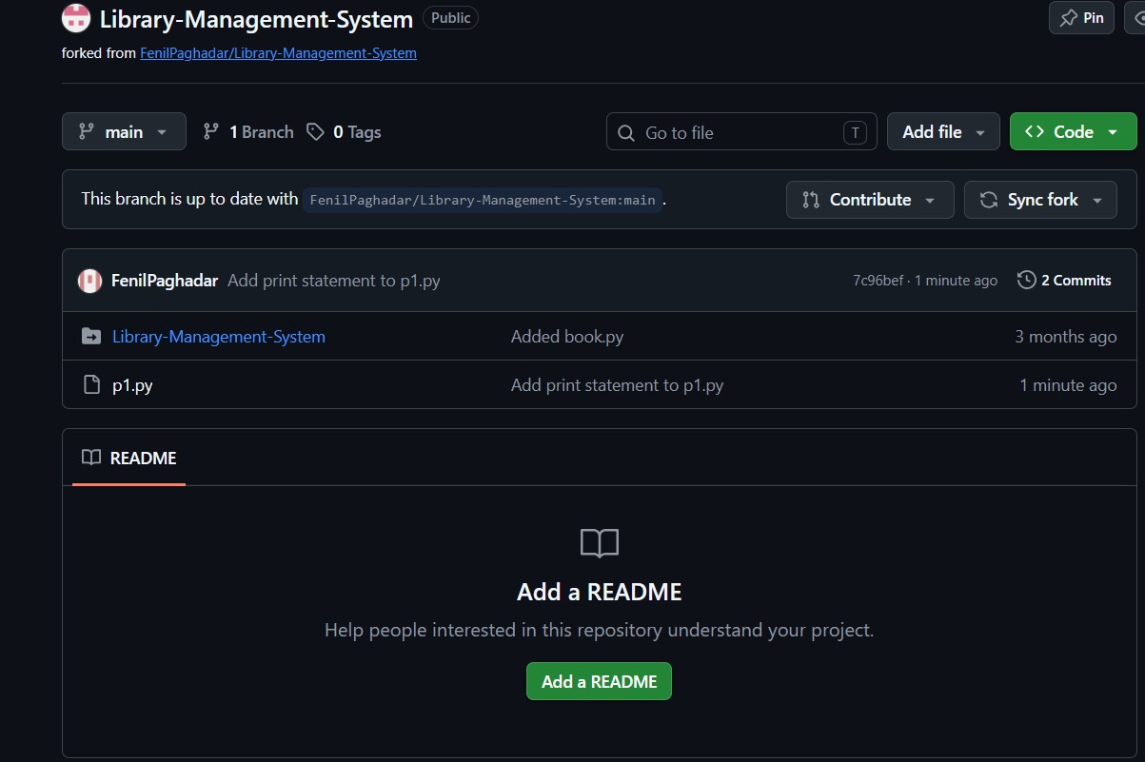

- Clone Your Fork to Your Computer
//In Fork -> Click: Code -> Select: HTTPS -> Copy URL
- In CMD
//Go to folder location
//git clone ‘Repo URL’
//git remote -v
//git status

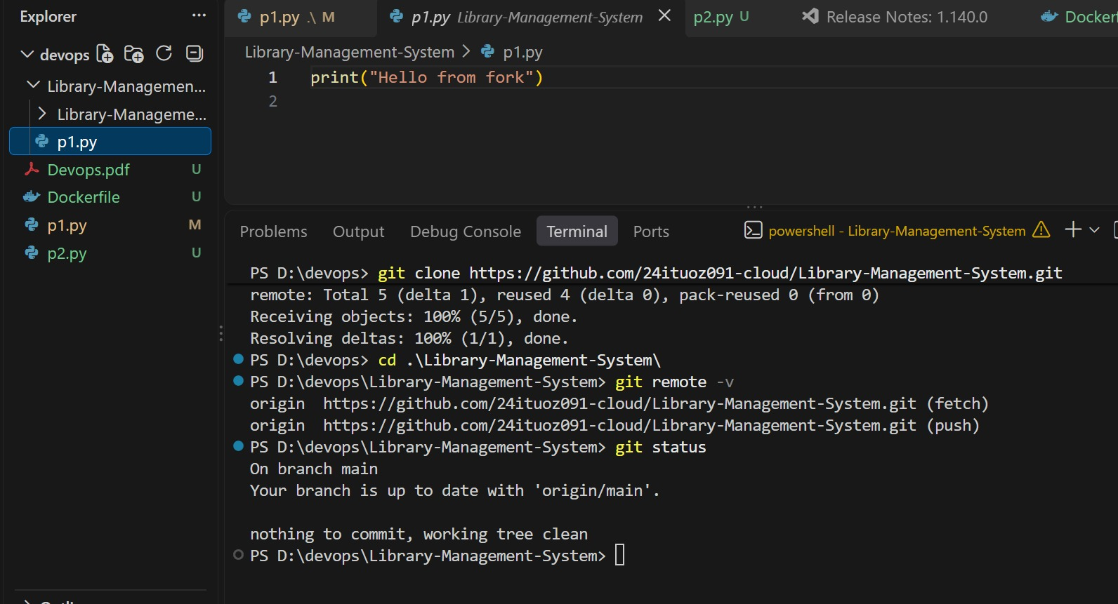
- Add Repository as ‘upstream’
//git remote add upstream ‘actual Repo URL’
//git remote -v
//git fetch upstream
//git branch -a
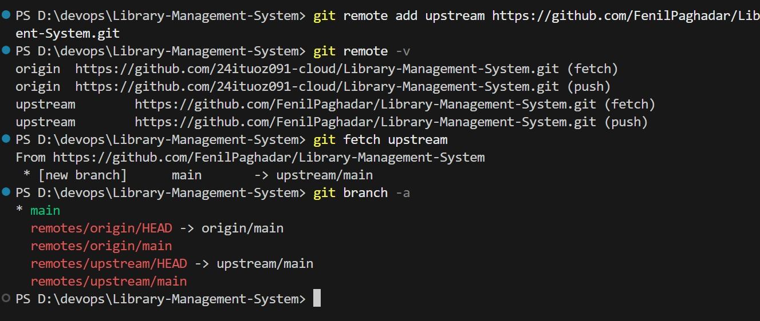
- Make change in Fork
//add print ("Change made in my fork") in python file
//save

- Commit Forked Repository changes
//git status
//git add .
//git commit -m "updated"
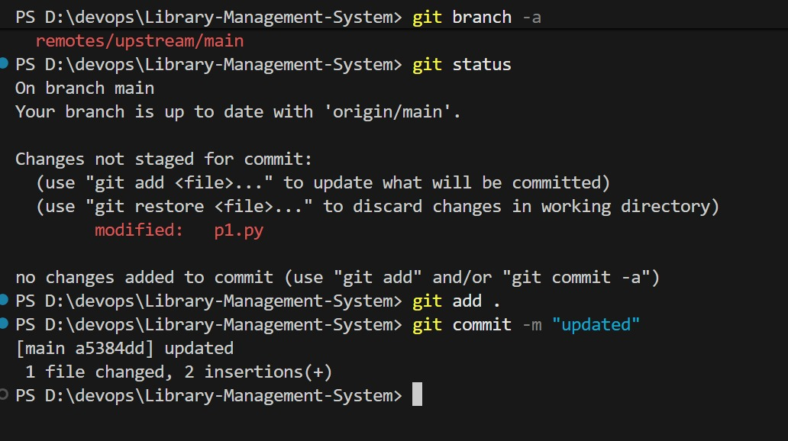
- Push Changes to Fork
//git push origin main
- Verify on GitHub
- Create a Pull Request
- Tell Repository Owner to verify changes and Merge Pull request
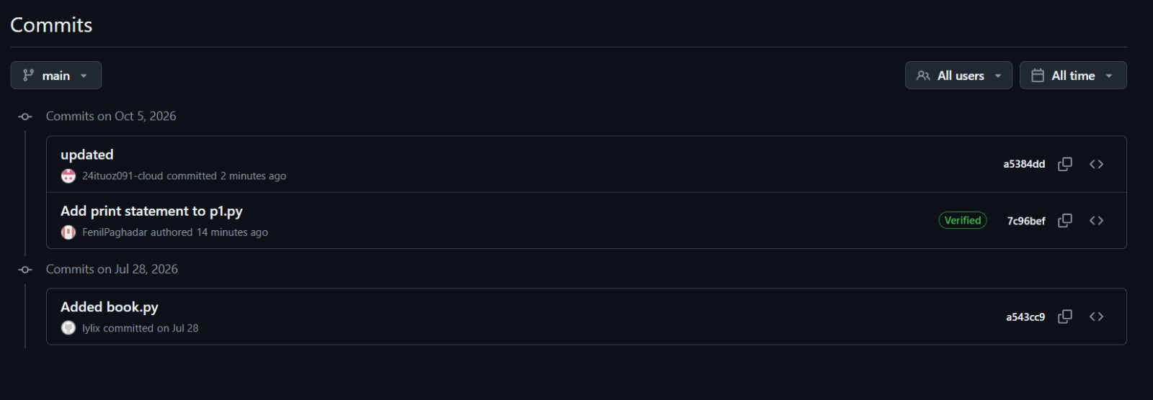
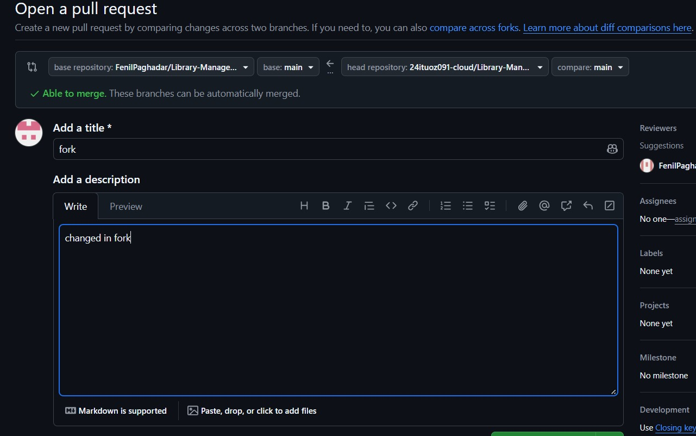
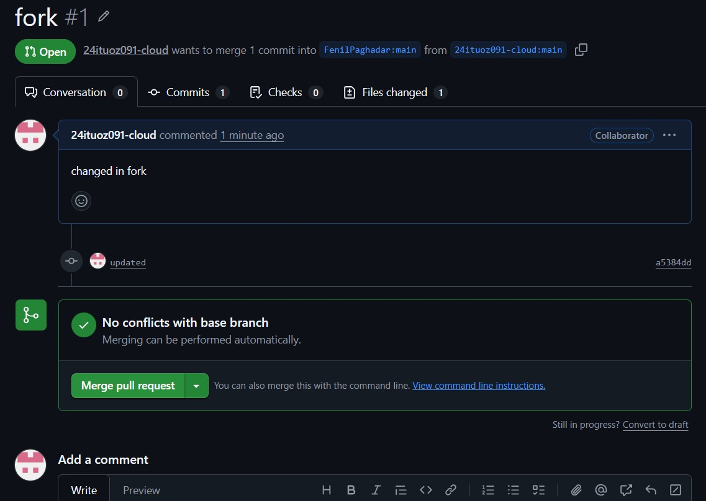
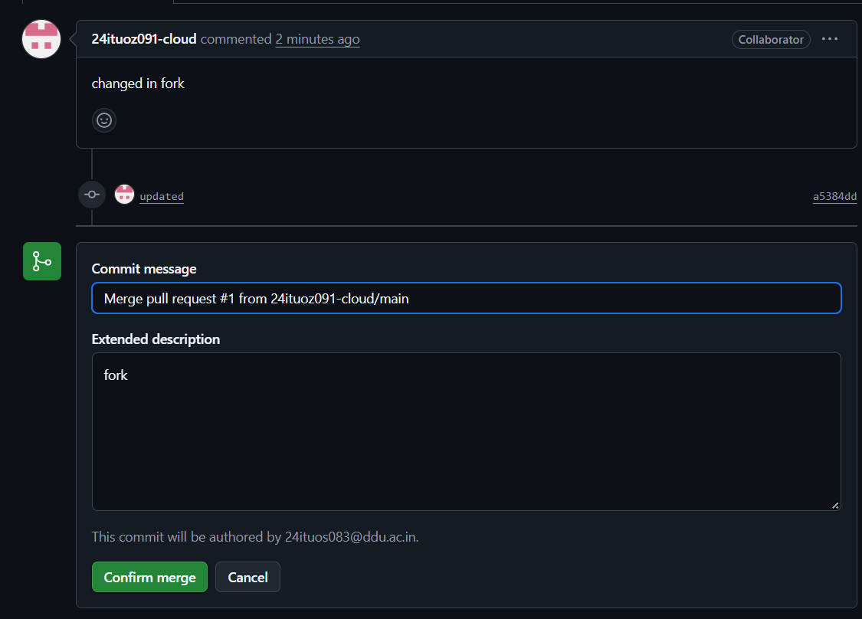
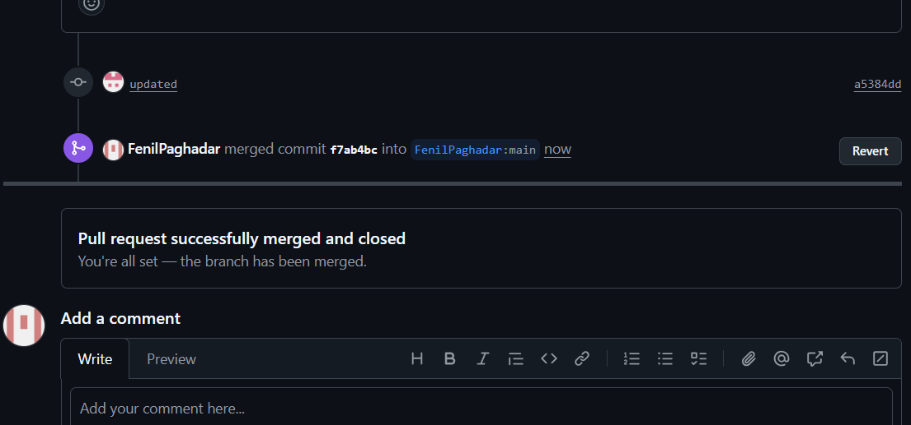

Experiment – 3
Aim : Managing Source Code on GitHub using Git
Steps to perform Experiment
- Create GitHub account
- Create public repository
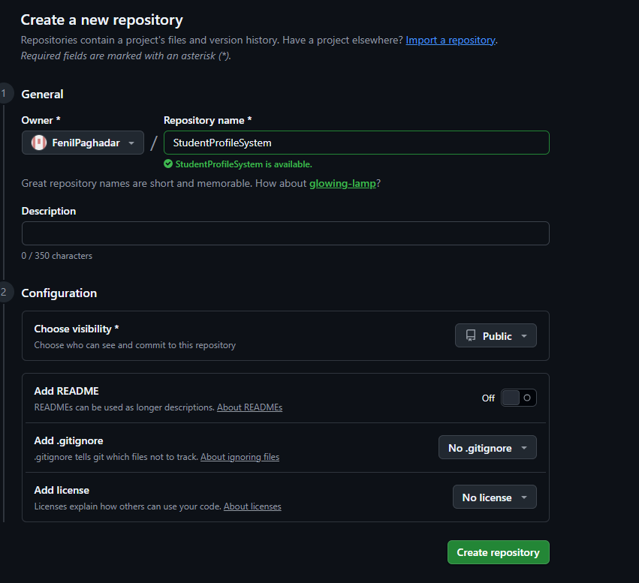
- Connect local Git repository with GitHub using origin
- Push local project to GitHub
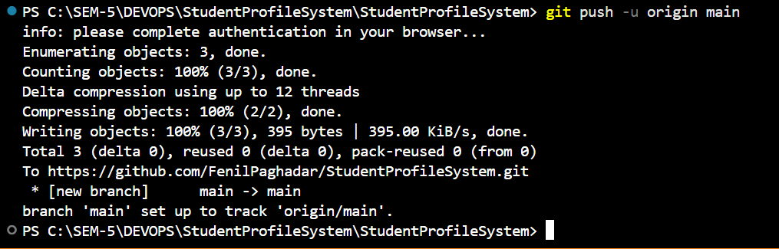
- Modify student.py program
- Commit the changes
- push updated changes to GitHub
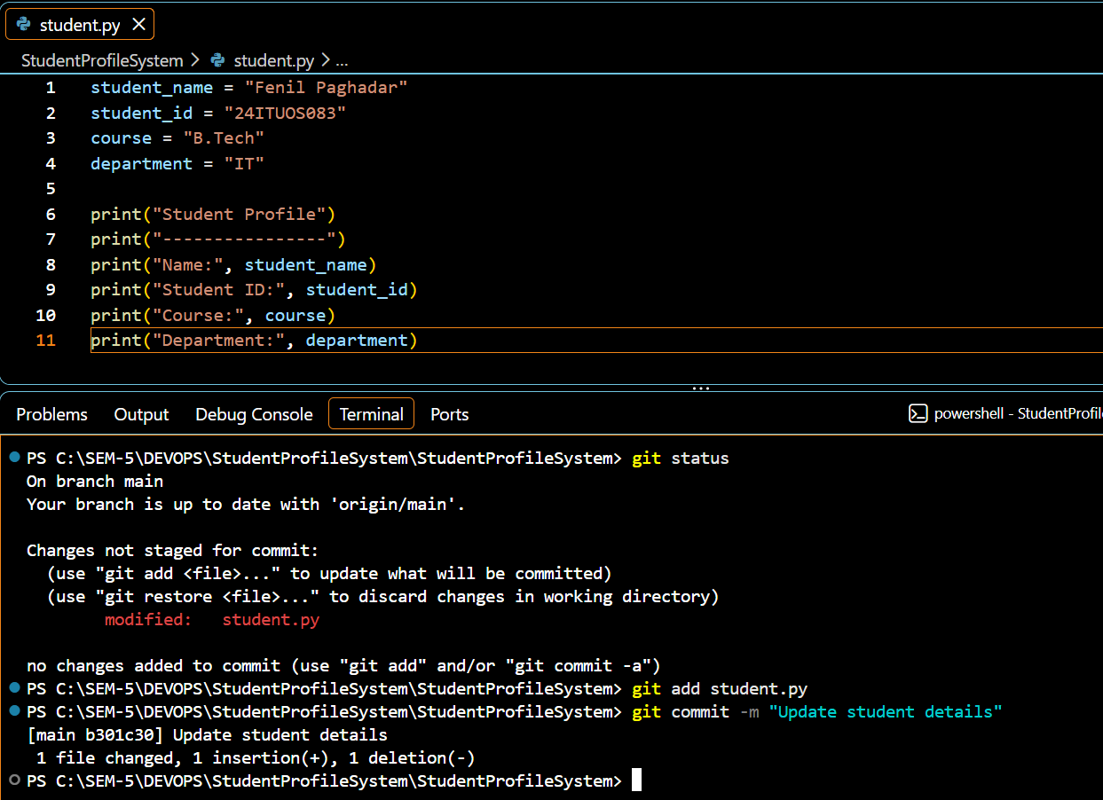
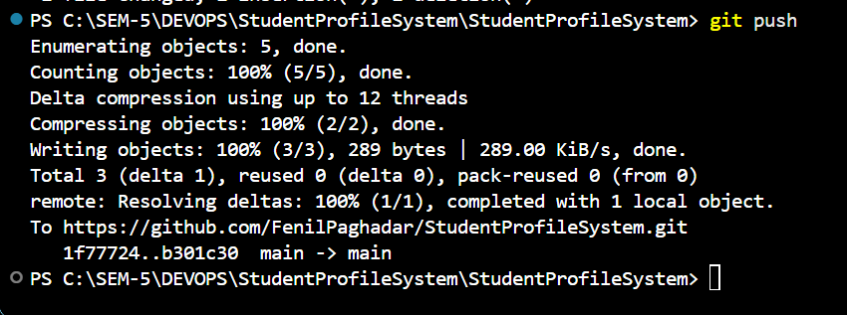
- Create feature-update branch
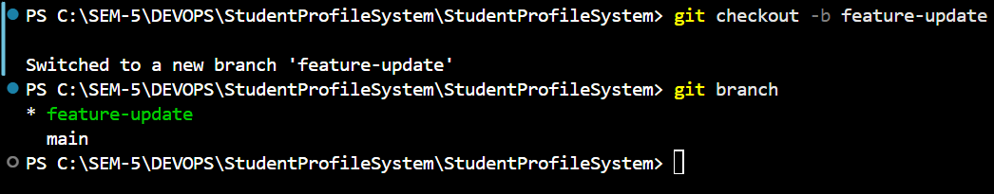
- Add CGPA and email feature
- Commit the feature
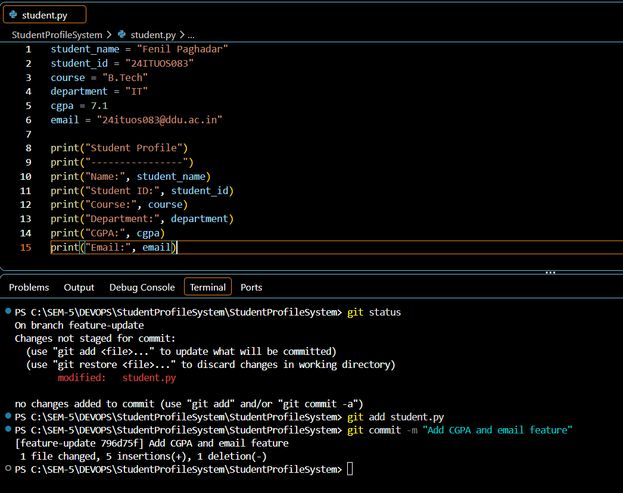
- Push feature-update branch to GitHub
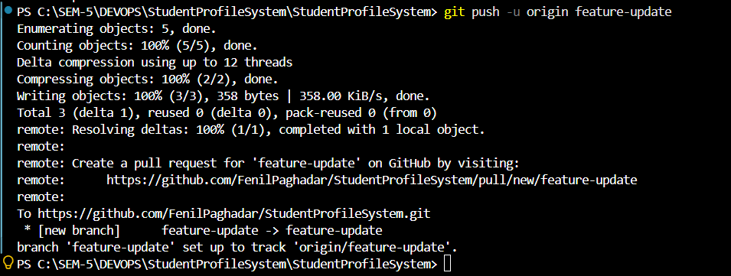
- Create Pull request
- Merge Pull request into main

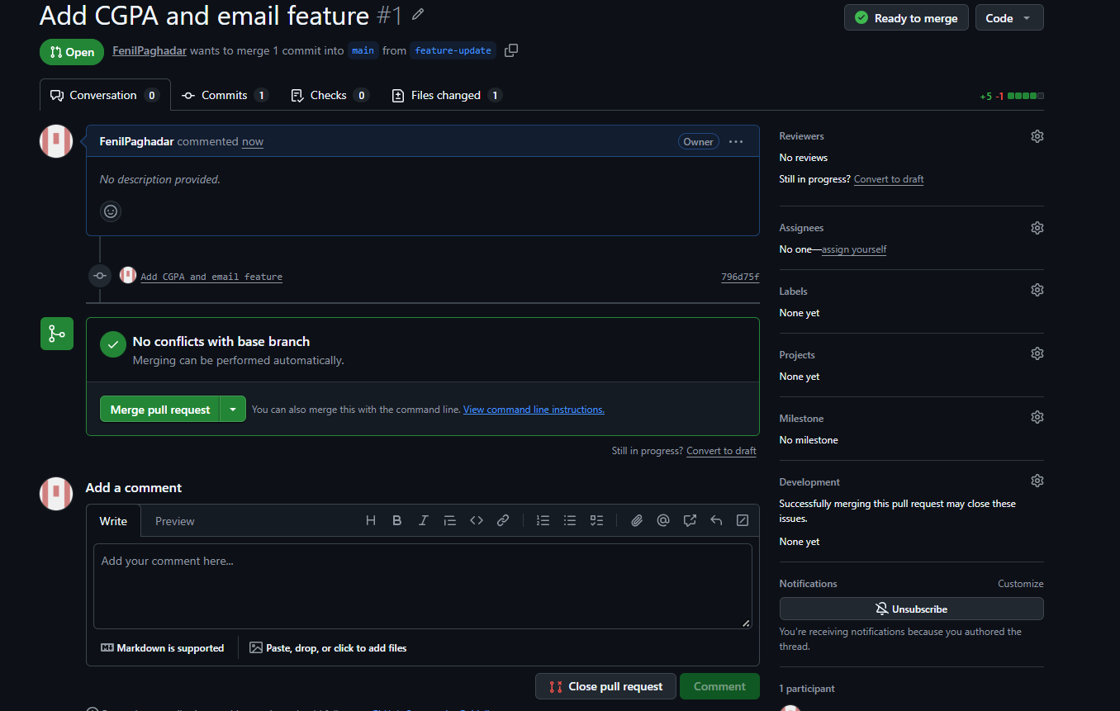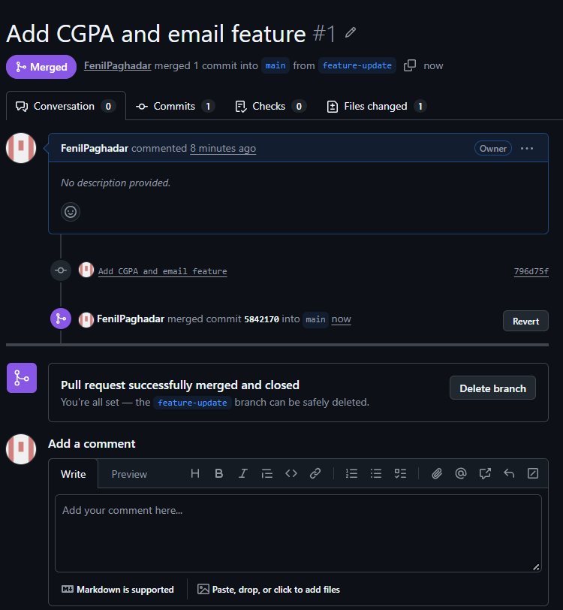
- Clone/use the GitHub repository locally
- Open StudentProfileSystem GitHub repository
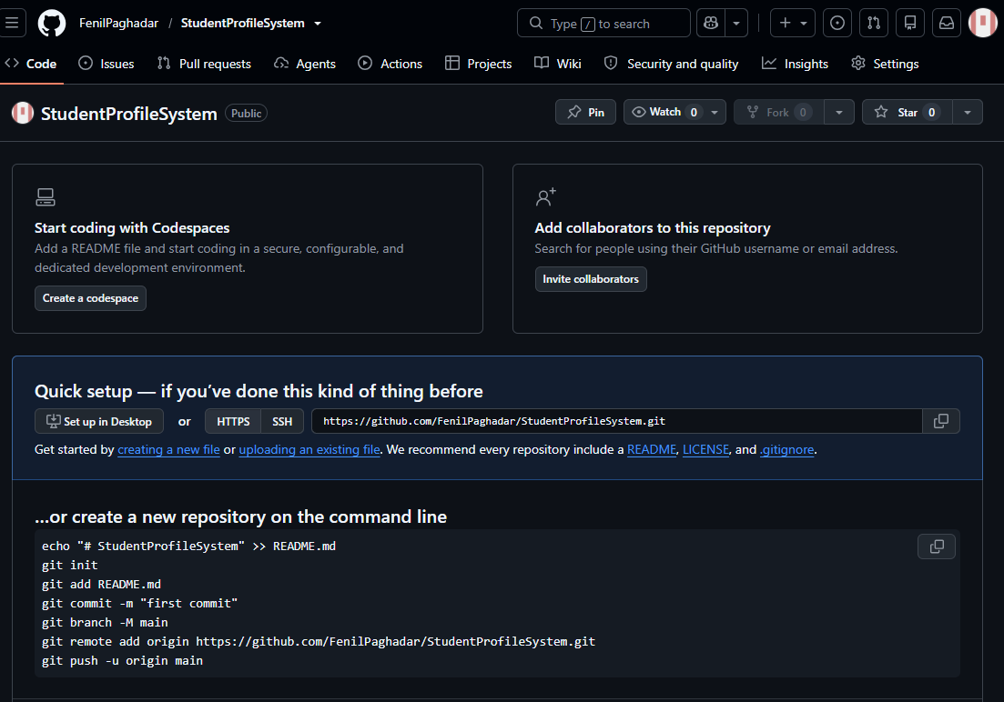
- Verify GitHub remote
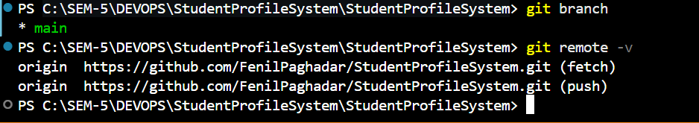
- Attempt
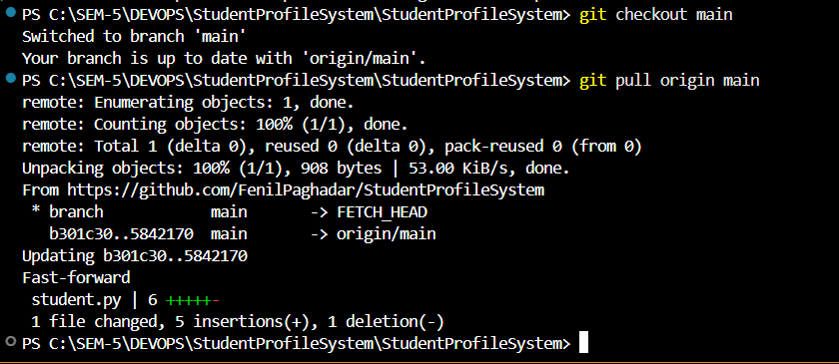
- Check merge state
- Conclude existing merge
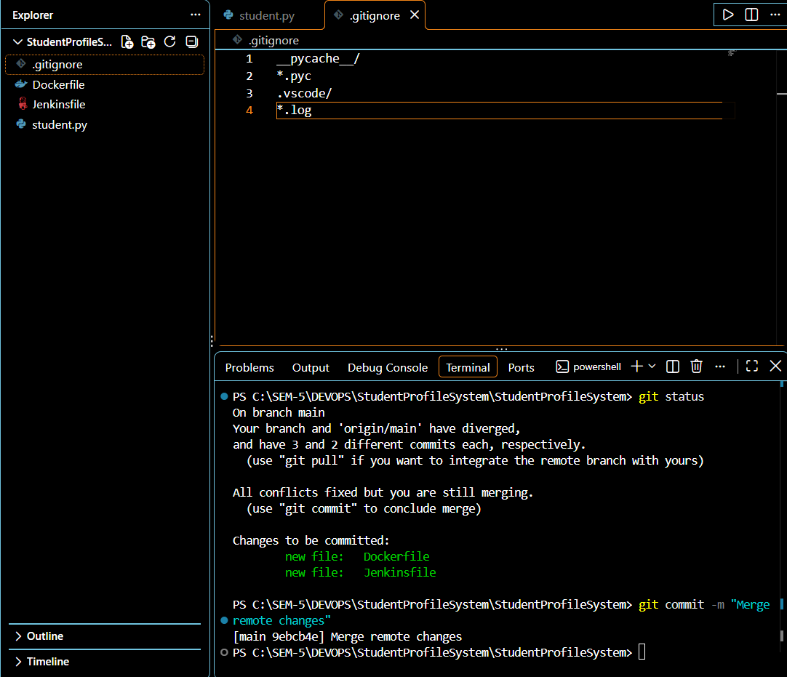

Experiment – 4
Aim : Docker Desktop, Docker and Existing Docker Hub Images
Steps to perform Experiment
- Install Docker Desktop
- Open Docker Desktop -> Images
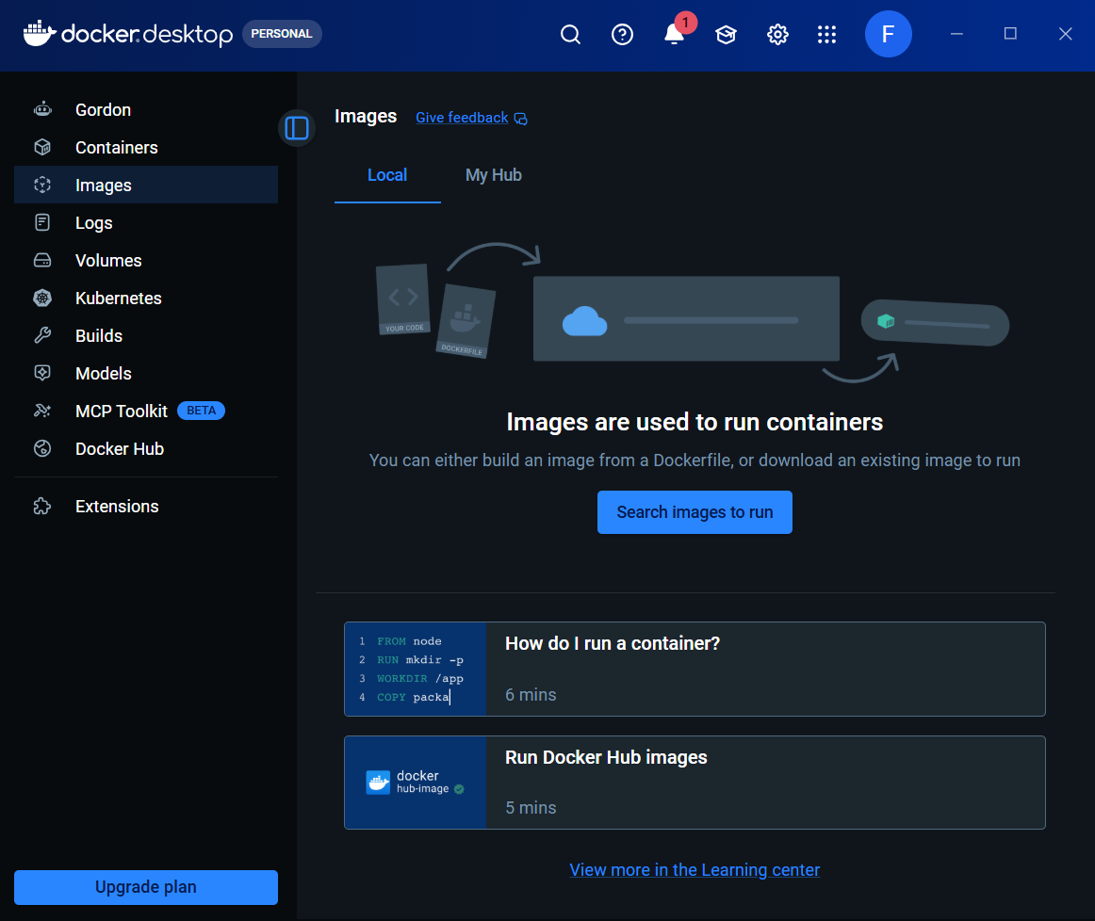
- Open Docker Hub and Login
- Verify Docker Hub image
- Check the available image tag(docker Screen shot)
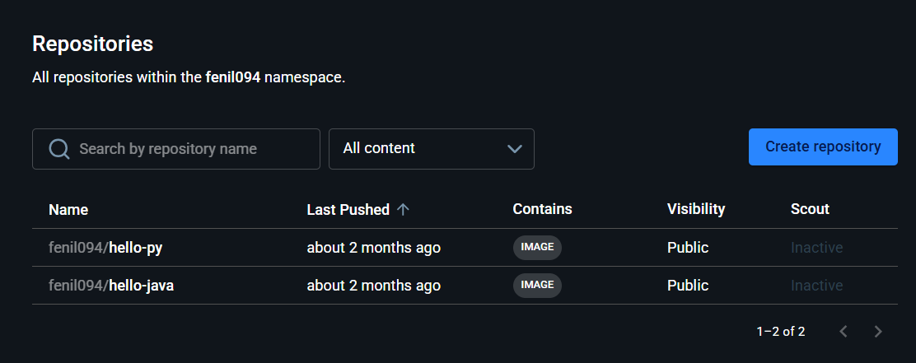
- Pull the existing Docker Hub image
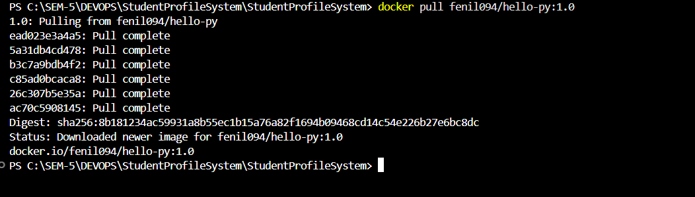
- Verify the downloaded image
- Run the Docker image
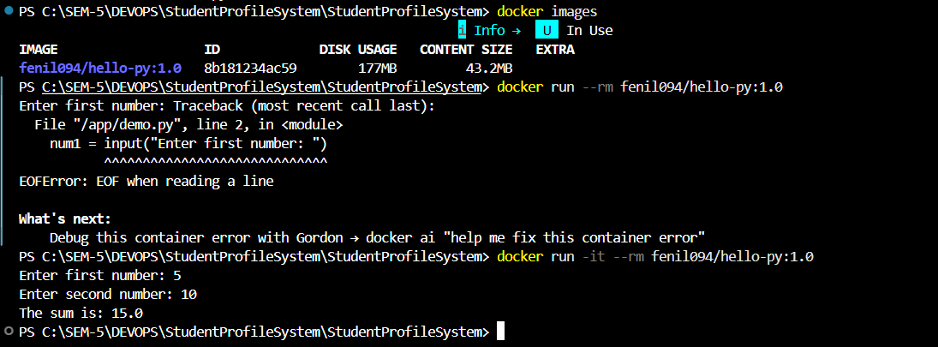
- Verify the containers
- Verify the image/container in Docker Desktop
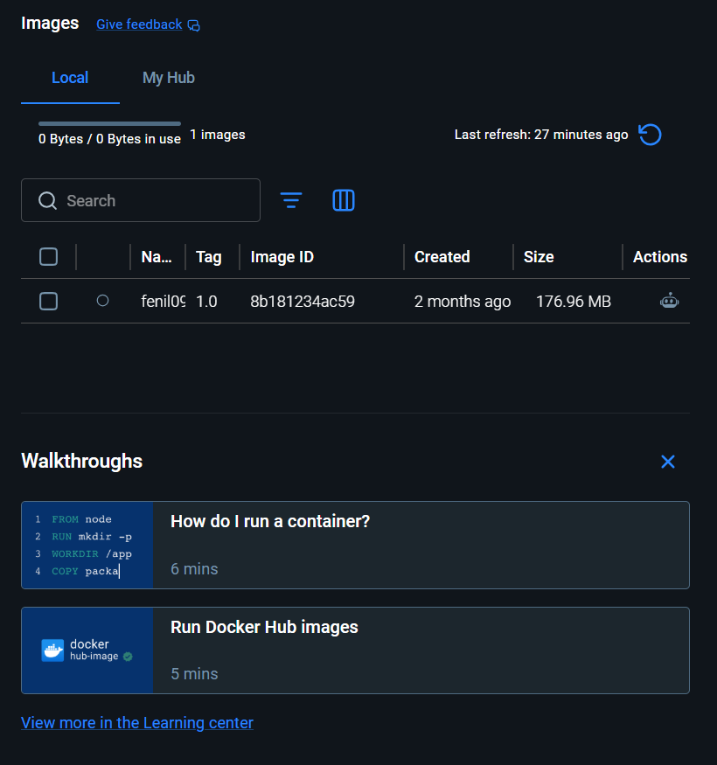

Experiment – 5
Aim : Containerizing an Application using Docker Container
Steps to perform Experiment
- Create a file ‘Dockerfile’ in project folder
- Add code in ‘Dockerfile’
- Build the Docker image
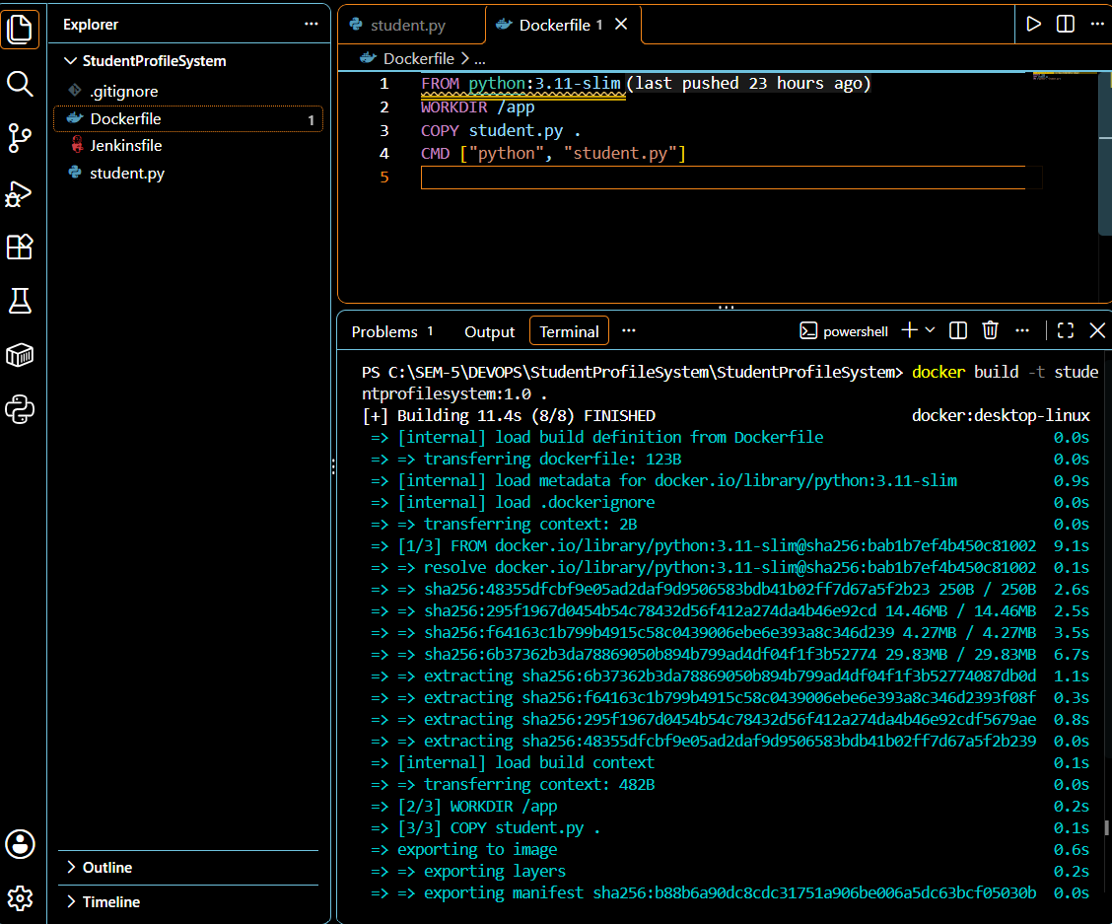
- Verify the Docker image
- Run the Docker container
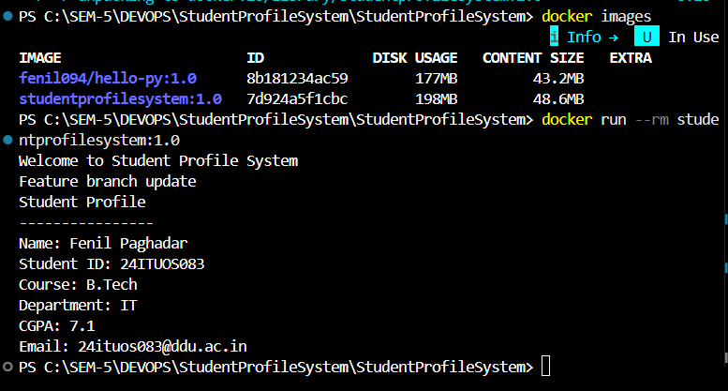
- Verify the Docker image/container in Docker Desktop
- Final verification of the containerized application (Run the Docker container)
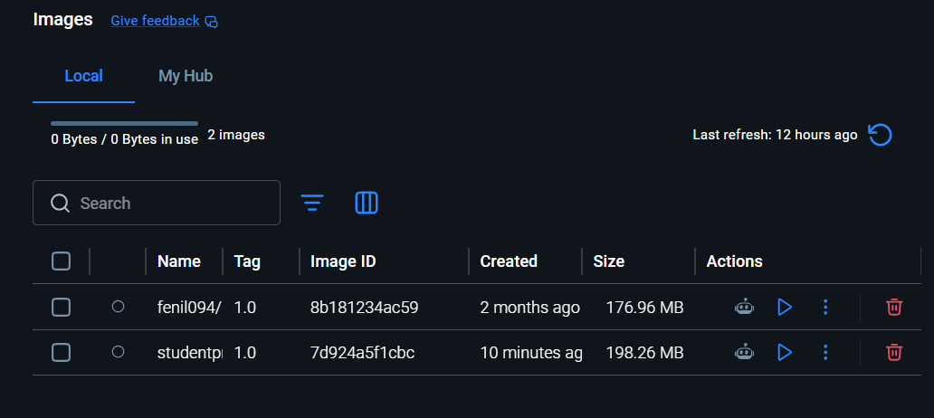

Experiment – 6
Aim : Kubernetes Orchestration with Docker Container
Steps to perform Experiment
- Kubernetes Orchestration with Docker Containers //Docker Desktop -> setting -> Kubernetes -> Enable Kubernetes -> Apply & Restart Docker Desktop
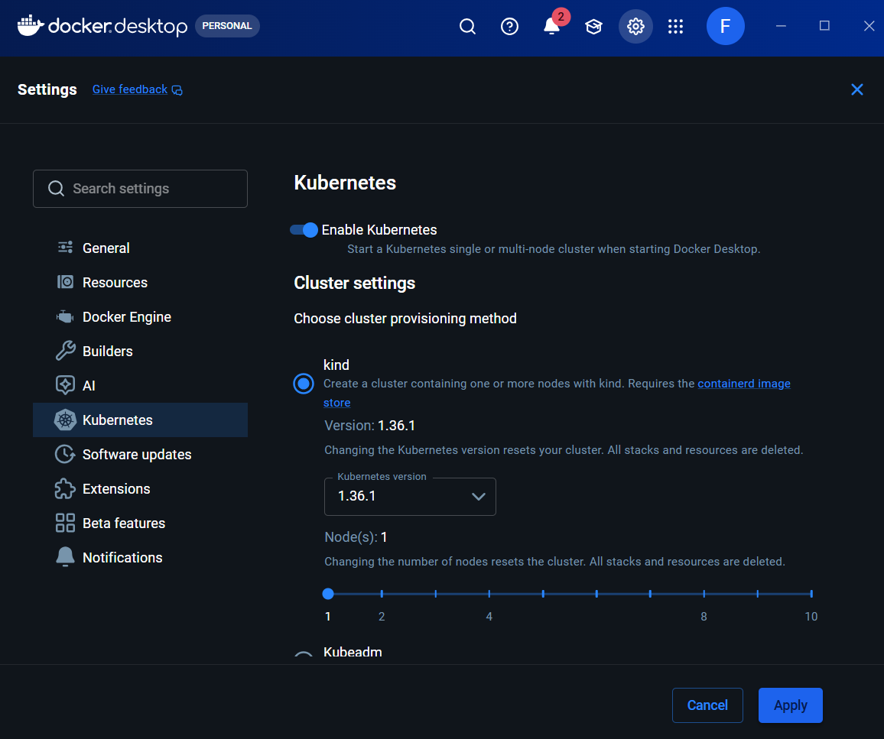
- Verify Kubernetes is running //Docker Desktop -> Settings -> Kubernetes
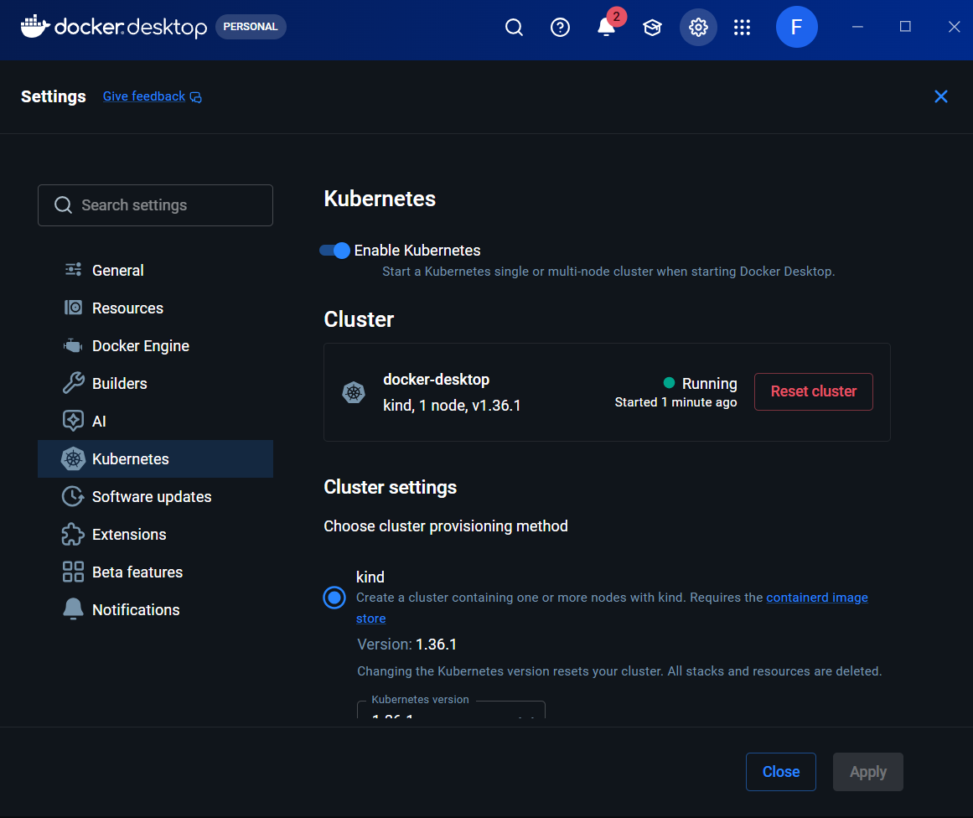
- Verify Kubernetes from the command line //IN CMD: kubectl version –client
- Check the Kubernetes cluster //kubectl get nodes
- Create a Kubernetes Deployment //kubectl create deployment student-profile //kubectl get deployments
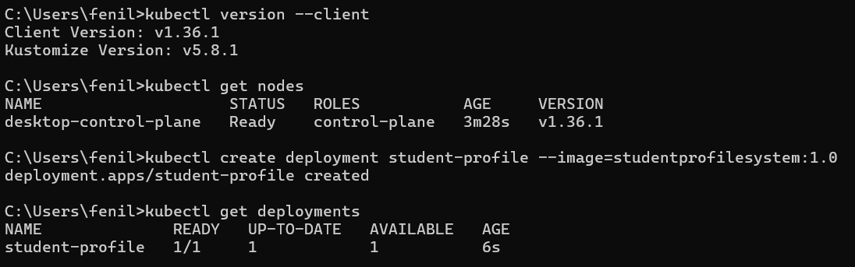

- Verify the Kubernetes Pod //kubectl get pods
- Expose the Kubernetes Deployment & Verify the service //kubectl expose deployment student-profile --type=NodePort --port=80 //kubectl get services
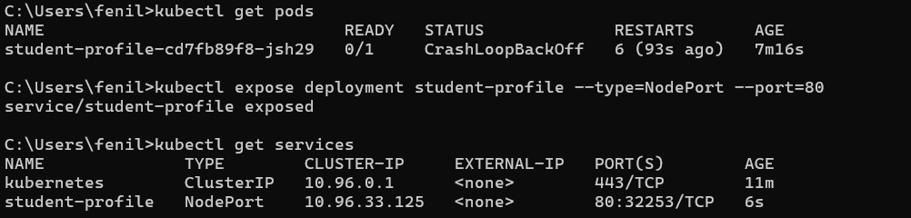
- Create a Kubernetes deployment that stays running & Verify pods & Deployment Status & Kubernetes service
- //kubectl create deployment student-profile --image=studentprofilesystem:1.0 -- /bin/sh -c "python student.py; sleep infinity"
- //kubectl get pods
- //kubectl get deployments
- //kubectl get services
- Scale the deployment to 3 replicas & verify the pods
- //kubectl scale deployment student-profile --replicas=3
- //kubectl get pods
- Verify the complete Kubernetes setup //kubectl get all
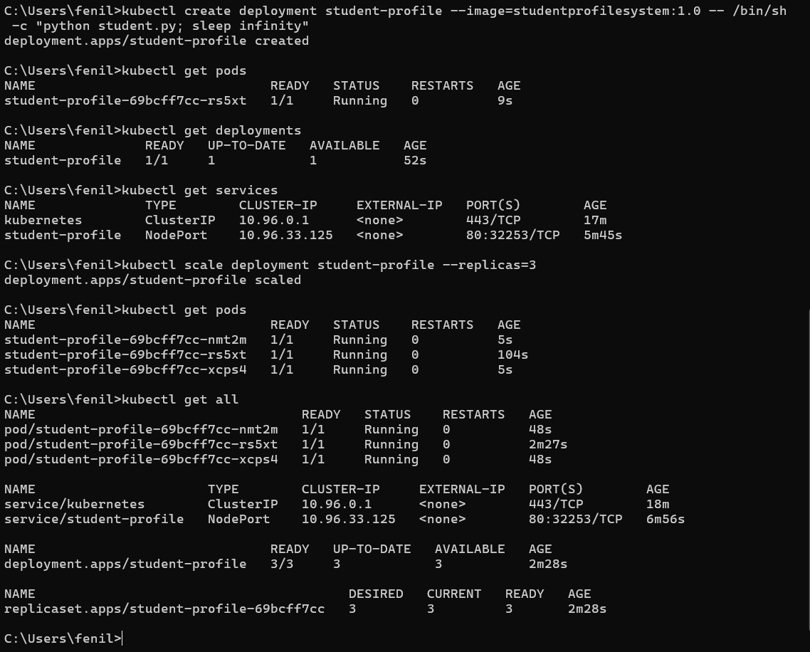
- Final Kubernetes verification
- //kubectl get nodes
- //kubectl get pods
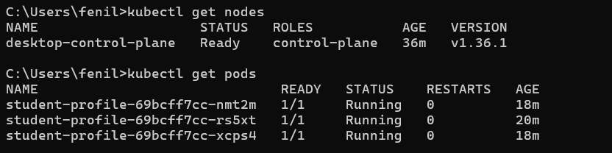

Experiment – 7
Aim : Jenkins Architecture, Installation and Configuration, and Pipeline Primitives
Steps to perform Experiment
- Install Jenkins (LTS installer)
- Open Downloaded folder and setup Wizard
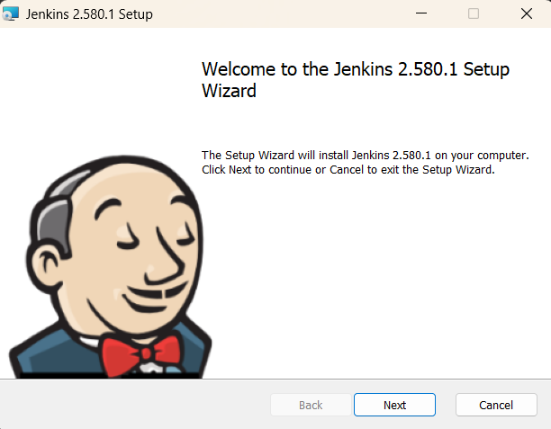  1.next | 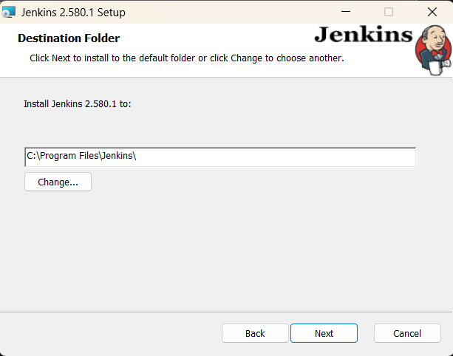  2.next
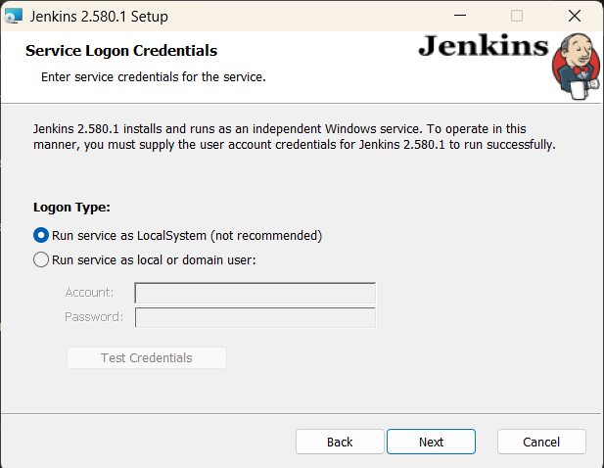  3.Run service as LocalSystem | 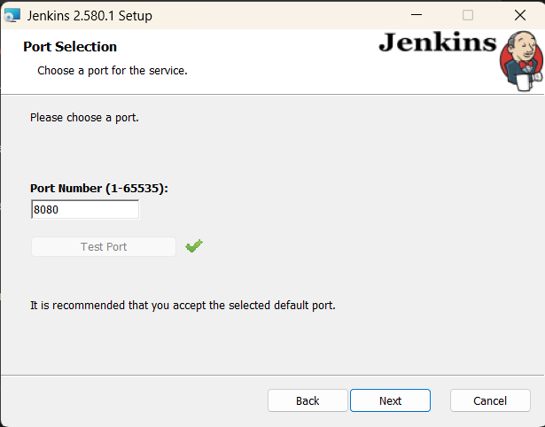  4.Click: Test Port

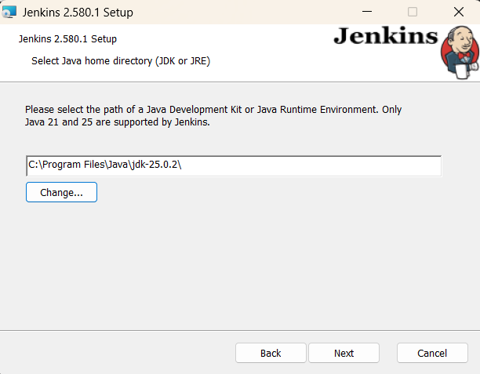  5.jdk-25.0.2 | 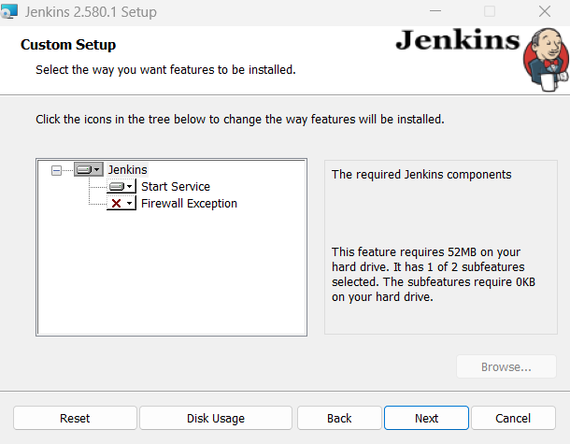  6.next
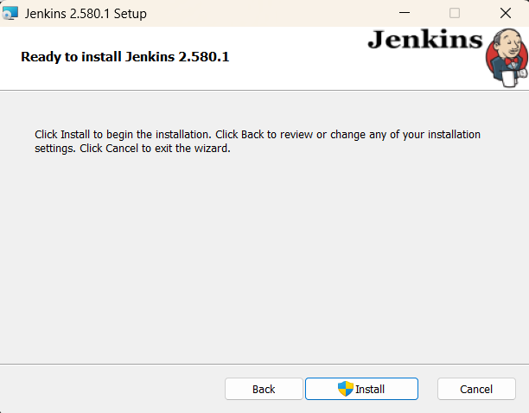
7.Install
- Open browser & Goto: http://127.0.0.1:8080
- Open file explorer & find initialAdminPassword file //Open file and copy the password
- Paste password at browser
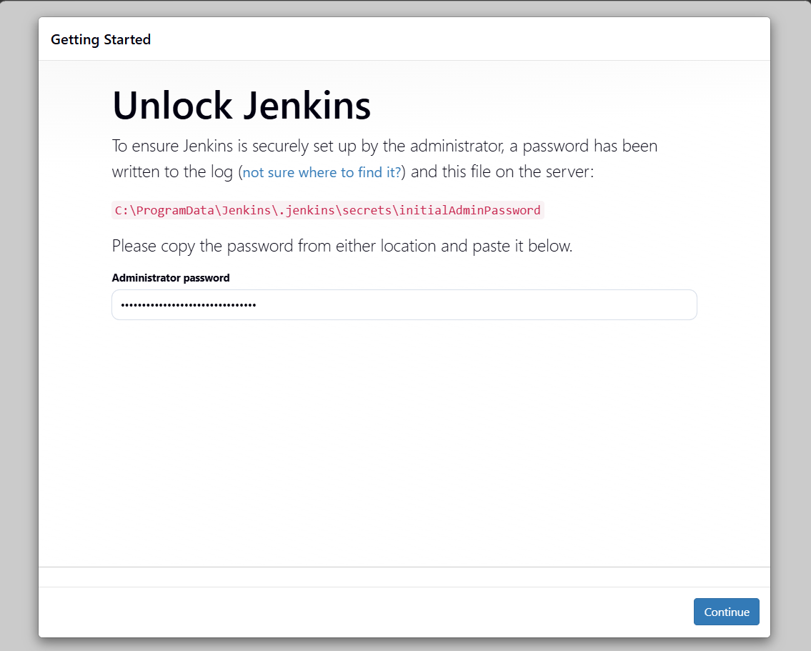
- Install suggested plugins //1
- Create the first administrator account //2
//Click: Save and Continue
// Click: Save and Finish
//wait
//Click: Start using Jenkins
- Verify the fresh Jenkins Dashboard

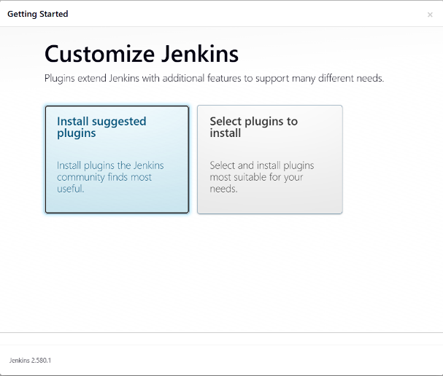  1.Install suggested plugins | 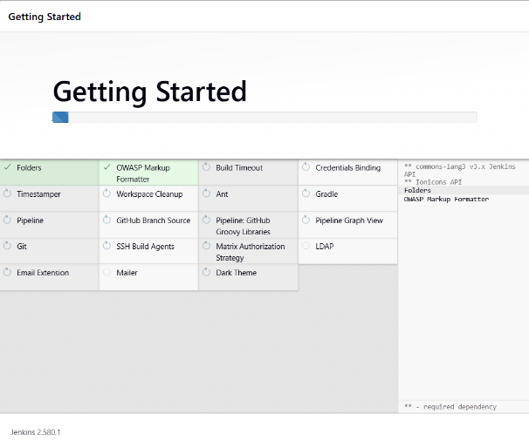  2.wait
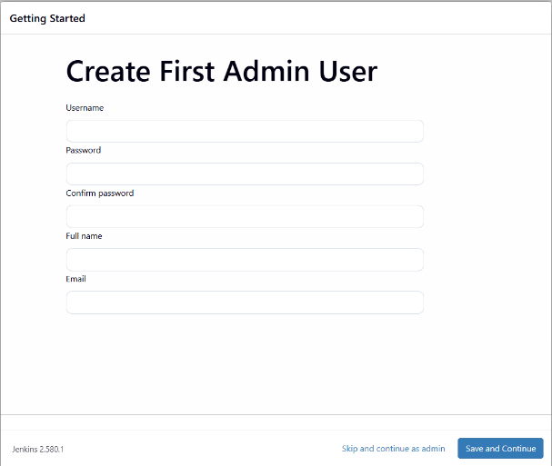  3.Enter details and Click: save &continue | 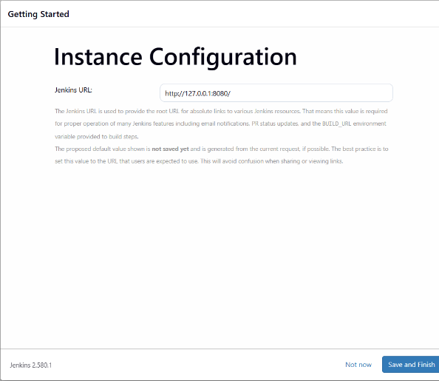  4.Click: Save & Finish
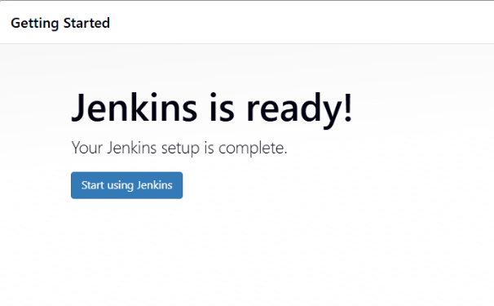  5.Click: Start using Jenkins | 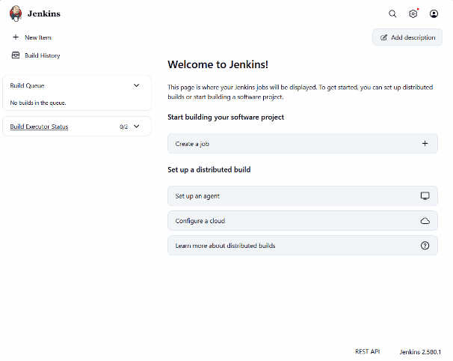  6.Dashboard

- Create a Jenkins Pipeline job
//Name: StudentProfileSystem-CICD
//Select Pipeline -> Click OK
- Configure the Pipeline script
//In Pipeline section Set Definition to: Pipeline script
//Enter the script
//Click Save
- Run the Jenkins pipeline
//Open the StudentProfileSystem-CICD job
//Click Build Now
//Wait
//Confirm that the build shows Success
- View the pipeline console output
//Open recent created build
//Click Console Output
//Verify four stages: Checkout, Build, Test, Deploy
//At the end: Pipeline completed successfully!

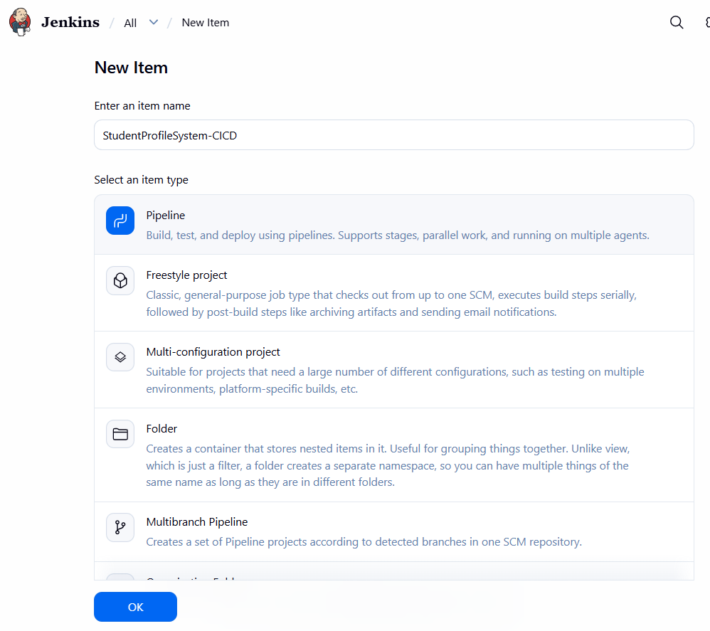  1.Click: ok | 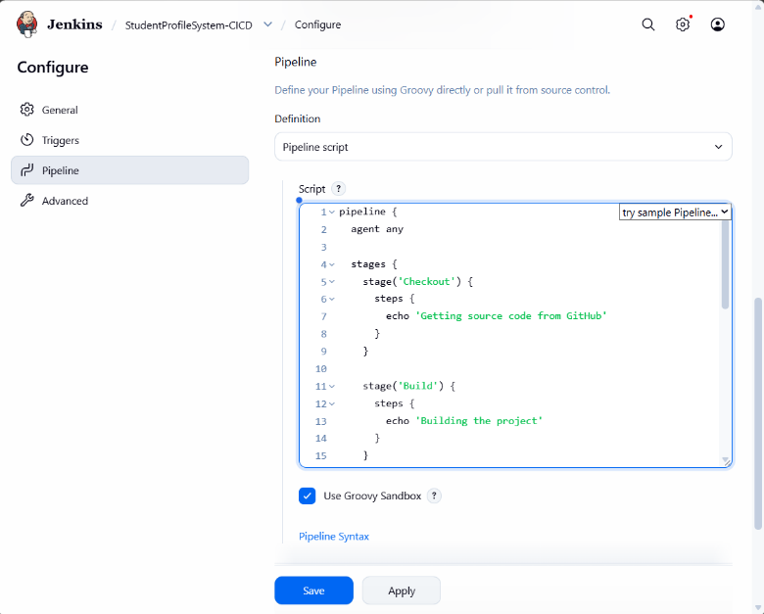  2.Click: Save
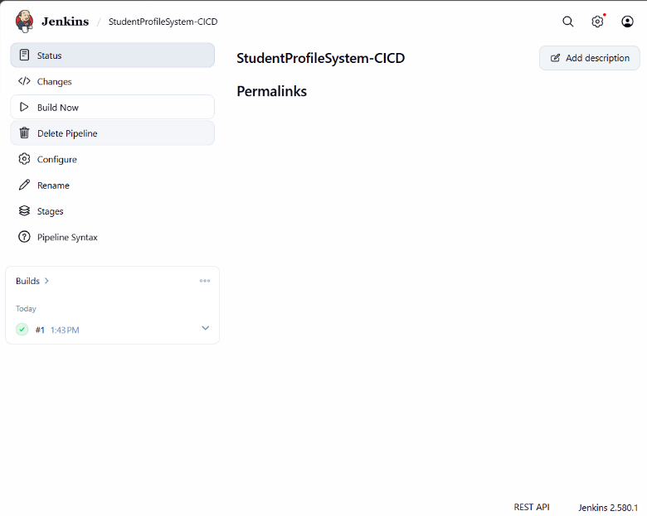  3.Click: Build Now | 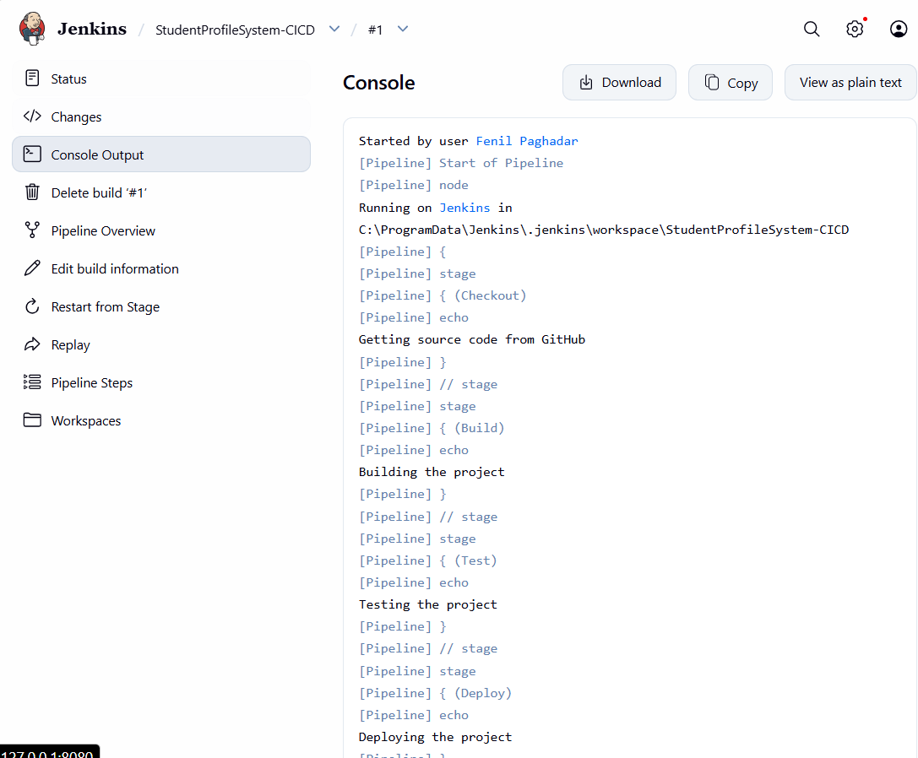  4.Click: Console Output

- Confirm all stages marked completed at Stages section
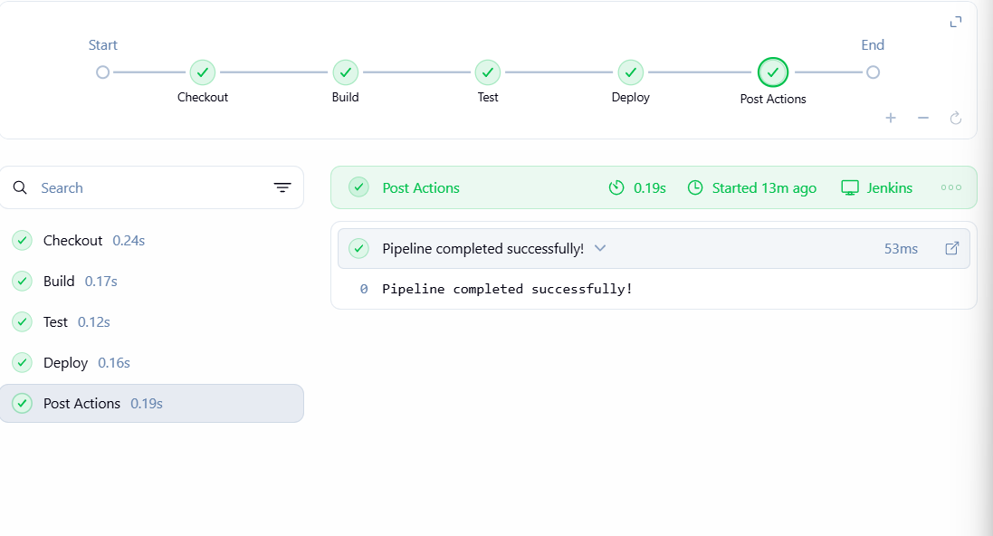
- Come back to Dashboard
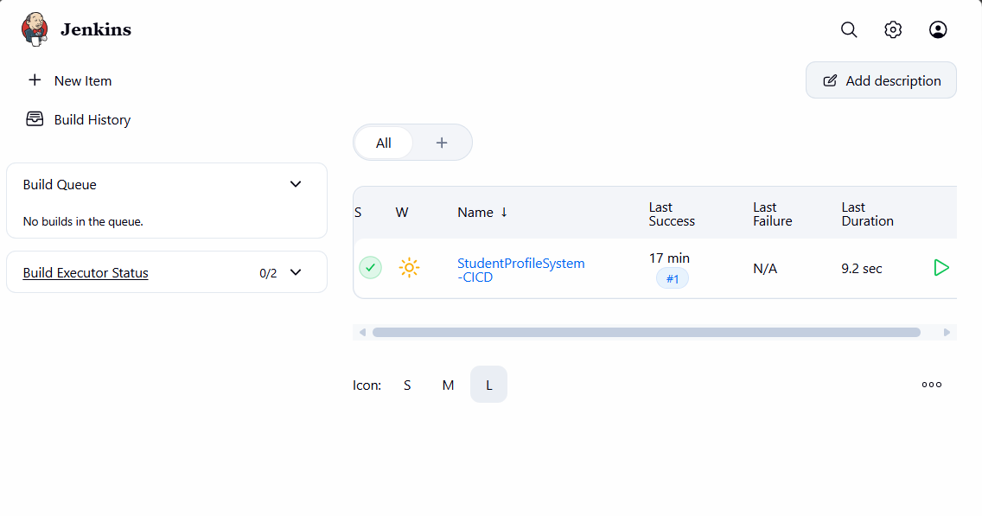

Experiment – 8
Aim : Creating Jenkins Pipelines and Triggering Based on Events
Steps to perform Experiment
- Open the existing Pipeline configuration
//Open Jenkins Dashboard -> Click StudentProfileSystem-CICD
//Click: Configure
//Go To: Triggers section and find: Poll SCM
//Tick Poll SCM -> Schedule text box will appear
//Enter: H/5 * * * * (Jenkins Check for changes approximately every 5 minutes)
//Click: Save
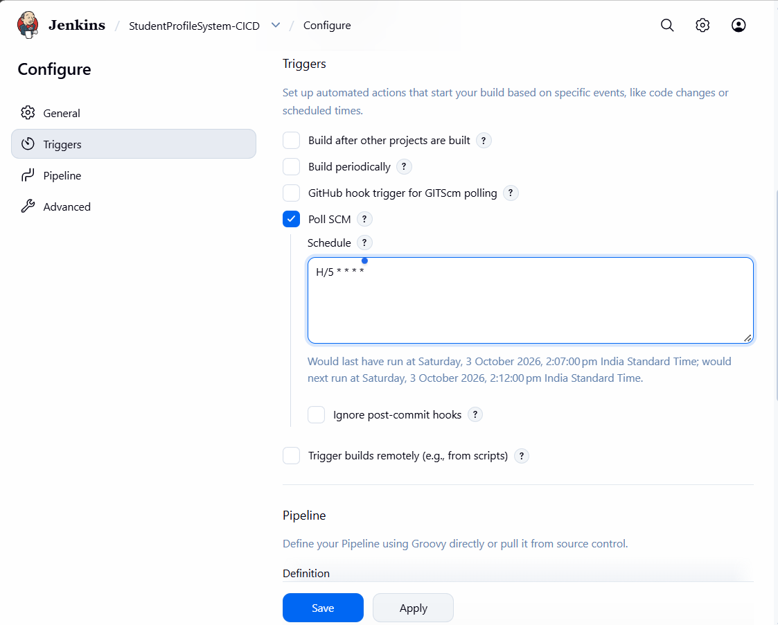
- Connect the Pipeline to GitHub
//Open Jenkins Dashboard -> Click StudentProfileSystem-CICD
//Click: Configure
//Go To: Pipeline
//Change: Definition from ‘Pipeline script’ to ‘Pipeline script from SCM’
//for SCM Select: Git
//Enter GitHub repository URL
//Set: Branch Specifier to ‘*/main’
//Set: Script Path to ‘Jenkinsfile’
//Click: Save
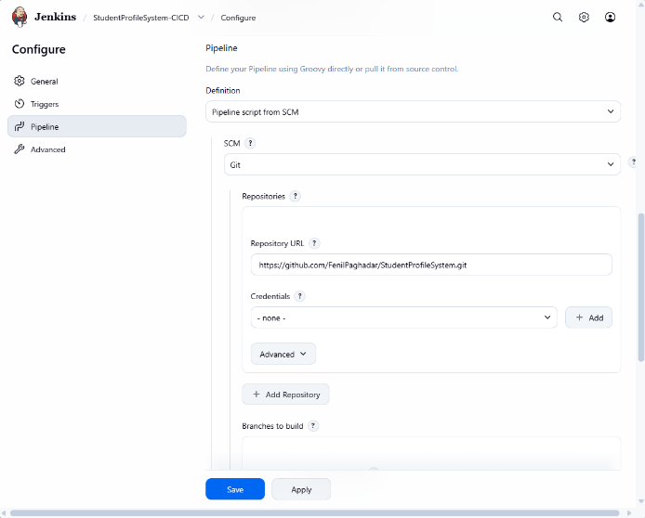  1. | 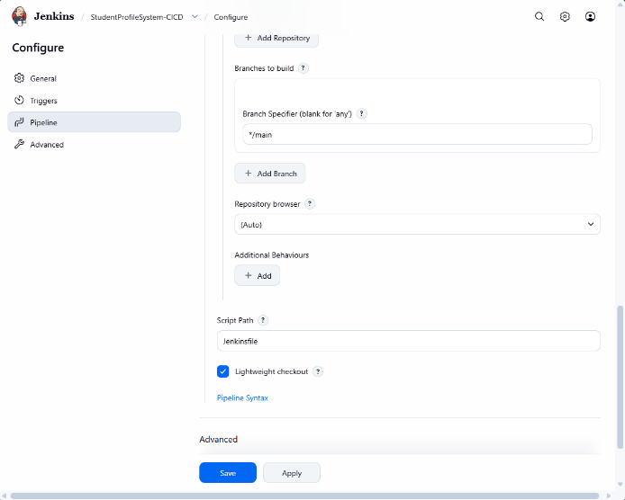2.

- Make a change in the GitHub repository
//Add: print ("Jenkins event trigger test") in student.py & save
//In VS Terminal: git add student.py
//git commit -m "Test Jenkins event trigger"
//git push origin main

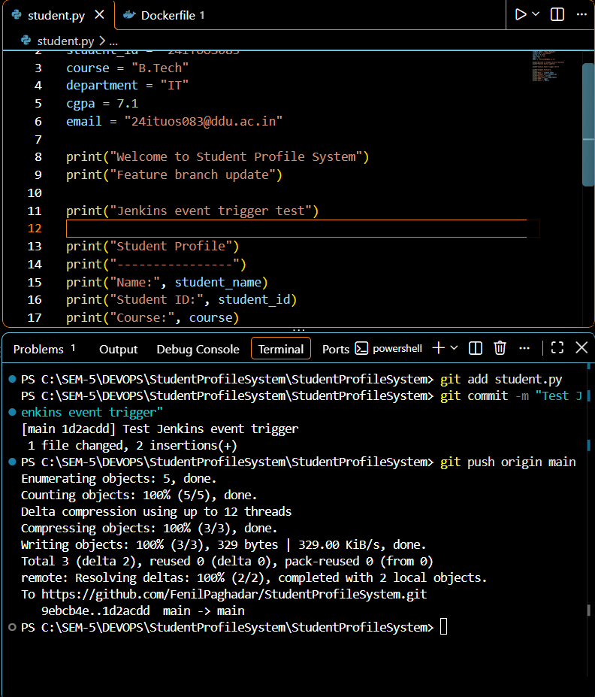
- Go To: StudentProfileSystem-CICD & Click: Build Now (Not Mandatory: It is build#2)
- Step 3 (repeat)
//Add: print ("Automatic Jenkins trigger verified") in student.py & save
//git commit -m "Verify automatic Jenkins trigger"

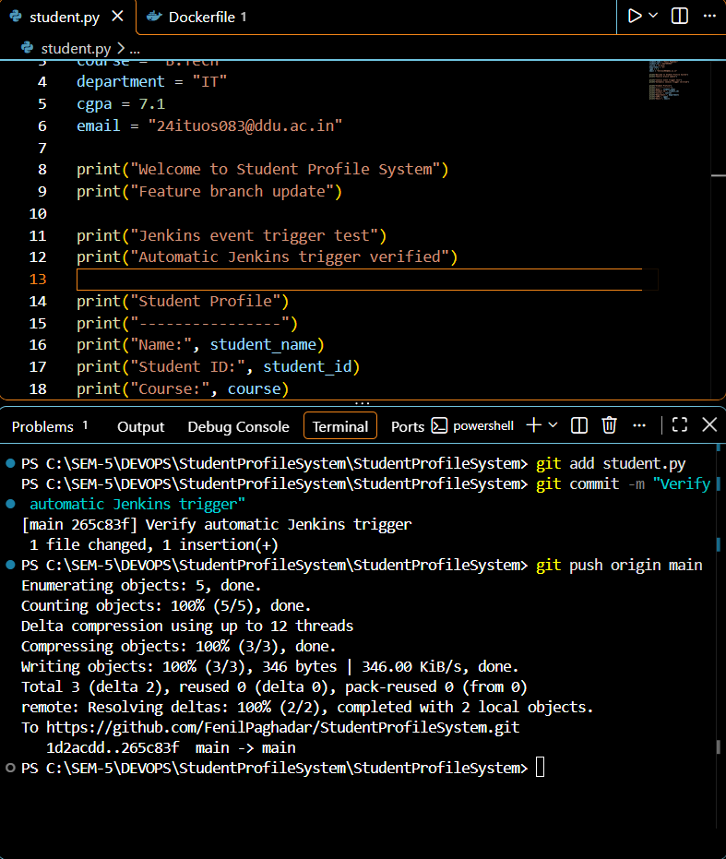
- Go To: StudentProfileSystem-CICD & Check Build History
- Open new build (It is build#3) -> Open Console Output
//Massage at end: Pipeline completed successfully!

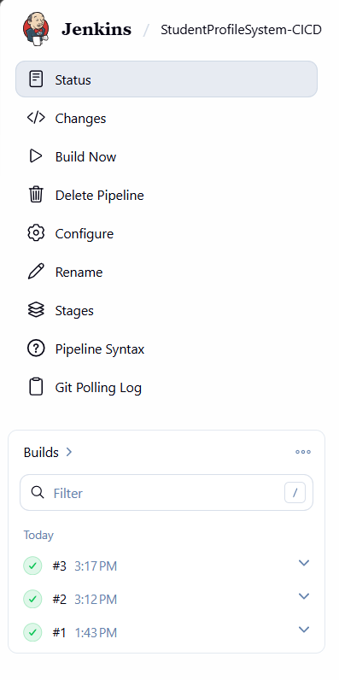 | 