PRACTICAL - 4
Aim: 1. Password strength (PasswordChecker.java + Driver.java)
- In PasswordChecker, check four rules — length ≥ 8, contains an uppercase letter, contains a digit, contains a special character — using regex (e.g. “.*[A-Z].*”) or String methods.
- Write strength(String pw) that counts how many rules pass and returns “Weak” (0– 1), “Medium” (2–3) or “Strong” (4).
- In Driver.main: test several passwords; for each, print which rules passed and the final label.Expected output: “abc” → Weak; “Abcd1234!” → Strong.2

Code Screenshot:
PasswordChecker.java
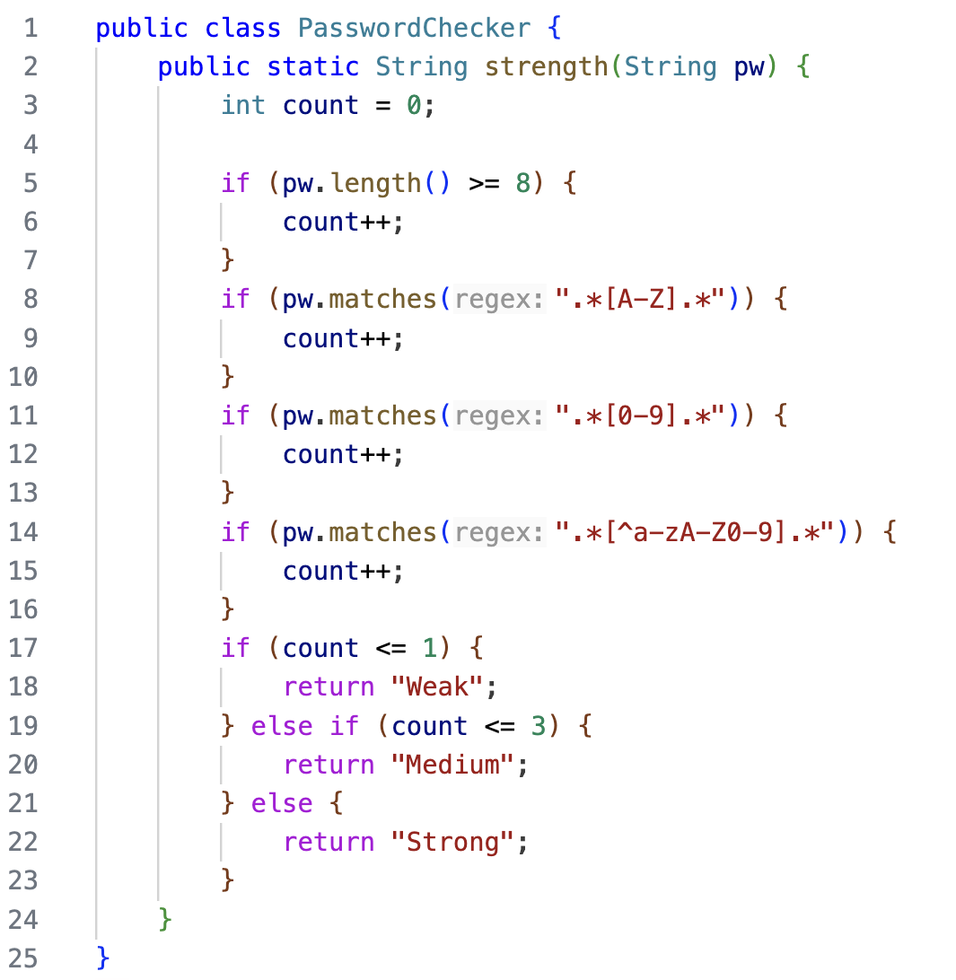

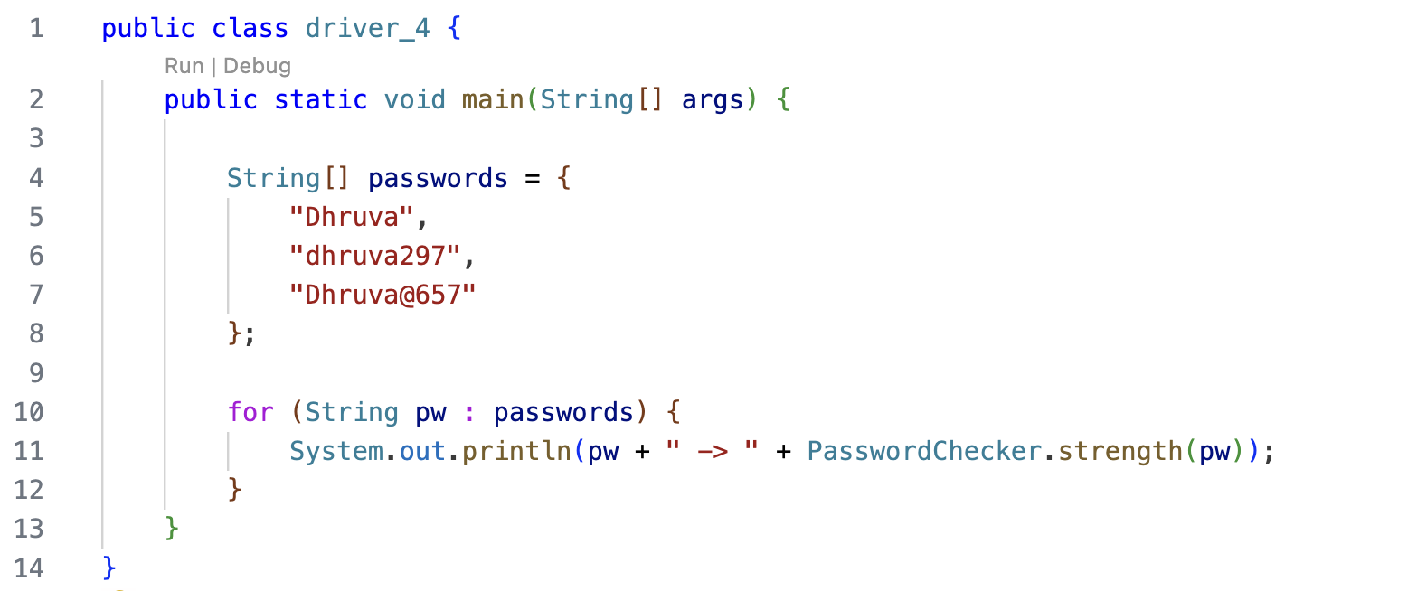
Driver.java

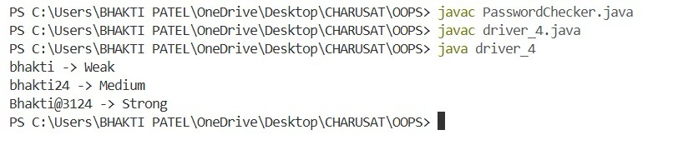
Output Screenshot:
Learning Outcome:
To understand and implement Java classes, methods, string handling, and conditional logic for validating password security rules. The program helps in checking password characteristics, calculating password strength, and classifying passwords as Weak, Medium, or Strong based on the number of rules satisfied.

Aim : 2. Chat-log filter (ChatFilter.java + Driver.java)

(a) In Driver.main, define a String[] of log lines like “10:05 alice Hello there” (include one malformed line with fewer than 3 parts).
(b) Read a keyword from the user.
(c) For each line, split into time/user/message with split(“ ”, 3); skip lines that do not have 3 parts.
(d) If the message contains the keyword (case-insensitive), increment a counter and append “time user: message” to a StringBuilder.
(e) Print “Matches: N” and the built report.Expected output: keyword “hello” over 3 lines (1 malformed) → “Matches: 1” and the matching line.3.

Code Screenshot:

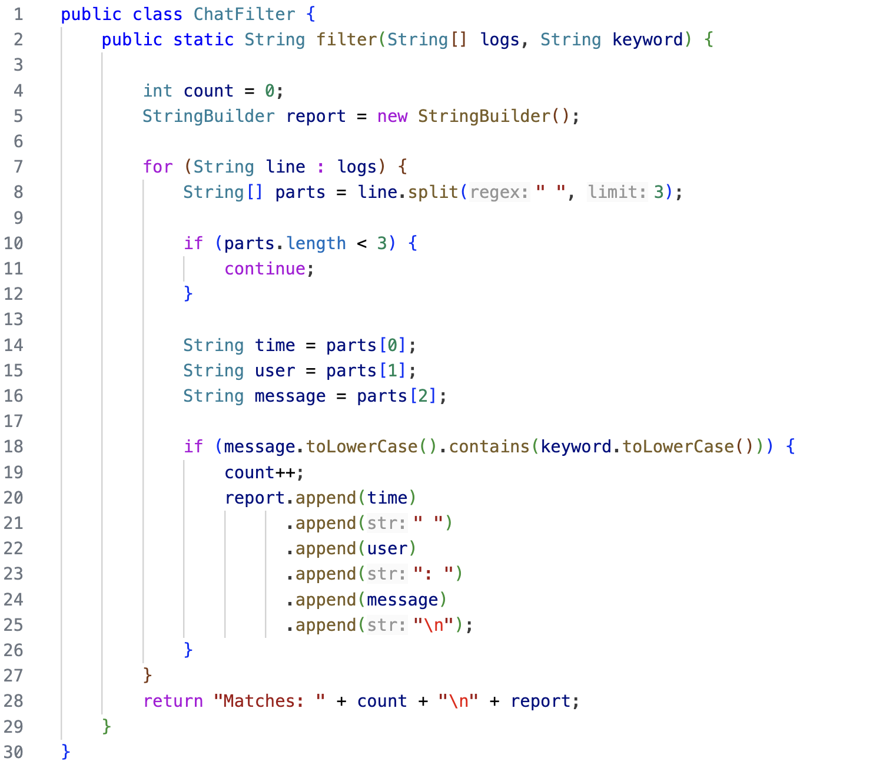
ChatFilter.java

Driver.java

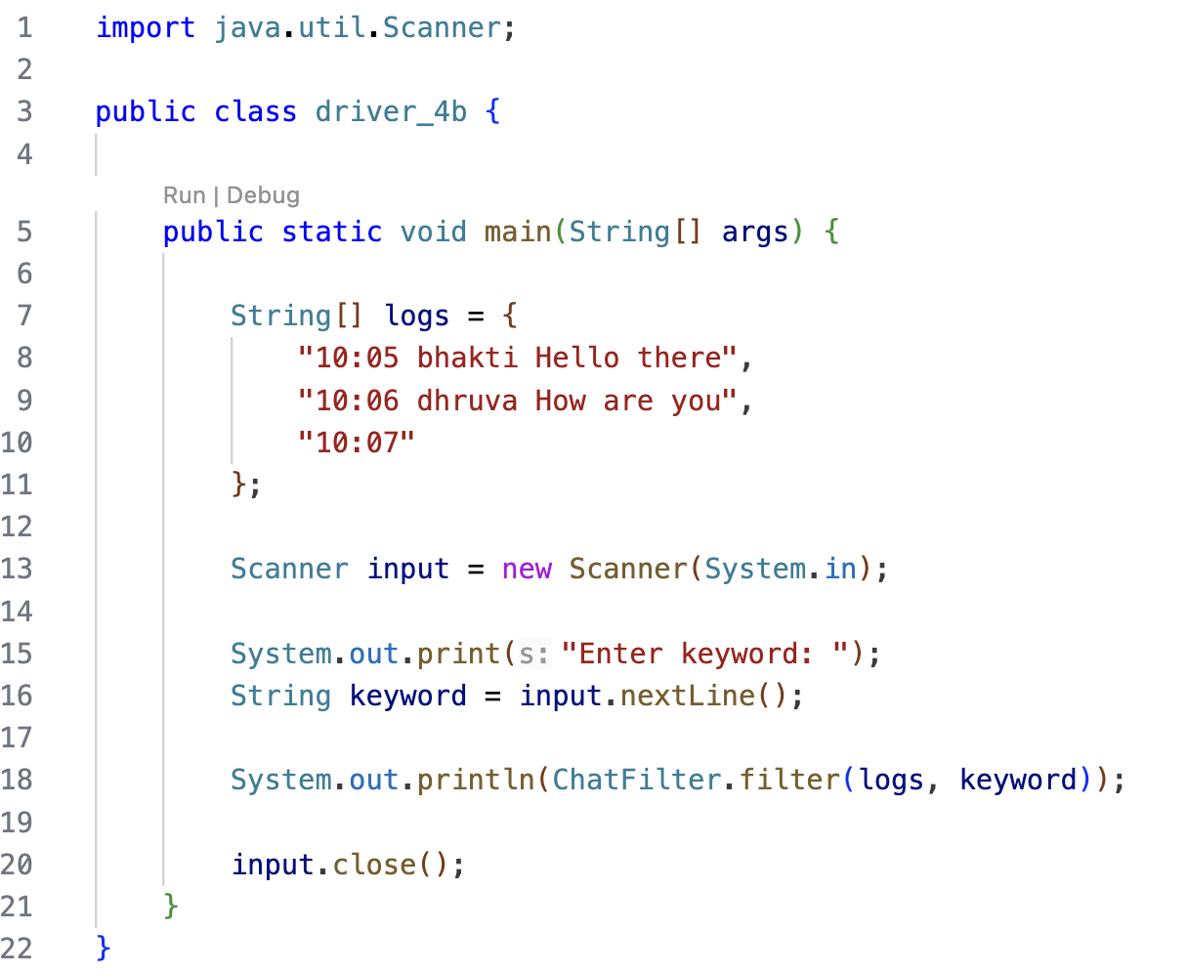

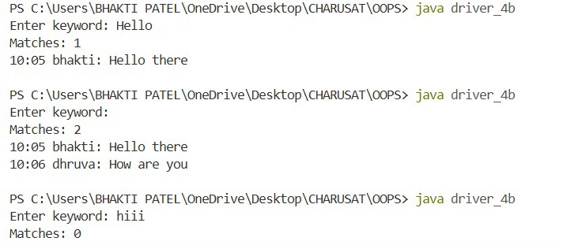
Output Screenshot:

PART - B

- util/Validator.java

package util;

import java.util.regex.Pattern;

public final class Validator {

private Validator() {
}
private static final Pattern MOBILE = Pattern.compile("^[6-9][0-9]{9}$"), EMAIL = Pattern.compile("^[A-Za-z0-9._%+-]+@[A-Za-z0-9.-]+\\.[A-Za-z]{2,}$"), PAN = Pattern.compile("^[A-Z]{5}[0-9]{4}[A-Z]$"), IFSC = Pattern.compile("^[A-Z]{4}0[A-Z0-9]{6}$"), AMOUNT = Pattern.compile("^[1-9][0-9]*$");

public static boolean isValidMobile(String s) {
return s != null && MOBILE.matcher(s).matches();
}

public static boolean isValidEmail(String s) {
return s != null && EMAIL.matcher(s).matches();
}

public static boolean isValidPan(String s) {
return s != null && PAN.matcher(s).matches();
}

public static boolean isValidIfsc(String s) {
return s != null && IFSC.matcher(s).matches();
}

public static boolean isValidAmount(String s) {
return s != null && AMOUNT.matcher(s).matches();
}
}

- Output:-

Learning Outcome:
To understand and implement Java string manipulation, arrays, Scanner, split(), StringBuilder, and conditional statements. The program helps in processing chat-log data, handling malformed input, performing case-insensitive keyword searches, and generating a filtered chat report efficiently.

