PRACTICAL - 2

Aim: To develop a Java program to implement a toll booth using record and switch expression to calculate the total toll collected and determine the most frequently used vehicle type.

Code Screenshot:
- cinema_show:

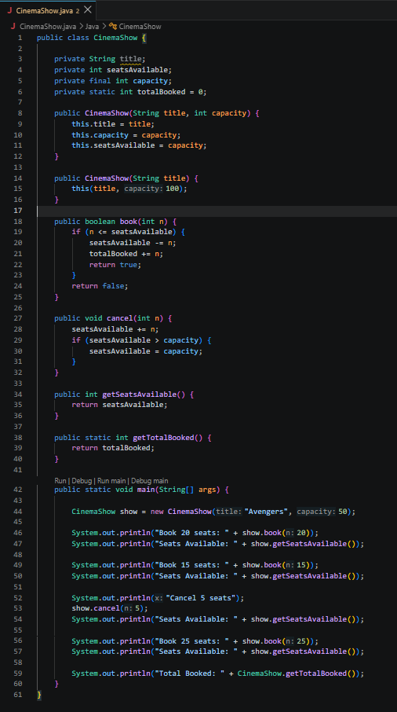
- smart_thermostat:

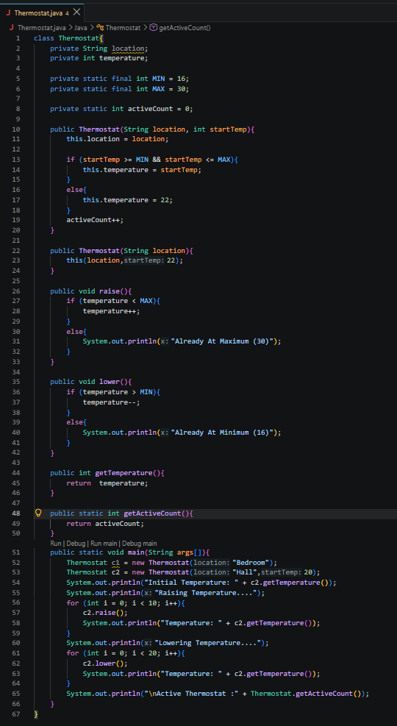

Output Screenshot:

- cinema_show:

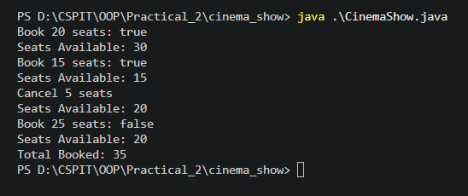

- smart_thermostat:

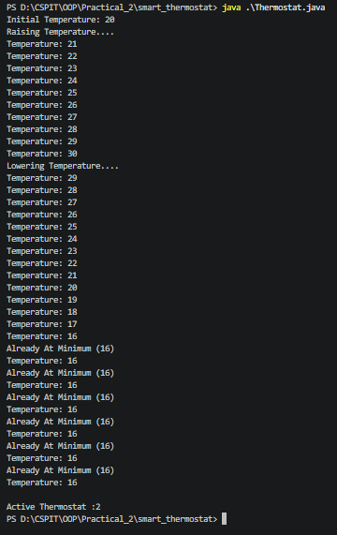

Learning Outcome:

The learning outcome of this practical is to understand and apply Java classes, constructors, constructor chaining, static and final variables, methods, conditional statements, and loops. Students will learn to manage object state, control values within specified limits, perform booking and cancellation operations, maintain shared counters, and access data using getter methods.

