PRACTICAL - 3

Aim: To develop a Java program to identify and count distinct points using classes, equals(), hashCode(), and toString() methods.

Code Screenshot:

- distinct_point:

Driver.java
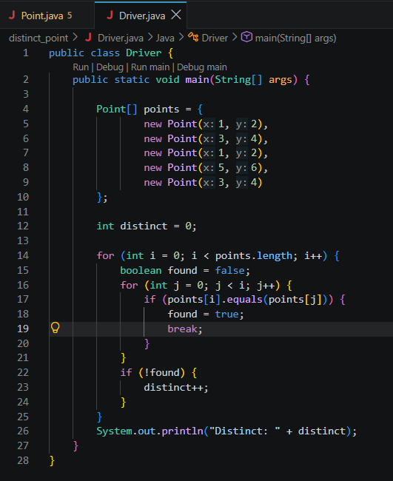

pointer.java

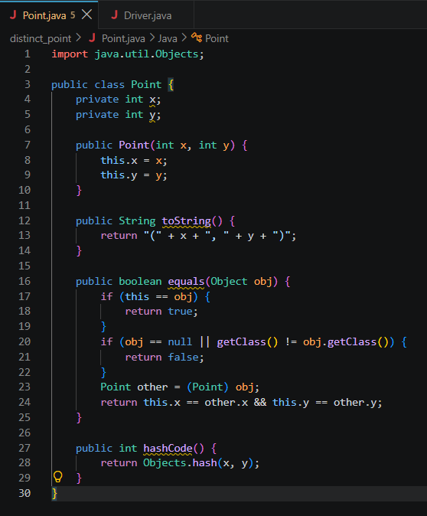

- duplicate_card_check:

Card.java
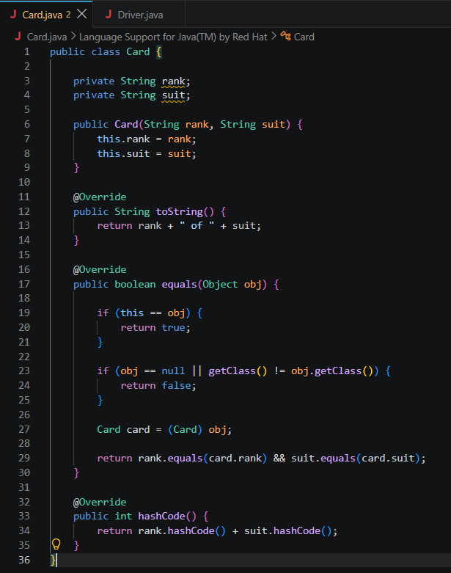
Driver.java
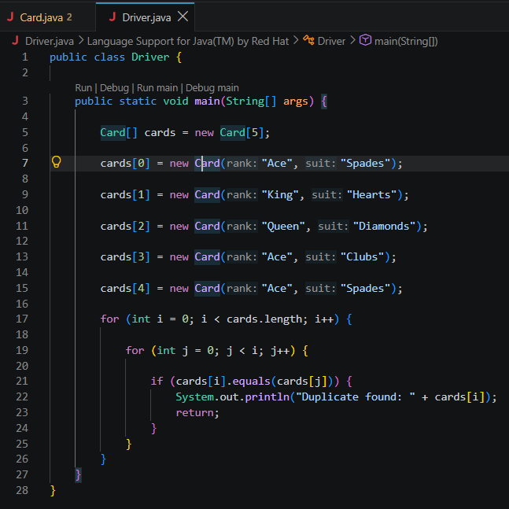

Output Screenshot:

- distinct_points:

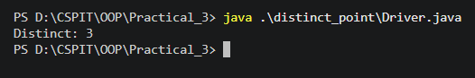

- duplicate_card_check:

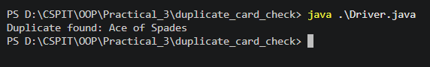

Learning Outcome:

The learning outcome of this practical is to understand and apply Java classes, constructors, arrays, toString(), equals(), and hashCode() methods. Students will learn how to compare objects based on their data, identify repeated objects, count distinct elements, and detect duplicate cards using object equality.

