PRACTICAL - 11

Aim: 1. Save/load: make a small class Serializable, save an array of its objects to a file with ObjectOutputStream, then read it back into fresh objects and confirm the values survived. Mark one field transient and show it is not saved.

Code:

SerializableRecord.java

import java.io.Serial; import java.io.Serializable;

public class SerializableRecord implements Serializable { @Serial
private static final long serialVersionUID = 1L;

private final int id; private final String name; private final double score;
private transient String sessionNote;

public SerializableRecord(int id, String name, double score, String sessionNote) {
this.id = id; this.name = name; this.score = score;
this.sessionNote = sessionNote;
}

public int getId() { return id; } public String getName() { return name; }
public double getScore() { return score; }
public String getSessionNote() { return sessionNote; }

@Override
public String toString() {
return "Record{id=" + id + ", name='" + name + "', score=" + score
+ ", sessionNote=" + sessionNote + "}";
}
}

SaveLoadDemo.java

import java.io.IOException; import java.io.ObjectInputStream;
import java.io.ObjectOutputStream; import java.nio.file.Files;
import java.nio.file.Path;

public class SaveLoadDemo {
public static void main(String[] args) throws IOException, ClassNotFoundException {
Path file = Path.of("data", "records.dat"); Files.createDirectories(file.getParent());

SerializableRecord[] original = {
new SerializableRecord(101, "Riya", 87.5, "active session"), new SerializableRecord(102, "Aarav", 92.0, "temporary note")
};

try (ObjectOutputStream output = new ObjectOutputStream(Files.newOutputStream(file))) {
output.writeObject(original);
}

SerializableRecord[] restored;
try (ObjectInputStream input = new ObjectInputStream(Files.newInputStream(file))) {
restored = (SerializableRecord[]) input.readObject();
}

System.out.println("Saved records to: " + file.toAbsolutePath()); System.out.println("Records after loading:");
for (SerializableRecord record : restored) { System.out.println(record);
}
System.out.println("Transient sessionNote after loading: "
+ restored[0].getSessionNote());
}
}

Output Screenshot:
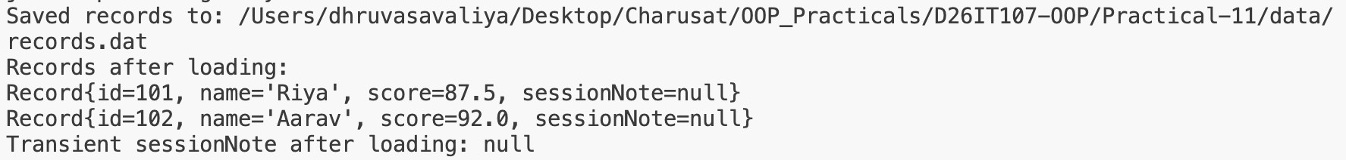

Learning Outcome:
I created a serializable class and saved an array of its objects to a file with ObjectOutputStream. I loaded the objects back with ObjectInputStream and confirmed their values were preserved. I marked the session note as transient and confirmed it was not restored.

Aim : 2. Log analyzer: create a few text files, then use Path/Files to read each line by line and count the total lines and how many contain a keyword across all files; also print each file’s size from its attributes.

Code:

LogAnalyzer.java
import java.io.BufferedReader; import java.io.IOException; import java.nio.file.Files; import java.nio.file.Path;
import java.nio.file.attribute.BasicFileAttributes; import java.util.List;
import java.util.Locale;

public class LogAnalyzer {
private static final String KEYWORD = "ERROR";

public static void main(String[] args) throws IOException { Path logsDirectory = Path.of("data", "logs"); List<Path> files;
try (var paths = Files.list(logsDirectory)) {
files = paths.filter(Files::isRegularFile).sorted().toList();
}

int totalLines = 0; int matchingLines = 0;
for (Path file : files) {
BasicFileAttributes attributes = Files.readAttributes(file, BasicFileAttributes.class);
int fileLines = 0; int fileMatches = 0;
try (BufferedReader reader = Files.newBufferedReader(file)) { String line;
while ((line = reader.readLine()) != null) { fileLines++;
if (line.toLowerCase(Locale.ROOT).contains(KEYWORD.toLowerCase(Locale.ROOT))) {
fileMatches++;
}
}
}
totalLines += fileLines; matchingLines += fileMatches;
System.out.printf("%s: %d bytes, %d lines, %d containing %s%n", file.getFileName(), attributes.size(), fileLines,
fileMatches, KEYWORD);
}

System.out.println("Files analyzed: " + files.size()); System.out.println("Total lines: " + totalLines);

System.out.println("Lines containing " + KEYWORD + ": " + matchingLines);
}
}

server-a.txt

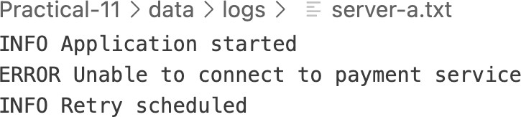

server-b.txt
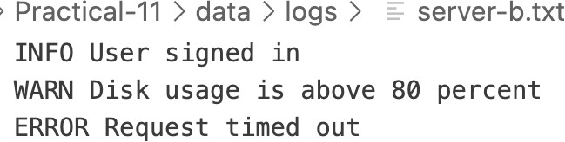

Output Screenshot:
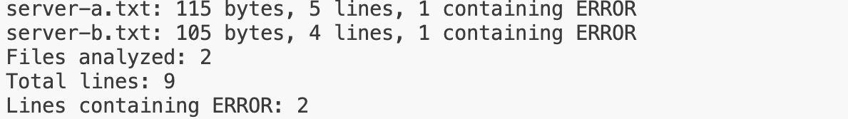

Learning Outcome:
I created sample log files and used Path and Files to locate them. The program opens each file with a BufferedReader and reads it one line at a time. It counts the total lines and the lines containing the keyword ERROR, then uses BasicFileAttributes to display each file’s size. This demonstrates basic file reading, keyword searching, resource management, and file attribute access with Java NIO.

MINIBANK
Aim: 1. Make Account (and its subclasses and Customer) implement Serializable, and add a private static final long serialVersionUID field.
2. Create a class named StatePersister with a public static method void save(Account[] accounts, Path file) that uses ObjectOutputStream inside try-with-resources, and a public static method Account[] load(Path file) that uses ObjectInputStream.
3. Create a class named TransactionLog with a public static method void append(Path file, String line) that uses Files.write(...) with CREATE and APPEND.
4. Create a class named ReportGenerator that walks the logs folder using Files.newDirectoryStream, reads each file line by line with a BufferedReader, and adds up the total deposits and total withdrawals in long variables; also read file details (size, last-modified) using Files.readAttributes, then write the summary to a report file.
5. In main, save the accounts, reload them into a new array and print them to confirm the data survived, then generate and print the report.

CODE (ReportGenerator.java)
package service;

import java.io.BufferedReader;
import java.io.IOException;
import java.nio.charset.StandardCharsets;
import java.nio.file.DirectoryStream;
import java.nio.file.Files;
import java.nio.file.Path;
import java.nio.file.StandardOpenOption;
import java.nio.file.attribute.BasicFileAttributes;
import java.util.Locale;

public final class ReportGenerator {
private ReportGenerator() { }

public static String generate(Path logsDirectory, Path reportFile) throws IOException {
Files.createDirectories(logsDirectory);
long totalDeposits = 0;
long totalWithdrawals = 0;
int malformedLines = 0;
StringBuilder report = new StringBuilder("MiniBank End-of-Day Report\n");
report.append("Log files:\n");

try (DirectoryStream<Path> files = Files.newDirectoryStream(logsDirectory)) {
for (Path file : files) {
if (!Files.isRegularFile(file)) {
continue;
}
BasicFileAttributes attributes = Files.readAttributes(
file, BasicFileAttributes.class);
report.append(" ").append(file.getFileName())
.append(" | ").append(attributes.size()).append(" bytes\n");

try (BufferedReader reader = Files.newBufferedReader(file, StandardCharsets.UTF_8)) {
String line;
while ((line = reader.readLine()) != null) {
String[] fields = line.trim().split("\\s+");
if (fields.length < 3) {
malformedLines++;
continue;
}
long amount;
try {
amount = Long.parseLong(fields[2]);
} catch (NumberFormatException e) {
malformedLines++;
continue;
}
if (amount < 0) {
malformedLines++;
continue;
}
switch (fields[0].toUpperCase(Locale.ROOT)) {
case "DEPOSIT" -> totalDeposits += amount;
case "WITHDRAW" -> totalWithdrawals += amount;
default -> malformedLines++;
}
}
}
}
}

report.append("Total deposits: ").append(totalDeposits).append(" rupees\n")
.append("Total withdrawals: ").append(totalWithdrawals).append(" rupees\n")
.append("Net change: ").append(totalDeposits - totalWithdrawals)
.append(" rupees\n")
.append("Unrecognized log lines: ").append(malformedLines).append('\n');

Path parent = reportFile.toAbsolutePath().getParent();
if (parent != null) {
Files.createDirectories(parent);
}
Files.writeString(reportFile, report.toString(), StandardCharsets.UTF_8,
StandardOpenOption.CREATE, StandardOpenOption.TRUNCATE_EXISTING);
return report.toString();
}
}

CODE (StatePersister.java)
package service;

import java.io.IOException;
import java.io.ObjectInputStream;
import java.io.ObjectOutputStream;
import java.nio.file.Files;
import java.nio.file.Path;
import model.Account;

public final class StatePersister {
private StatePersister() { }

public static void save(Account[] accounts, Path file) throws IOException {
Path parent = file.toAbsolutePath().getParent();
if (parent != null) {
Files.createDirectories(parent);
}
try (ObjectOutputStream output = new ObjectOutputStream(Files.newOutputStream(file))) {
output.writeObject(accounts);
}
}

public static Account[] load(Path file) throws IOException, ClassNotFoundException {
if (Files.notExists(file)) {
return new Account[0];
}
try (ObjectInputStream input = new ObjectInputStream(Files.newInputStream(file))) {
Object savedState = input.readObject();
if (!(savedState instanceof Account[] accounts)) {
throw new IOException("Saved bank data has an unexpected format.");
}
return accounts;
}
}
}
CODE (ReportGenerator.java)
package service;

import java.io.BufferedReader;
import java.io.IOException;
import java.nio.charset.StandardCharsets;
import java.nio.file.DirectoryStream;
import java.nio.file.Files;
import java.nio.file.Path;
import java.nio.file.StandardOpenOption;
import java.nio.file.attribute.BasicFileAttributes;
import java.util.Locale;

public final class ReportGenerator {
private ReportGenerator() { }

public static String generate(Path logsDirectory, Path reportFile) throws IOException {
Files.createDirectories(logsDirectory);
long totalDeposits = 0;
long totalWithdrawals = 0;
int malformedLines = 0;
StringBuilder report = new StringBuilder("MiniBank End-of-Day Report\n");
report.append("Log files:\n");

try (DirectoryStream<Path> files = Files.newDirectoryStream(logsDirectory)) {
for (Path file : files) {
if (!Files.isRegularFile(file)) {
continue;
}
BasicFileAttributes attributes = Files.readAttributes(
file, BasicFileAttributes.class);
report.append(" ").append(file.getFileName())
.append(" | ").append(attributes.size()).append(" bytes\n");

try (BufferedReader reader = Files.newBufferedReader(file, StandardCharsets.UTF_8)) {
String line;
while ((line = reader.readLine()) != null) {
String[] fields = line.trim().split("\\s+");
if (fields.length < 3) {
malformedLines++;
continue;
}
long amount;
try {
amount = Long.parseLong(fields[2]);
} catch (NumberFormatException e) {
malformedLines++;
continue;
}
if (amount < 0) {
malformedLines++;
continue;
}
switch (fields[0].toUpperCase(Locale.ROOT)) {
case "DEPOSIT" -> totalDeposits += amount;
case "WITHDRAW" -> totalWithdrawals += amount;
default -> malformedLines++;
}
}
}
}
}

report.append("Total deposits: ").append(totalDeposits).append(" rupees\n")
.append("Total withdrawals: ").append(totalWithdrawals).append(" rupees\n")
.append("Net change: ").append(totalDeposits - totalWithdrawals)
.append(" rupees\n")
.append("Unrecognized log lines: ").append(malformedLines).append('\n');

Path parent = reportFile.toAbsolutePath().getParent();
if (parent != null) {
Files.createDirectories(parent);
}
Files.writeString(reportFile, report.toString(), StandardCharsets.UTF_8,
StandardOpenOption.CREATE, StandardOpenOption.TRUNCATE_EXISTING);
return report.toString();
}
}
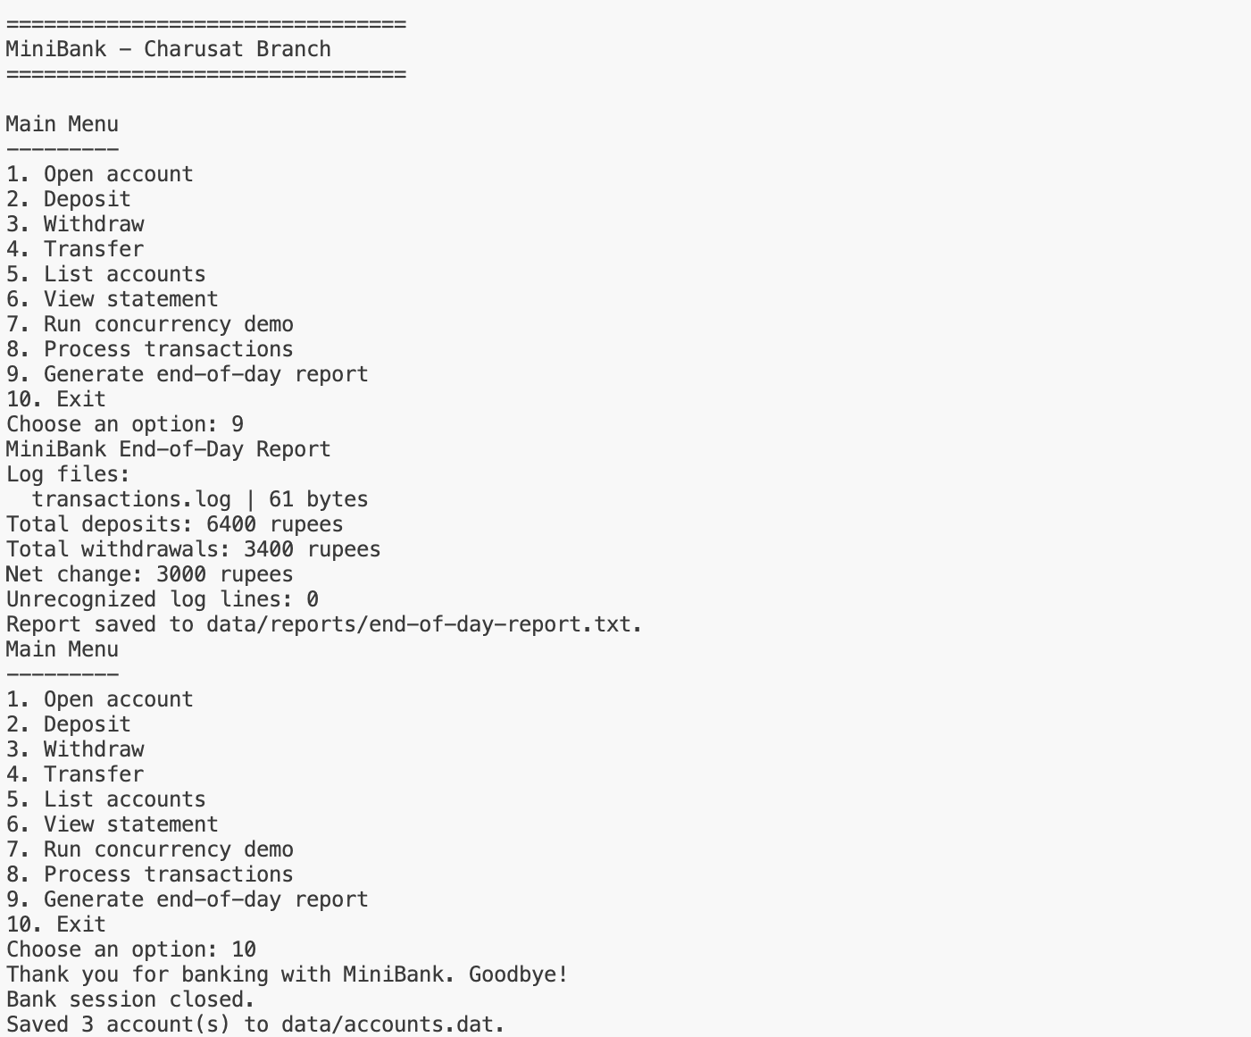
OUTPUT

