PRACTICAL - 12

Aim: 1. Word frequency: split a paragraph into words, count each in a HashMap, and print the words sorted by frequency (highest first) using a Comparator.
Code:

WordFrequency.java
import java.util.Comparator; import java.util.HashMap; import java.util.Locale; import java.util.Map;

public class WordFrequency {
public static void main(String[] args) {
String paragraph = "Java makes reliable software. Java collections make software "
+ "easier to organize, and reliable code is easier to
maintain.";
Map<String, Integer> frequencies = new HashMap<>();

for (String word : paragraph.toLowerCase(Locale.ROOT).split("[^\\p{L}\
\p{N}]+")) {
if (!word.isBlank()) { frequencies.merge(word, 1, Integer::sum);
}
}

System.out.println("Word frequencies (highest first):"); frequencies.entrySet().stream()
.sorted(Map.Entry.<String, Integer>comparingByValue(Comparator.reverseOrder())
.thenComparing(Map.Entry.comparingByKey()))
.forEach(entry -> System.out.printf("%s: %d%n", entry.getKey(), entry.getValue()));
}
}

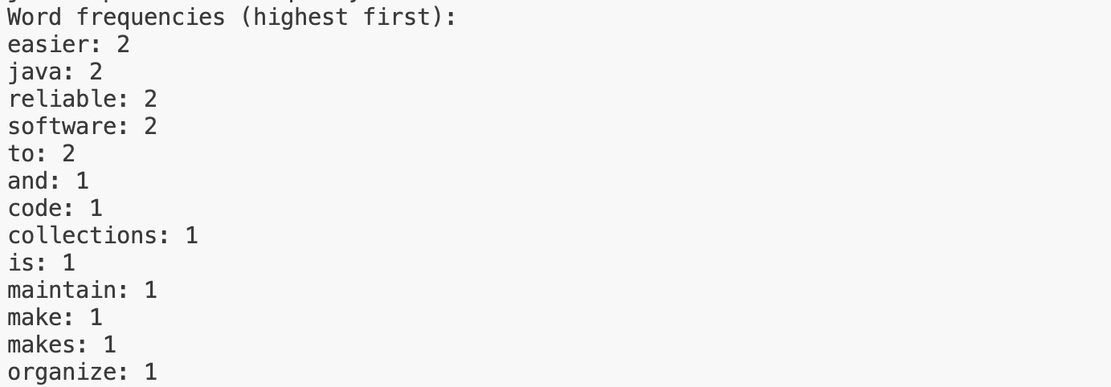

Learning Outcome:
I used a paragraph as input and split it into individual words, ignoring punctuation and differences in letter case. I stored each word and its count in a HashMap, updating the count whenever the word appeared again. I then sorted the map entries with a Comparator so the most frequent words appear first. When words have equal counts, they are displayed alphabetically.

Aim : 2. Unique visitors: from a list of login names with repeats, use a HashSet to count unique users and a LinkedHashSet to keep first-seen order; print the unique count and the first three distinct names.

Code:

UniqueVisitors.java
import java.util.Arrays; import java.util.HashSet;
import java.util.LinkedHashSet; import java.util.List;
import java.util.Set;

public class UniqueVisitors {
public static void main(String[] args) { List<String> logins = Arrays.asList(
"riya", "aarav", "diya", "riya", "kabir", "aarav", "meera"); Set<String> uniqueUsers = new HashSet<>(logins);
Set<String> firstSeenOrder = new LinkedHashSet<>(logins);

System.out.println("Unique visitor count: " + uniqueUsers.size()); System.out.println("First three distinct visitors:"); firstSeenOrder.stream().limit(3).forEach(System.out::println);
}
}

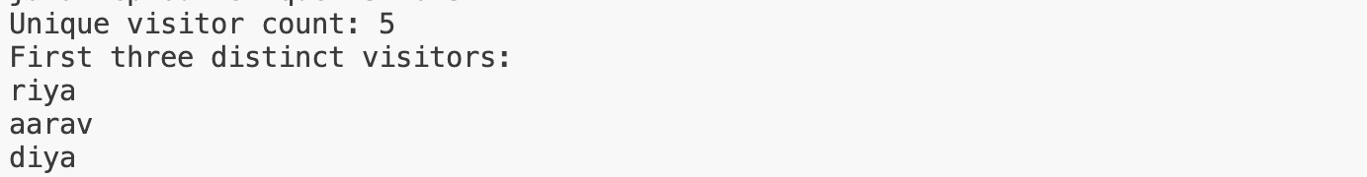

Learning Outcome:
I used a list of login names that contains repeated visitors. A HashSet removes duplicates so the program can calculate the number of unique visitors. A LinkedHashSet also removes duplicates, while preserving the order in which each visitor first appeared. The program prints the unique count and the first three names in that order.

MINIBANK
Aim: 1. Create a class named AccountStore that keeps accounts in a HashMap<String, Account> using the account number as the key. Add methods add(Account account), get(String accountNumber) and getAll().
2. Keep a transaction history in an ArrayList<String>.
3. Add a method sortedByBalance() that returns an ArrayList<Account> sorted with a Comparator.
4. Make Account implement Comparable<Account> by comparing account numbers in compareTo().
5. In the TransactionProcessor, use a ConcurrentHashMap for the shared accounts so it is thread-safe.
6. In main, add several accounts to the store and print them sorted by balance.

CODE (AccountStore.java)
package service;

import java.util.ArrayList;
import java.util.Comparator;
import java.util.HashMap;
import model.Account;

public final class AccountStore {
private final HashMap<String, Account> accounts = new HashMap<>();
private final ArrayList<String> transactionHistory = new ArrayList<>();

public void add(Account account) {
if (account == null) {
throw new IllegalArgumentException("Account cannot be null.");
}
accounts.put(account.getAccountNumber(), account);
}

public Account get(String accountNumber) {
return accounts.get(accountNumber);
}

public ArrayList<Account> getAll() {
return new ArrayList<>(accounts.values());
}

/** Returns accounts from highest balance to lowest; account number breaks ties. */
public ArrayList<Account> sortedByBalance() {
ArrayList<Account> sortedAccounts = getAll();
sortedAccounts.sort(Comparator.comparingDouble(Account::getBalance)
.reversed().thenComparing(Account::getAccountNumber));
return sortedAccounts;
}

public void recordTransaction(String transaction) {
transactionHistory.add(transaction);
}

public ArrayList<String> getTransactionHistory() {
return new ArrayList<>(transactionHistory);
}
}

CODE (Account.java)
package model;

import java.io.Serial;
import java.io.Serializable;
import exception.AccountNotFoundException;
import exception.BankException;
import exception.InsufficientFundsException;
import exception.InvalidAmountException;
import model.annotation.Id;
import model.annotation.MaxLength;
import model.annotation.Positive;

public abstract class Account implements Transactable, InterestBearing,
Serializable, Comparable<Account> {

@Serial
private static final long serialVersionUID = 1L;

private static int nextAccountNumber = 1;

@Id
private final String accountNumber;
@MaxLength(50)
private String ownerName;
@Positive
protected double balance;

public Account(String ownerName) {
this.accountNumber = String.format("AC%04d", nextAccountNumber++);
this.ownerName = ownerName;
this.balance = 0;
}

public Account(String ownerName, double balance) {
this.accountNumber = String.format("AC%04d", nextAccountNumber++);
this.ownerName = ownerName;
this.balance = balance;
}

public String getAccountNumber() {
return accountNumber;
}

public static void synchronizeAccountNumberSequence(Iterable<? extends Account> accounts) {
int largestNumber = 0;
for (Account account : accounts) {
String number = account.getAccountNumber();
if (number != null && number.startsWith("AC")) {
try {
largestNumber = Math.max(largestNumber,
Integer.parseInt(number.substring(2)));
} catch (NumberFormatException ignored) {
// Ignore account numbers that do not use the generated AC-number format.
}
}
}
nextAccountNumber = Math.max(nextAccountNumber, largestNumber + 1);
}

public String getOwnerName() {
return ownerName;
}

public synchronized double getBalance() {
return balance;
}

@Override
public synchronized void deposit(long amount) throws InvalidAmountException {
if (amount <= 0) {
throw new InvalidAmountException("Deposit amount must be greater than zero.");
}
balance += amount;
}

@Override
public synchronized boolean withdraw(long amount)
throws InsufficientFundsException, InvalidAmountException {
if (amount <= 0) {
throw new InvalidAmountException("Withdrawal amount must be greater than zero.");
}
if (!canWithdraw(amount)) {
long shortfall = Math.max(1, amount - Math.max(0, (long) balance));
throw new InsufficientFundsException(shortfall);
}
balance -= amount;
return true;
}

void depositUnsynchronizedForRaceDemo(long amount) throws InvalidAmountException {
if (amount <= 0) {
throw new InvalidAmountException("Deposit amount must be greater than zero.");
}
double currentBalance = balance;
Thread.yield();
balance = currentBalance + amount;
}

public void transfer(Account to, long amount) throws BankException {
boolean withdrawn = false;
boolean completed = false;
try {
if (to == null) {
throw new AccountNotFoundException("destination");
}
if (equals(to)) {
throw new InvalidAmountException("Source and destination must be different accounts.");
}
withdraw(amount);
withdrawn = true;
to.deposit(amount);
completed = true;
} catch (BankException e) {
throw e;
} finally {
if (withdrawn && !completed) {
balance += amount;
}
}
}

public abstract double interestRate();

public abstract boolean canWithdraw(long amount);

@Override
public synchronized String toString() {
return accountNumber + " | " + ownerName + " | " + balance;
}

@Override
public boolean equals(Object o) {
if (this == o) {
return true;
}

if (o instanceof Account) {
Account other = (Account) o;
return this.accountNumber.equals(other.accountNumber);
}

return false;
}

@Override
public int hashCode() {
return accountNumber.hashCode();
}

@Override
public int compareTo(Account other) {
return accountNumber.compareTo(other.accountNumber);
}
}

CODE (TransactionProcessor.java)

package service;

import java.util.concurrent.ExecutorService;
import java.util.concurrent.Executors;
import java.util.concurrent.TimeUnit;
import java.util.concurrent.ConcurrentHashMap;
import java.util.Collection;
import model.Account;

public final class TransactionProcessor {
private final ExecutorService executor = Executors.newFixedThreadPool(4);
private final ConcurrentHashMap<String, Account> sharedAccounts = new ConcurrentHashMap<>();

public TransactionProcessor() { }

public TransactionProcessor(Collection<? extends Account> accounts) {
for (Account account : accounts) {
registerAccount(account);
}
}

public void registerAccount(Account account) {
if (account == null) {
throw new IllegalArgumentException("Account cannot be null.");
}
sharedAccounts.put(account.getAccountNumber(), account);
}

public Account getAccount(String accountNumber) {
return sharedAccounts.get(accountNumber);
}

public int getSharedAccountCount() {
return sharedAccounts.size();
}

public void submit(Runnable task) {
executor.execute(task);
}

public void stop() throws InterruptedException {
executor.shutdown();
if (!executor.awaitTermination(30, TimeUnit.SECONDS)) {
executor.shutdownNow();
if (!executor.awaitTermination(30, TimeUnit.SECONDS)) {
throw new IllegalStateException("Transaction workers did not stop.");
}
}
}

public void stopNow() {
executor.shutdownNow();
}
}
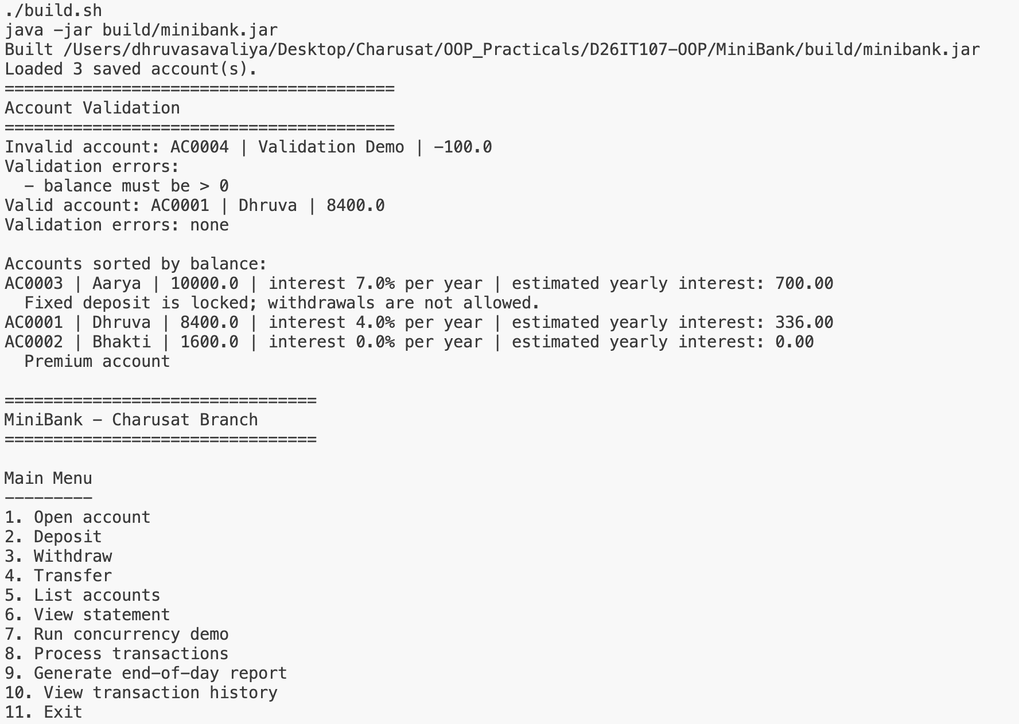
OUTPUT



