PRACTICAL - 13
Aim: 1. Generic containers: a generic Box<T> with get/set and a Pair<A,B>; use them with different types to show type safety without casts, and write a generic method that returns the first element of any array.

Code:

Box.java
public class Box<T> { private T value;

public Box(T value) { this.value = value; } public T get() { return value; }
public void set(T value) { this.value = value; }
}

GenericContainersDemo.java

public class GenericContainersDemo { public static <T> T first(T[] values) {
if (values == null || values.length == 0) {
throw new IllegalArgumentException("Array must contain at least one
value.");
}
return values[0];
}

public static void main(String[] args) {
Box<String> message = new Box<>("Generic types in Java"); Box<Integer> count = new Box<>(3);
Pair<String, Integer> accountSummary = new Pair<>("AC0001", 5000);

System.out.println("String box: " + message.get()); System.out.println("Integer box: " + count.get()); System.out.println("Pair: " + accountSummary.first() + " -> " +
accountSummary.second());
System.out.println("First string: " + first(new String[]{"Java", "Generics"}));
System.out.println("First integer: " + first(new Integer[]{10, 20,
30}));
}
}

Pair.java

public record Pair<A, B>(A first, B second) { }

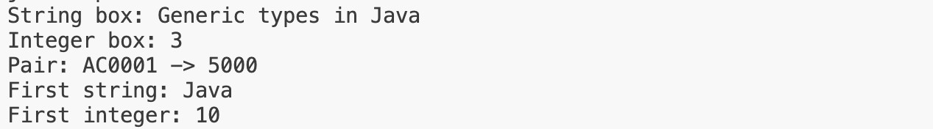

Learning Outcome:
I created Box<T> to store a value of any chosen type and Pair<A, B> to store two values that may have different types. The demo uses these classes with values such as text and integers, showing how the compiler checks that values are used with their declared types. I also wrote a generic first method that returns the first element from an array. The same method works with arrays of different element types without requiring casts.

Aim : 2. Bounded stats: a generic method <N extends Number> double average(N[] values) that works for Integer[], Double[] and Long[]; note why it refuses non-Number types.

Code:

BoundedStats.java
public class BoundedStats {
public static <N extends Number> double average(N[] values) { if (values == null || values.length == 0) {
throw new IllegalArgumentException("Values must not be empty.");
}
double sum = 0.0;
for (N value : values) { if (value == null) {
throw new IllegalArgumentException("Values must not contain
null.");
}
sum += value.doubleValue();
}
return sum / values.length;
}

public static void main(String[] args) {
System.out.println("Integer average: " + average(new Integer[]{10, 20,
30}));
System.out.println("Double average: " + average(new Double[]{2.5, 3.5,
4.0}));
System.out.println("Long average: " + average(new Long[]{100L, 200L,
300L}));
System.out.println("The <N extends Number> bound rejects non-number types at compile time.");
}
}

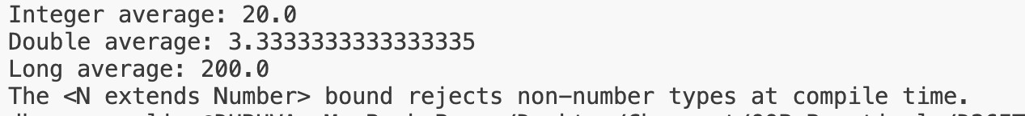

Learning Outcome:
I wrote an average method with the type parameter <N extends Number>. The method accepts arrays whose elements are numeric types and converts each value to double to calculate the average. I demonstrated it with Integer[], Double[], and Long[]. The Number bound provides compile-time type safety: an array of non-numeric values cannot be passed to this method.

MINIBANK
Aim: 1. Create a generic class named Repository<T> that holds a HashMap<String, T>. Add methods T save(T entity), T findById(String id), ArrayList<T> findAll() and boolean delete(String id).
2. Inside save(), find the id by reflection: look for the field marked @Id (from Practical 7) and read its value as the map key.
3. Add a method marked @SafeVarargs called saveAll(T... items) that saves several objects at once.
4. Add one generic method with a bounded type parameter, for example static <N extends Number> double average(N[] values).
5. In main, create a Repository<Account>, save several accounts, fetch one by id, and print all of them.

CODE (Repository.java)
package service;

import java.lang.reflect.Field;
import java.util.ArrayList;
import java.util.HashMap;
import model.annotation.Id;

public final class Repository<T> {
private final HashMap<String, T> entities = new HashMap<>();

public T save(T entity) {
if (entity == null) {
throw new IllegalArgumentException("Entity cannot be null.");
}
String id = readId(entity);
entities.put(id, entity);
return entity;
}

@SafeVarargs
public final void saveAll(T... items) {
if (items == null) {
throw new IllegalArgumentException("Items cannot be null.");
}
for (T item : items) {
save(item);
}
}

public T findById(String id) {
return entities.get(id);
}

public ArrayList<T> findAll() {
return new ArrayList<>(entities.values());
}

public boolean delete(String id) {
return entities.remove(id) != null;
}

public static <N extends Number> double average(N[] values) {
if (values == null || values.length == 0) {
throw new IllegalArgumentException("Values must contain at least one number.");
}
double total = 0;
for (N value : values) {
if (value == null) {
throw new IllegalArgumentException("Values cannot contain null.");
}
total += value.doubleValue();
}
return total / values.length;
}

private String readId(T entity) {
Field idField = null;
Class<?> type = entity.getClass();
while (type != null && type != Object.class) {
for (Field field : type.getDeclaredFields()) {
if (field.isAnnotationPresent(Id.class)) {
if (idField != null) {
throw new IllegalArgumentException("Entity has multiple @Id fields: "
+ entity.getClass().getName());
}
idField = field;
}
}
type = type.getSuperclass();
}
if (idField == null) {
throw new IllegalArgumentException("Entity has no @Id field: "
+ entity.getClass().getName());
}

try {
idField.setAccessible(true);
Object value = idField.get(entity);
if (value == null) {
throw new IllegalArgumentException("Entity @Id value cannot be null.");
}
return value.toString();
} catch (IllegalAccessException e) {
throw new IllegalStateException("Cannot read the entity @Id field.", e);
}
}
}

CODE (Customer.java)
package model;

import java.io.Serial;
import java.io.Serializable;
import model.annotation.Id;

public class Customer implements Cloneable, Serializable {

@Serial
private static final long serialVersionUID = 1L;

private static long customerCounter = 100;

@Id
private final String customerId;
private String name;
private String email;
private String mobile;
private Address address;

public Customer(String name, String email, String mobile) {
this.customerId = generateCustomerId();
this.name = name;
this.email = email;
this.mobile = mobile;
}

public Customer(String name, Address address) {
this(name, "", "");
this.address = address;
}

private static String generateCustomerId() {
return "CUST" + (++customerCounter);
}

public String getCustomerId() {
return customerId;
}

public String getName() {
return name;
}

public String getEmail() {
return email;
}

public String getMobile() {
return mobile;
}

public Address getAddress() {
return address;
}

public static class Address implements Serializable {

@Serial
private static final long serialVersionUID = 1L;

private String line;
private String city;
private String pincode;

public Address(String line, String city, String pincode) {
this.line = line;
this.city = city;
this.pincode = pincode;
}

public String getLine() {
return line;
}

public String getCity() {
return city;
}

public String getPincode() {
return pincode;
}
}

@Override
public Customer clone() {

try {
return (Customer) super.clone();
} catch (CloneNotSupportedException e) {
return null;
}
}
}

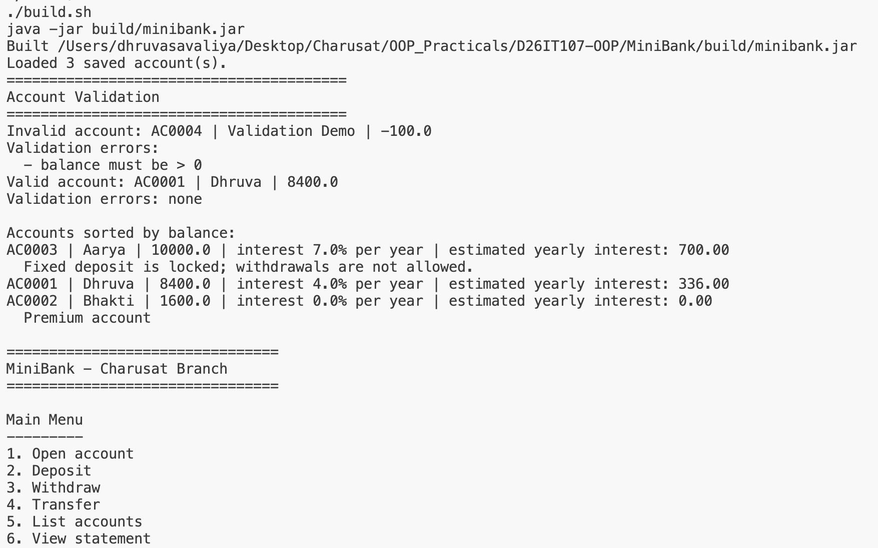
OUTPUT



