PRACTICAL - 7
Aim : 1. Form validator: define @NotBlank and @MaxLength(int) for fields and annotate a Signup Form. Write a checker that uses reflection to read each field’s annotations and returns the list of validation errors for a given object.

Code Screenshot: FormValidator.java
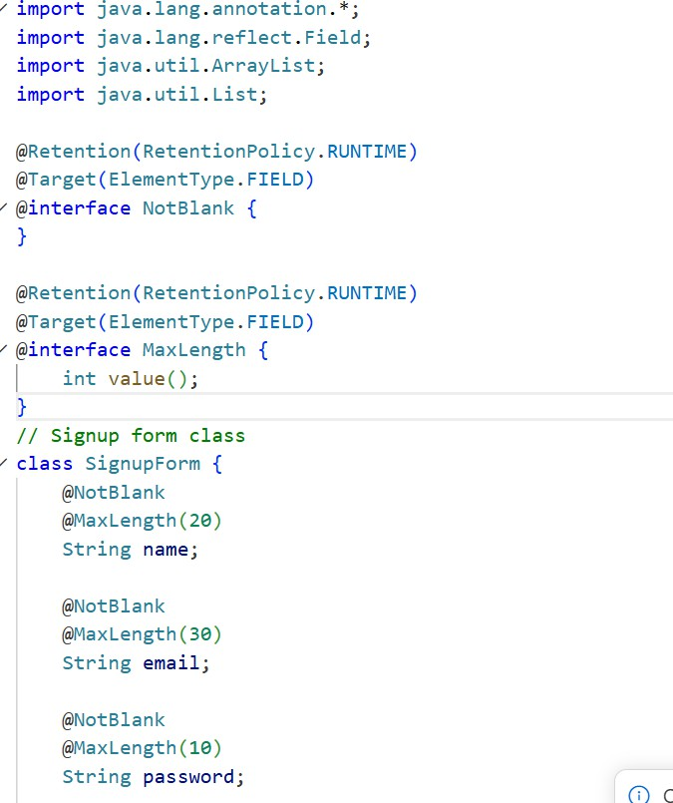
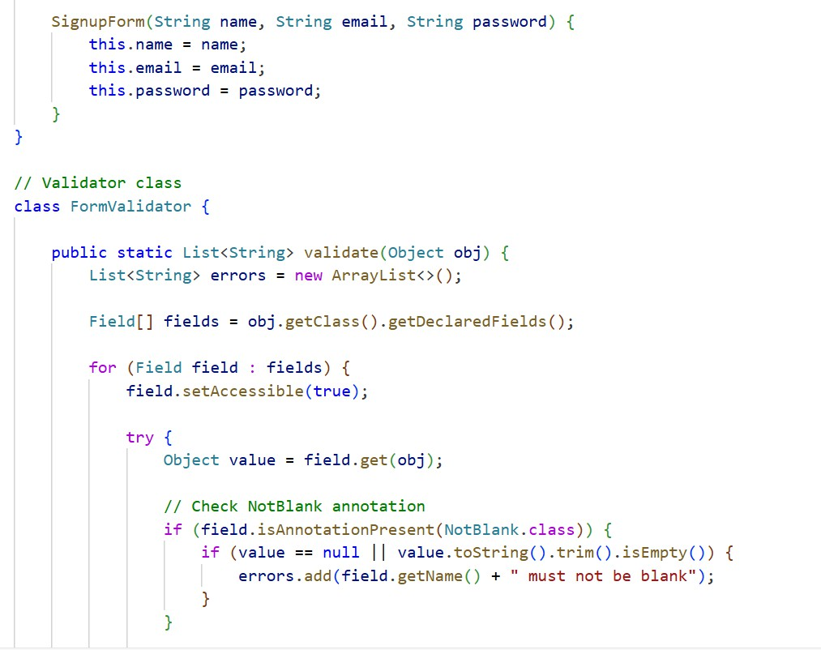

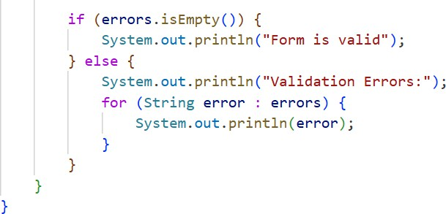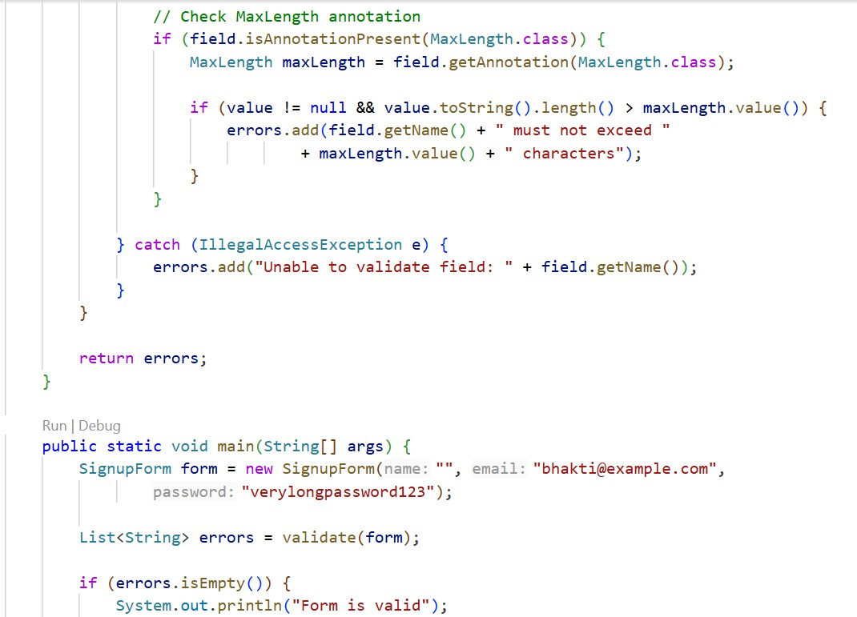

Output Screenshot:
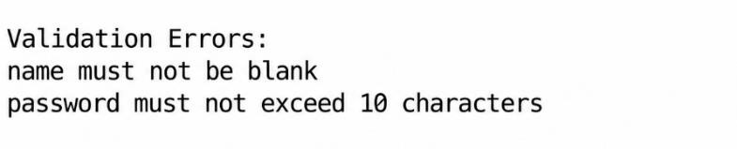

Aim: Mini test runner: define a @Run annotation and mark some no-arg methods of a class with it. Use reflection to find and invoke only the @Run methods and report how many
ran — the idea behind how JUnit finds @Test methods.

Code Screenshot: MiniTestRunner.java
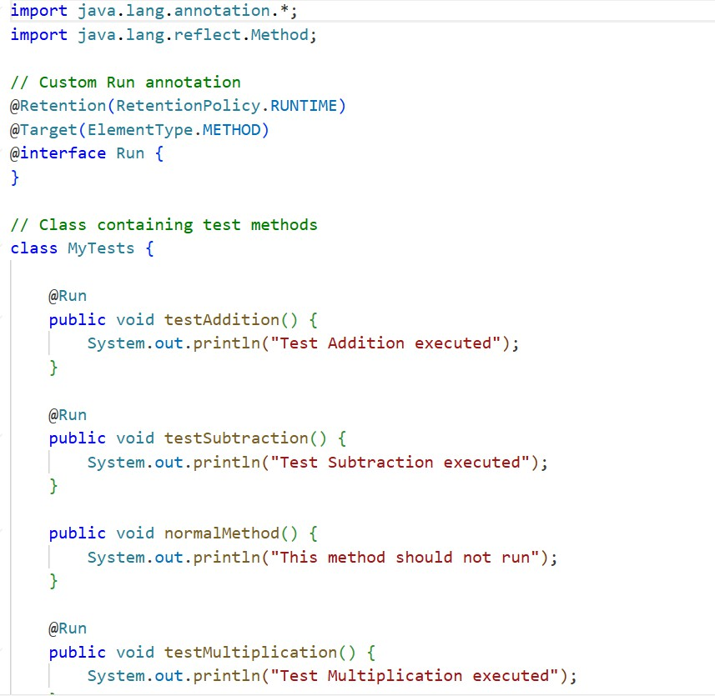
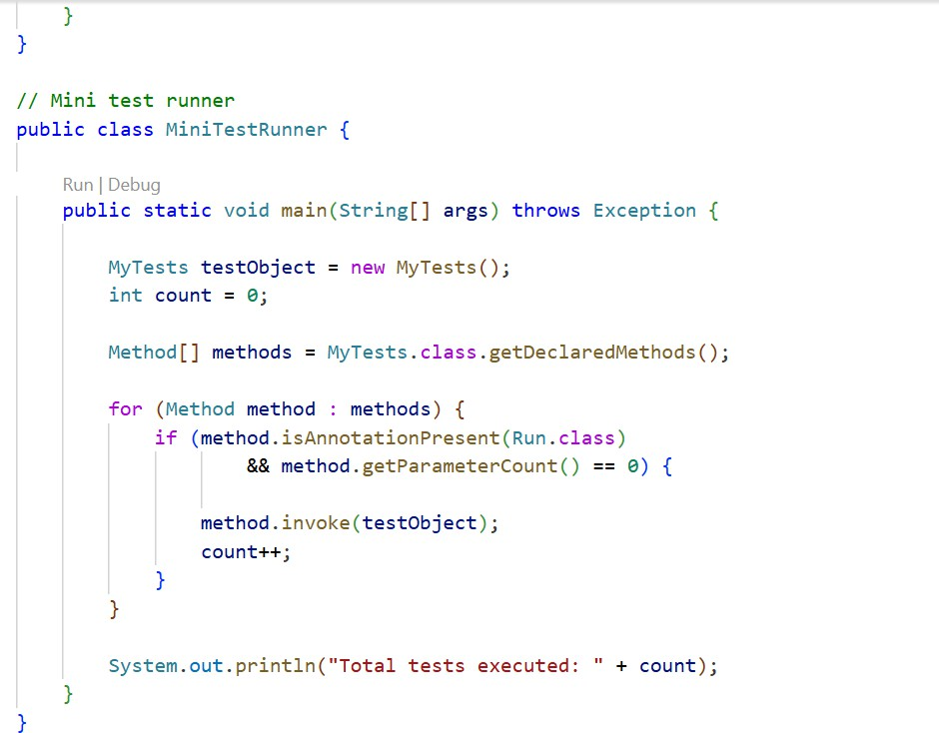

Output Screenshot
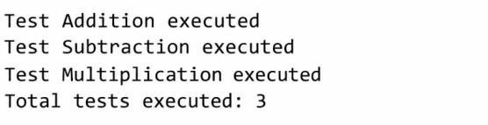

Learning Outcome:
To understand the creation and use of custom annotations in Java. Learned how to use Reflection API to identify and execute methods annotated with @Run at runtime. Also understood how to check method parameters and count the total number of test methods executed.

