INDEX

D26IT117 – Object Oriented Programming with Java

Practical | Topics | Date | Page No.
1 (A) | Vending Machine; Toll Booth | 07-07-26 | 1
1 (B) | MiniBank Menu, BankInfo Record and Account Setup | 07-07-26 | 4
2 (A) | Smart Thermostat; Cinema Show | 13-07-26 | 8
2 (B) | Customer and Account Classes; Deposits and Withdrawals | 13-07-26 | 11
3 (A) | Distinct Points; Duplicate Card Check | 20-07-26 | 19
3 (B) | Account Equality and Formatting; Nested Address; Cloning | 20-07-26 | 24
4 (A) | Password Strength; Chat-Log Filter | 29-07-26 | 30
4 (B) | Input Validation; Command Parsing; Statement Formatting | 29-07-26 | 34
5 (A) | Shape Areas; Payroll | 03-08-26 | 36
5 (B) | Abstract Account and Account Types; Polymorphism | 03-08-26 | 41
6 (A) | Remote Control Interfaces; Notification Senders | 17-08-26 | 44
6 (B) | Banking Interfaces; Withdrawal Rules; Packages and Runnable JAR | 17-08-26 | 48
7 (A) | Mini Test Runner; Form Validator | 27-10-26 | 50
7 (B) | Custom Annotations and Reflective Account Validation | 27-10-26 | 52
8 (A) | Guarded Calculator; Stock Issue | 16-09-26 | 54
8 (B) | Custom Exceptions; Withdrawal and Transfer Handling | 16-09-26 | 58
9 (A) | Counter Race; Seat Booking Race | 16-09-26 | 62
9 (B) | Concurrent Account Workers and Synchronized Transactions | 16-09-26 | 67
10 (A) | Thread-Pool Runner; Producer-Consumer | 05-10-26 | 70

10 (B) | Transaction Processing, Queues and Deadlock | 05-10-26 | 75
11 (A) | Save/Load Serialization; Log Analyzer | 27-10-26 | 78
11 (B) | Account Persistence, Transaction Logs and Reports | 27-10-26 | 82
12 (A) | Word Frequency; Unique Visitors | 27-10-26 | 89
12 (B) | AccountStore, Sorting, Comparable and Concurrent Map | 27-10-26 | 92
13 (A) | Generic Containers; Bounded Statistics | 27-10-26 | 99
13 (B) | Generic Repository, Reflection and saveAll | 27-10-26 | 101
14 (A) | Layered Application and JUnit Tests | 27-10-26 | 105
14 (B) | Integrated MiniBank Application, Tests and Runnable JAR | 27-10-26 | 105

PRACTICAL - 1
Aim: To develop a Java program to implement a vending machine using enum and switch expression to calculate the total amount paid and the change to be returned. Code Screenshot:
PART - A
- Vending_Machine:
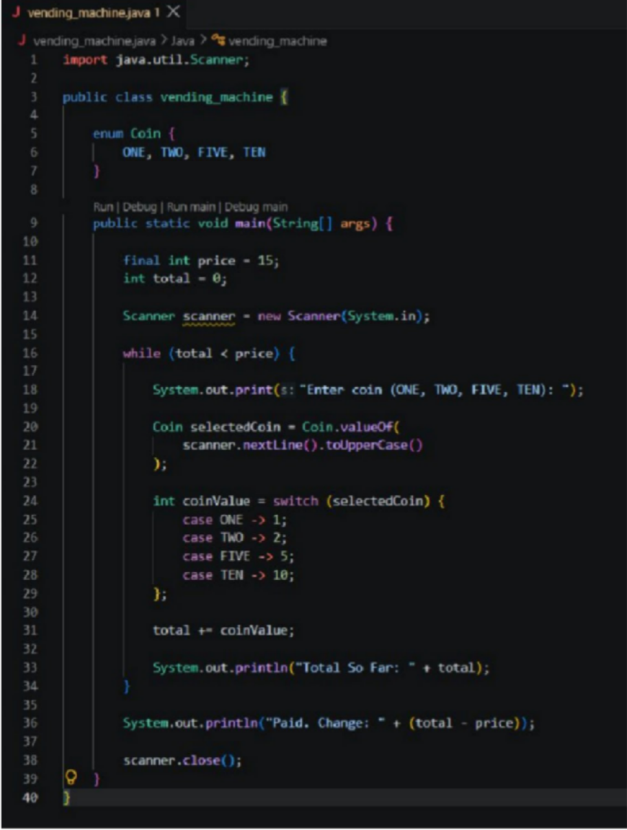

- Toll_booth:
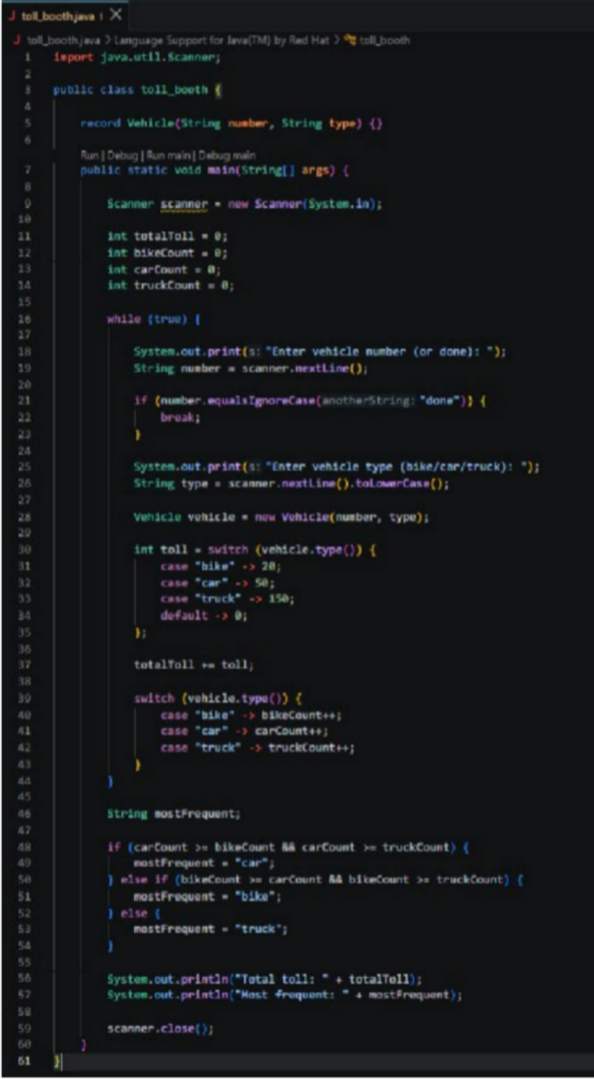

Output Screenshot:
- Vending_Machine:
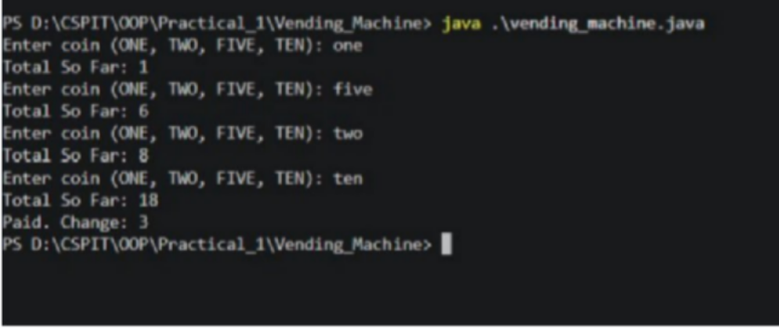

- Toll_booth:
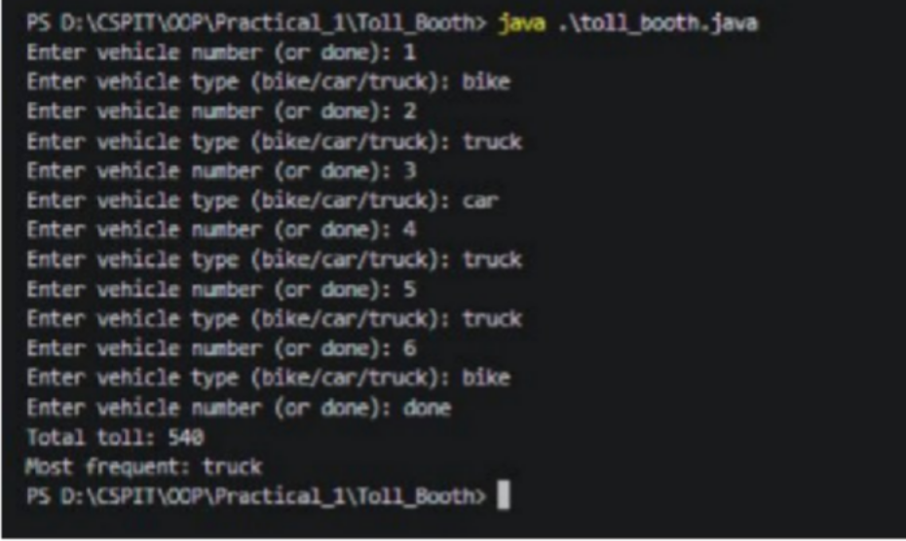

PART - B

MiniBank.java
public class MiniBank {

private static final Map<String, Account> accounts = new LinkedHashMap<>(); private static final BankInfo BANK = new BankInfo("MiniBank", "CSPIT Branch");

public static void main(String[] args) {
if (Arrays.asList(args).contains("--demo"))
{ runDemo(); return;
}
interactive();
}

private static void interactive()
{ System.out.println(BANK);
try (Scanner scanner = new Scanner(System.in))
{ boolean running = true; while (running) {
System.out.println("\n1.Open 2.Deposit 3.Withdraw 4.Transfer 5.Working hours 6.Exit"); System.out.print("Choice: ");
String input = scanner.nextLine().trim(); try {
int choice = Integer.parseInt(input);
String result = switch (choice) {

case 1 -> open(scanner);
case 2 -> deposit(scanner);
case 3 -> withdraw(scanner);
case 4 -> transfer(scanner);
case 5 ->
"Working hours: Monday-Saturday, 10:00 to 16:00."; case 6 -> {
running = false;
yield "Goodbye from MiniBank.";
}
default ->
"Invalid menu number. Please choose 1-6.";
};
System.out.println(result);
} catch (NumberFormatException e)
{ System.out.println("Enter a numbered menu option.");
}
}
}
}

Output :-
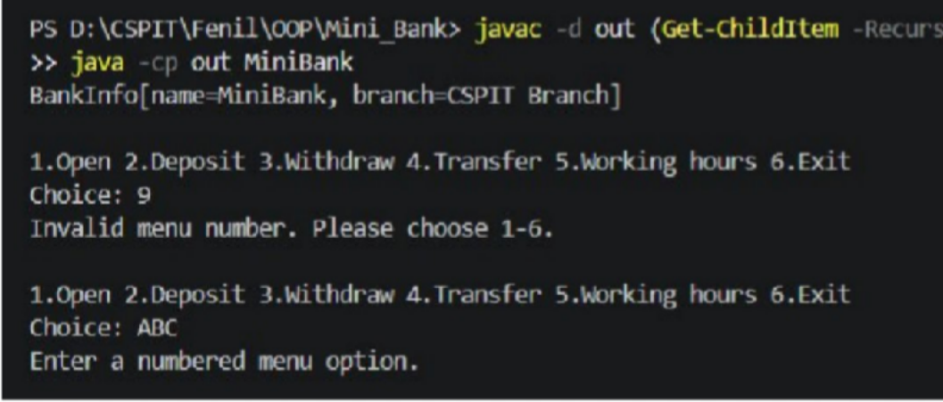

Learning Outcome:

The learning outcome of this practical is to understand and apply basic Java programming concepts such as enums, records, switch expressions, loops, user input, counters, and accumulators. Students will learn how to process user input, perform decision-making using switch expressions, calculate totals, track different categories, and determine the most frequent category.

PRACTICAL - 2
Aim: To develop a Java program to implement a toll booth using record and switch expression to calculate the total toll collected and determine the most frequently used vehicle type.

Code Screenshot:
- cinema_show:
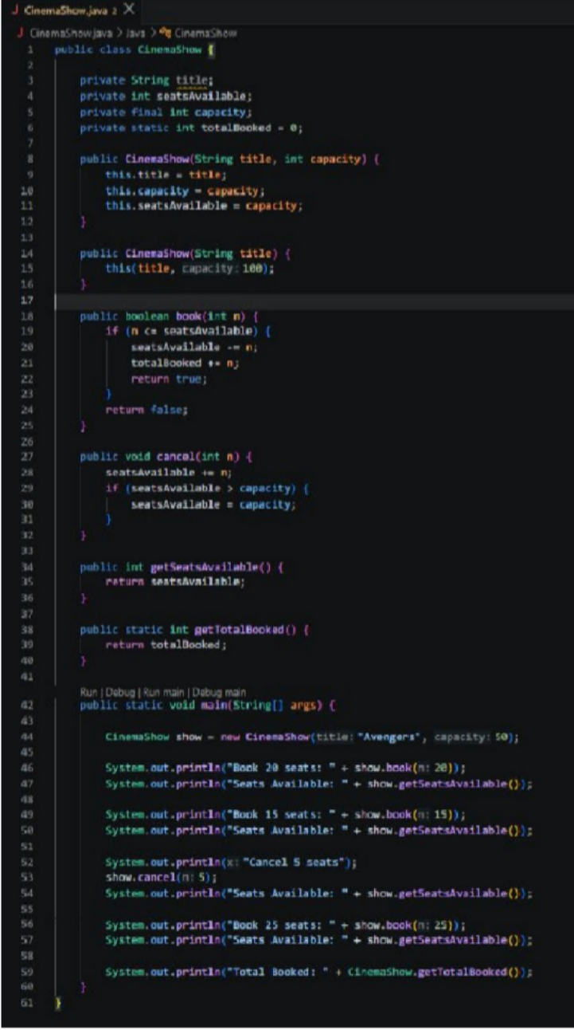

- smart_thermostat:
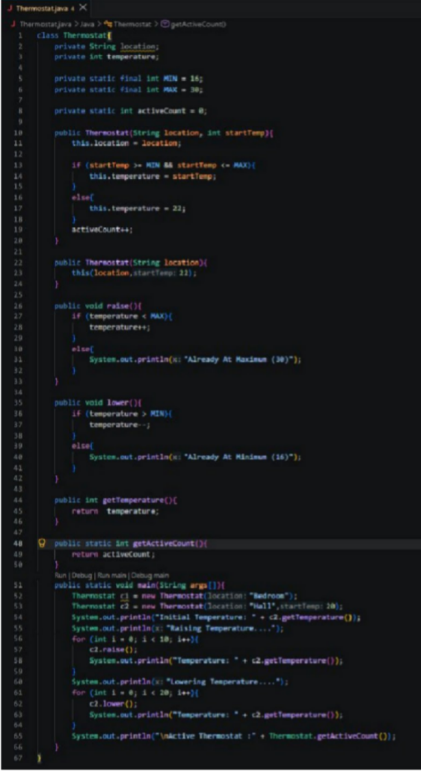

Output Screenshot:
- cinema_show:
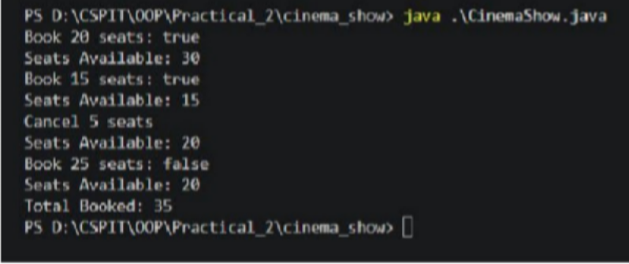

- smart_thermostat:
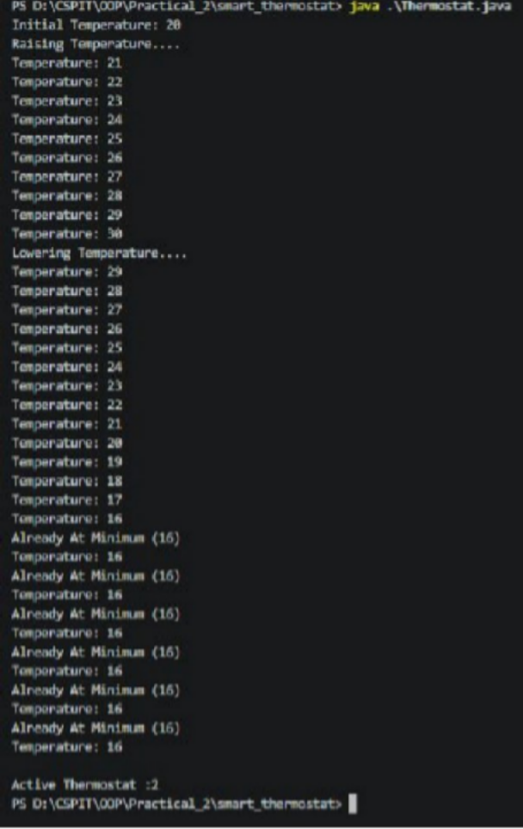

PART - B

Account.java
package model;

import exception.*; import java.io.*;
import java.util.Objects; import model.annotation.Id;
import model.annotation.Positive;

public abstract class Account implements Transactable, Serializable {

private static final long serialVersionUID = 1L; private static long counter = 1;
@Id
private final String accountNumber; private final String ownerName; @Positive
private long balance;
private boolean active = true;
private transient Object lock = new Object();

protected Account(String ownerName, long openingBalance) {
if (ownerName == null || ownerName.isBlank() || openingBalance < 0) {
throw new IllegalArgumentException("Owner and non-negative opening balance are required");

}this.accountNumber = nextNumber(); this.ownerName = ownerName; this.balance = openingBalance;
}

private static synchronized String nextNumber()
{ return String.format("AC%04d", counter++);
}

public final String getAccountNumber()
{ return accountNumber;
}

public final String getOwnerName()
{ return ownerName;
}

public final long getBalance()
{ synchronized (lock) { return balance;
}
}

public final boolean isActive() {

return active;
}

protected final Object accountLock()
{ return lock;
}

protected final long balanceUnsafe()
{ return balance;
}

@Override
public final void deposit(long amount) throws InvalidAmountException
{ synchronized (lock) { validateAmount(amount);
balance = Math.addExact(balance, amount);
}
}

@Override
public final boolean withdraw(long amount) throws InsufficientFundsException, InvalidAmountException {
synchronized (lock)
{ validateAmount(amount); if (!canWithdraw(amount)) {

throw new InsufficientFundsException("Withdrawal denied by account policy", Math.max(0, amount - Math.max(0, balance)));

}balance -= amount; return true;
}
}

public final void transfer(Account to, long amount) throws BankException
{ if (to == null) {
throw new AccountNotFoundException("Destination account is required");

}if (to == this) {
throw new BankException("Cannot transfer to the same account");

}Account first = this.accountNumber.compareTo(to.accountNumber) < 0 ? this : to; Account second = first == this ? to : this;
synchronized (first.lock)
{ synchronized (second.lock) { try {
validateAmount(amount);
if (!canWithdraw(amount)) {
throw new InsufficientFundsException("Transfer denied by account policy", Math.max(0, amount - Math.max(0, balance)));

}this.balance -= amount;

try {
to.balance = Math.addExact(to.balance, amount);
} catch (ArithmeticException e)
{ this.balance += amount;
throw new BankException("Transfer rolled back", e);
}
} finally {
/* locks release automatically */ }
}
}
}

private static void validateAmount(long amount) throws InvalidAmountException
{ if (amount <= 0) {
throw new InvalidAmountException("Amount must be positive");

}}

public abstract double interestRate();

public abstract boolean canWithdraw(long amount);

public final double monthlyInterest() {
return getBalance() * interestRate() / 1200.0;
}

@Override
public final boolean equals(Object other) {
return other instanceof Account a && accountNumber.equals(a.accountNumber);
}

@Override
public final int hashCode() {
return Objects.hash(accountNumber);
}

@Override
public String toString() {
return "%s{number=%s, owner=%s, balance=%d, active=%s}".formatted(getClass().getSimpleName(), accountNumber, ownerName, getBalance(), active);
}

private void readObject(ObjectInputStream in) throws IOException, ClassNotFoundException
{ in.defaultReadObject(); lock = new Object();
}
}

- Output :-
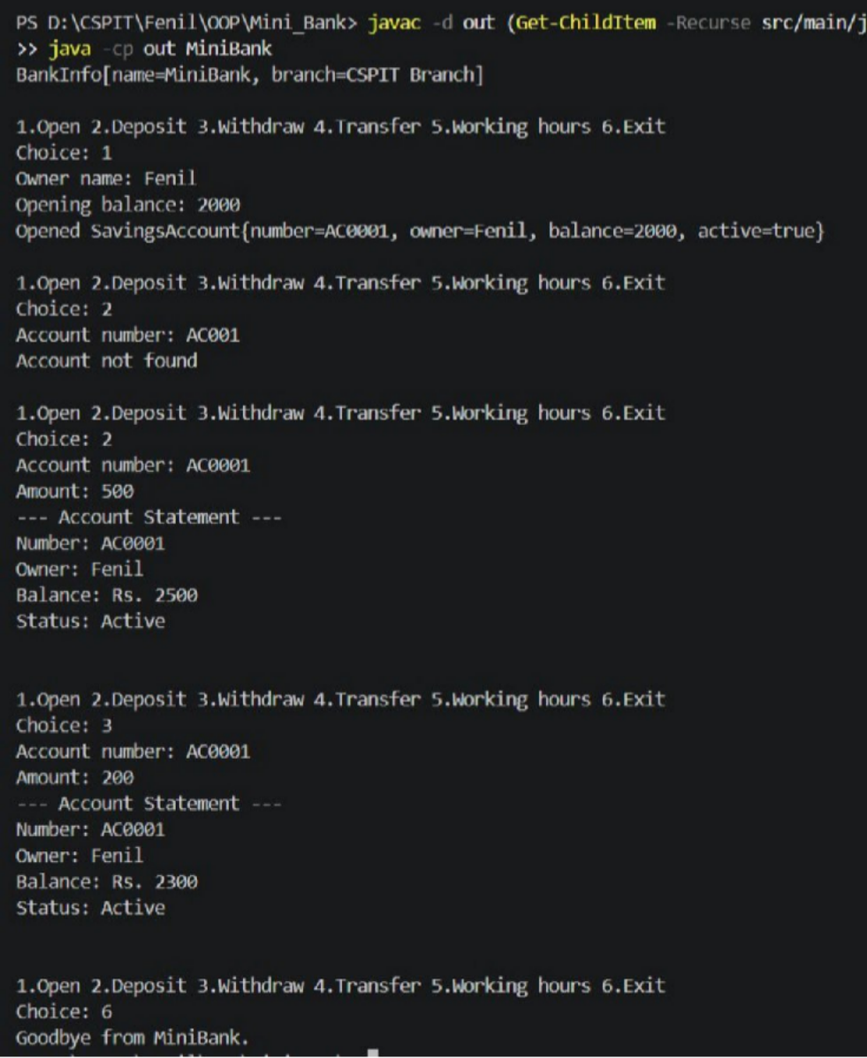

Learning Outcome:

The learning outcome of this practical is to understand and apply Java classes, constructors, constructor chaining, static and final variables, methods, conditional statements, and loops. Students will learn to manage object state, control values within specified limits, perform booking and cancellation operations, maintain shared counters, and access data using getter methods.

PRACTICAL - 3
Aim: To develop a Java program to identify and count distinct points using classes, equals(), hashCode(), and toString() methods.

Code Screenshot:
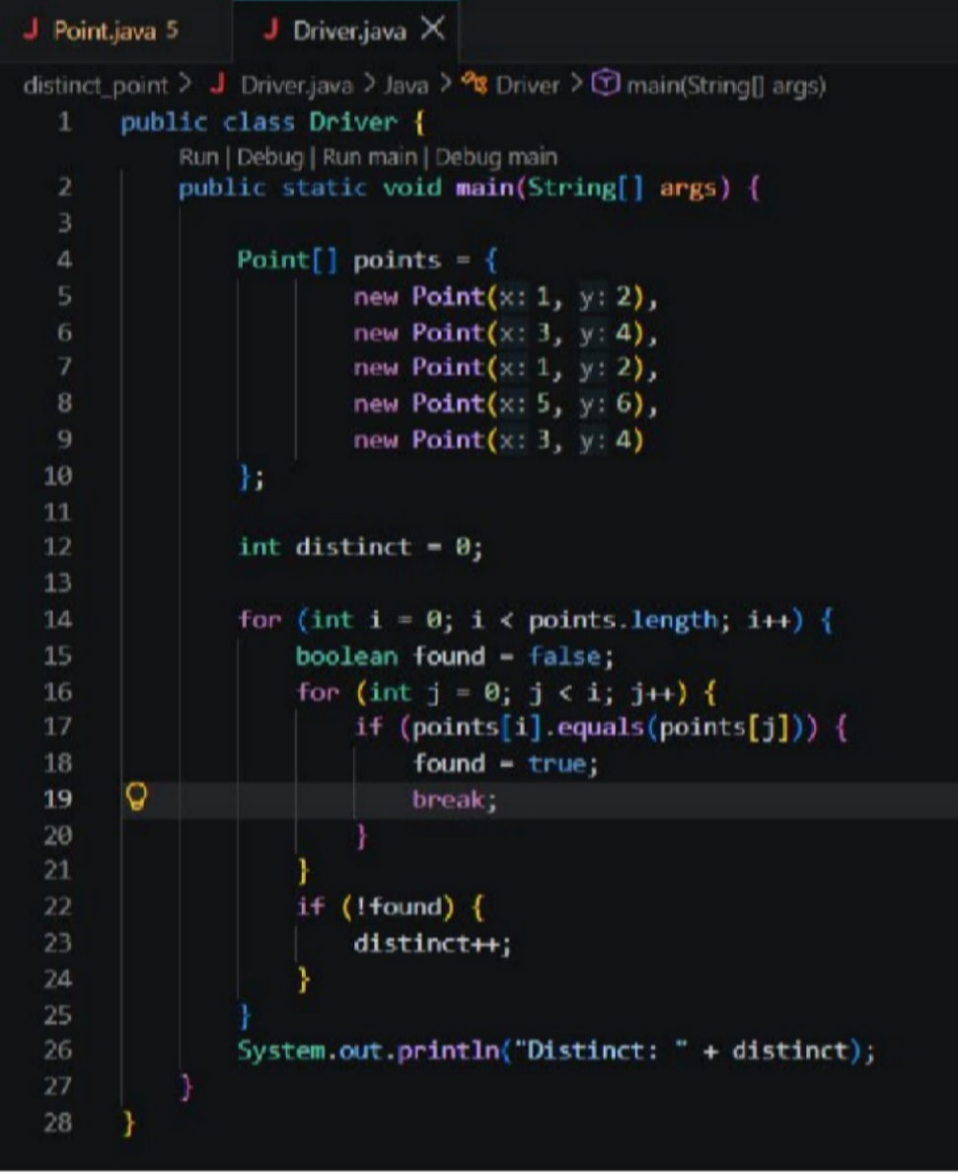
- distinct_point: Driver.java

pointer.java
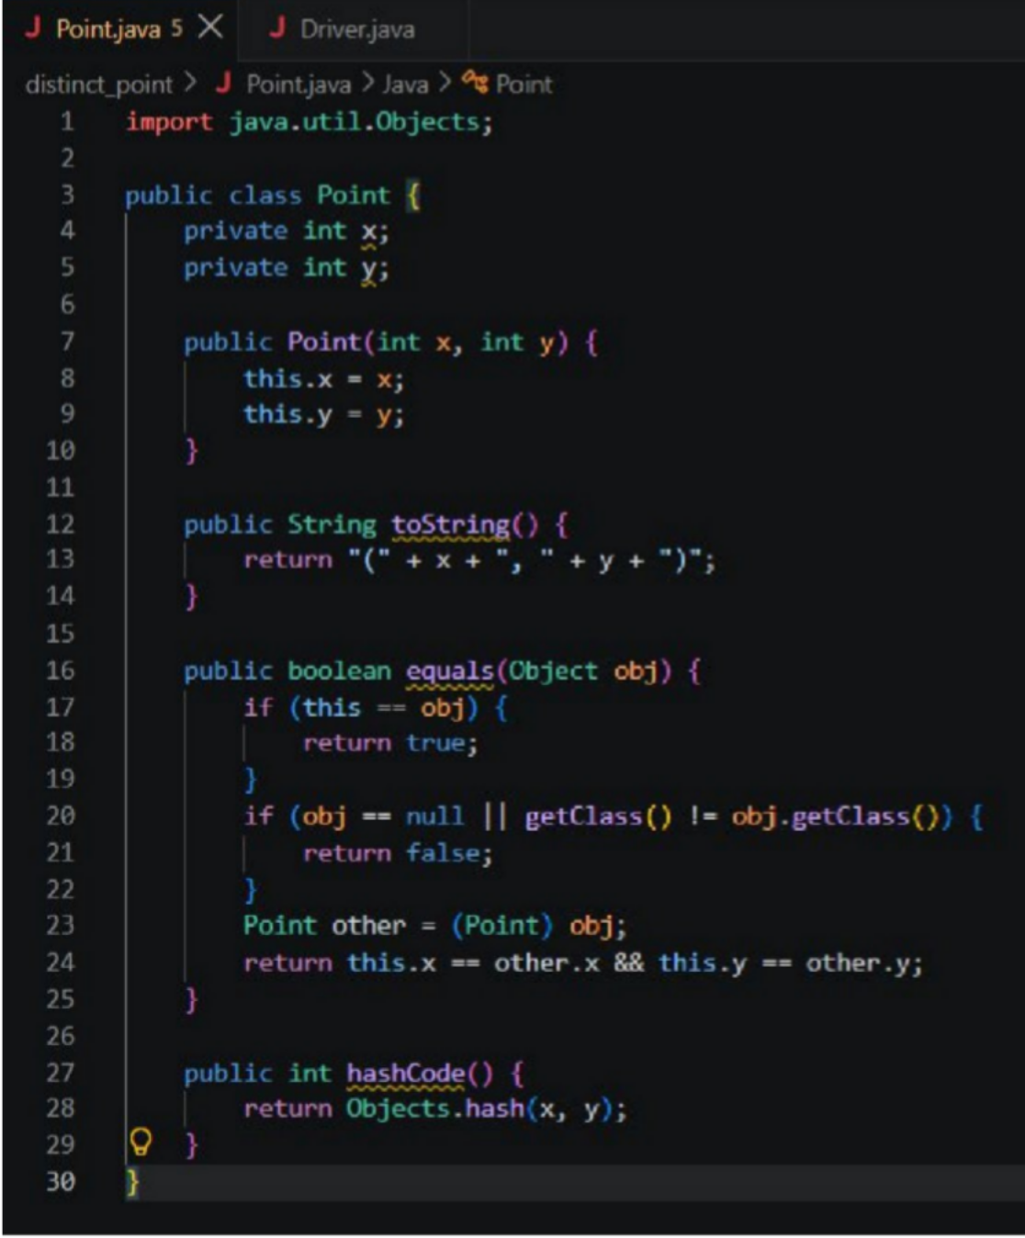

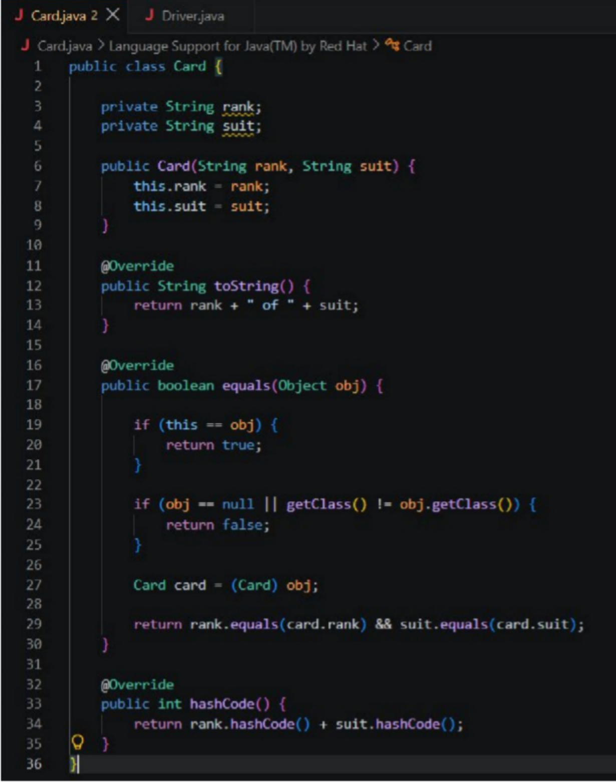
- duplicate_card_check: Card.java

Driver.java
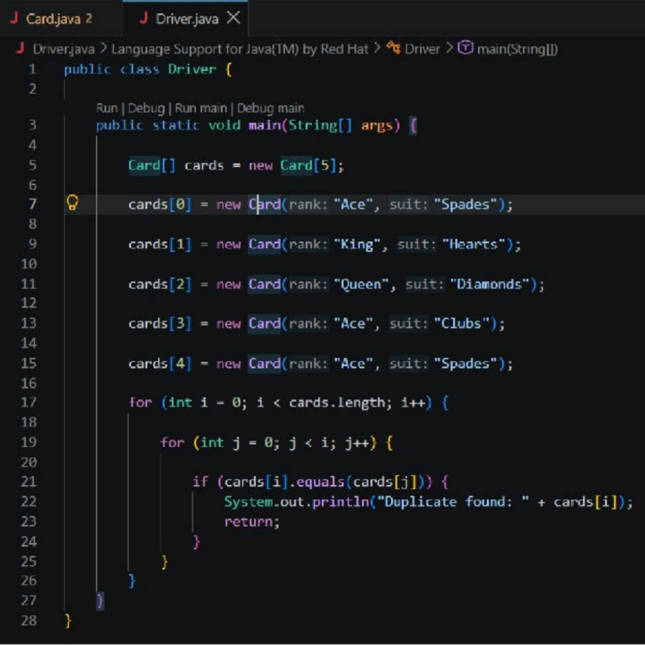

Output Screenshot:
- distinct_points:
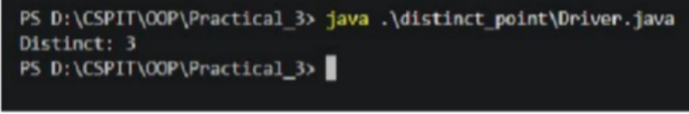
- duplicate_card_check:
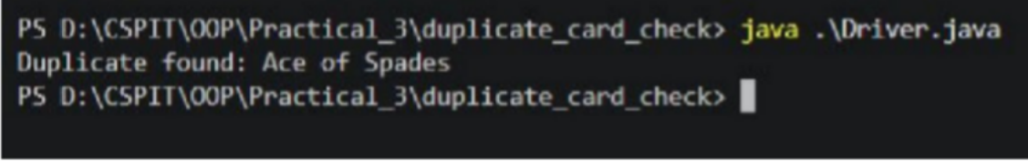

PART - B

Customer.java
package model;

import java.io.Serializable;
import model.annotation.MaxLength;

public class Customer implements Cloneable, Serializable {

private static final long serialVersionUID = 1L; private static long customerCounter = 101; private final String customerId; @MaxLength(10)
private String name;
private final String email, mobile; private final Address address;

public Customer(String name, String email, String mobile, Address address)
{ this.customerId = generateCustomerId(); this.name = name;
this.email = email; this.mobile = mobile;
this.address = address == null ? null : new Address(address.line, address.city, address.pincode);
}

private static synchronized String generateCustomerId()
{ return "CUST" + customerCounter++;
}

public String getCustomerId()
{ return customerId;
}

public String getName()
{ return name;
}

public String getEmail()
{ return email;
}

public String getMobile()
{ return mobile;
}

public Address getAddress() {
return address == null ? null : new Address(address.line, address.city, address.pincode);
}

@Override

public Customer clone()
{ try {
return (Customer) super.clone();
} catch (CloneNotSupportedException e)
{ throw new AssertionError(e);
}
}

public static class Address implements Serializable {

private static final long serialVersionUID = 1L; private final String line, city, pincode;

public Address(String line, String city, String pincode)
{ this.line = line; this.city = city; this.pincode = pincode;
}

public String getLine()
{ return line;
}

public String getCity()
{ return city;

}

public String getPincode()
{ return pincode;
}
}
}

- Output:-
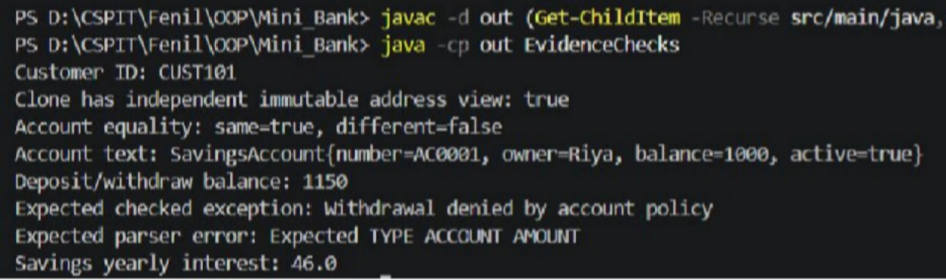

Learning Outcome:

The learning outcome of this practical is to understand and apply Java classes, constructors, arrays, toString(), equals(), and hashCode() methods. Students will learn how to compare objects based on their data, identify repeated objects, count distinct elements, and detect duplicate cards using object equality.

PRACTICAL - 4
Aim: 1. Password strength (PasswordChecker.java + Driver.java)
- In PasswordChecker, check four rules — length ≥ 8, contains an uppercase letter, contains a digit, contains a special character — using regex (e.g. “.*[A-Z].*”) or String methods.
- Write strength(String pw) that counts how many rules pass and returns “Weak” (0– 1), “Medium” (2–3) or “Strong” (4).
- In Driver.main: test several passwords; for each, print which rules passed and the final label.Expected output: “abc” → Weak; “Abcd1234!” → Strong.2

Code Screenshot:
PasswordChecker.java
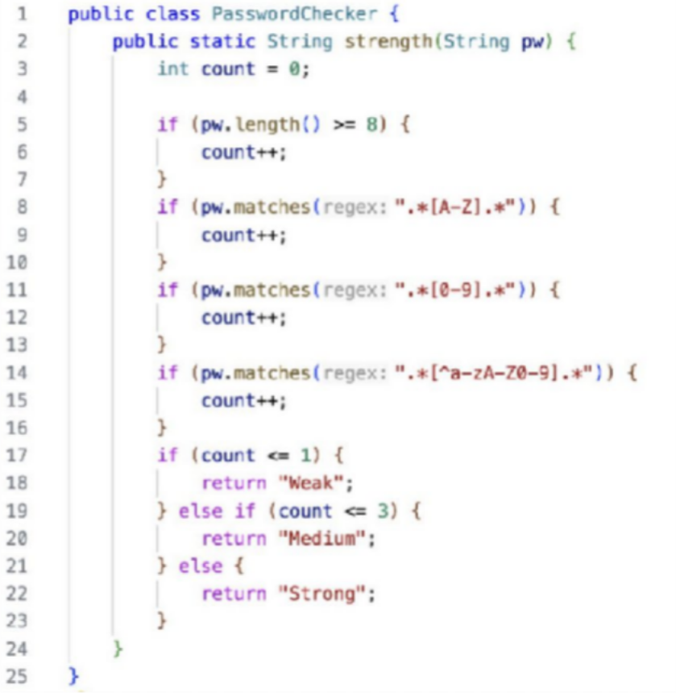

Driver.java

Output Screenshot:
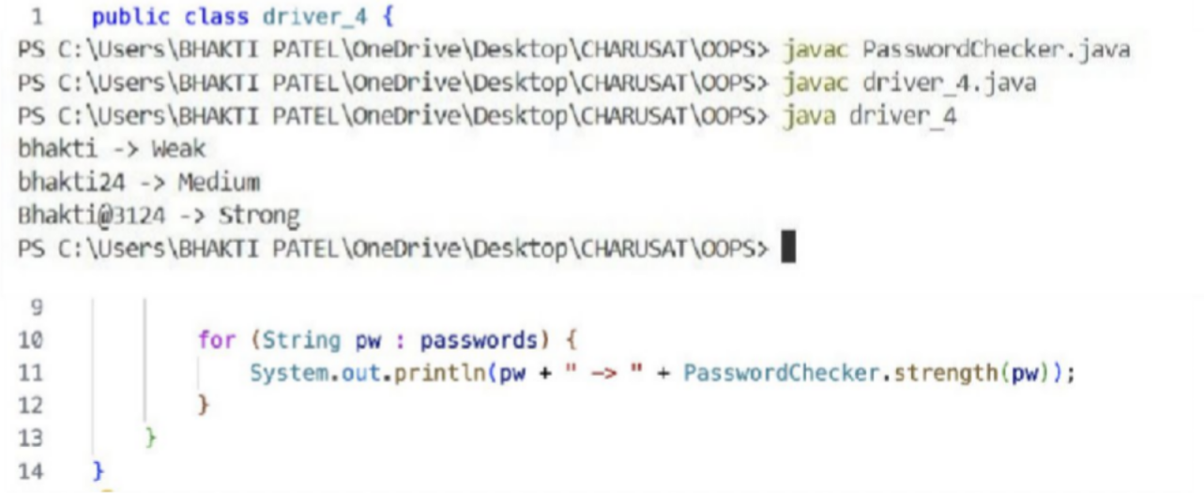

Learning Outcome:
To understand and implement Java classes, methods, string handling, and conditional logic for validating password security rules. The program helps in checking password characteristics, calculating password strength, and classifying passwords as Weak, Medium, or Strong based on the number of rules satisfied.

Aim : 2. Chat-log filter (ChatFilter.java + Driver.java)
- In Driver.main, define a String[] of log lines like “10:05 alice Hello there” (include one malformed line with fewer than 3 parts).
- Read a keyword from the user.
- For each line, split into time/user/message with split(“ ”, 3); skip lines that do not have 3 parts.
- If the message contains the keyword (case-insensitive), increment a counter and append “time user: message” to a StringBuilder.

- Print “Matches: N” and the built report.Expected output: keyword
“hello” over 3 lines (1 malformed) → “Matches: 1” and the matching line.3.

Code Screenshot:
ChatFilter.java

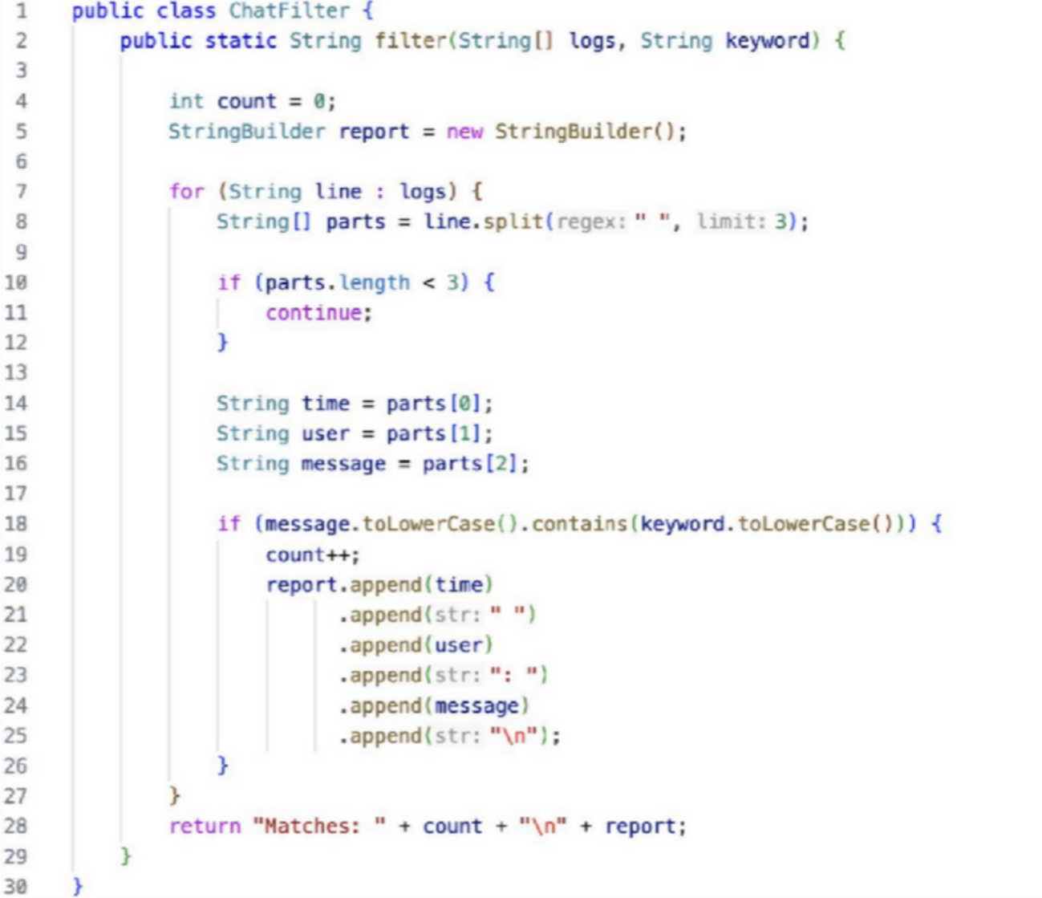

Driver.java
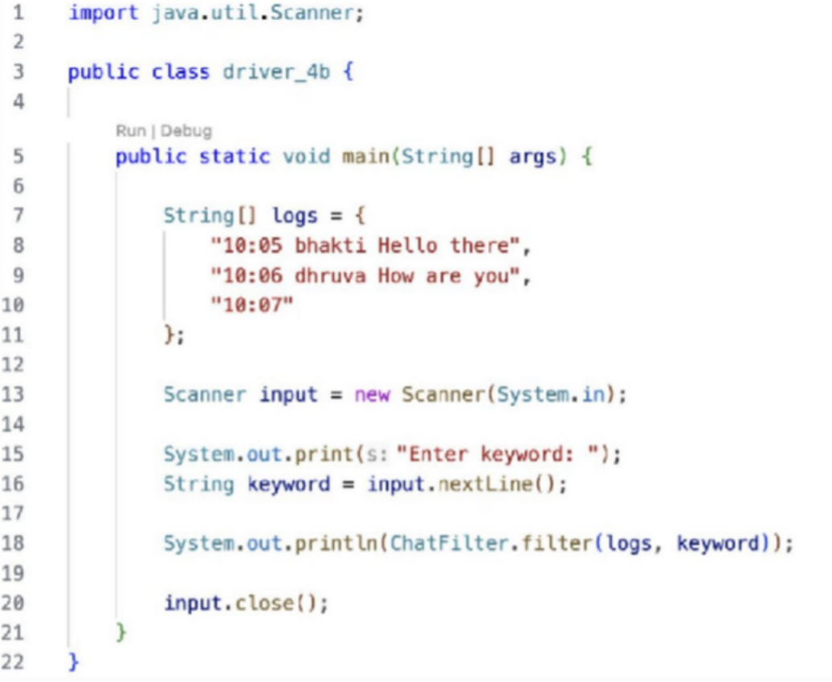

Output Screenshot:
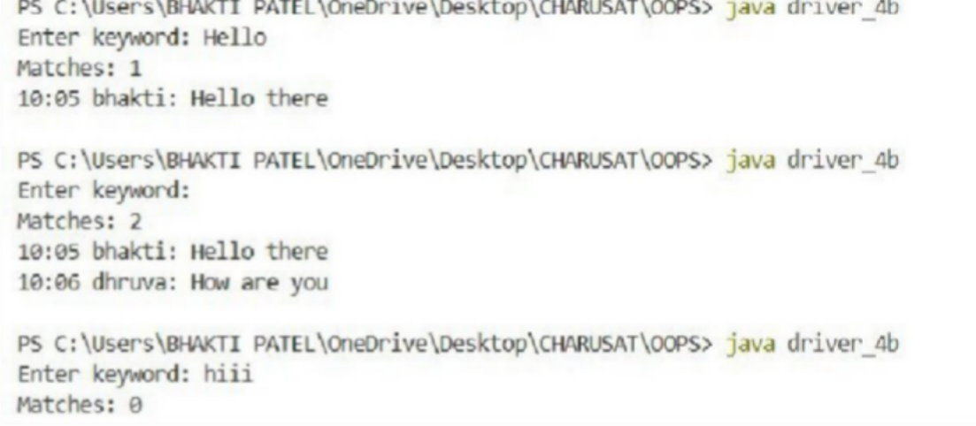

PART - B

util/Validator.java

package util;

import java.util.regex.Pattern; public final class Validator {
private Validator() {
}
private static final Pattern MOBILE = Pattern.compile("^[6-9][0-9]{9}$"), EMAIL = Pattern.compile("^[A-Za-z0-9._%+-]+@[A-Za-z0-9.-]+\\.[A-Za-z]{2,}$"), PAN =
Pattern.compile("^[A-Z]{5}[0-9]{4}[A-Z]$"), IFSC = Pattern.compile("^[A-Z]{4}0[A-Z0-9]{6}$"), AMOUNT = Pattern.compile("^[1-9][0-9]*$");

public static boolean isValidMobile(String s) {
return s != null && MOBILE.matcher(s).matches();
}

public static boolean isValidEmail(String s) {
return s != null && EMAIL.matcher(s).matches();
}

public static boolean isValidPan(String s)
{ return s != null && PAN.matcher(s).matches();
}

public static boolean isValidIfsc(String s) { return s != null && IFSC.matcher(s).matches();
}

public static boolean isValidAmount(String s) {
return s != null && AMOUNT.matcher(s).matches();
}
}
- Output:-

Learning Outcome:
To understand and implement Java string manipulation, arrays, Scanner, split(), StringBuilder, and conditional statements. The program helps in processing chat-log data, handling malformed input, performing case-insensitive keyword searches, and generating a filtered chat report efficiently.

PRACTICAL - 5
Aim: This practical demonstrates abstraction, inheritance, constructors, arrays, and polymorphism in Java. Abstract classes and methods are used to define common behavior, while subclasses provide specific implementations for shape areas and employee salaries.

Code Screenshot:
- shape_areas: Shape_Test.java
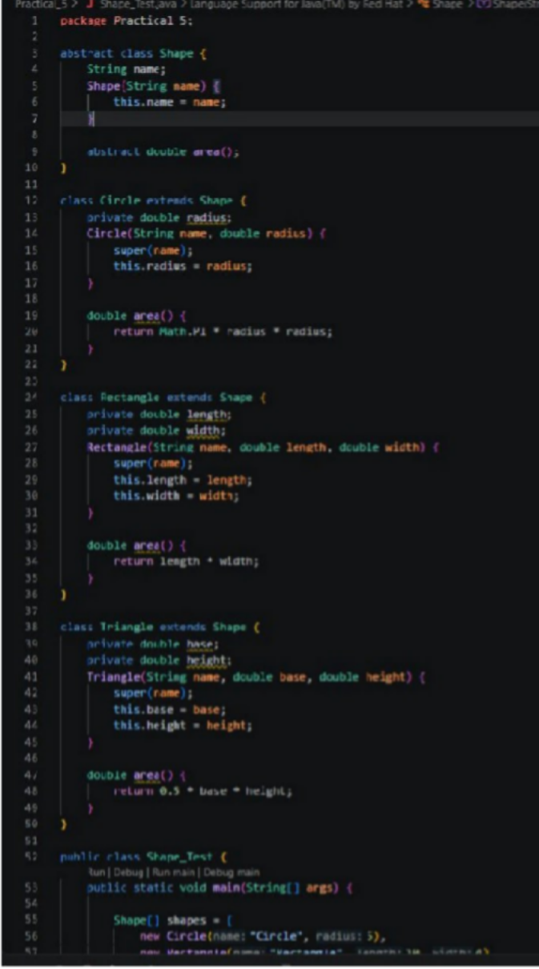

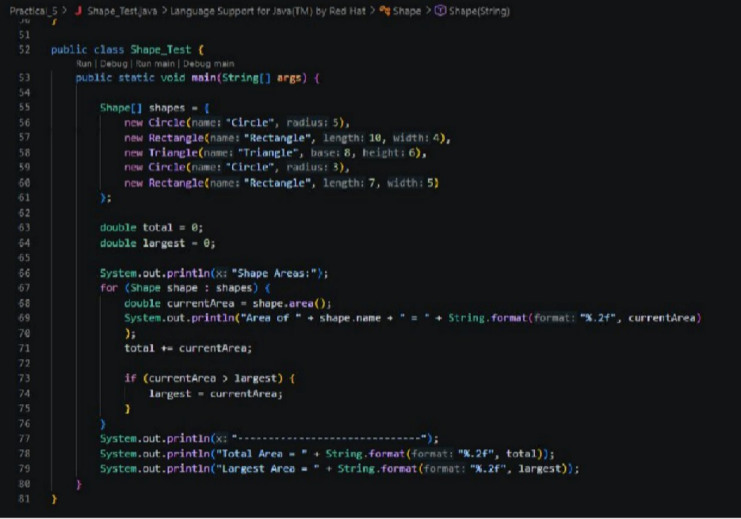

Payroll: Payroll.java
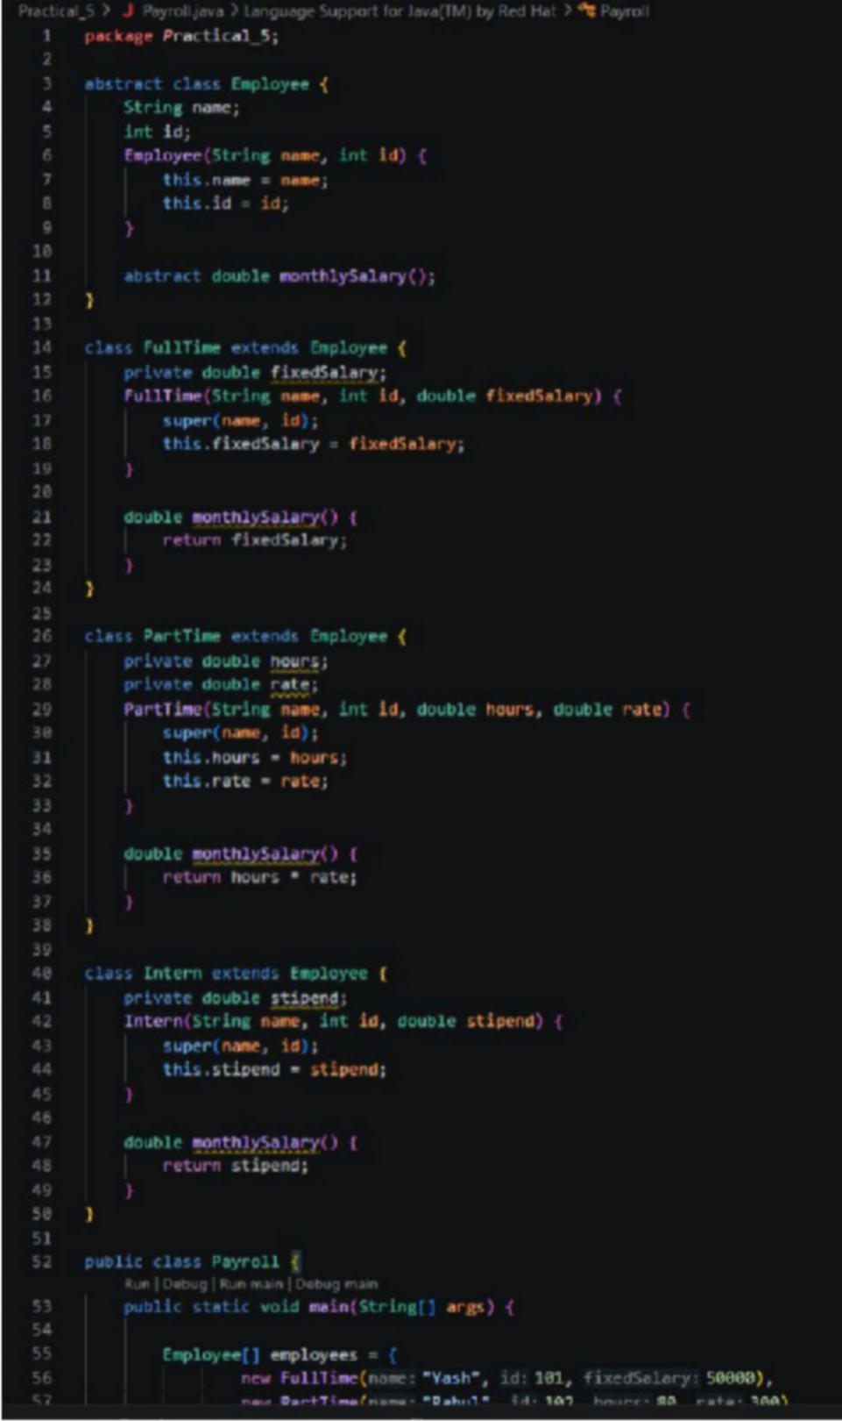

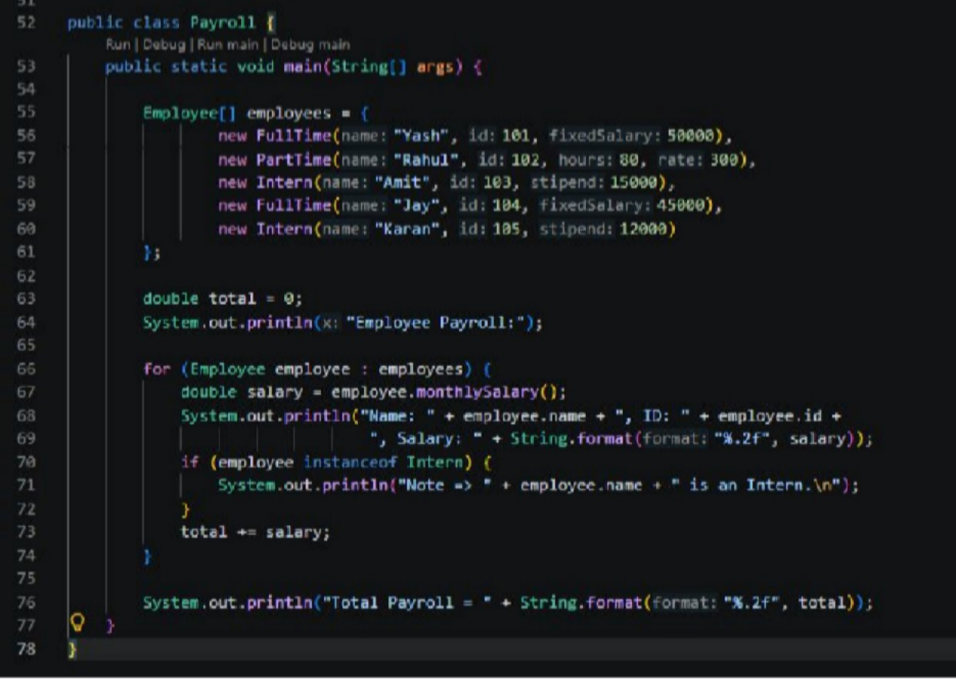

Output Screenshot:
- Shape_Test:
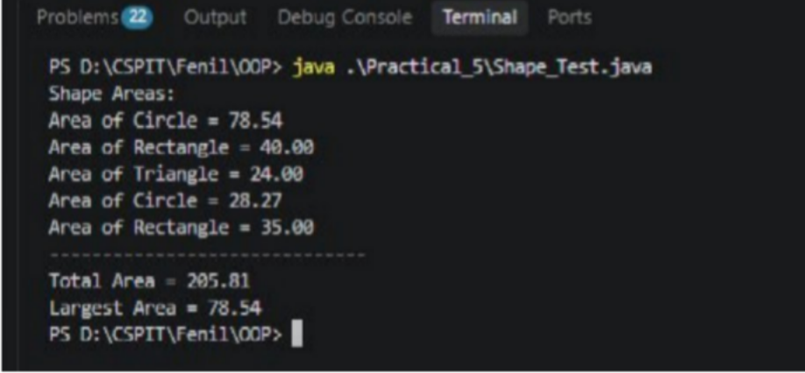

Payroll:
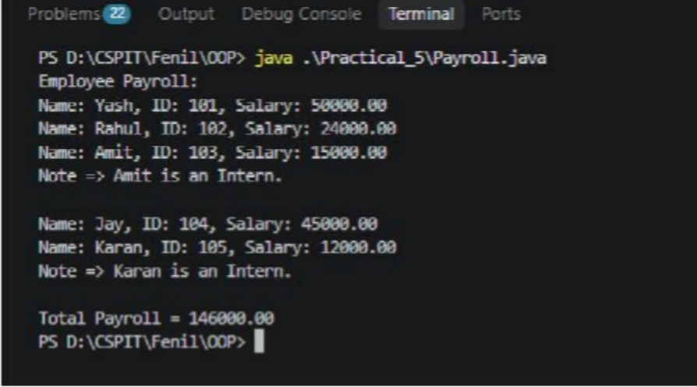

PART – B

SavingsAccount.java
package model;

public class SavingsAccount extends Account implements InterestBearing {

private static final long serialVersionUID = 1L; private final long minBalance;

public SavingsAccount(String owner, long opening, long minBalance)
{ super(owner, opening); if (minBalance < 0) {
throw new IllegalArgumentException("Minimum balance cannot be negative");

}this.minBalance = minBalance;
}

public long getMinBalance()
{ return minBalance;
}

@Override
public double interestRate()
{ return 4.0;

}

@Override
public boolean canWithdraw(long amount) {
return amount > 0 && balanceUnsafe() - amount >= minBalance;
}
}

- Output:-
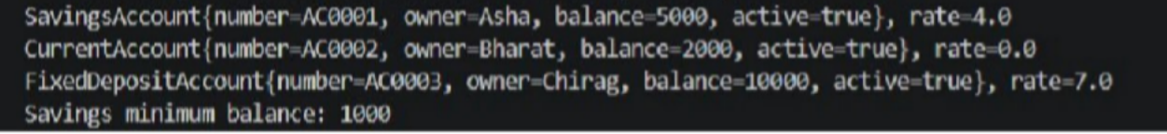

Learning Outcome:
The learning outcome of this practical is to understand and apply abstract classes, abstract methods, inheritance, constructors, arrays, and polymorphism in Java. Students will learn to process different objects through a common parent reference, calculate shape areas and employee salaries, find totals and maximum values, and use instance of to identify specific object types.

PRACTICAL - 6

Aim: 1. Remote control: an interface Switchable with on()/off() and a default toggle(); Fan and Light implement it. Loop over a Switchable[] toggling each. Then add a functional interface that decides, given a device and an hour, whether it may switch on, and supply it once as an anonymous class and once as a lambda.

Code Screenshot:

RemoteControl.java
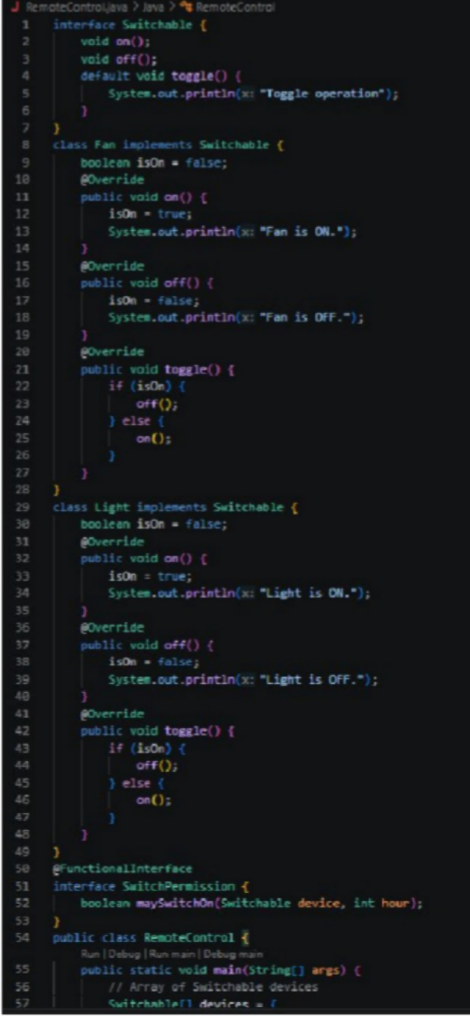

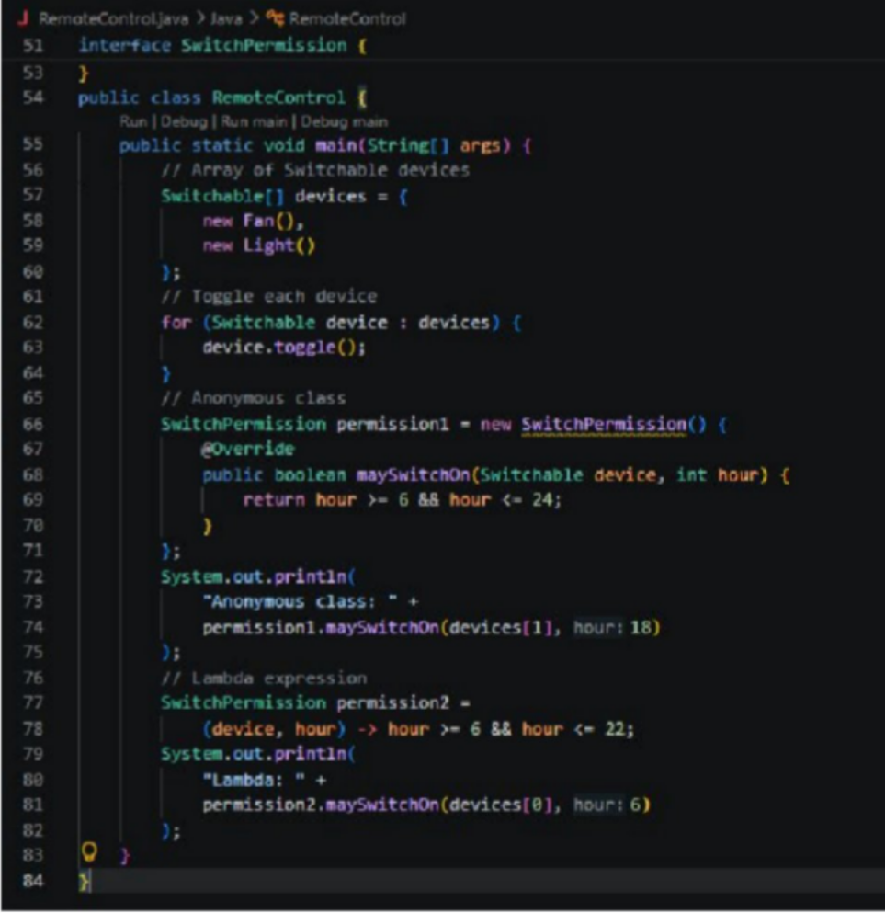

Output Screenshot:
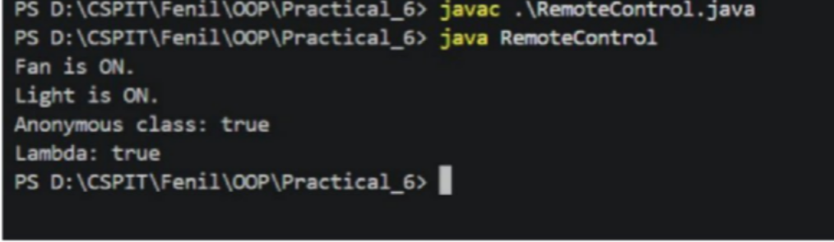

Learning Outcome:
To understand and implement interfaces, default methods, method overriding, polymorphism, functional interfaces, anonymous classes, and lambda expressions in Java. The program demonstrates how different devices such as Fan and Light implement a common Switchable interface, use the toggle() method through an array of Switchable objects, and define switching permissions using a functional interface implemented by both an anonymous class and a lambda expression.

Aim : 2. Notification senders: a functional interface Notifier with send(String); make email and SMS senders as lambdas, hold them in an array, and broadcast one message through all. Add a marker interface Urgent and send twice for senders marked urgent.

Code Screenshot:

NotificationSender.java
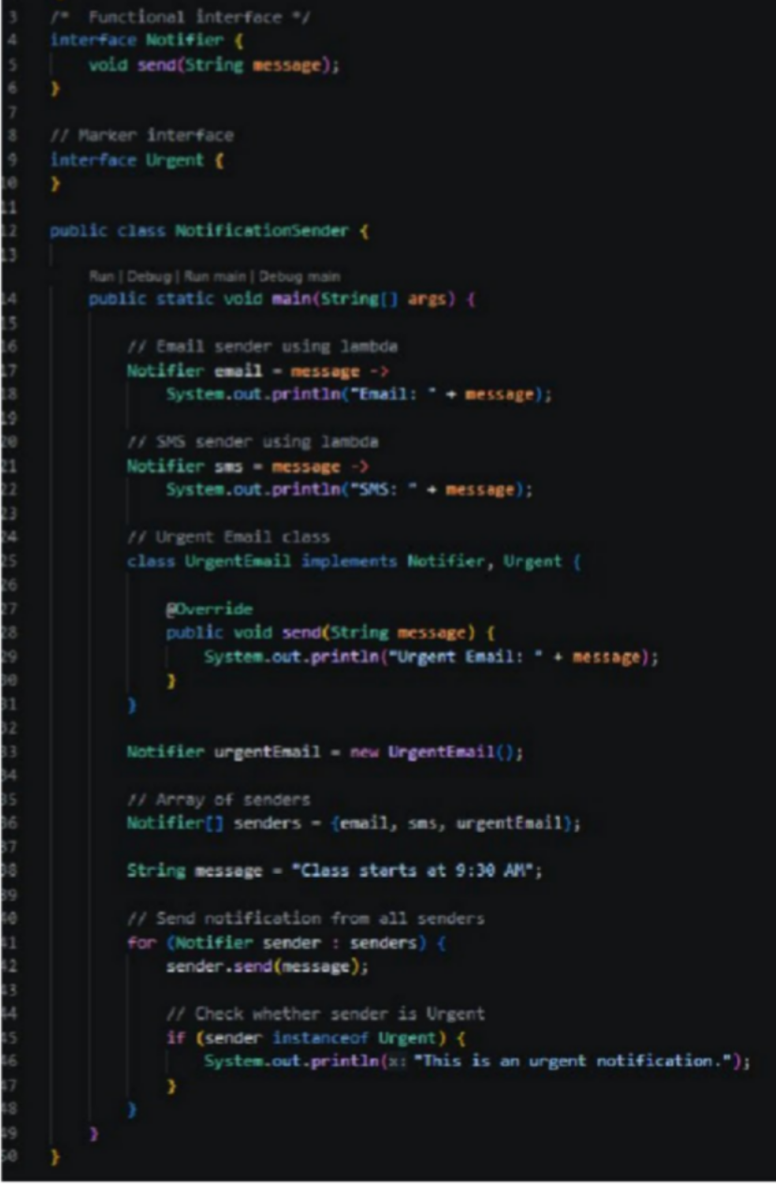

Output Screenshot:

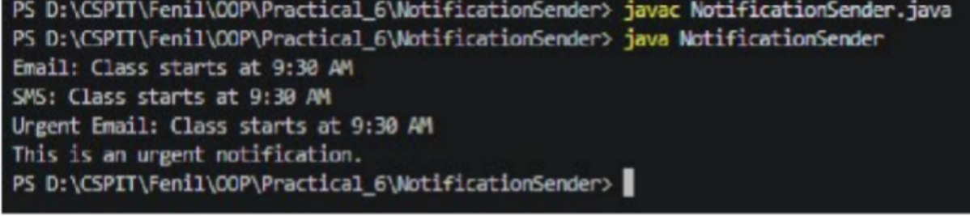

PART - B

Model/InterestBearing.java

package model;
public interface InterestBearing
{ double interestRate(); long getBalance();
default double yearlyInterest() { return getBalance() * interestRate() / 100.0; }
}
- Output:-

Learning Outcome:
To understand and implement functional interfaces, lambda expressions, arrays of interface objects, and marker interfaces in Java. The program demonstrates how Email and SMS notification senders can implement a common Notifier functional interface using lambda expressions, store them in an array, and broadcast a message to all senders. It also demonstrates the use of the Urgent marker interface to identify urgent senders and send the notification twice to them.

PRACTICAL - 7
Aim : 1. Form validator: define @NotBlank and @MaxLength(int) for fields and annotate a Signup Form. Write a checker that uses reflection to read each field’s annotations and returns the list of validation errors for a given object.

Code Screenshot: FormValidator.java
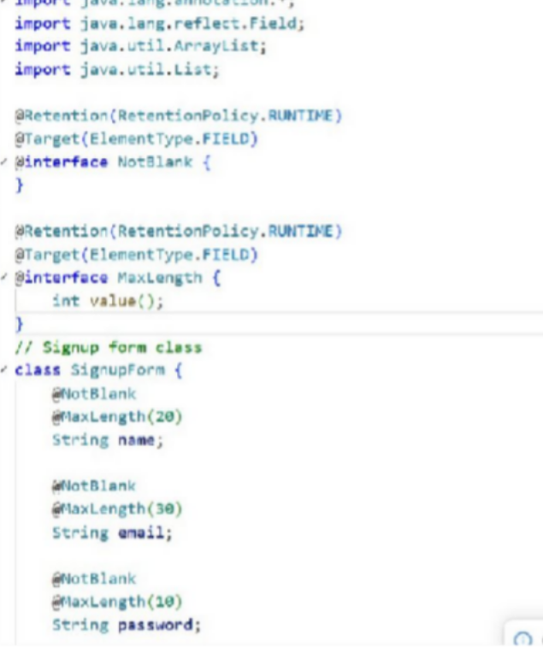
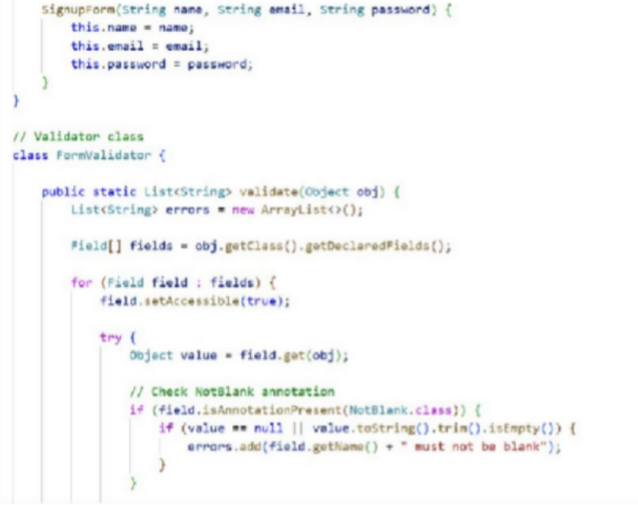

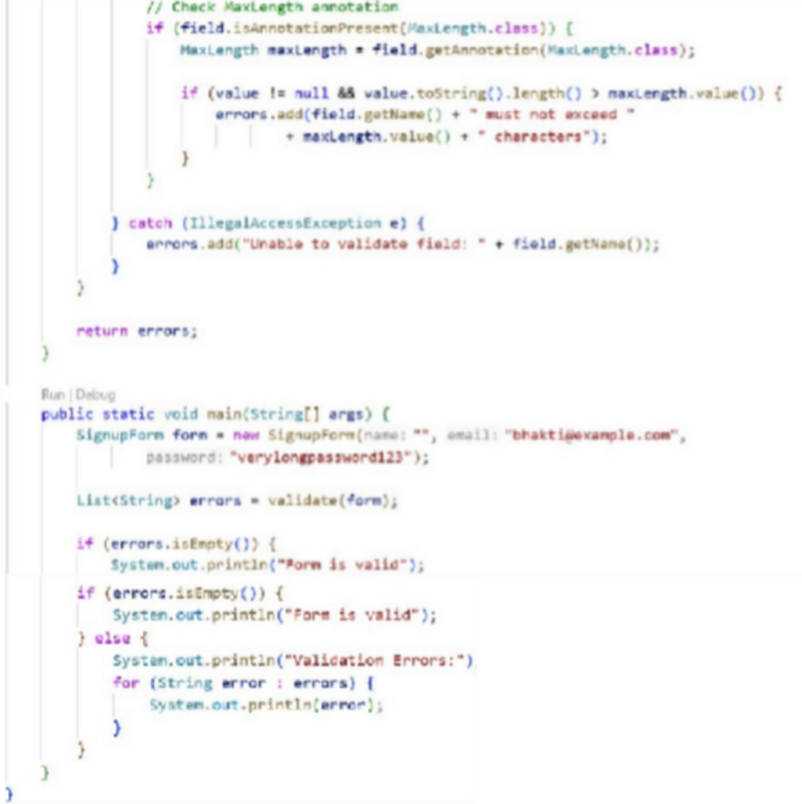

Output Screenshot:
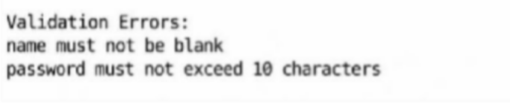

Aim: Mini test runner: define a @Run annotation and mark some no-arg methods of a class with it. Use reflection to find and invoke only the @Run methods and report how many
ran — the idea behind how JUnit finds @Test methods.

Code Screenshot: MiniTestRunner.java
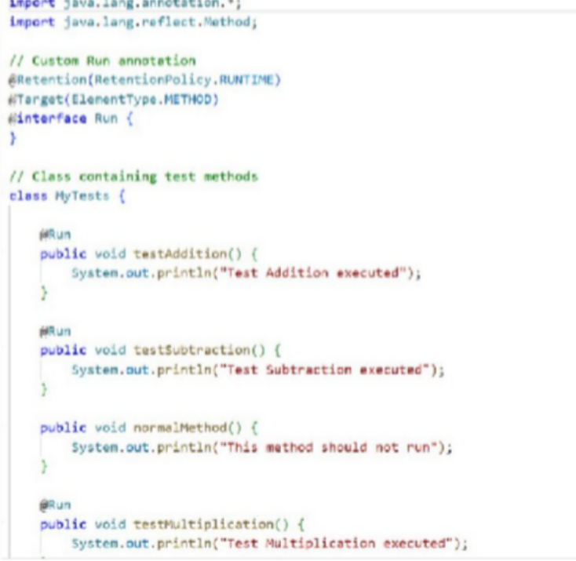
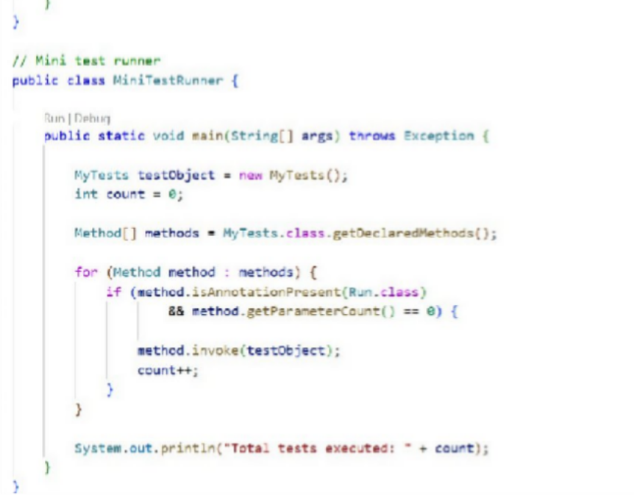

Output Screenshot
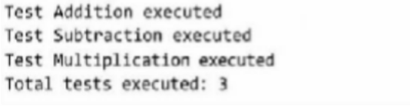

Learning Outcome:
To understand the creation and use of custom annotations in Java. Learned how to use Reflection API to identify and execute methods annotated with @Run at runtime. Also understood how to check method parameters and count the total number of test methods executed.

PRACTICAL - 8

Aim: 1. Guarded calculator: read two numbers and an operator; throw a custom DivideByZeroException and catch invalid-number input separately, printing a clear message each time; loop until a valid calculation succeeds and use finally to log each attempt.
Code Screenshot:
GuardedCalculator.java

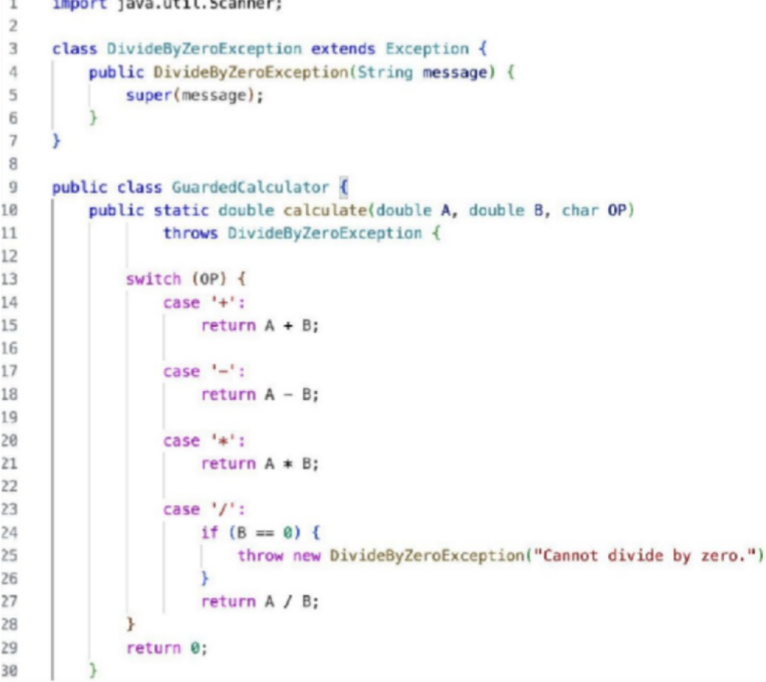

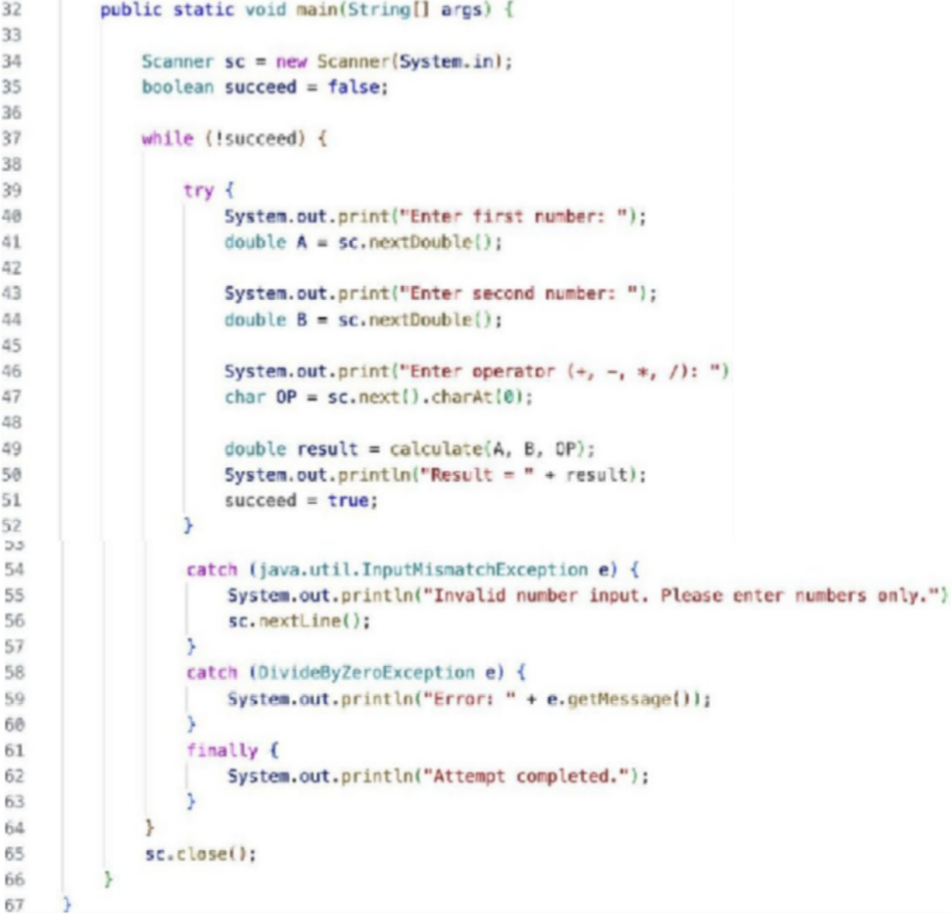

Output Screenshot:
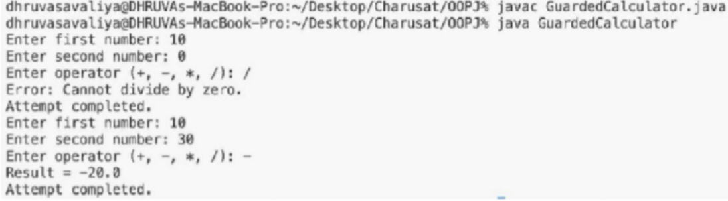

Learning Outcome:
To understand and implement exception handling in Java using custom exceptions, try-catch-finally blocks, and loops. The program demonstrates how to create and throw a custom DivideByZeroException, handle invalid number input separately using NumberFormatException, use the finally block to log every calculation attempt, and repeatedly accept input until a valid calculation is successfully completed.

Aim : 2. Stock issue: a Warehouse where issue(item, qty) throws a custom checked OutOfStockException carrying the shortfall, and InvalidQuantityException for qty ≤ 0. Process a list of requests, catching and reporting each failure without stopping the run.

Code Screenshot:
StockIssue.java
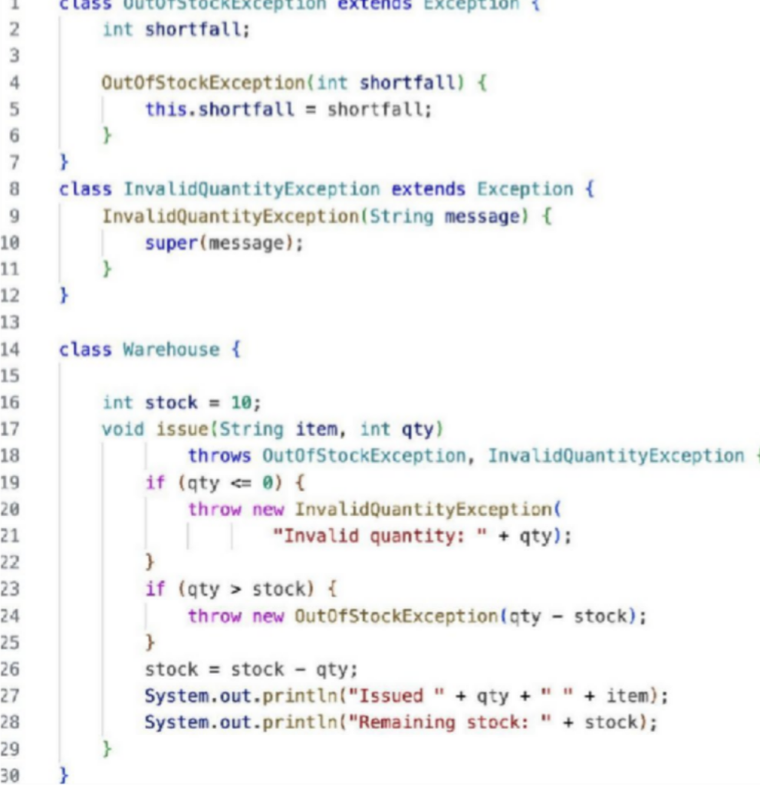

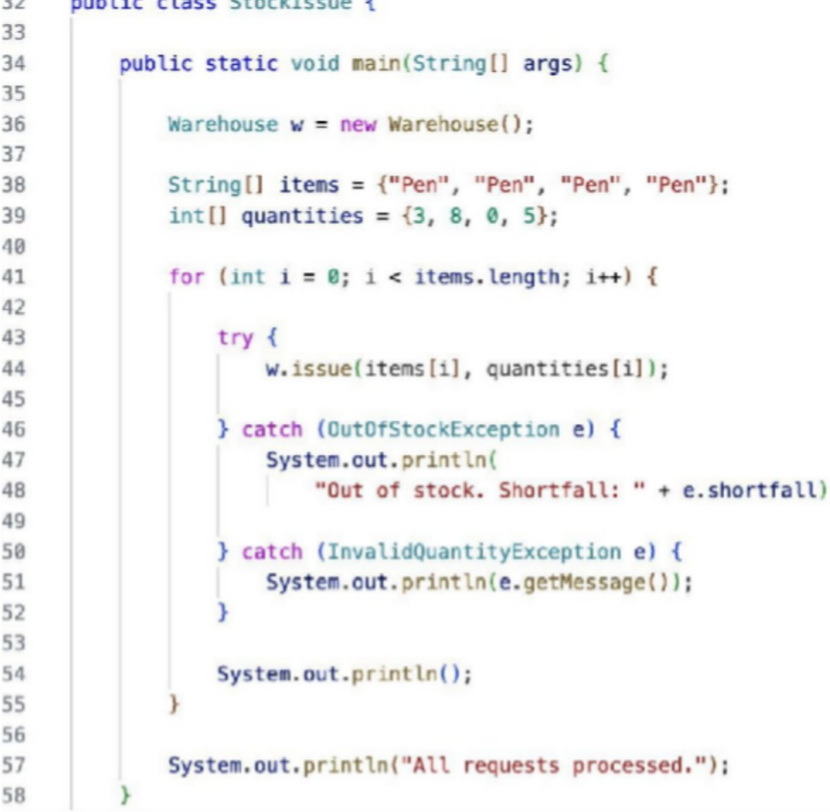

Output Screenshot:
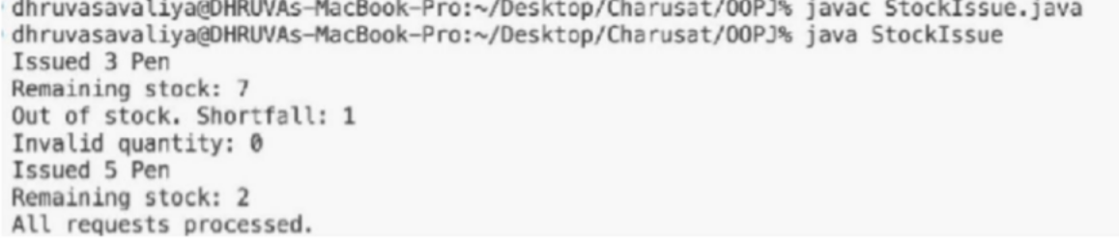

PART - B

Model/Account.java
package model;

import exception.*; import java.io.*;
import java.util.Objects; import model.annotation.Id;
import model.annotation.Positive;

public abstract class Account implements Transactable, Serializable
{ private static final long serialVersionUID = 1L; private static long counter = 1;
@Id
private final String accountNumber; private final String ownerName; @Positive
private long balance;
private boolean active = true;
private transient Object lock = new Object();

protected Account(String ownerName, long openingBalance) {
if (ownerName == null || ownerName.isBlank() || openingBalance < 0) {
throw new IllegalArgumentException("Owner and non-negative opening balance are required");

}this.accountNumber = nextNumber(); this.ownerName = ownerName; this.balance = openingBalance;
}

private static synchronized String nextNumber()
{ return String.format("AC%04d", counter++);
}

public final String getAccountNumber()
{ return accountNumber;
}

public final String getOwnerName()
{ return ownerName;
}

public final long getBalance()
{ synchronized (lock) { return balance;
}
}

public final boolean isActive()
{ return active;
}

protected final Object accountLock()
{ return lock;
}

protected final long balanceUnsafe()
{ return balance;
}
@Override
public final void deposit(long amount) throws InvalidAmountException
{ synchronized (lock) { validateAmount(amount);
balance = Math.addExact(balance, amount);
}
}
@Override
public final boolean withdraw(long amount) throws InsufficientFundsException, InvalidAmountException
{ synchronized (lock) { validateAmount(amount);
if (!canWithdraw(amount)) {
throw new InsufficientFundsException("Withdrawal denied by account policy", Math.max(0, amount - Math.max(0, balance)));
}balance -= amount; return true;
}
}
public final void transfer(Account to, long amount) throws BankException
{ if (to == null) {
throw new AccountNotFoundException("Destination account is required");
}if (to == this) {
throw new BankException("Cannot transfer to the same account");
}Account first = this.accountNumber.compareTo(to.accountNumber) < 0 ? this : to; Account second = first == this ? to : this;
synchronized (first.lock)
{ synchronized (second.lock) { try {
validateAmount(amount);
if (!canWithdraw(amount)) {
throw new InsufficientFundsException("Transfer denied by account policy", Math.max(0, amount - Math.max(0, balance)));
}this.balance -= amount; try {
to.balance = Math.addExact(to.balance, amount);
} catch (ArithmeticException e)
{ this.balance += amount;
throw new BankException("Transfer rolled back", e);
}
} finally {
/* locks release automatically */ }
}
}
}

private static void validateAmount(long amount) throws InvalidAmountException
{ if (amount <= 0) {

throw new InvalidAmountException("Amount must be positive");
}}
public abstract double interestRate();
public abstract boolean canWithdraw(long amount); public final double monthlyInterest() {
return getBalance() * interestRate() / 1200.0;
}
@Override
public final boolean equals(Object other) {
return other instanceof Account a && accountNumber.equals(a.accountNumber);
}
@Override
public final int hashCode() {
return Objects.hash(accountNumber);
}
@Override
public String toString() {
return "%s{number=%s, owner=%s, balance=%d, active=%s}".formatted(getClass().getSimpleName(), accountNumber, ownerName, getBalance(), active);
}
private void readObject(ObjectInputStream in) throws IOException, ClassNotFoundException
{ in.defaultReadObject(); lock = new Object();
}
}

- Output:-

Learning Outcome:
To understand and implement custom checked exceptions in Java for handling stock-related errors. The program demonstrates how to create and throw custom OutOfStockException carrying the required shortfall and InvalidQuantityException for invalid quantities, while processing multiple stock requests. It also demonstrates exception handling that reports each failure individually without stopping the execution of the remaining requests.

PRACTICAL - 9

Aim: 1. Counter race: several threads each increment a shared counter many times. Run it without synchronization to watch the total come out too low, then make the increment synchronized and confirm it is exactly right every run.
Code Screenshot:
CounterRace.java:-
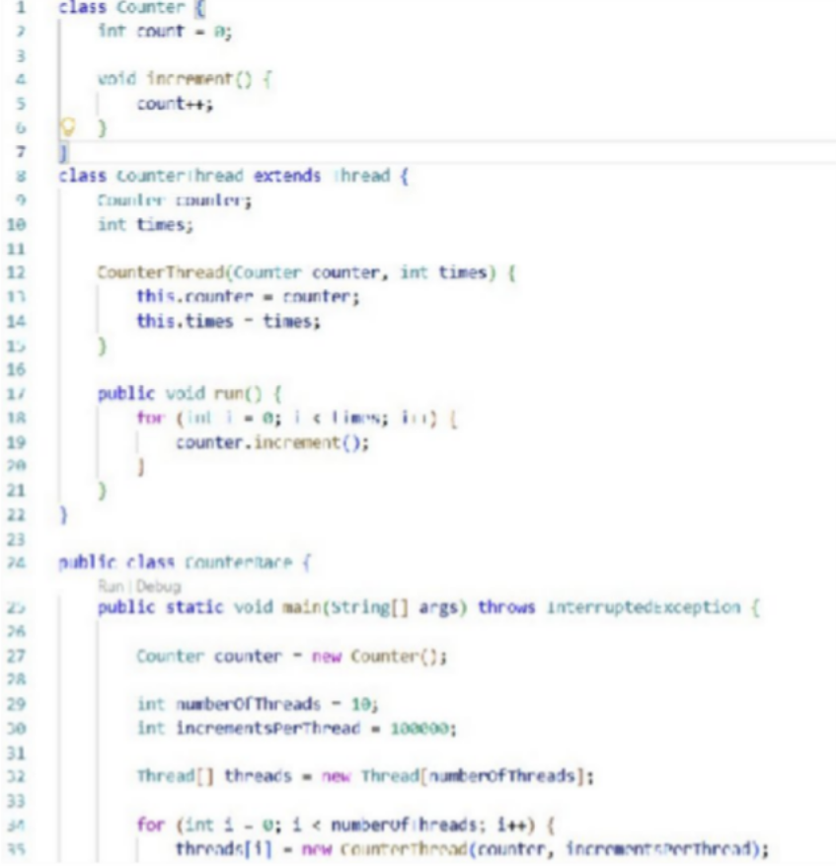
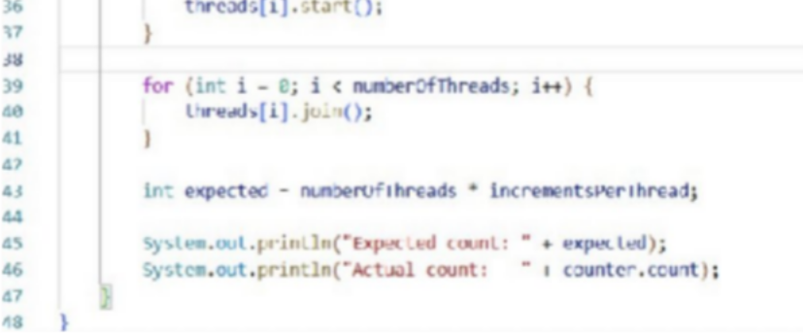
Program 1A - Without Synchronization

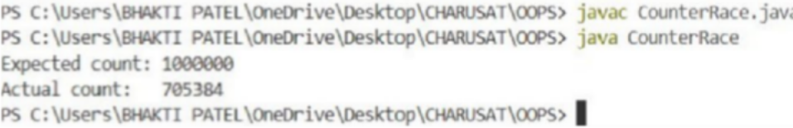
Output Screenshot:
Program 1B - With Synchronization
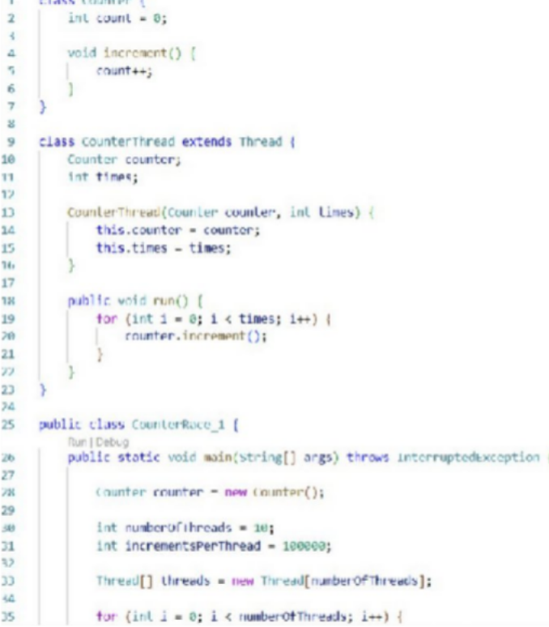
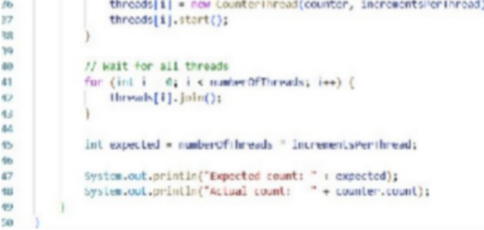

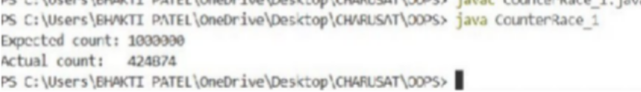
Output Screenshot:

Aim : 2 Seat booking race: a shared seatsLeft of 5 with about 10 threads each trying to book one seat. Without synchronization show that more than 5 can succeed (oversell); with a synchronized book() exactly 5 do.

2A. Without Synchronization
SeatBookingRace.java :-
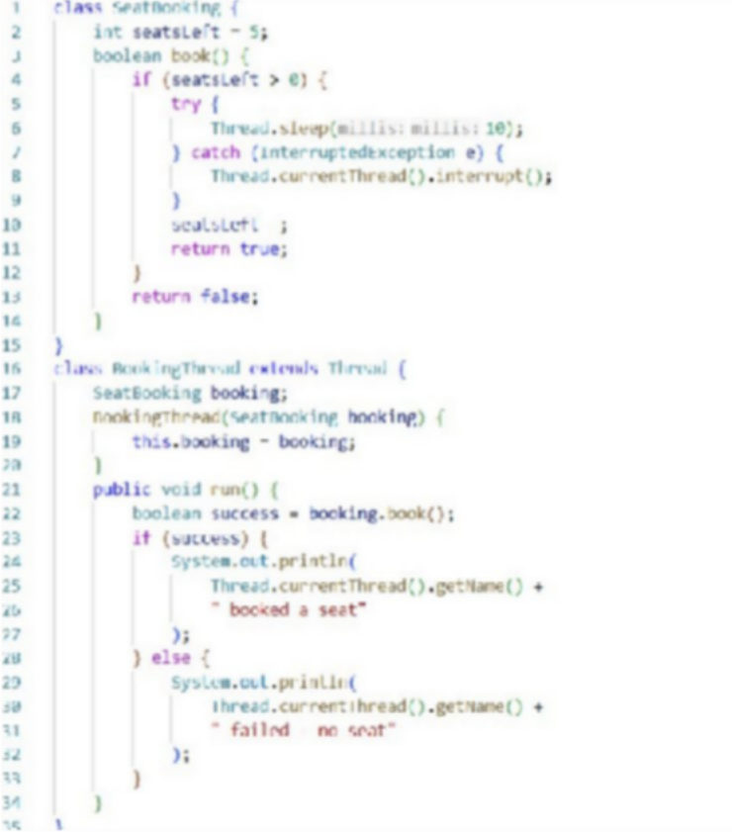
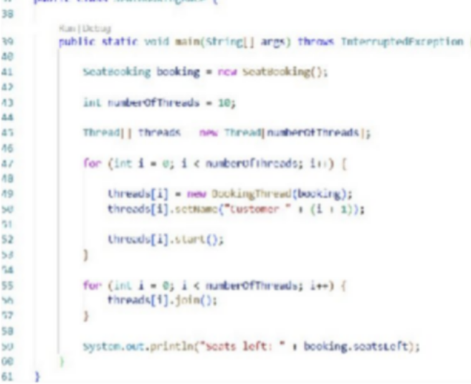

Output Screenshot:
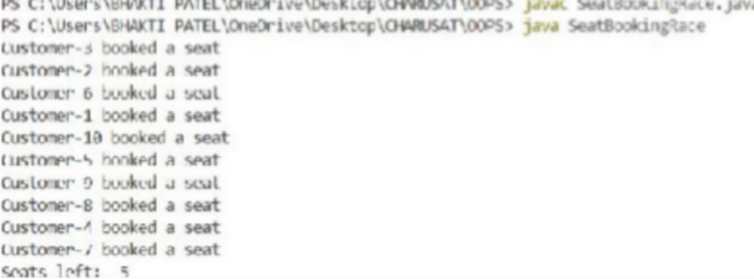

2B. With Synchronization :

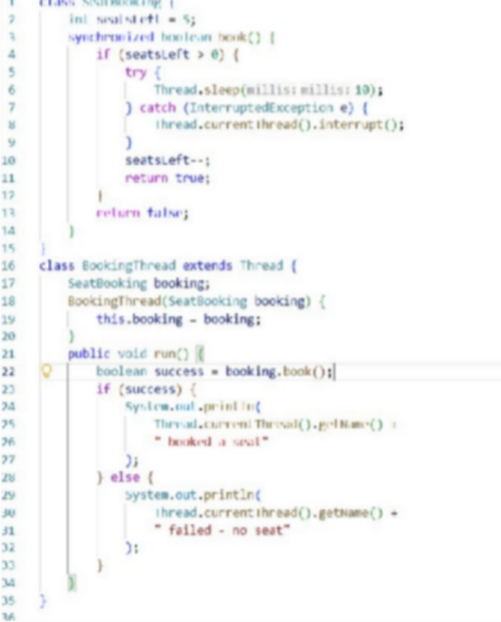
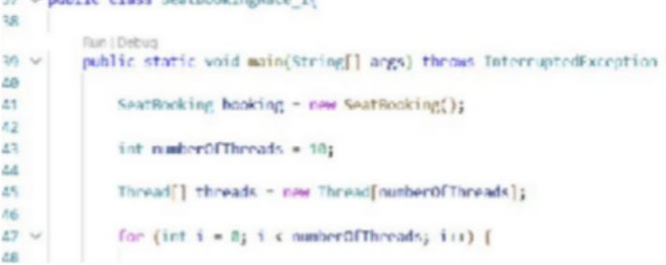

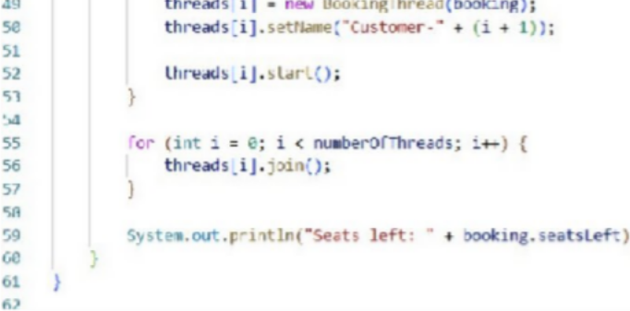

Output Screenshot:
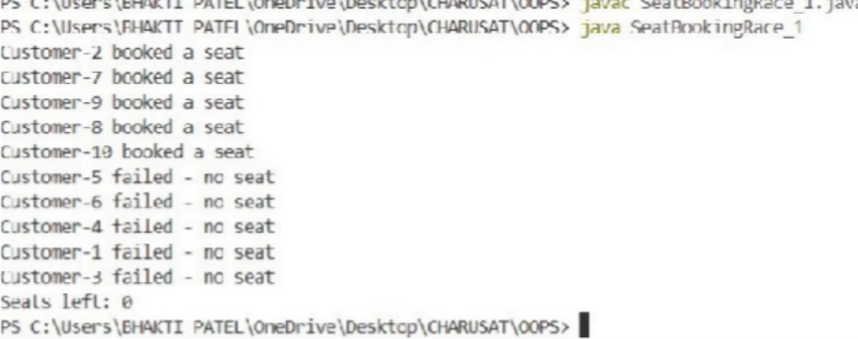

PART – B

- AccountWorker.java
package service;

import exception.InvalidAmountException; import model.Account;

public class AccountWorker implements Runnable
{ private final Account account; private final int times;
private final long amount;

public AccountWorker(Account account, int times, long amount)
{ this.account = account; this.times = times; this.amount = amount;
}

@Override public void run()
{ System.out.println(Thread.currentThread().getName() + " started"); for (int i = 0; i < times; i++)try {
account.deposit(amount);
} catch (InvalidAmountException e)
{ System.err.println("Worker error: " + e.getMessage()); return;
}
System.out.println(Thread.currentThread().getName() + " finished");
}
}

- Output:-
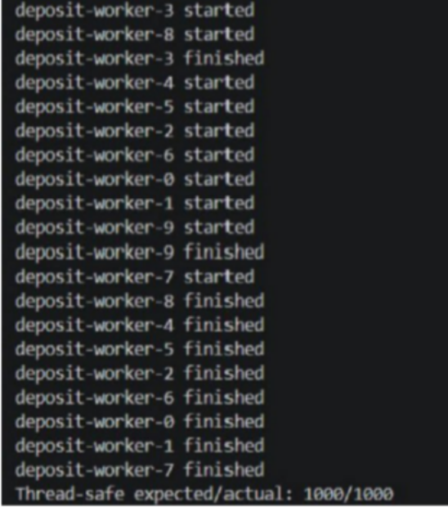

Learning Outcome:
The three programs demonstrated the importance of thread synchronization when multiple threads access shared data. In the Counter Race program, unsynchronized access could produce an incorrect counter value, while using synchronized ensured the expected result every time. In the Seat Booking Race, lack of synchronization could cause more than the available 5 seats to be booked, whereas a synchronized book() method allowed exactly 5 successful bookings. The Advanced Array Sum program further showed how shared data can cause race conditions and how synchronization or separate partial results can solve the problem. Overall, these experiments demonstrated that synchronization prevents race conditions and maintains data consistency in multithreaded programs, although synchronization may introduce some performance overhead.

Practical – 10 (A1)
Aim: Thread-pool runner: with a fixed pool of 3 (ExecutorService), submit about 10 Runnable tasks that print their id and sleep briefly; shut down and await completion, observing the few threads being reused.

Source Code:
Thread_Pool_Runner.java
package Practical_10;
import java.util.concurrent.ExecutorService; import java.util.concurrent.Executors; import java.util.concurrent.TimeUnit;
public class Thread_Pool_Runner { public static void main(String[] args) {
// Create a fixed thread pool with 3 threads
ExecutorService executor = Executors.newFixedThreadPool(3);

// Submit 10 tasks
for (int i = 1; i <= 10; i++) { final int taskId = i; executor.submit(() -> {
System.out.println("Task " + taskId + " is running on "
+Thread.currentThread().getName());

try {
// Sleep briefly to simulate some work Thread.sleep(1000);
} catch (InterruptedException e) { Thread.currentThread().interrupt(); System.out.println("Task " + taskId + " was interrupted.");
}

System.out.println("Task " + taskId + " completed by "
+Thread.currentThread().getName()
);
});
}

// No more tasks can be submitted
executor.shutdown();

try {
// Wait until all tasks are completed
if (executor.awaitTermination(30, TimeUnit.SECONDS))
{ System.out.println("\nAll tasks completed.");
} else {
System.out.println("\nTimeout occurred. Some tasks may still be running.");
}
} catch (InterruptedException e) { Thread.currentThread().interrupt(); System.out.println("Main thread was interrupted.");
}
}
}

Output:
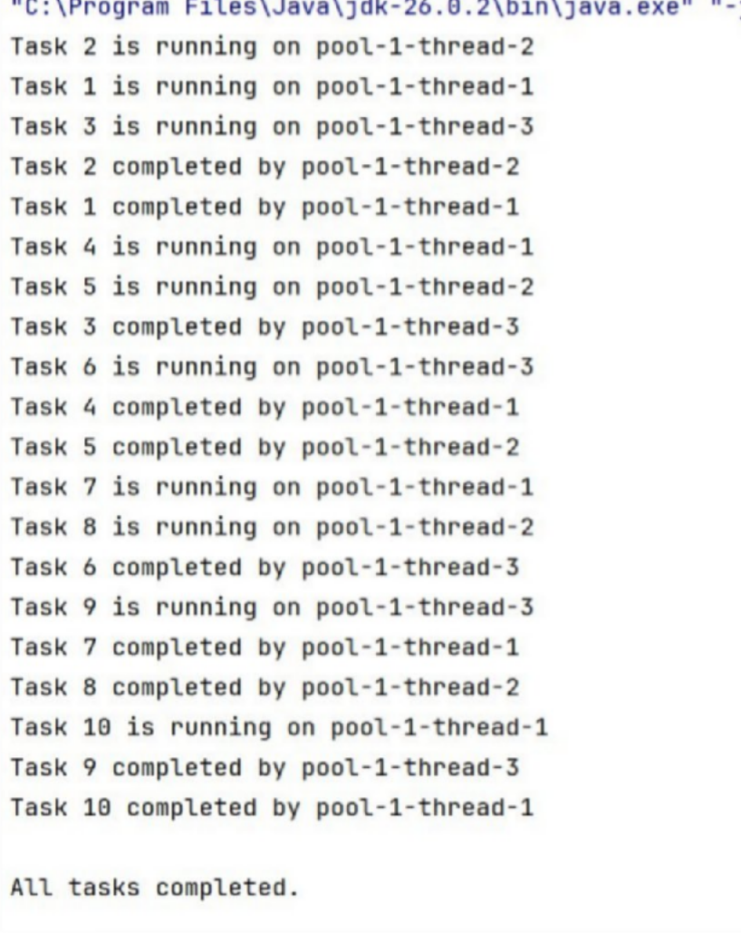

Practical – 10 (A2)
Aim: Producer–consumer: one thread adds numbers to a small shared buffer and another removes them, coordinated with wait()/notify(); produce and consume a fixed number of items in order with none lost.

Source Code:
Producer_Consumer.java package Practical_10; import java.util.LinkedList; import java.util.Queue;
public class Producer_Consumer {

// Shared buffer
static class SharedBuffer {
private final Queue<Integer> buffer = new LinkedList<>(); private final int capacity = 3;

// Add item to buffer
public synchronized void produce(int item) throws InterruptedException {
// Wait if buffer is full
while (buffer.size() == capacity) { wait();
}
buffer.add(item);
System.out.println("Produced: " + item + " | Buffer: " + buffer);
// Notify consumer
notifyAll();
}

// Remove item from buffer
public synchronized int consume() throws InterruptedException {
// Wait if buffer is empty
while (buffer.isEmpty()) { wait();
}
int item = buffer.remove();
System.out.println("Consumed: " + item + " | Buffer: " + buffer);
// Notify producer notifyAll(); return item;
}
}

public static void main(String[] args) { SharedBuffer buffer
= new SharedBuffer(); final int itemCount = 10;
// Producer thread
Thread producer = new Thread(() -> { try { for (int i = 1; i <= itemCount; i++)
{ buffer.produce(i); Thread.sleep(200);
}
} catch (InterruptedException e) { Thread.currentThread().interrupt();
}
}, "Producer");

// Consumer thread
Thread consumer = new Thread(() -> { try { for (int i = 1; i <= itemCount; i++) {
buffer.consume(); Thread.sleep(400);
}

} catch (InterruptedException e) { Thread.currentThread().interrupt();
}
}, "Consumer");

// Start both threads producer.start(); consumer.start();

// Wait for both threads to finish
try {
producer.join(); consumer.join();
} catch (InterruptedException e)
{ Thread.currentThread().interrupt();
}

System.out.println("\nAll items produced and consumed successfully.");
}
}

Output:

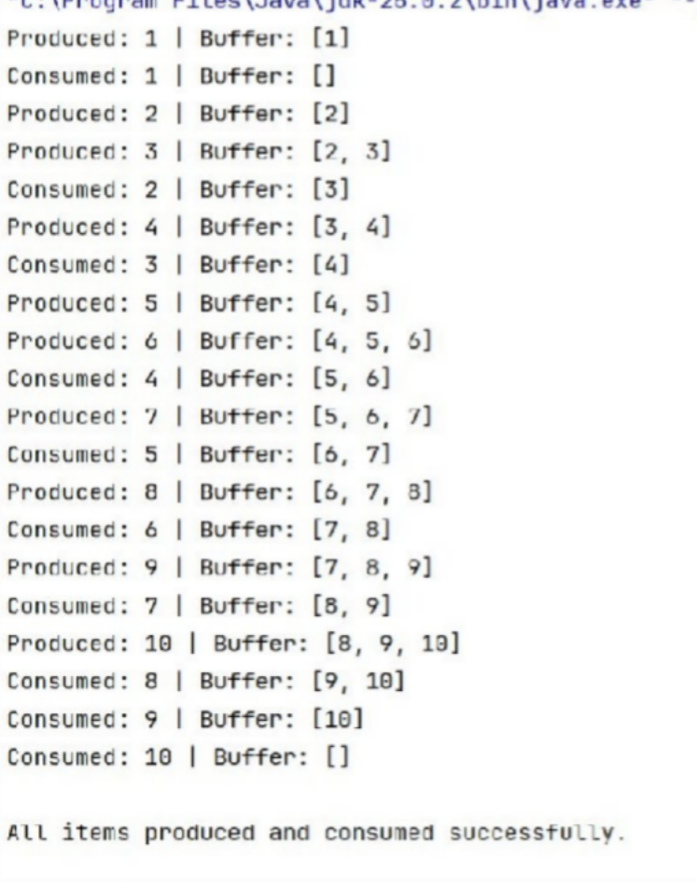

PART - B
- TransactionBuffer.java
package service;

import model.Command;

public final class TransactionBuffer {

private final Command[] buffer; private int head, tail, count; private boolean closed;

public TransactionBuffer(int capacity)
{ buffer = new Command[capacity];
}

public synchronized void put(Command c) throws InterruptedException
{ while (count == buffer.length && !closed) { wait();

}if (closed) {
throw new IllegalStateException("Buffer closed");

}buffer[tail] = c;
tail = (tail + 1) % buffer.length; count++;
notifyAll();
}

public synchronized Command take() throws InterruptedException
{ while (count == 0 && !closed) {
wait();

}if (count == 0)
{ return null;

}Command c = buffer[head];
head = (head + 1) % buffer.length; count--;
notifyAll(); return c;
}

public synchronized void close()
{ closed = true; notifyAll();
}
}

Output:-
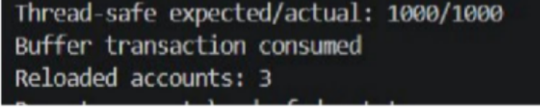

Learning Outcome:
- Understand multithreading and create multiple threads to perform tasks concurrently.
- Use ExecutorService and thread pools to manage and execute multiple tasks efficiently.
- Implement thread synchronization using synchronized, wait(), and notify().
- Develop a producer-consumer model using a shared buffer while ensuring no transactions are lost.
- Understand and identify deadlocks caused by inconsistent locking of shared resources.
- Prevent deadlocks by following a consistent lock-ordering strategy, such as locking the account with the smaller account number first.
- Apply multithreading concepts to MiniBank by processing deposits, withdrawals, and transfers safely and concurrently.
- Understand safe transaction processing in a banking system using concurrency and synchronization.

GitHub Repository:
https://github.com/Fenilrathod002/D26IT117-Fenil.git

PRACTICAL - 11

Aim: 1. Save/load: make a small class Serializable, save an array of its objects to a file with ObjectOutputStream, then read it back into fresh objects and confirm the values survived. Mark one field transient and show it is not saved.

Code:

SerializableRecord.java

import java.io.Serial; import java.io.Serializable;

public class SerializableRecord implements Serializable
{ @Serial
private static final long serialVersionUID = 1L;

private final int id; private final String name; private final double score;
private transient String sessionNote;

public SerializableRecord(int id, String name, double score, String sessionNote) {
this.id = id; this.name = name; this.score = score;
this.sessionNote = sessionNote;
}

public int getId() { return id; } public String getName() { return name; } public double getScore() { return score; }
public String getSessionNote() { return sessionNote; }

@Override
public String toString() {
return "Record{id=" + id + ", name='" + name + "', score=" + score
+ ", sessionNote=" + sessionNote + "}";
}
}

SaveLoadDemo.java

import java.io.IOException; import java.io.ObjectInputStream; import java.io.ObjectOutputStream; import java.nio.file.Files; import java.nio.file.Path;

public class SaveLoadDemo {
public static void main(String[] args) throws IOException, ClassNotFoundException {
Path file = Path.of("data", "records.dat"); Files.createDirectories(file.getParent());

SerializableRecord[] original = {
new SerializableRecord(101, "Riya", 87.5, "active session"), new SerializableRecord(102, "Aarav", 92.0, "temporary note")
};

try (ObjectOutputStream output = new ObjectOutputStream(Files.newOutputStream(file))) {
output.writeObject(original);
}

SerializableRecord[] restored;
try (ObjectInputStream input = new ObjectInputStream(Files.newInputStream(file))) {
restored = (SerializableRecord[]) input.readObject();
}

System.out.println("Saved records to: " + file.toAbsolutePath()); System.out.println("Records after loading:");
for (SerializableRecord record : restored)
{ System.out.println(record);
}
System.out.println("Transient sessionNote after loading: "
+ restored[0].getSessionNote());
}
}

Output Screenshot:
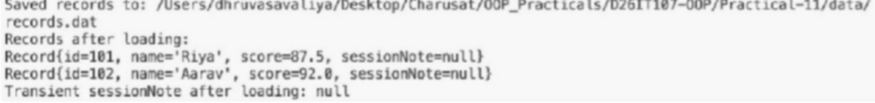

Learning Outcome:
I created a serializable class and saved an array of its objects to a file with ObjectOutputStream. I loaded the objects back with ObjectInputStream and confirmed their values were preserved. I marked the session note as transient and confirmed it was not restored.

Aim : 2. Log analyzer: create a few text files, then use Path/Files to read each line by line and count the total lines and how many contain a keyword across all files; also print each file’s size from its attributes.

Code:

LogAnalyzer.java
import java.io.BufferedReader; import java.io.IOException; import java.nio.file.Files; import java.nio.file.Path;
import java.nio.file.attribute.BasicFileAttributes; import java.util.List;
import java.util.Locale;

public class LogAnalyzer {
private static final String KEYWORD = "ERROR";

public static void main(String[] args) throws IOException
{ Path logsDirectory = Path.of("data", "logs"); List<Path> files;
try (var paths = Files.list(logsDirectory)) {
files = paths.filter(Files::isRegularFile).sorted().toList();
}

int totalLines = 0; int matchingLines = 0;
for (Path file : files) {
BasicFileAttributes attributes = Files.readAttributes(file, BasicFileAttributes.class);
int fileLines = 0; int fileMatches = 0;
try (BufferedReader reader = Files.newBufferedReader(file))
{ String line;
while ((line = reader.readLine()) != null)
{ fileLines++; if
(line.toLowerCase(Locale.ROOT).contains(KEYWORD.toLowerCase(Locale.ROOT))) {
fileMatches++;
}
}
}
totalLines += fileLines; matchingLines += fileMatches;
System.out.printf("%s: %d bytes, %d lines, %d containing %s%n", file.getFileName(), attributes.size(), fileLines,
fileMatches, KEYWORD);
}

System.out.println("Files analyzed: " + files.size()); System.out.println("Total lines: " + totalLines);

System.out.println("Lines containing " + KEYWORD + ": " + matchingLines);
}
}

server-a.txt

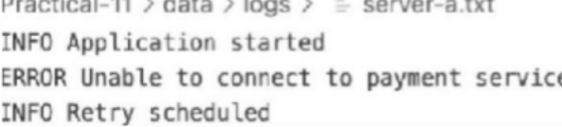

server-b.txt
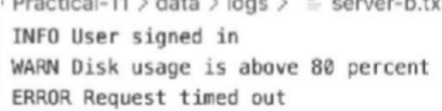

Output Screenshot:
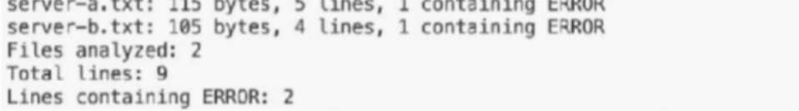

Learning Outcome:
I created sample log files and used Path and Files to locate them. The program opens each file with a BufferedReader and reads it one line at a time. It counts the total lines and the lines containing the keyword ERROR, then uses BasicFileAttributes to display each file’s size. This demonstrates basic file reading, keyword searching, resource management, and file attribute access with Java NIO.

MINIBANK
Aim: 1. Make Account (and its subclasses and Customer) implement Serializable, and add a private static final long serialVersionUID field.

- Create a class named StatePersister with a public static method void save(Account[] accounts, Path file) that uses ObjectOutputStream inside try-with-resources, and a public static method Account[] load(Path file) that uses ObjectInputStream.

- Create a class named TransactionLog with a public static method void append(Path file, String line) that uses Files.write(...) with CREATE and APPEND.

- Create a class named ReportGenerator that walks the logs folder using Files.newDirectoryStream, reads each file line by line with a BufferedReader, and adds up the total deposits and total withdrawals in long variables; also read file details (size, last-modified) using Files.readAttributes, then write the summary to a report file.

- In main, save the accounts, reload them into a new array and print them to confirm the data survived, then generate and print the report.

CODE (ReportGenerator.java)
package service;

import java.io.BufferedReader; import java.io.IOException;
import java.nio.charset.StandardCharsets; import java.nio.file.DirectoryStream; import java.nio.file.Files;
import java.nio.file.Path;
import java.nio.file.StandardOpenOption; import java.nio.file.attribute.BasicFileAttributes; import java.util.Locale;

public final class ReportGenerator
{ private ReportGenerator() { }

public static String generate(Path logsDirectory, Path reportFile) throws IOException
{ Files.createDirectories(logsDirectory); long totalDeposits = 0;
long totalWithdrawals = 0; int malformedLines = 0;
StringBuilder report = new StringBuilder("MiniBank End-of-Day Report\n"); report.append("Log files:\n");

try (DirectoryStream<Path> files = Files.newDirectoryStream(logsDirectory))
{ for (Path file : files) {
if (!Files.isRegularFile(file))
{ continue;
}
BasicFileAttributes attributes = Files.readAttributes( file, BasicFileAttributes.class);
report.append(" ").append(file.getFileName())
.append(" | ").append(attributes.size()).append(" bytes\n");

try (BufferedReader reader = Files.newBufferedReader(file, StandardCharsets.UTF_8))
{ String line;
while ((line = reader.readLine()) != null)
{ String[] fields = line.trim().split("\\s+"); if (fields.length
< 3) {
malformedLines++; continue;
}
long amount; try {
amount = Long.parseLong(fields[2]);
} catch (NumberFormatException e)
{ malformedLines++; continue;
}
if (amount < 0)
{ malformedLines++; continue;
}
switch (fields[0].toUpperCase(Locale.ROOT))
{ case "DEPOSIT" -> totalDeposits += amount; case "WITHDRAW" -> totalWithdrawals += amount; default -> malformedLines++;
}
}
}
}

}

report.append("Total deposits: ").append(totalDeposits).append(" rupees\n")
.append("Total withdrawals: ").append(totalWithdrawals).append(" rupees\n")
.append("Net change: ").append(totalDeposits - totalWithdrawals)
.append(" rupees\n")
.append("Unrecognized log lines: ").append(malformedLines).append('\n');

Path parent = reportFile.toAbsolutePath().getParent(); if (parent != null) {
Files.createDirectories(parent);
}
Files.writeString(reportFile, report.toString(), StandardCharsets.UTF_8, StandardOpenOption.CREATE, StandardOpenOption.TRUNCATE_EXISTING);
return report.toString();
}
}

CODE (StatePersister.java)
package service;

import java.io.IOException; import java.io.ObjectInputStream;
import java.io.ObjectOutputStream; import java.nio.file.Files;
import java.nio.file.Path; import model.Account;

public final class StatePersister
{ private StatePersister() { }

public static void save(Account[] accounts, Path file) throws IOException
{ Path parent = file.toAbsolutePath().getParent(); if (parent != null)
{ Files.createDirectories(parent);
}
try (ObjectOutputStream output = new ObjectOutputStream(Files.newOutputStream(file)))
{ output.writeObject(accounts);
}
}

public static Account[] load(Path file) throws IOException, ClassNotFoundException
{ if (Files.notExists(file)) { return new Account[0];
}
try (ObjectInputStream input = new ObjectInputStream(Files.newInputStream(file)))
{ Object savedState = input.readObject();
if (!(savedState instanceof Account[] accounts)) {
throw new IOException("Saved bank data has an unexpected format.");
}
return accounts;
}
}
}

CODE (ReportGenerator.java)
package service;

import java.io.BufferedReader; import java.io.IOException;
import java.nio.charset.StandardCharsets; import java.nio.file.DirectoryStream; import java.nio.file.Files;

import java.nio.file.Path;
import java.nio.file.StandardOpenOption; import java.nio.file.attribute.BasicFileAttributes; import java.util.Locale;

public final class ReportGenerator
{ private ReportGenerator() { }

public static String generate(Path logsDirectory, Path reportFile) throws IOException
{ Files.createDirectories(logsDirectory); long totalDeposits = 0;
long totalWithdrawals = 0; int malformedLines = 0;
StringBuilder report = new StringBuilder("MiniBank End-of-Day Report\n"); report.append("Log files:\n");

try (DirectoryStream<Path> files = Files.newDirectoryStream(logsDirectory))
{ for (Path file : files) {
if (!Files.isRegularFile(file))
{ continue;
}
BasicFileAttributes attributes = Files.readAttributes( file, BasicFileAttributes.class);
report.append(" ").append(file.getFileName())
.append(" | ").append(attributes.size()).append(" bytes\n");

try (BufferedReader reader = Files.newBufferedReader(file, StandardCharsets.UTF_8))
{ String line;
while ((line = reader.readLine()) != null)
{ String[] fields = line.trim().split("\\s+"); if (fields.length
< 3) {
malformedLines++; continue;
}
long amount; try {
amount = Long.parseLong(fields[2]);
} catch (NumberFormatException e)
{ malformedLines++; continue;
}
if (amount < 0)
{ malformedLines++; continue;
}
switch (fields[0].toUpperCase(Locale.ROOT))
{ case "DEPOSIT" -> totalDeposits += amount; case "WITHDRAW" -> totalWithdrawals += amount; default -> malformedLines++;
}
}
}
}
}

report.append("Total deposits: ").append(totalDeposits).append(" rupees\n")
.append("Total withdrawals: ").append(totalWithdrawals).append(" rupees\n")
.append("Net change: ").append(totalDeposits - totalWithdrawals)
.append(" rupees\n")
.append("Unrecognized log lines: ").append(malformedLines).append('\n');

Path parent = reportFile.toAbsolutePath().getParent(); if (parent != null) {

Files.createDirectories(parent);
}
Files.writeString(reportFile, report.toString(), StandardCharsets.UTF_8, StandardOpenOption.CREATE, StandardOpenOption.TRUNCATE_EXISTING);
return report.toString();
}
}
OUTPUT
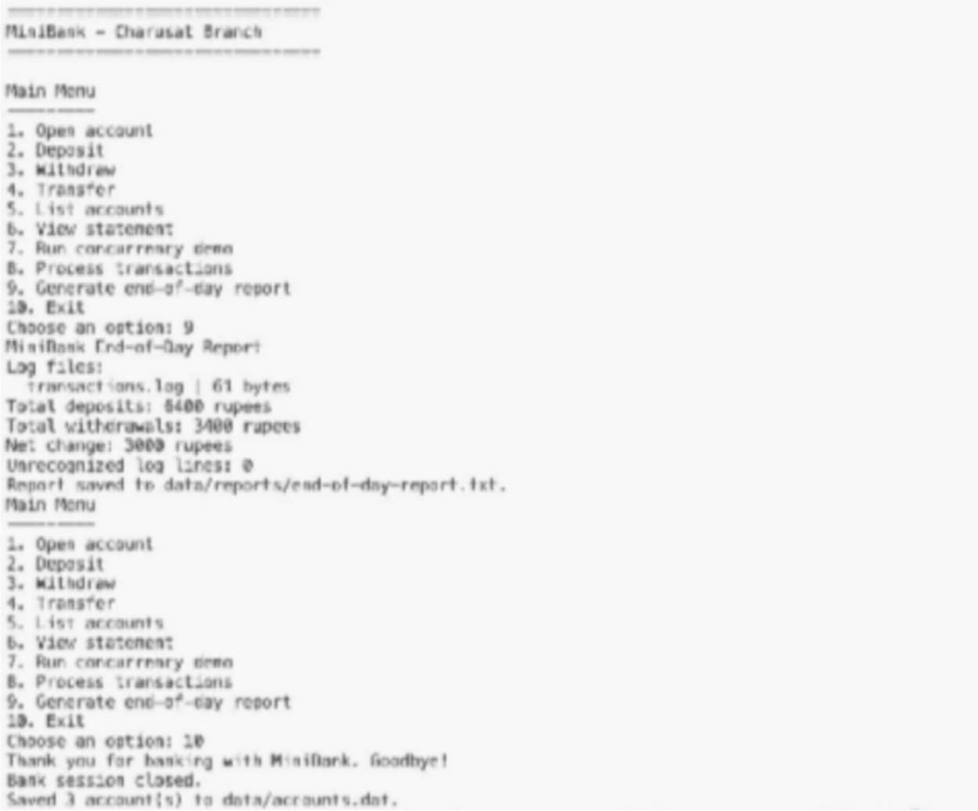

PRACTICAL - 12

Aim: 1. Word frequency: split a paragraph into words, count each in a HashMap, and print the words sorted by frequency (highest first) using a Comparator.
Code:
WordFrequency.java
import java.util.Comparator; import java.util.HashMap; import java.util.Locale; import java.util.Map;

public class WordFrequency {
public static void main(String[] args) {
String paragraph = "Java makes reliable software. Java collections make software "
+ "easier to organize, and reliable code is easier to
maintain.";
Map<String, Integer> frequencies = new HashMap<>();

for (String word : paragraph.toLowerCase(Locale.ROOT).split("[^\\p{L}\
\p{N}]+")) {
if (!word.isBlank())
{ frequencies.merge(word, 1, Integer::sum);
}
}

System.out.println("Word frequencies (highest first):"); frequencies.entrySet().stream()
.sorted(Map.Entry.<String, Integer>comparingByValue(Comparator.reverseOrder())
.thenComparing(Map.Entry.comparingByKey()))
.forEach(entry -> System.out.printf("%s: %d%n", entry.getKey(), entry.getValue()));
}
}

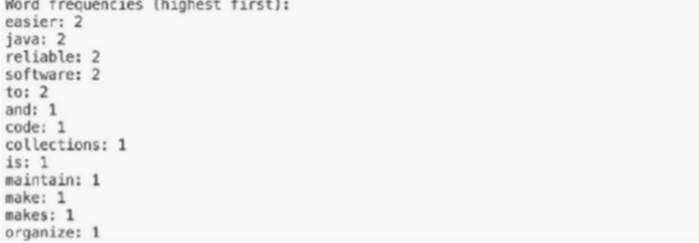

Learning Outcome:
I used a paragraph as input and split it into individual words, ignoring punctuation and differences in letter case. I stored each word and its count in a HashMap, updating the count whenever the word appeared again. I then sorted the map entries with a Comparator so the most frequent words appear first. When words have equal counts, they are displayed alphabetically.

Aim : 2. Unique visitors: from a list of login names with repeats, use a HashSet to count unique users and a LinkedHashSet to keep first-seen order; print the unique count and the first three distinct names.

Code:
UniqueVisitors.java
import java.util.Arrays; import java.util.HashSet; import java.util.LinkedHashSet; import java.util.List;
import java.util.Set;

public class UniqueVisitors {
public static void main(String[] args)
{ List<String> logins = Arrays.asList(
"riya", "aarav", "diya", "riya", "kabir", "aarav", "meera"); Set<String> uniqueUsers = new HashSet<>(logins);
Set<String> firstSeenOrder = new LinkedHashSet<>(logins);

System.out.println("Unique visitor count: " + uniqueUsers.size()); System.out.println("First three distinct visitors:"); firstSeenOrder.stream().limit(3).forEach(System.out::println);
}
}

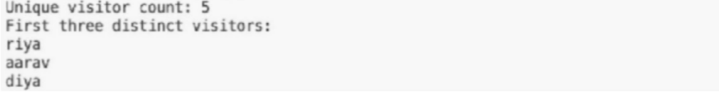

Learning Outcome:
I used a list of login names that contains repeated visitors. A HashSet removes duplicates so the program can calculate the number of unique visitors. A LinkedHashSet also removes duplicates, while preserving the order in which each visitor first appeared. The program prints the unique count and the first three names in that order.

MINIBANK
Aim: 1. Create a class named AccountStore that keeps accounts in a HashMap<String, Account> using the account number as the key. Add methods add(Account account), get(String accountNumber) and getAll().

- Keep a transaction history in an ArrayList<String>.

- Add a method sortedByBalance() that returns an ArrayList<Account> sorted with a Comparator.

- Make Account implement Comparable<Account> by comparing account numbers in compareTo().

- In the TransactionProcessor, use a ConcurrentHashMap for the shared accounts so it is thread-safe.

- In main, add several accounts to the store and print them sorted by balance.

CODE (AccountStore.java)
package service;

import java.util.ArrayList; import java.util.Comparator; import java.util.HashMap; import model.Account;

public final class AccountStore {
private final HashMap<String, Account> accounts = new HashMap<>(); private final ArrayList<String> transactionHistory = new ArrayList<>();

public void add(Account account)
{ if (account == null) {
throw new IllegalArgumentException("Account cannot be null.");
}
accounts.put(account.getAccountNumber(), account);
}

public Account get(String accountNumber)
{ return accounts.get(accountNumber);
}

public ArrayList<Account> getAll() {
return new ArrayList<>(accounts.values());
}

/** Returns accounts from highest balance to lowest; account number breaks ties. */ public ArrayList<Account> sortedByBalance() {
ArrayList<Account> sortedAccounts = getAll(); sortedAccounts.sort(Comparator.comparingDouble(Account::getBalance)
.reversed().thenComparing(Account::getAccountNumber)); return sortedAccounts;
}

public void recordTransaction(String transaction)
{ transactionHistory.add(transaction);
}

public ArrayList<String> getTransactionHistory()
{ return new ArrayList<>(transactionHistory);
}
}

CODE (Account.java)
package model;

import java.io.Serial; import java.io.Serializable;
import exception.AccountNotFoundException; import exception.BankException;
import exception.InsufficientFundsException; import exception.InvalidAmountException; import model.annotation.Id;
import model.annotation.MaxLength; import model.annotation.Positive;

public abstract class Account implements Transactable, InterestBearing,

Serializable, Comparable<Account>

{ @Serial
private static final long serialVersionUID = 1L; private static int nextAccountNumber = 1;
@Id
private final String accountNumber; @MaxLength(50)
private String ownerName; @Positive
protected double balance;

public Account(String ownerName) {
this.accountNumber = String.format("AC%04d", nextAccountNumber++); this.ownerName = ownerName;
this.balance = 0;
}

public Account(String ownerName, double balance) {
this.accountNumber = String.format("AC%04d", nextAccountNumber++); this.ownerName = ownerName;
this.balance = balance;
}

public String getAccountNumber()
{ return accountNumber;
}

public static void synchronizeAccountNumberSequence(Iterable<? extends Account> accounts)
{ int largestNumber = 0;
for (Account account : accounts) {
String number = account.getAccountNumber(); if (number != null && number.startsWith("AC")) {
try {
largestNumber = Math.max(largestNumber, Integer.parseInt(number.substring(2)));
} catch (NumberFormatException ignored) {
// Ignore account numbers that do not use the generated AC-number format.
}
}
}
nextAccountNumber = Math.max(nextAccountNumber, largestNumber + 1);
}

public String getOwnerName()
{ return ownerName;
}

public synchronized double getBalance()
{ return balance;
}

@Override
public synchronized void deposit(long amount) throws InvalidAmountException
{ if (amount <= 0) {
throw new InvalidAmountException("Deposit amount must be greater than zero.");
}
balance += amount;
}

@Override
public synchronized boolean withdraw(long amount)
throws InsufficientFundsException, InvalidAmountException
{ if (amount <= 0) {
throw new InvalidAmountException("Withdrawal amount must be greater than zero.");
}
if (!canWithdraw(amount)) {
long shortfall = Math.max(1, amount - Math.max(0, (long) balance)); throw new InsufficientFundsException(shortfall);
}
balance -= amount; return true;
}

void depositUnsynchronizedForRaceDemo(long amount) throws InvalidAmountException
{ if (amount <= 0) {
throw new InvalidAmountException("Deposit amount must be greater than zero.");
}
double currentBalance = balance; Thread.yield();
balance = currentBalance + amount;
}

public void transfer(Account to, long amount) throws BankException
{ boolean withdrawn = false; boolean completed = false; try {
if (to == null) {
throw new AccountNotFoundException("destination");
}
if (equals(to)) {
throw new InvalidAmountException("Source and destination must be different accounts.");
}
withdraw(amount); withdrawn = true; to.deposit(amount); completed = true;
} catch (BankException e)
{ throw e;
} finally {
if (withdrawn && !completed)
{ balance += amount;
}
}
}

public abstract double interestRate();
public abstract boolean canWithdraw(long amount); @Override
public synchronized String toString() {
return accountNumber + " | " + ownerName + " | " + balance;
}

@Override
public boolean equals(Object o)
{ if (this == o) { return true;
}

if (o instanceof Account) {

Account other = (Account) o;
return this.accountNumber.equals(other.accountNumber);
}

return false;
}

@Override
public int hashCode() {
return accountNumber.hashCode();
}

@Override
public int compareTo(Account other) {
return accountNumber.compareTo(other.accountNumber);
}
}

CODE (TransactionProcessor.java)

package service;

import java.util.concurrent.ExecutorService; import java.util.concurrent.Executors; import java.util.concurrent.TimeUnit;
import java.util.concurrent.ConcurrentHashMap; import java.util.Collection;
import model.Account;

public final class TransactionProcessor {
private final ExecutorService executor = Executors.newFixedThreadPool(4);
private final ConcurrentHashMap<String, Account> sharedAccounts = new ConcurrentHashMap<>(); public TransactionProcessor() { }
public TransactionProcessor(Collection<? extends Account> accounts)
{ for (Account account : accounts) { registerAccount(account);
}
}

public void registerAccount(Account account)
{ if (account == null) {
throw new IllegalArgumentException("Account cannot be null.");
}
sharedAccounts.put(account.getAccountNumber(), account);
}

public Account getAccount(String accountNumber)
{ return sharedAccounts.get(accountNumber);
}

public int getSharedAccountCount()
{ return sharedAccounts.size();
}

public void submit(Runnable task)
{ executor.execute(task);
}

public void stop() throws InterruptedException
{ executor.shutdown();
if (!executor.awaitTermination(30, TimeUnit.SECONDS))
{ executor.shutdownNow();
if (!executor.awaitTermination(30, TimeUnit.SECONDS)) {
throw new IllegalStateException("Transaction workers did not stop.");
}
}
}

public void stopNow()
{ executor.shutdownNow();
}
}
OUTPUT
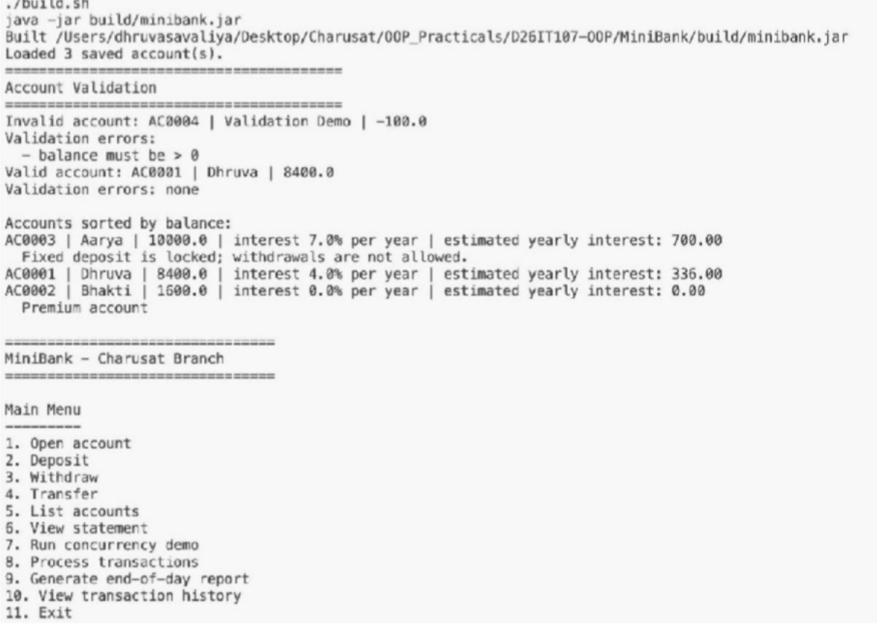

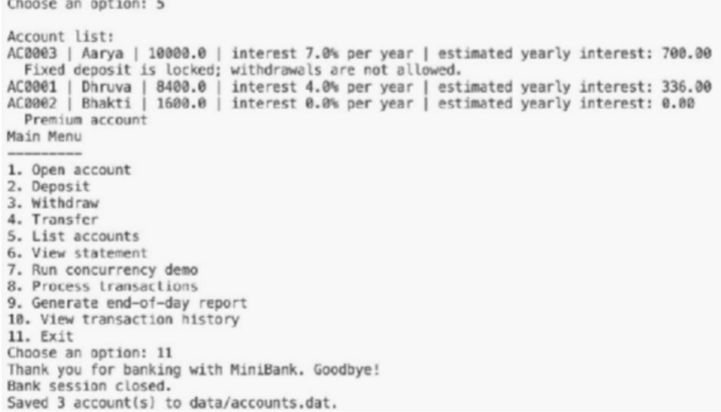

PRACTICAL - 13

Aim: 1. Generic containers: a generic Box<T> with get/set and a Pair<A,B>; use them with different types to show type safety without casts, and write a generic method that returns the first element of any array.

Code:
Box.java
public class Box<T>
{ private T value;

public Box(T value) { this.value = value; } public T get() { return value; }
public void set(T value) { this.value = value; }
}

GenericContainersDemo.java

public class GenericContainersDemo
{ public static <T> T first(T[] values)
{
if (values == null || values.length == 0) {
throw new IllegalArgumentException("Array must contain at least one
value.");
}
return values[0];
}

public static void main(String[] args) {
Box<String> message = new Box<>("Generic types in Java"); Box<Integer> count = new Box<>(3);
Pair<String, Integer> accountSummary = new Pair<>("AC0001", 5000);

System.out.println("String box: " + message.get()); System.out.println("Integer box: " + count.get()); System.out.println("Pair: " + accountSummary.first() + " -> " +
accountSummary.second());
System.out.println("First string: " + first(new String[]{"Java", "Generics"}));
System.out.println("First integer: " + first(new Integer[]{10, 20,
30}));
}
}

Pair.java

public record Pair<A, B>(A first, B second) { }

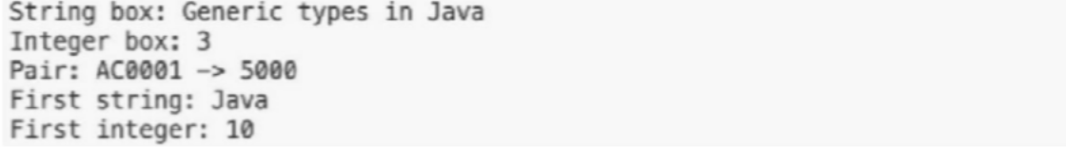

Learning Outcome:
I created Box<T> to store a value of any chosen type and Pair<A, B> to store two values that may have different types. The demo uses these classes with values such as text and integers, showing how the compiler checks that values are used with their declared types. I also wrote a generic first method that returns the first element from an array. The same method works with arrays of different element types without requiring casts.

Aim : 2. Bounded stats: a generic method <N extends Number> double average(N[] values) that works for Integer[], Double[] and Long[]; note why it refuses non-Number types.

Code:
BoundedStats.java
public class BoundedStats {
public static <N extends Number> double average(N[] values)
{ if (values == null || values.length == 0) {
throw new IllegalArgumentException("Values must not be empty.");
}
double sum = 0.0;
for (N value : values)
{ if (value == null)
{

null.");
throw new IllegalArgumentException("Values must not contain

}

sum += value.doubleValue();
}
return sum / values.length;
}

public static void main(String[] args) {
System.out.println("Integer average: " + average(new Integer[]{10, 20,

30}));

4.0}));

300L}));
System.out.println("Double average: " + average(new Double[]{2.5, 3.5, System.out.println("Long average: " + average(new Long[]{100L, 200L, System.out.println("The <N extends Number> bound rejects non-number

types at compile time.");
}

}

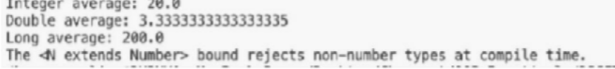

Learning Outcome:
I wrote an average method with the type parameter <N extends Number>. The method accepts arrays whose elements are numeric types and converts each value to double to calculate the average. I demonstrated it with Integer[], Double[], and Long[]. The Number bound provides compile-time type safety: an array of non-numeric values cannot be passed to this method.

MINIBANK
Aim: 1. Create a generic class named Repository<T> that holds a HashMap<String, T>. Add methods T save(T entity), T findById(String id), ArrayList<T> findAll() and boolean delete(String id).

- Inside save(), find the id by reflection: look for the field marked @Id (from Practical 7) and read its value as the map key.

- Add a method marked @SafeVarargs called saveAll(T... items) that saves several objects at once.

- Add one generic method with a bounded type parameter, for example static <N extends Number> double average(N[] values).

- In main, create a Repository<Account>, save several accounts, fetch one by id, and print all of them.

CODE (Repository.java)
package service;

import java.lang.reflect.Field; import java.util.ArrayList; import java.util.HashMap; import model.annotation.Id;

public final class Repository<T> {
private final HashMap<String, T> entities = new HashMap<>();

public T save(T entity)
{ if (entity == null) {
throw new IllegalArgumentException("Entity cannot be null.");
}
String id = readId(entity); entities.put(id, entity); return entity;
}

@SafeVarargs
public final void saveAll(T... items)
{ if (items == null) {
throw new IllegalArgumentException("Items cannot be null.");
}
for (T item : items)
{ save(item);
}
}

public T findById(String id)
{ return entities.get(id);
}

public ArrayList<T> findAll() {
return new ArrayList<>(entities.values());
}

public boolean delete(String id)
{ return entities.remove(id) != null;
}

public static <N extends Number> double average(N[] values)
{ if (values == null || values.length == 0) {
throw new IllegalArgumentException("Values must contain at least one number.");
}
double total = 0;
for (N value : values)
{ if (value == null) {
throw new IllegalArgumentException("Values cannot contain null.");
}
total += value.doubleValue();
}
return total / values.length;
}

private String readId(T entity)
{ Field idField = null;
Class<?> type = entity.getClass();
while (type != null && type != Object.class)
{ for (Field field : type.getDeclaredFields()) { if (field.isAnnotationPresent(Id.class))
{ if (idField != null) {
throw new IllegalArgumentException("Entity has multiple @Id fields: "

+ entity.getClass().getName());
}
idField = field;
}
}
type = type.getSuperclass();
}
if (idField == null) {
throw new IllegalArgumentException("Entity has no @Id field: "
+ entity.getClass().getName());
}

try {
idField.setAccessible(true); Object value = idField.get(entity); if (value == null) {
throw new IllegalArgumentException("Entity @Id value cannot be null.");
}
return value.toString();
} catch (IllegalAccessException e) {
throw new IllegalStateException("Cannot read the entity @Id field.", e);
}
}
}

CODE (Customer.java)
package model;

import java.io.Serial; import java.io.Serializable; import model.annotation.Id;

public class Customer implements Cloneable, Serializable

{ @Serial
private static final long serialVersionUID = 1L;
private static long customerCounter = 100; @Id
private final String customerId; private String name;
private String email; private String mobile; private Address address;

public Customer(String name, String email, String mobile)
{ this.customerId = generateCustomerId(); this.name = name;
this.email = email; this.mobile = mobile;
}

public Customer(String name, Address address)
{ this(name, "", ""); this.address = address;
}

private static String generateCustomerId()
{ return "CUST" + (++customerCounter);
}

public String getCustomerId()
{ return customerId;
}

public String getName()
{ return name;
}

public String getEmail()
{ return email;
}

public String getMobile()
{ return mobile;
}

public Address getAddress()
{ return address;
}

public static class Address implements Serializable

{ @Serial
private static final long serialVersionUID = 1L;

private String line; private String city; private String pincode;

public Address(String line, String city, String pincode)
{ this.line = line; this.city = city; this.pincode = pincode;
}

public String getLine()
{ return line;
}

public String getCity()
{ return city;
}

public String getPincode()
{ return pincode;
}
}

@Override
public Customer clone() {

try {
return (Customer) super.clone();
} catch (CloneNotSupportedException e)
{ return null;
}
}

}
OUTPUT
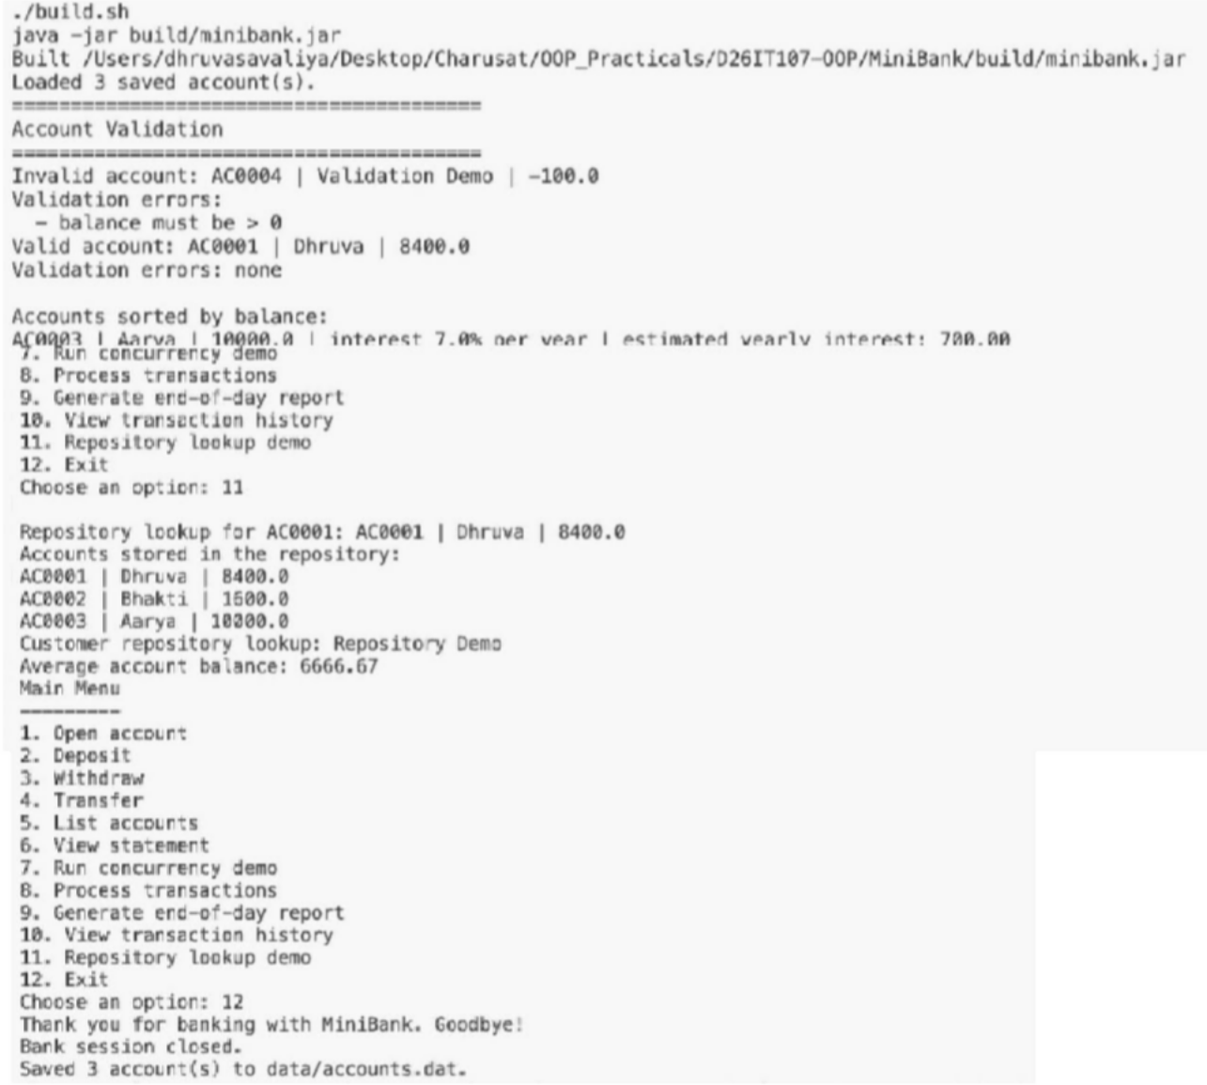

PRACTICAL - 14 (A)

Aim: 1. Assemble and test: build a tiny layered app (a model, a service using an ArrayList, and a menu main), then write two or three JUnit @Test methods checking that adding increases the count and an invalid action throws — practice before testing MiniBank.

PRACTICAL - 14 (B)
Aim: 1. Create a class named BankService that uses Repository<Account>, the Validator and the exception classes to provide openAccount, deposit, withdraw, transfer, statement and listAccounts.

- Connect the Practical 1 menu so each option calls the matching BankService method; load saved accounts on start-up (Practical 11) and save them on exit.
- Use the TransactionProcessor (Practical 10) over the thread-safe store (Practical 12) to process a batch of transactions safely, and add the report (Practical 11) as a menu option.
- Write a few JUnit tests using @Test: a deposit increases the balance; a withdrawal over the limit throws an exception; many concurrent deposits keep the balance correct.
- (Optional) Add an @Audit annotation and a reflective logger that records which service method was called.
- Build the final runnable JAR and complete the README.

FINAL OUTPUT


