Practical – 10 (A1)
Aim: Thread-pool runner: with a fixed pool of 3 (ExecutorService), submit about 10 Runnable tasks that print their id and sleep briefly; shut down and await completion, observing the few threads being reused.
Source Code:
Thread_Pool_Runner.java
package Practical_10;
import java.util.concurrent.ExecutorService;
import java.util.concurrent.Executors;
import java.util.concurrent.TimeUnit;
public class Thread_Pool_Runner {
public static void main(String[] args) {
// Create a fixed thread pool with 3 threads
ExecutorService executor = Executors.newFixedThreadPool(3);
// Submit 10 tasks
for (int i = 1; i <= 10; i++) {
final int taskId = i;
executor.submit(() -> {
System.out.println("Task " + taskId + " is running on " +Thread.currentThread().getName());
try {
// Sleep briefly to simulate some work
Thread.sleep(1000);
} catch (InterruptedException e) {
Thread.currentThread().interrupt();
System.out.println("Task " + taskId + " was interrupted.");
}
System.out.println("Task " + taskId + " completed by " +Thread.currentThread().getName()
);
});
}
// No more tasks can be submitted
executor.shutdown();
try {
// Wait until all tasks are completed
if (executor.awaitTermination(30, TimeUnit.SECONDS)) {
System.out.println("\nAll tasks completed.");
} else {
System.out.println("\nTimeout occurred. Some tasks may still be running.");
}
} catch (InterruptedException e) {
Thread.currentThread().interrupt();
System.out.println("Main thread was interrupted.");
}
}
}

Output:
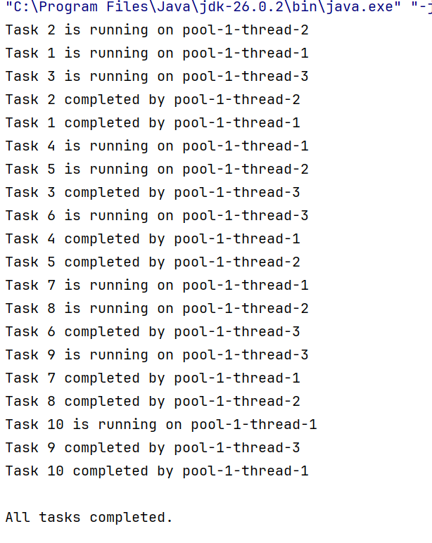

Practical – 10 (A2)
Aim: Producer–consumer: one thread adds numbers to a small shared buffer and another removes them, coordinated with wait()/notify(); produce and consume a fixed number of items in order with none lost.
Source Code:
Producer_Consumer.java
package Practical_10;
import java.util.LinkedList;
import java.util.Queue;
public class Producer_Consumer {
// Shared buffer
static class SharedBuffer {
private final Queue<Integer> buffer = new LinkedList<>();
private final int capacity = 3;
// Add item to buffer
public synchronized void produce(int item) throws InterruptedException {
// Wait if buffer is full
while (buffer.size() == capacity) {
wait();
}
buffer.add(item);
System.out.println("Produced: " + item + " | Buffer: " + buffer);
// Notify consumer
notifyAll();
}
// Remove item from buffer
public synchronized int consume() throws InterruptedException {
// Wait if buffer is empty
while (buffer.isEmpty()) {
wait();
}
int item = buffer.remove();
System.out.println("Consumed: " + item + " | Buffer: " + buffer);
// Notify producer
notifyAll();
return item;
}
}
public static void main(String[] args) {
SharedBuffer buffer = new SharedBuffer();
final int itemCount = 10;
// Producer thread
Thread producer = new Thread(() -> {
try {
for (int i = 1; i <= itemCount; i++) {
buffer.produce(i);
Thread.sleep(200);
}
} catch (InterruptedException e) {
Thread.currentThread().interrupt();
}
}, "Producer");
// Consumer thread
Thread consumer = new Thread(() -> {
try {
for (int i = 1; i <= itemCount; i++) {
buffer.consume();
Thread.sleep(400);
}
} catch (InterruptedException e) {
Thread.currentThread().interrupt();
}
}, "Consumer");
// Start both threads
producer.start();
consumer.start();
// Wait for both threads to finish
try {
producer.join();
consumer.join();
} catch (InterruptedException e) {
Thread.currentThread().interrupt();
}
System.out.println("\nAll items produced and consumed successfully.");
}
}

Output:
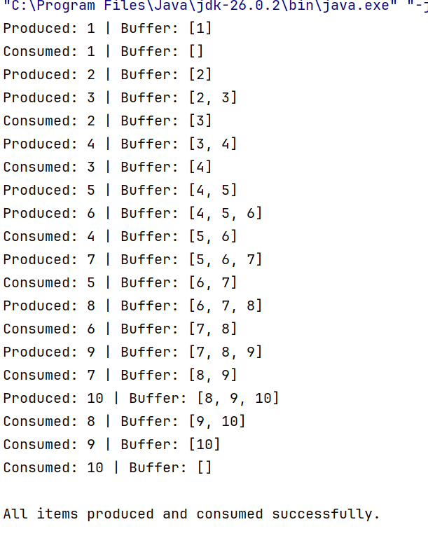

Learning Outcome:
- Understand multithreading and create multiple threads to perform tasks concurrently.
- Use ExecutorService and thread pools to manage and execute multiple tasks efficiently.
- Implement thread synchronization using synchronized, wait(), and notify().
- Develop a producer-consumer model using a shared buffer while ensuring no transactions are lost.
- Understand and identify deadlocks caused by inconsistent locking of shared resources.
- Prevent deadlocks by following a consistent lock-ordering strategy, such as locking the account with the smaller account number first.
- Apply multithreading concepts to MiniBank by processing deposits, withdrawals, and transfers safely and concurrently.
- Understand safe transaction processing in a banking system using concurrency and synchronization.

GitHub Repository:
https://github.com/Fenilrathod002/D26IT117-Fenil.git

