PRACTICAL - 8

Aim: 1. Guarded calculator: read two numbers and an operator; throw a custom DivideByZeroException and catch invalid-number input separately, printing a clear message each time; loop until a valid calculation succeeds and use finally to log each attempt.
Code Screenshot:

GuardedCalculator.java

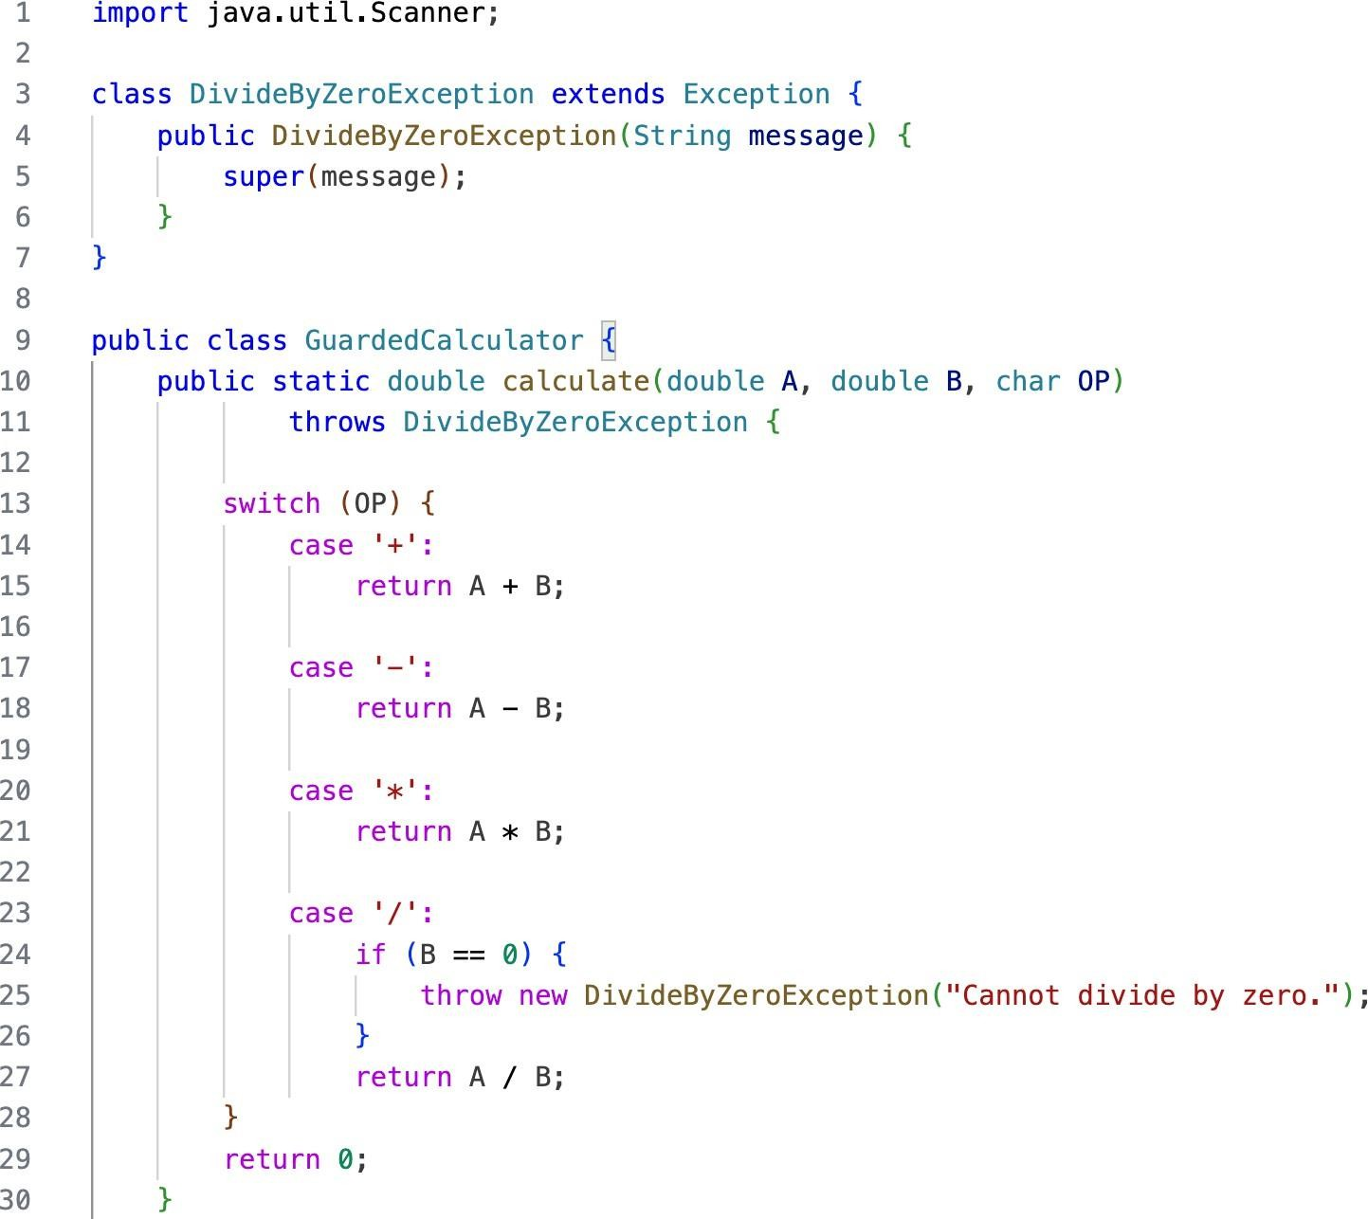

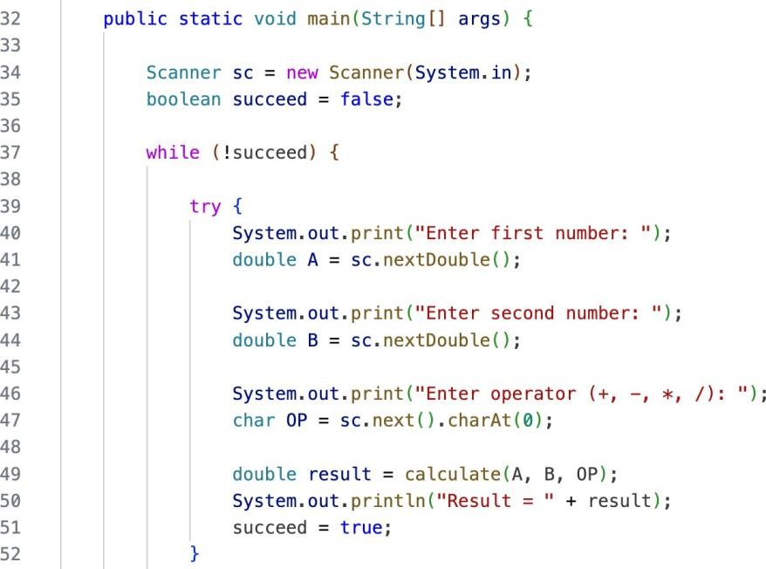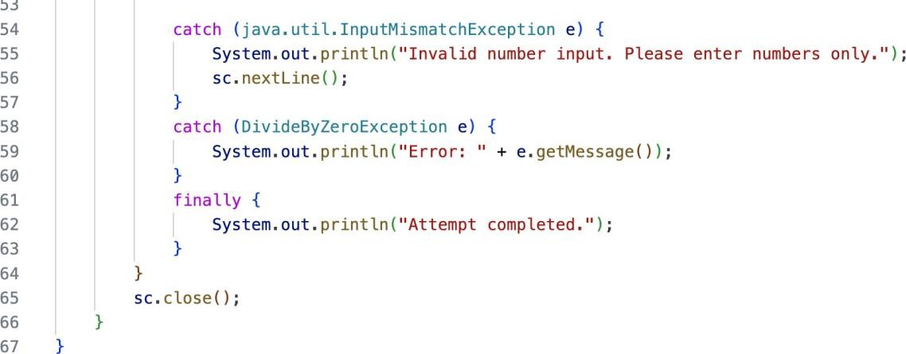

Output Screenshot:
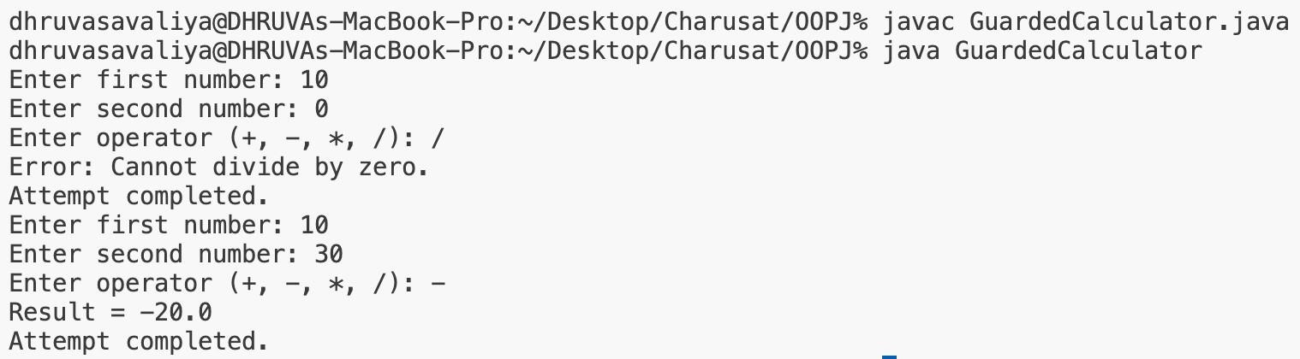

Learning Outcome:
To understand and implement exception handling in Java using custom exceptions, try-catch-finally blocks, and loops. The program demonstrates how to create and throw a custom DivideByZeroException, handle invalid number input separately using NumberFormatException, use the finally block to log every calculation attempt, and repeatedly accept input until a valid calculation is successfully completed.

Aim : 2. Stock issue: a Warehouse where issue(item, qty) throws a custom checked OutOfStockException carrying the shortfall, and InvalidQuantityException for qty ≤ 0. Process a list of requests, catching and reporting each failure without stopping the run.

Code Screenshot:

StockIssue.java
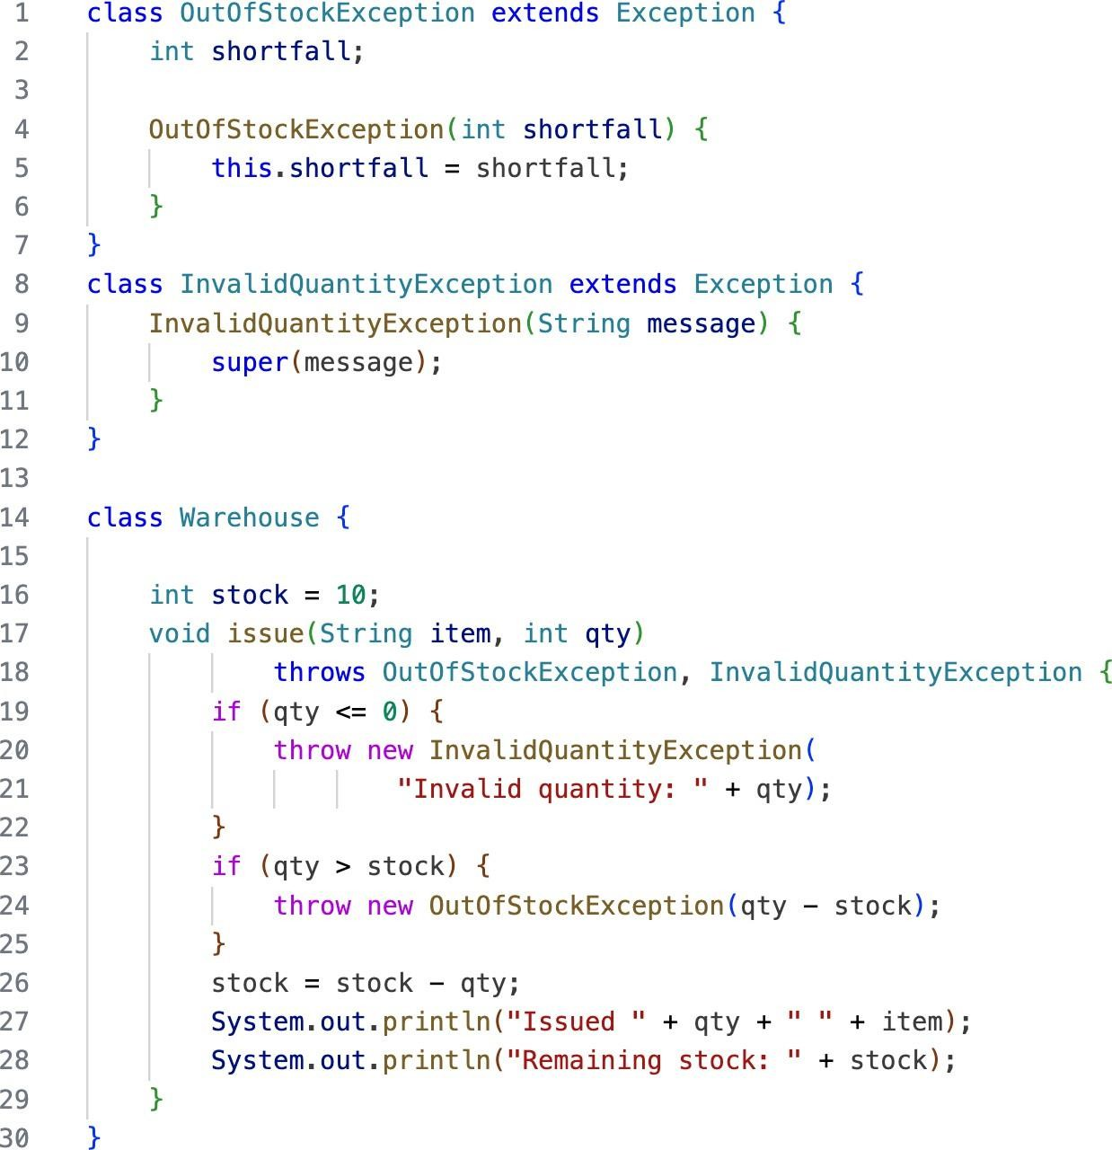

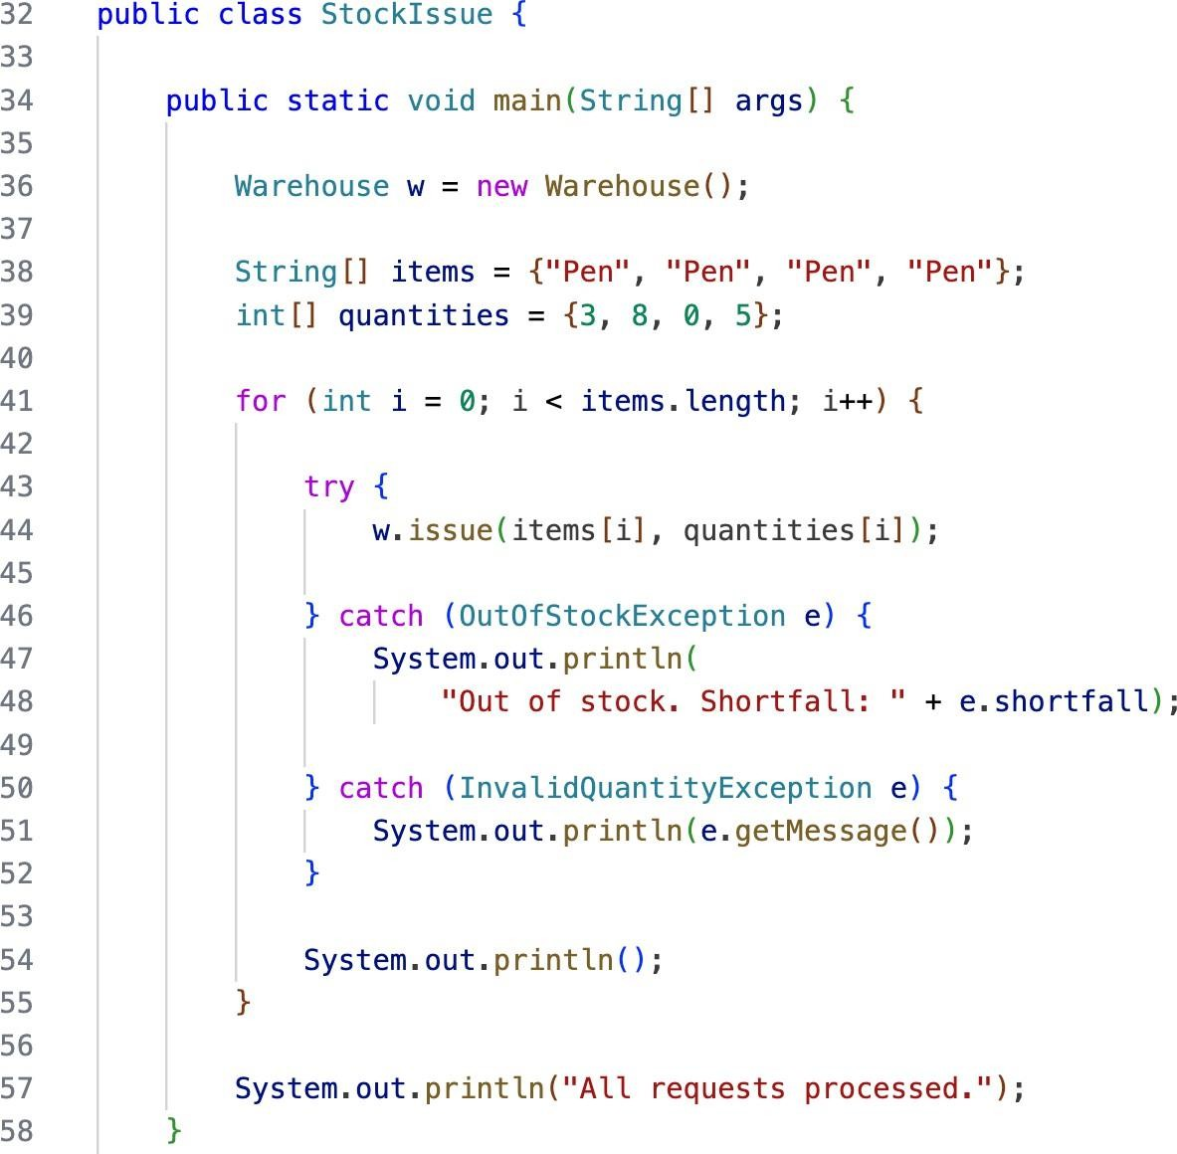

Output Screenshot:
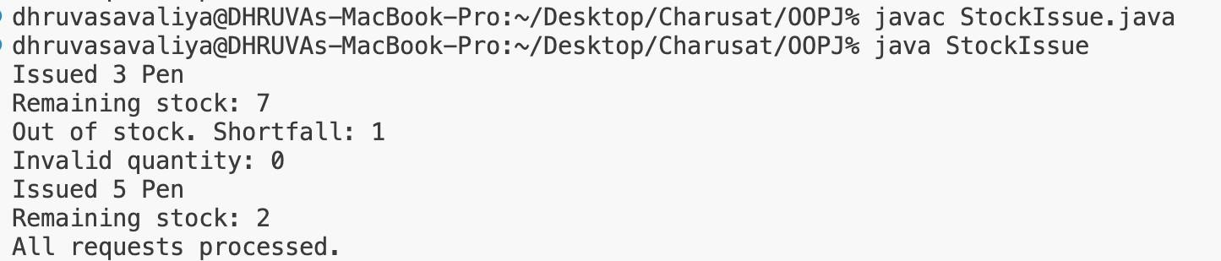

Learning Outcome:
To understand and implement custom checked exceptions in Java for handling stock-related errors. The program demonstrates how to create and throw custom OutOfStockException carrying the required shortfall and InvalidQuantityException for invalid quantities, while processing multiple stock requests. It also demonstrates exception handling that reports each failure individually without stopping the execution of the remaining requests.

