PRACTICAL - 9

Aim: 1. Counter race: several threads each increment a shared counter many times. Run it without synchronization to watch the total come out too low, then make the increment synchronized and confirm it is exactly right every run.
Code Screenshot:
CounterRace.java:-

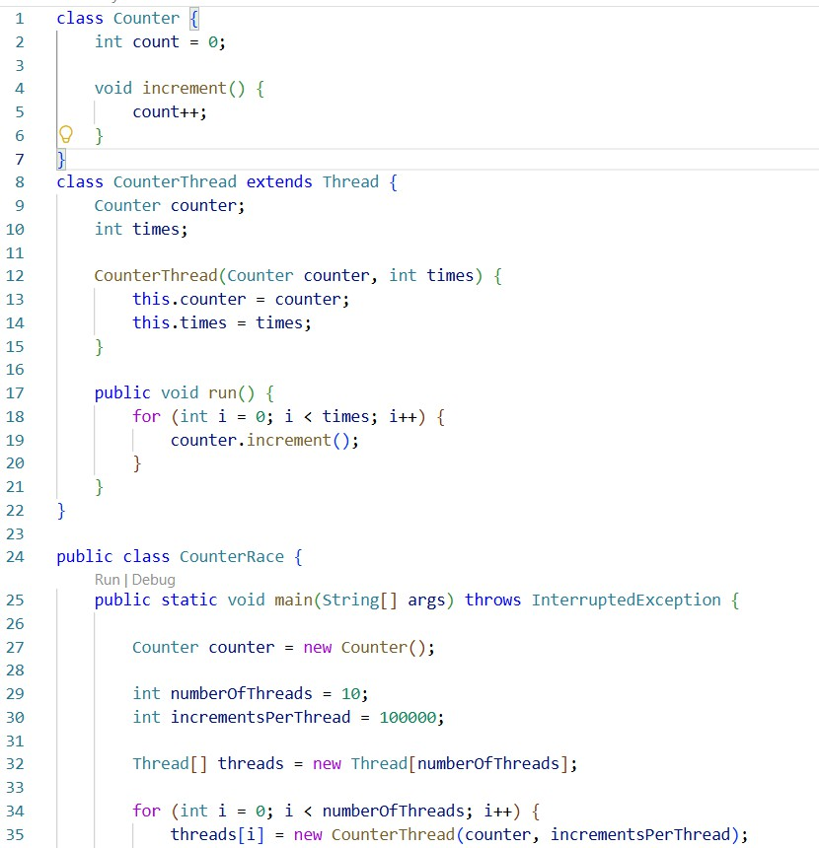
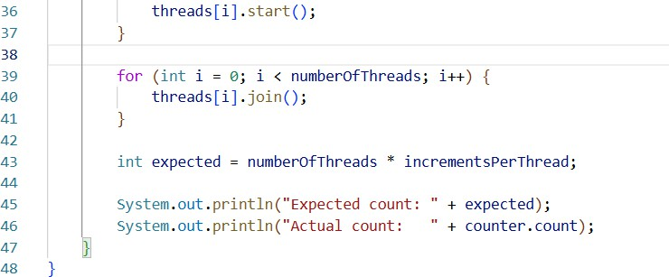
Program 1A - Without Synchronization

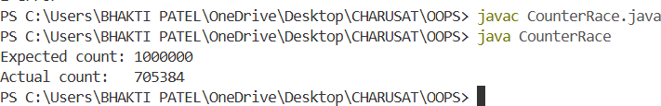
Output Screenshot:
Program 1B - With Synchronization
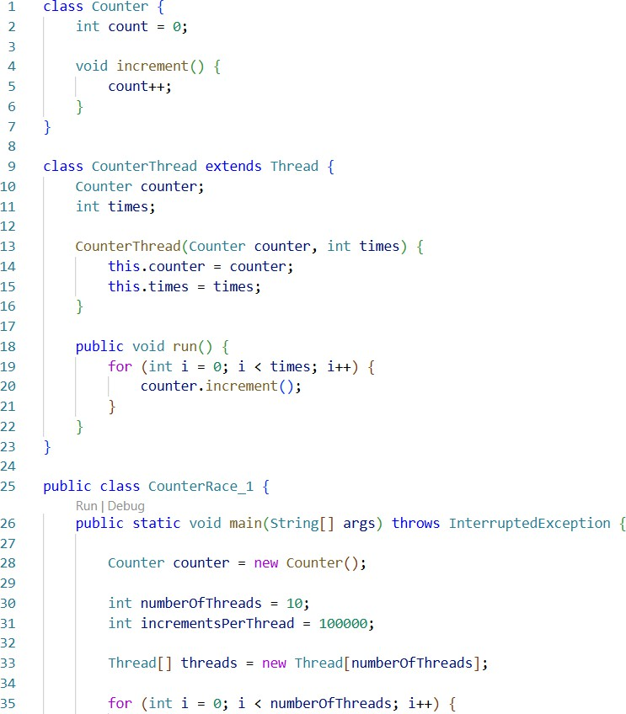
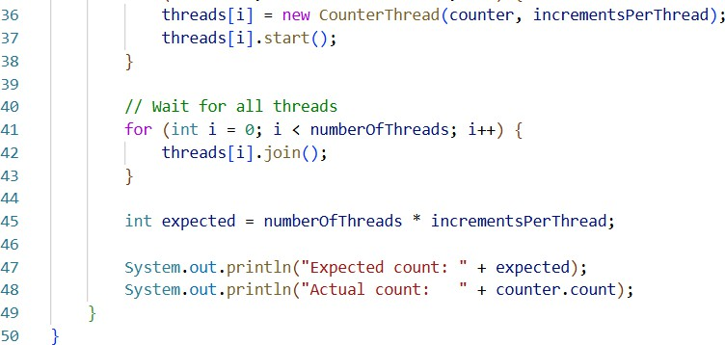

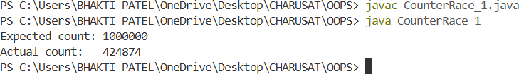
Output Screenshot:

Aim : 2 Seat booking race: a shared seatsLeft of 5 with about 10 threads each trying to book one seat. Without synchronization show that more than 5 can succeed (oversell); with a synchronized book() exactly 5 do.

2A. Without Synchronization
SeatBookingRace.java :-
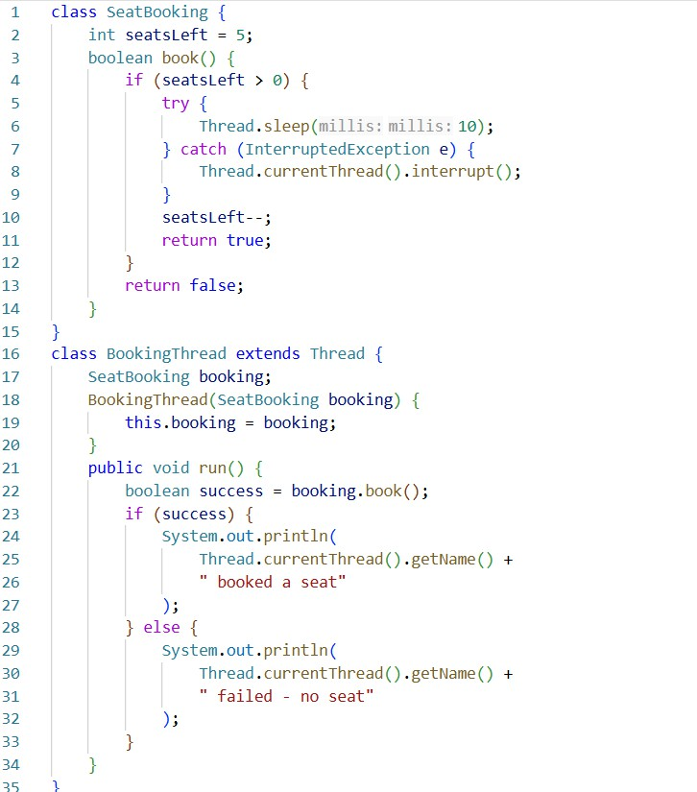
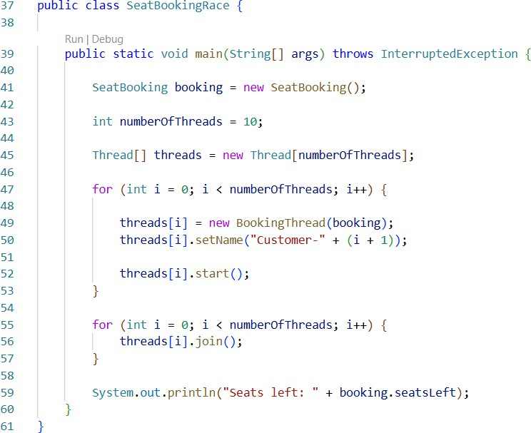

Output Screenshot:
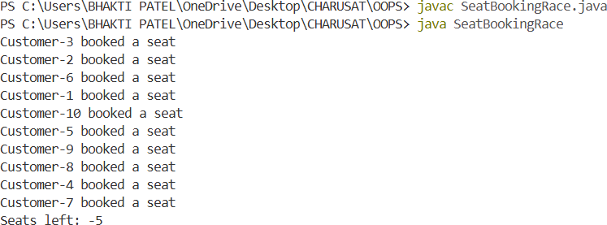

2B. With Synchronization :

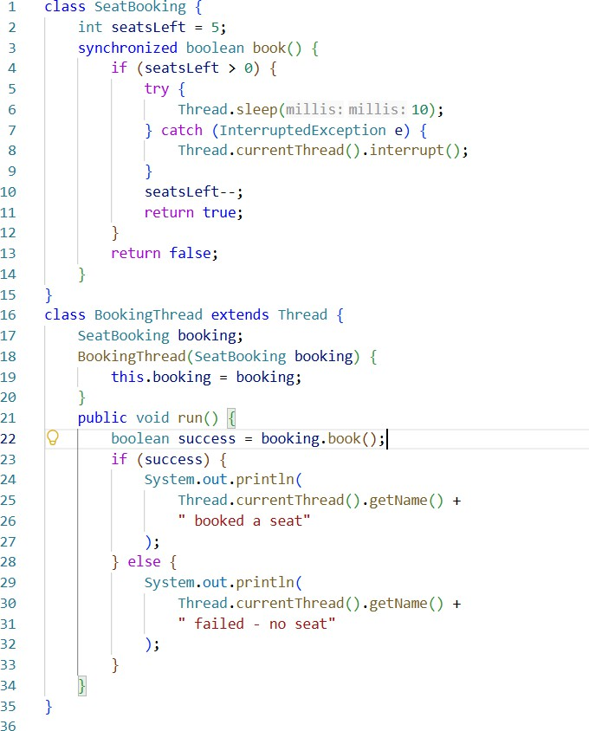
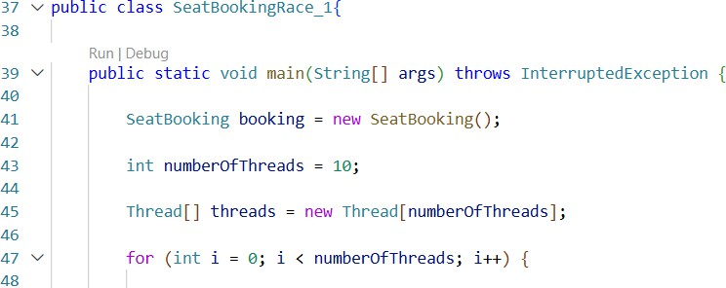

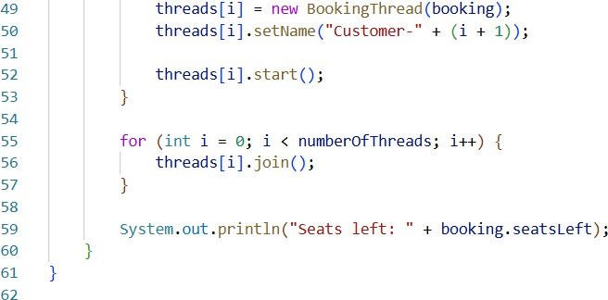

Output Screenshot:
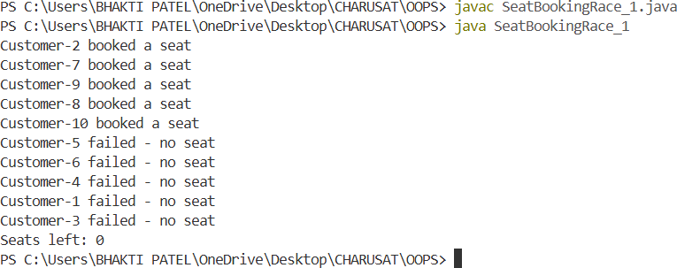

Learning Outcome:
The three programs demonstrated the importance of thread synchronization when multiple threads access shared data. In the Counter Race program, unsynchronized access could produce an incorrect counter value, while using synchronized ensured the expected result every time. In the Seat Booking Race, lack of synchronization could cause more than the available 5 seats to be booked, whereas a synchronized book() method allowed exactly 5 successful bookings. The Advanced Array Sum program further showed how shared data can cause race conditions and how synchronization or separate partial results can solve the problem. Overall, these experiments demonstrated that synchronization prevents race conditions and maintains data consistency in multithreaded programs, although synchronization may introduce some performance overhead.

