PRACTICAL - 1

Aim: To develop a Java program to implement a vending machine using enum and switch expression to calculate the total amount paid and the change to be returned.

Code Screenshot:

- Vending_Machine:

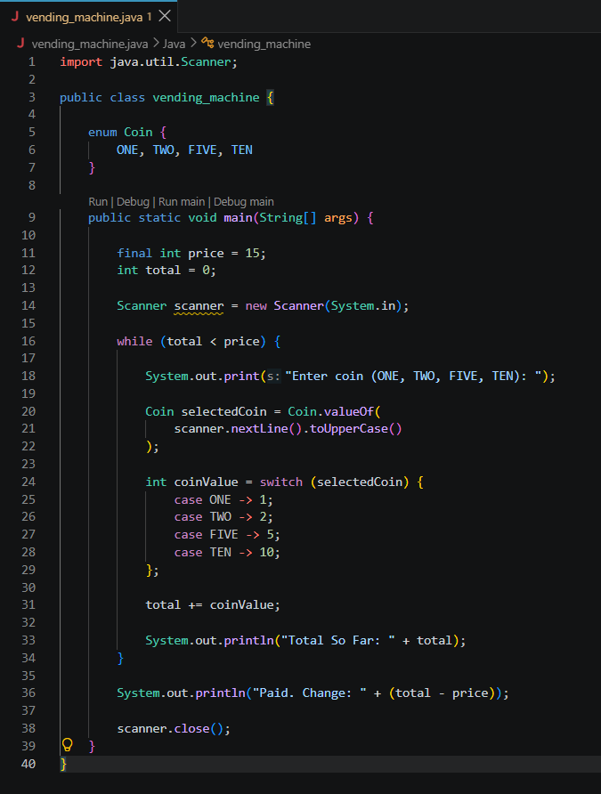

- Toll_booth:

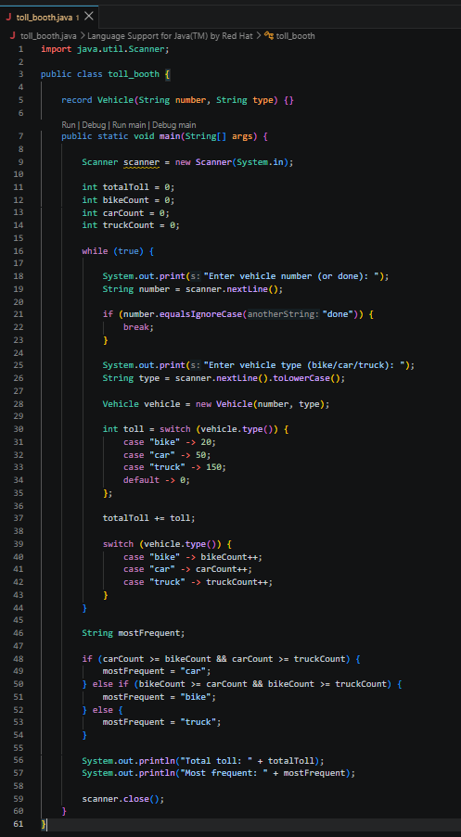

Output Screenshot:

- Vending_Machine:

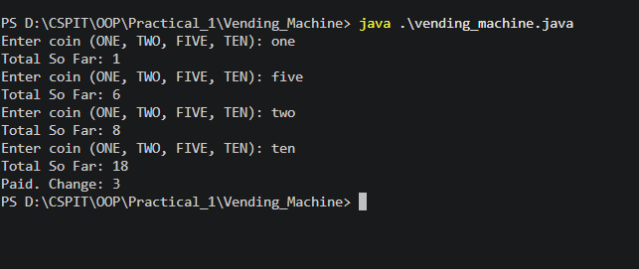

- Toll_booth:

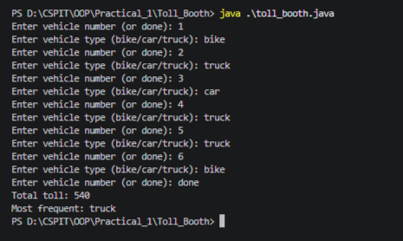

Learning Outcome:

The learning outcome of this practical is to understand and apply basic Java programming concepts such as enums, records, switch expressions, loops, user input, counters, and accumulators. Students will learn how to process user input, perform decision-making using switch expressions, calculate totals, track different categories, and determine the most frequent category.

