PRACTICAL - 5

Aim: This practical demonstrates abstraction, inheritance, constructors, arrays, and polymorphism in Java. Abstract classes and methods are used to define common behavior, while subclasses provide specific implementations for shape areas and employee salaries.

Code Screenshot:

- shape_areas:
Shape_Test.java
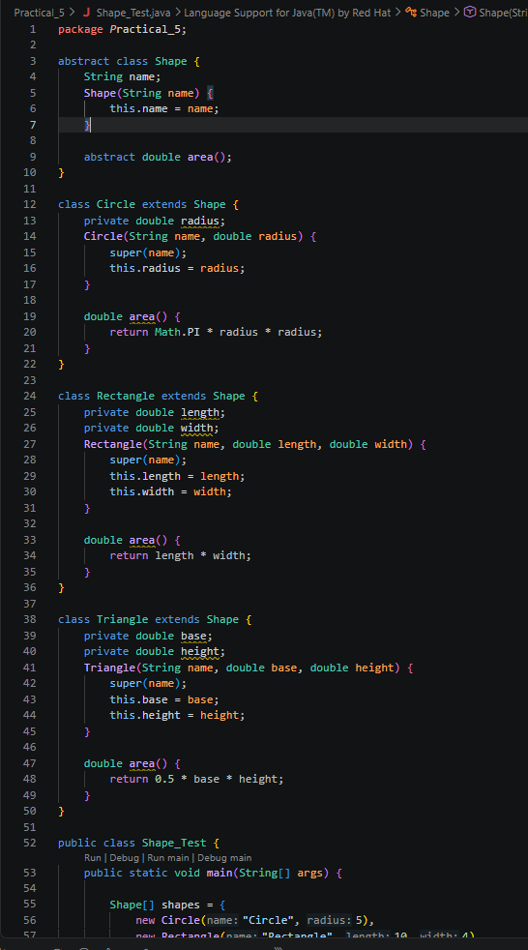

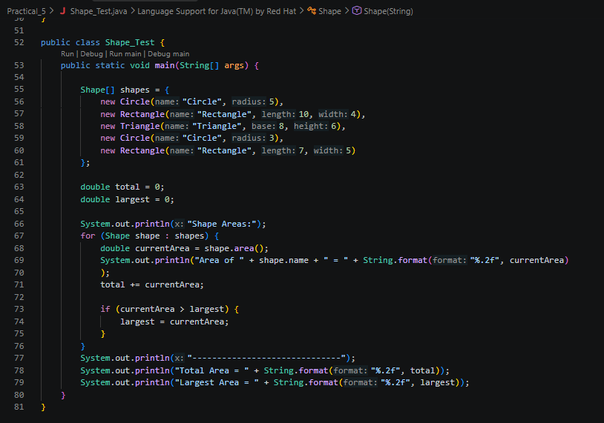

- Payroll:
Payroll.java
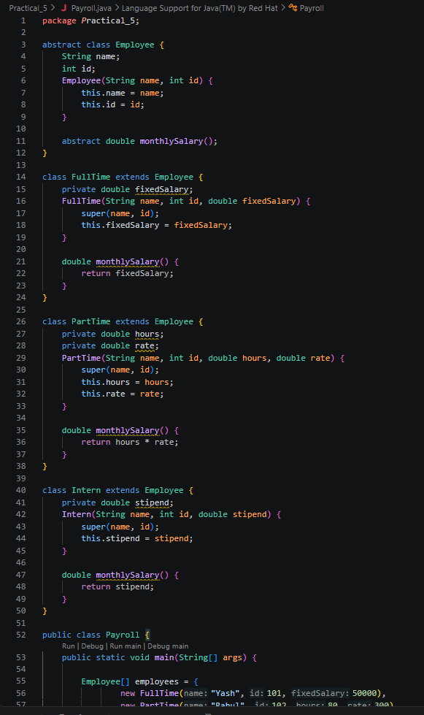
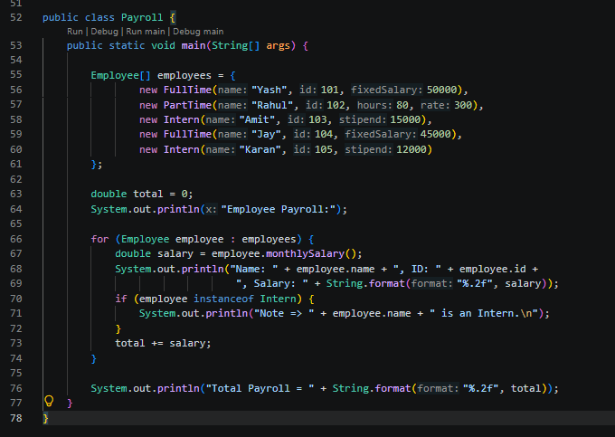

Output Screenshot:

- Shape_Test:

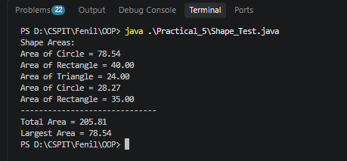

- Payroll:

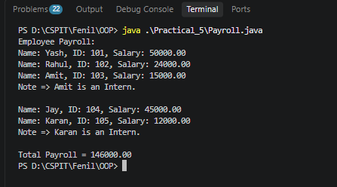

Learning Outcome:
The learning outcome of this practical is to understand and apply abstract classes, abstract methods, inheritance, constructors, arrays, and polymorphism in Java. Students will learn to process different objects through a common parent reference, calculate shape areas and employee salaries, find totals and maximum values, and use instance of to identify specific object types.

