PRACTICAL - 6
Aim: 1. Remote control: an interface Switchable with on()/off() and a default toggle(); Fan and Light implement it. Loop over a Switchable[] toggling each. Then add a functional interface that decides, given a device and an hour, whether it may switch on, and supply it once as an anonymous class and once as a lambda.

Code Screenshot:

RemoteControl.java
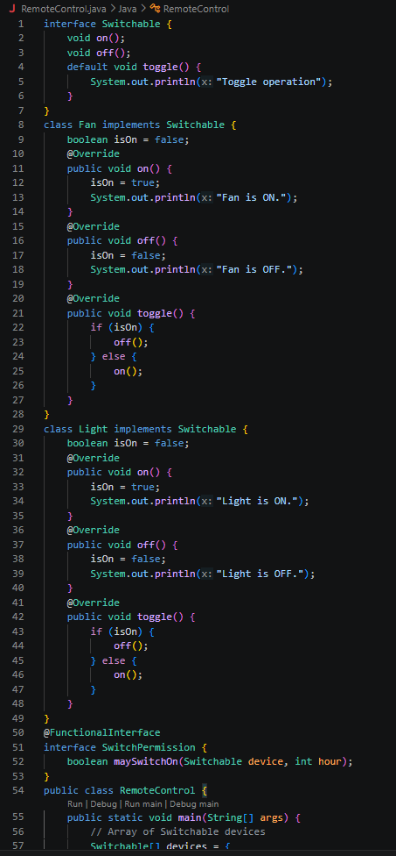

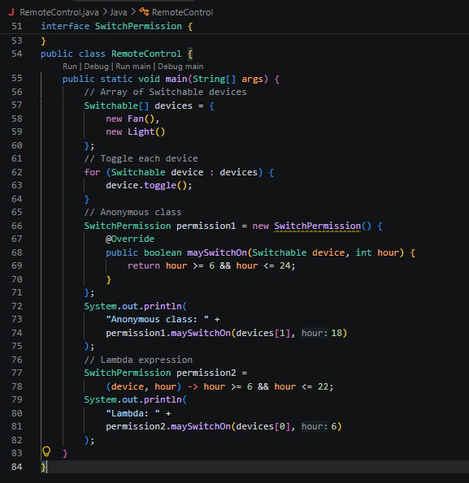
Output Screenshot: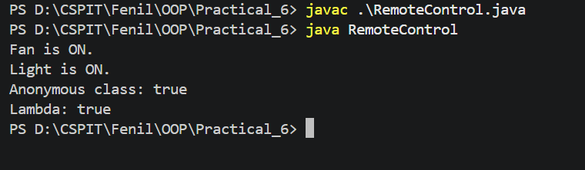

Learning Outcome:
To understand and implement interfaces, default methods, method overriding, polymorphism, functional interfaces, anonymous classes, and lambda expressions in Java. The program demonstrates how different devices such as Fan and Light implement a common Switchable interface, use the toggle() method through an array of Switchable objects, and define switching permissions using a functional interface implemented by both an anonymous class and a lambda expression.

Aim : 2. Notification senders: a functional interface Notifier with send(String); make email and SMS senders as lambdas, hold them in an array, and broadcast one message through all. Add a marker interface Urgent and send twice for senders marked urgent.

Code Screenshot:

NotificationSender.java

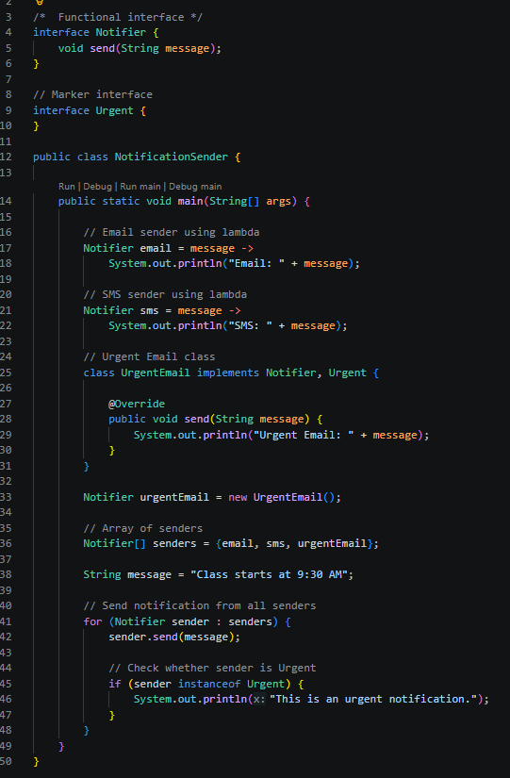

Output Screenshot:
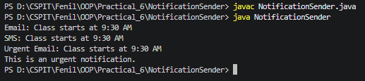

Learning Outcome:
To understand and implement functional interfaces, lambda expressions, arrays of interface objects, and marker interfaces in Java. The program demonstrates how Email and SMS notification senders can implement a common Notifier functional interface using lambda expressions, store them in an array, and broadcast a message to all senders. It also demonstrates the use of the Urgent marker interface to identify urgent senders and send the notification twice to them.

