|  |  |  |
| --- | --- | --- |
|  | **Rochester Institute of Technology**  **Golisano College of Computing and Information Sciences**  **School of Interactive Games and Media**  **2145 Golisano Hall – (585) 475-7680** |  |

**Data Structures & Algorithms for Games & Simulation II**

**IGME 309**

**First exam – Practical (version r)**

Video instructions can be found here: <https://youtu.be/k8KMaQ4pVpI>

I’ve included a solution under the _Binary folder. Please take a look at that before continuing reading this document.

Right out of the box you will begin with this:

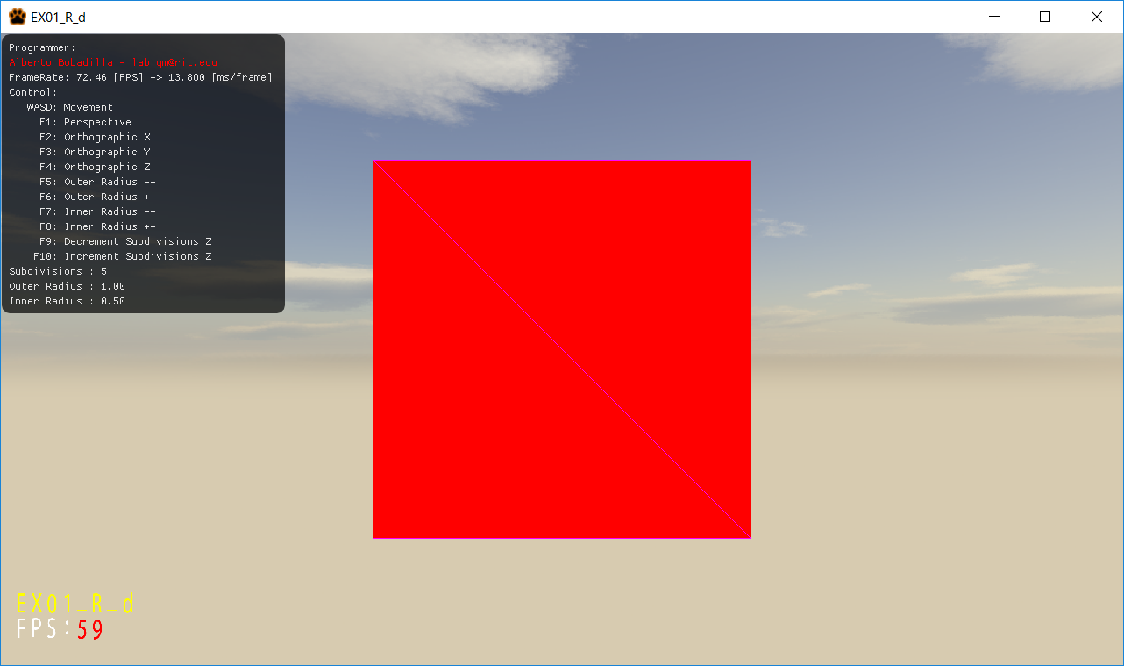

You are working on an app that will display a star model that can be dynamically generated and modified into different shapes. The end result should look like this:

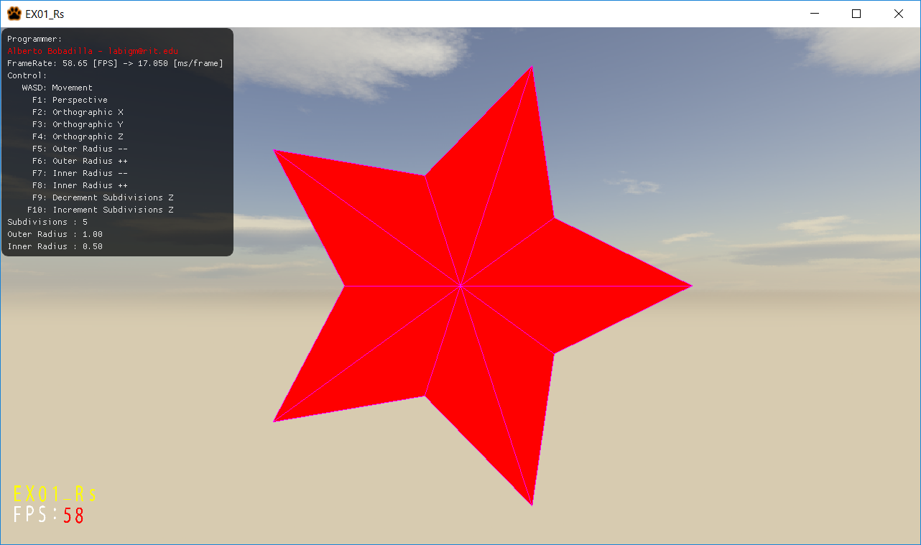

From the starter code there are some things you need to do:

1. Modify the MyMesh.cpp GenerateStar method to generate the shape

Tips

1. Your files need to compile, if the code does not compile it gets an automatic 0, its better for you to comment the faulty lines and receive partial credit than no credit at all.
2. You are allowed to add more variables and methods as needed. But you will **only submit one file MyMesh.cpp** if you are adding more variables make sure you are giving me all the files I need to grade.
3. Memory is handled for you unless you make new variables.
4. The only file you need to modify is:
   1. MyMesh.cpp
      * GenerateStar(…)

You will be graded as follows (up to 100%):

100% (up to) if you can generate the shape

Deductions will happen as follows (no more than 100% deductions can happen):

-100% your code does not compile

-100% (up to) your code does not generate the shape

-20% Outer Radius does not change the shape (its hardcoded)

-20% Inner Radius does not change the shape (its hardcoded)

-20% subdivisions does not change the shape (its hardcoded)

-20% you submit more than the single unzipped MyMesh.cpp file (unless you really needed to include more files for a reason)

***Submit to the dropbox labeled Exam 1 –Practical***

The required submission asks only for a single unzipped MyMesh.cpp, not the whole solution, it should be no larger than 10kb, if you are using extra files for creating variables and such, please include those files as well as a zipped file. The content of your submission should look like this (routes might be different):

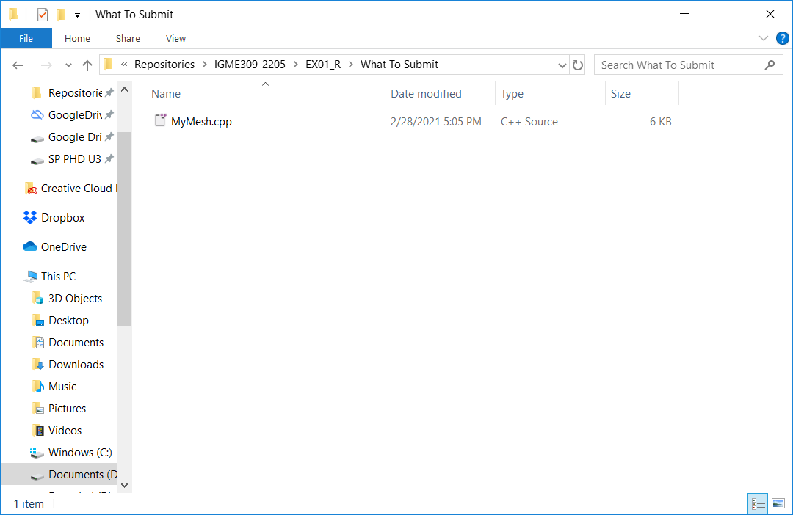

You are also required to push to your repository and give me the link to it in the comment of your submission. But there is no penalty if you forget.

After you submit your file it is your responsibility to download your submission and make it is what you worked on and not the starter code, **it has happened to other students before, do not let it happen to you.**