**Assignment 1**

**React Application**



**By:** Gavin Fennelly

**Student Number:** 20062979

**Overview**

My application is an app about the Spanish football team Real Madrid. The app will allow fans of the football team be able to view all their heroes’ stats and info from how many goals they have scored to what nationality they are and also view photos of them in action for both Real Madrid and also for their county.

They app will also allow fans go to a Real Madrid Fan Community page where they will be able to comment anything they want! They will be able to enter in there comment about the previous matches that were played to general comments about whether Real Madrid are going to sign a new player or not and if there are any charity events in the nearby area where fans might be able to see the Real Madrid players and go an autograph. Each fan that posts a comment will also be asked to enter in their name so that so that each fans name will be linked to their comment on the Real Madrid Fan Community Page. A list of the user features is listed below in detail:

I planned on creating a list of the most popular Real Madrid players where a user can scroll through and view them and see a snippet of information about the players.

On the main page where the list of players is, the user will be able to search for the player they wish to view alphabetically if they do not wish to score down through all the players list.

Another function is that the user can sort the list so the youngest appears first. This is useful if the user wants to see which players have the most potential and will player for many years to come.

I plan on creating a new route when the user can click on a link provided beside the players name that they can click on and it will bring them to a new page where they can see additional information about the player such as his age, nationality and total goals scored for the club etc. and also more pictures of the player.

I will create another link/route where a user can click on a link and it will redirect him/her to the official Real Madrid website where the user can view all the tickets available for the upcoming games and purchase them if they wish.

In the additional info page at the end of the page, there will be another section where the user can link on a link and will be redirected to another route in which they will see a comments page where they can enter their name and then make comments about whatever they wish or post news about any upcoming events they may want others to see.

2.

**Data Model Design**

A data model is a diagram which breaks down complex software systems into easy to understand diagram which anyone can understand using text, boxes and symbols to display the way data needs and will flow. Here I will display my application using a data design model.

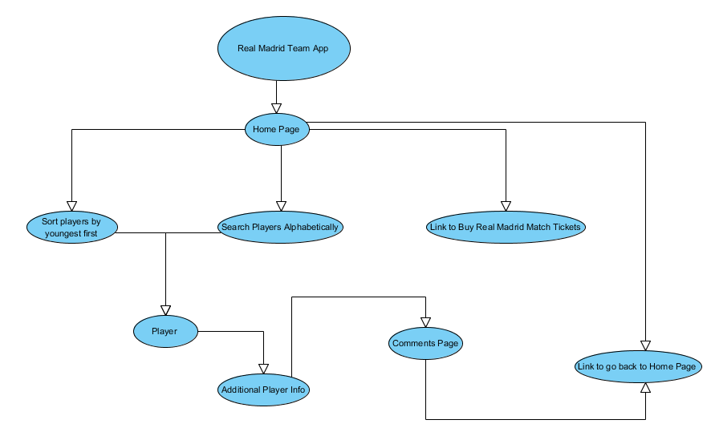

**Data Model Entity**

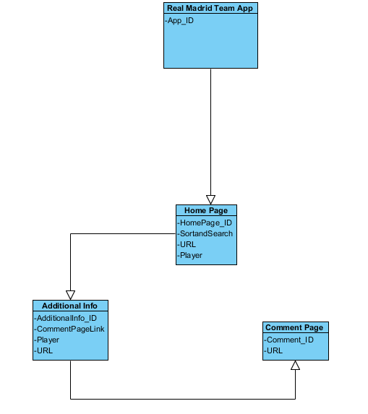

**UI Design**

1. **Screenshots**

Home page of app, this is where the list of players will be displayed

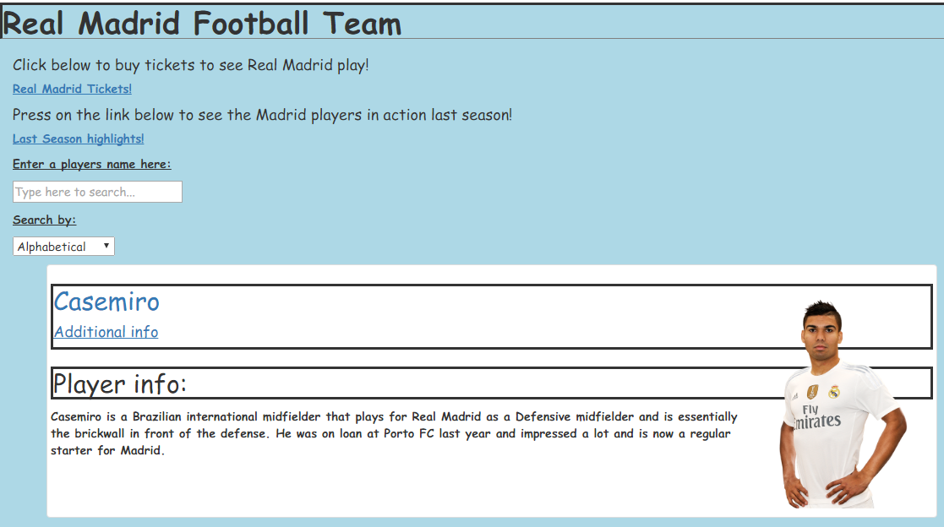

Additional Info page where you can see more information about the players you are interested in.

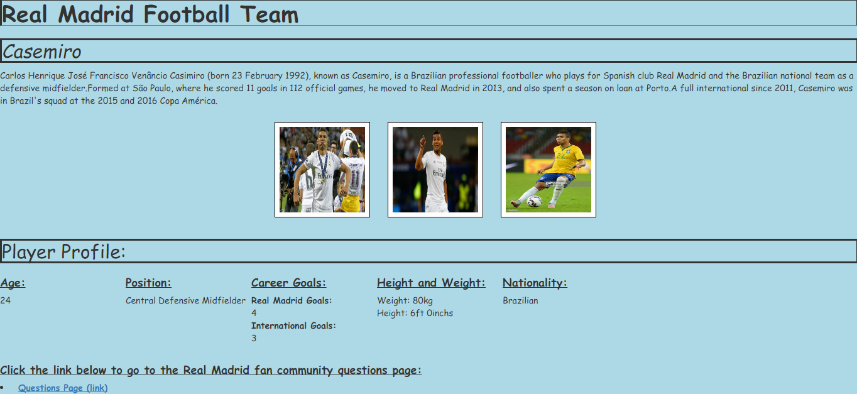

This is the comments page where people can either ask questions or just comment whatever they are thinking

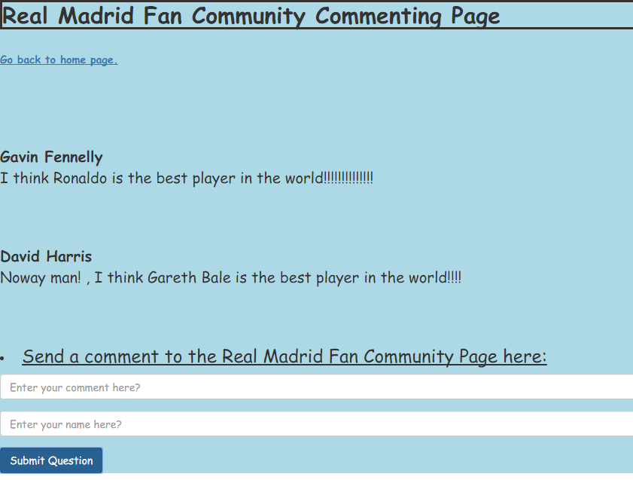

1. **URL Pattern.**

Application Main Page - <http://localhost:3000/>

Page of Real Madrid player Casemiro - <http://localhost:3000/players/casemiro>

Url of Real Madird player Pepe - <http://localhost:3000/players/pepe>

Comments page URL - <http://localhost:3000/commentPage/>

Real Madrid tickets Page – <http://www.realmadrid.com/en/tickets>

Season highlights page - <https://www.youtube.com/watch?v=8pXtRXavA2s>

Back Button URL - <http://localhost:3000/players/>

1. **Component Hierarchy Diagram**

**Stateless:** A stateless component doesn’t require the server retain all the session information about each communication for the time of the multiple requests.

**Stateful:** A stateful component require keeping the inner state on the sever, unlike stateless components.

**Stateful components are:** Real Madrid home page, Comments Page, Additional info page.

**Stateless components are:** Search Alphabetically, Search by youngest first, Player.

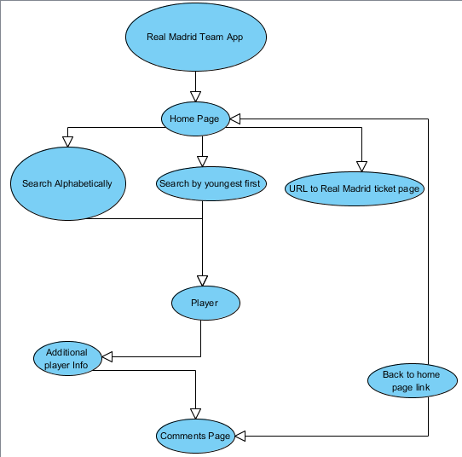

**App Hierarchy in text form**

Real Madrid Team App

Home Page

Search Alphabetically

Search by Youngest First

URL to Real Madrid Ticket Page

Player

Additional Player Info

Comments Page

Back to Home Page Link

**Extra Features**

In my app I added in a few extra features, some of the extra features I added in include a link on the apps home page and allows the user go to the official Real Madrid home page where they are going to be able to purchase official Real Madrid match tickets. I also added an extra route where the user will be able to go and post comments about the app I created and when they are finished commenting there is another link which will instantly bring them user back to the homepage where they can view more information about the players if they wish. If they see a player, they are really interested in there is an additional info button that I added in which they can actually click and in doing so it will bring them to another page that is solely about the player they clicked. In this page I have added further information about the player and additional pictures of the player in action for either his club or country.

On the home page there is a sorting function with will sort the players from youngest to oldest or another function where you can search players alphabetically depending on your needs.

**Independent Learning**

In my assignment I researched around the internet a lot. I used websites such as YouTube and W3schools quite a bit.

With W3Schools I learned how to change the colour of the background of the app using CSS. This was only done to the div part in my application.

I also learned how to put borders around selected parts of my text and headings using CSS as well. I done this in order to make the text and heading layouts look a lot more presentable.

I learned on YouTube how to put links to alternative websites on my homepage of the website where Real Madrid fans will be able to click and it will bring them to a website where they can buy tickets for Real Madrid football matches.

YouTube also helped me with configuring my code to help me route between pages and helped me add my comments page to my app.