Predicting Age from MRI-Derived Brain Measurements Using Machine Learning and Data Mining Techniques

Team Members:
Fenny Bharucha
Nhan Nguyen
Khoi Phan

__

June 26, 2026
__

Data Mining – II
__

Professor Larry Tang

1. Introduction
The goal of this project is to predict a person's age using MRI brain measurements from the OASIS-1 dataset. We first used a brain tumor dataset, but after cleaning, only 41 samples remained, which caused poor regression results. We switched to the OASIS-1 dataset because it has more subjects and is better for regression analysis. In this project, we apply a complete data mining workflow, including exploratory data analysis, feature selection, regression, classification, regularization methods, generalized linear models, tree-based learning, dimension reduction, clustering, and model evaluation to identify the most effective model for predicting age from MRI-derived brain measurements. The full project code is available at the following GitHub repository:
GitHub: https://github.com/Fenny2109/MRI-Brain-Tumor-Volume-Prediction.git

2. Dataset Description
The OASIS-1 dataset contains MRI brain measurements, demographic information, and clinical data for 436 subjects. Our target variable is Age, and the predictors include M/F, Educ, SES, MMSE, CDR, eTIV, nWBV, and ASF. These variables may help explain changes in age based on brain measurements.
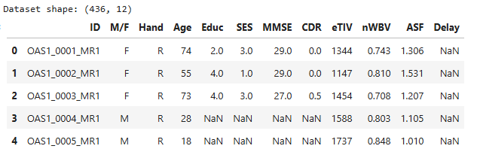
Table 1: Final Modeling Dataset

3. Data Cleaning and Preprocessing
We removed the ID, Hand, and Delay columns because they were not useful for prediction. We also removed rows with missing values in the selected variables, leaving 216 complete observations for modeling. The M/F variable was converted into numeric values, and the data was standardized before applying models that require feature scaling. These steps prepared the dataset for machine learning.
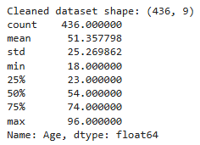
Table 2: Cleaned Dataset

4. Exploratory Data Analysis (EDA)
We explored the dataset using summary statistics, histograms, boxplots, scatterplots, and a correlation heatmap. The age distribution shows that most subjects are older adults. The correlation heatmap shows that nWBV has the strongest negative relationship with Age, while MMSE has a moderate negative relationship. These visualizations helped us understand the data before building models.
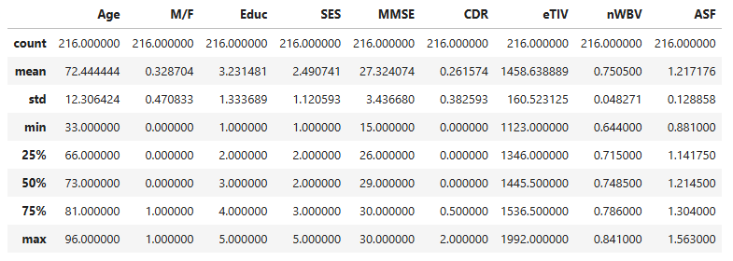
Table 3: Summary Statistics

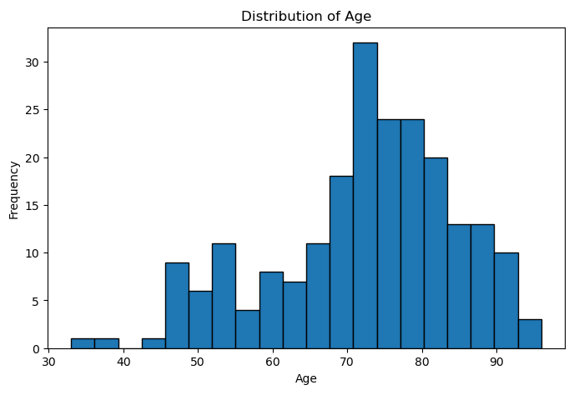
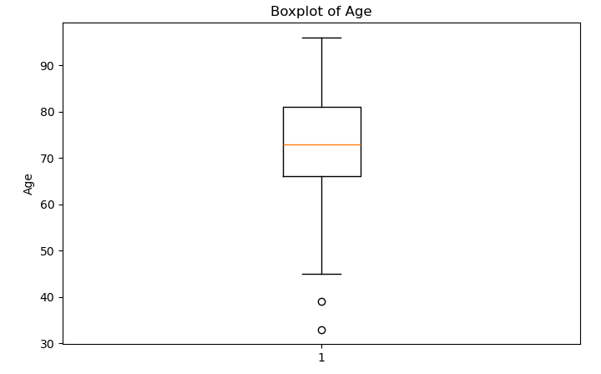
Figure 1: Distribution of Age Figure 2: Boxplot of Age
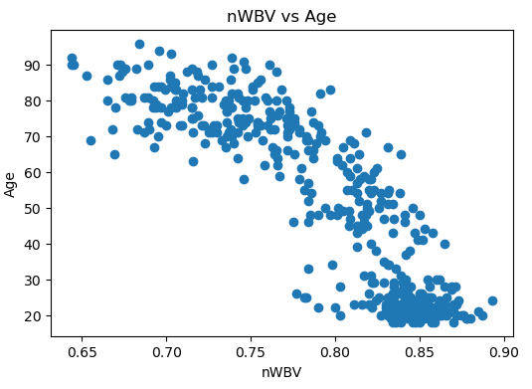
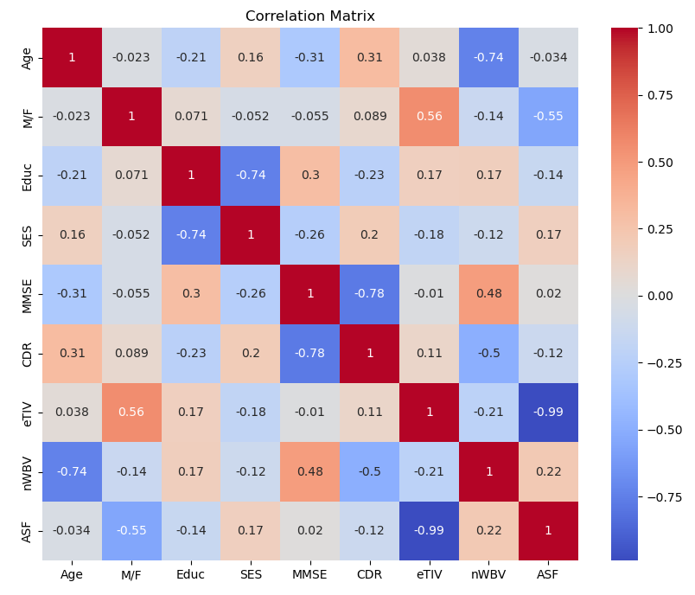
Figure 3: Correlation Matrix Figure 4: Scatterplots for nWBV vs Age
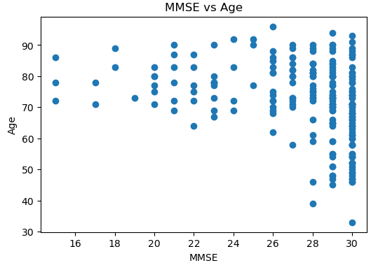
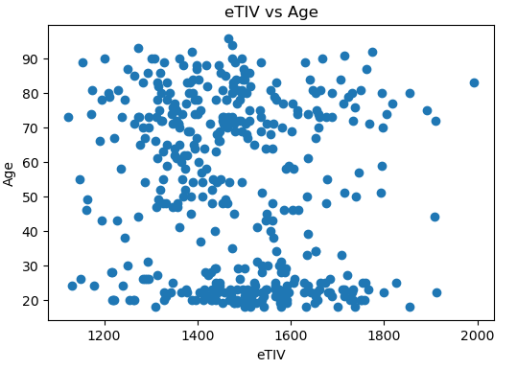
Figure 5: Scatterplots for eTIV vs Age Figure 6: Scatterplots for MMSE vs Age

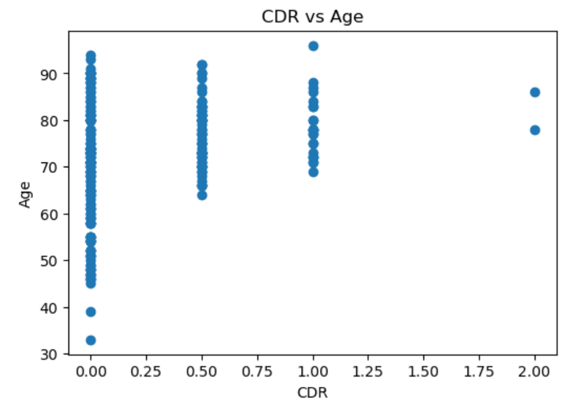
Figure 7: Scatterplots for CDR vs Age

5. Feature Selection
We used correlation analysis, VIF, and LASSO regression to identify important predictors. VIF was used to check multicollinearity among the variables. LASSO selected variables such as nWBV, M/F, Educ, and ASF as important predictors for Age. These methods helped reduce unnecessary variables and improve model interpretation.
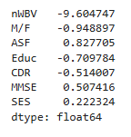
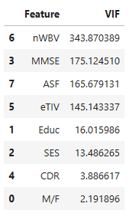
Table 4: Multicollinearity check using VIF Table 5: Lasso Feature Selection

6. Regression Analysis
We compared several regression models, including Linear Regression, Ridge Regression, LASSO Regression, and Elastic Net Regression. The models were evaluated using MAE, RMSE, and R². Linear Regression, Ridge, and LASSO produced very similar results, while Elastic Net balanced regularization and feature selection. These models served as the baseline for comparison with more complex models.
Elastic Net combines both L1 (LASSO) and L2 (Ridge) regularization, allowing it to perform feature selection while reducing multicollinearity.
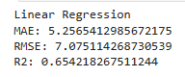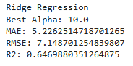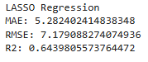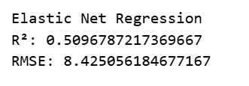
Table 6: Regression Analysis – Linear, ridge, Lasso, elastic

7. Generalized Linear Model (GLM)
We built a Gaussian Generalized Linear Model because Age is a continuous variable. The GLM allowed us to study the relationship between each predictor and the target variable. The results showed that nWBV was the most significant predictor of Age. The model also helped explain how each variable affected the prediction.
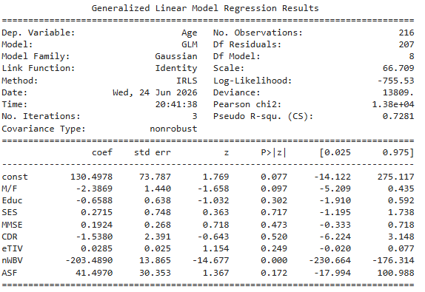
Table 7: GLM

8. Tree-Based Analysis
We trained a Decision Tree Regression model and a Random Forest Regression model. The Decision Tree had lower prediction accuracy and was more likely to overfit the training data. Random Forest improved prediction by combining many decision trees through ensemble learning. We also tuned the Random Forest model to improve its performance.
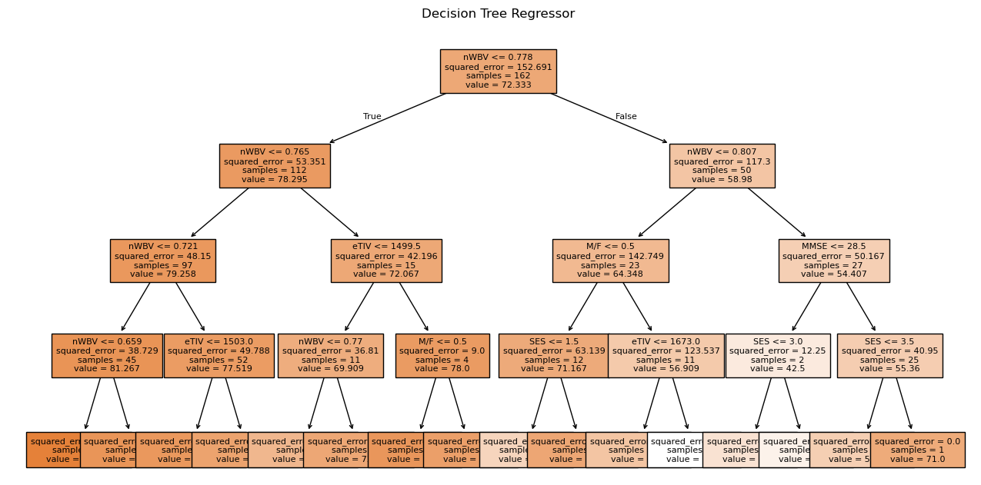
Figure 8: Decision Tree Regressor
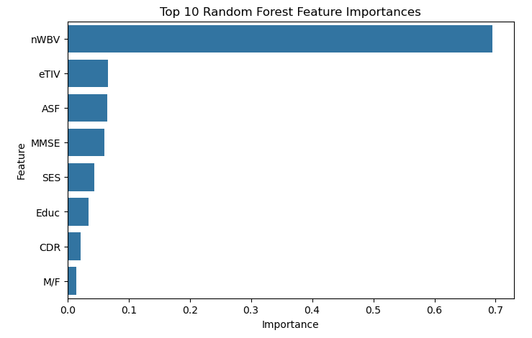
Figure 9: Random Forest Feature Importance

9. Dimension Reduction (PCA)
Principal Component Analysis (PCA) was used to reduce the number of variables while retaining most of the information in the dataset. The explained variance plot showed that only a few principal components captured most of the variation in the data. This indicates that the original predictors contain substantial redundancy and are highly correlated. Therefore, PCA helps simplify the dataset by reducing dimensionality while preserving most of the information, making it particularly useful when working with correlated predictors.
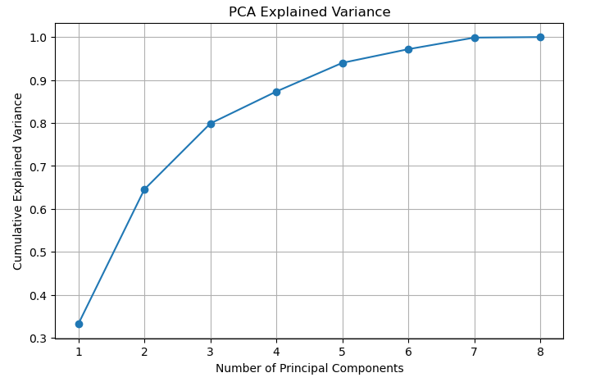
Figure 10: PCA
10. Clustering
We applied K-Means clustering to groups based on their MRI measurements. The elbow method was used to choose the best number of clusters. The results suggested that three clusters provided a reasonable grouping of the data. Clustering helped us explore hidden patterns without using the target variable.
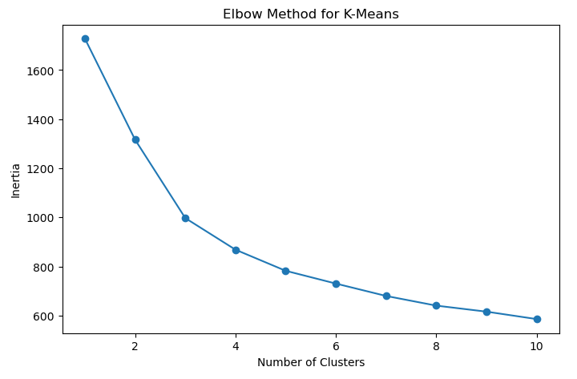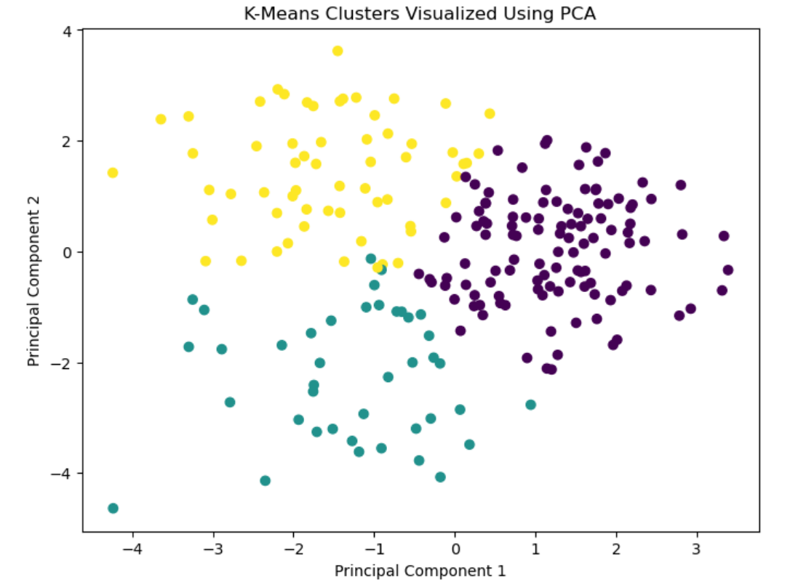
Figure 11: Elbow method for K-means Figure 12: K-means using PCA

11. Classification Analysis
To demonstrate classification methods, we converted Age into two groups: younger and older subjects. We trained Logistic Regression and Random Forest Classifier models using these two classes. The models were evaluated using accuracy, precision, recall, F1-score, and confusion matrices. This analysis shows how the same dataset can be used for both regression and classification problems.
The Random Forest achieved approximately 90% accuracy, demonstrating that MRI-derived features can effectively distinguish between younger and older subjects.
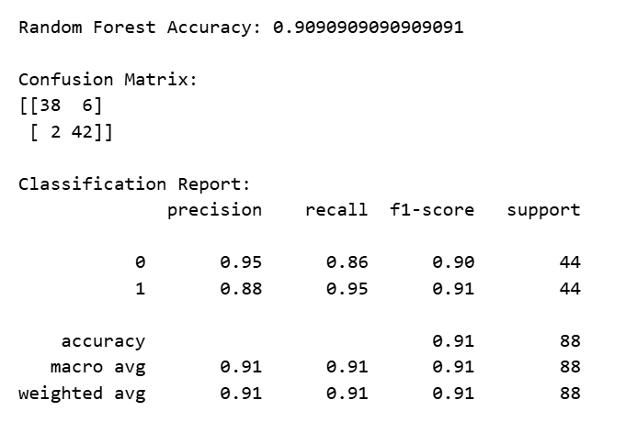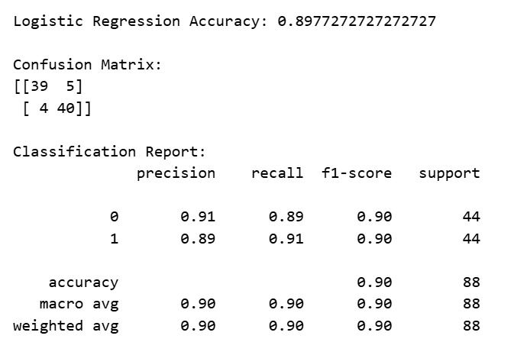
Table 7: Classification Analysis

12. Model Comparison
We compared all regression models using MAE, RMSE, and R². The Tuned Random Forest achieved the highest R² (0.663), while also producing the lowest RMSE among all evaluated regression models, making it the best-performing model for predicting Age. Decision Tree had the weakest performance among all models. Comparing multiple models helped us choose the most suitable method for this dataset.
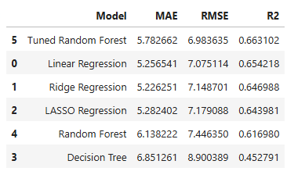
Table 8: Model comparison

13. Cross-Validation
Five-fold cross-validation was performed to evaluate the stability and generalization ability of the regression models. The results showed consistent performance across folds, indicating that the models generalized well and were not overly dependent on a single train-test split.
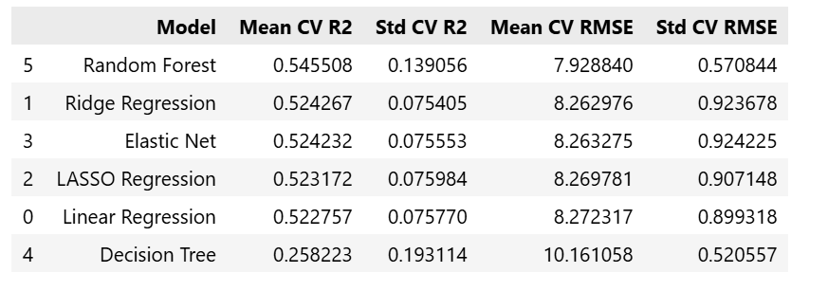
Table 9: Cross Validation

13. Conclusion
In this project, we applied exploration data analysis, feature selection, regression, GLM, tree-based analysis, PCA, clustering, and classification to the OASIS-1 MRI dataset. The results show that MRI-derived brain measurements can be used to predict Age with good accuracy. Among all predictors, nWBV was the most important variable. Overall, the Tuned Random Forest produced the best prediction performance, although the linear models also performed well.
14. Reference
- Marcus, D. S., Wang, T. H., Parker, J., Csernansky, J. G., Morris, J. C., & Buckner, R. L. (2007). Open Access Series of Imaging Studies (OASIS): Cross-sectional MRI Data in Young, Middle Aged, Nondemented, and Demented Older Adults. Journal of Cognitive Neuroscience, 19(9), 1498–1507. https://doi.org/10.1162/jocn.2007.19.9.1498
- James, G., Witten, D., Hastie, T., Tibshirani, R., & Taylor, J. (2023). An Introduction to Statistical Learning with Applications in Python (ISLP). Springer. https://www.statlearning.com/
- Pedregosa, F., Varoquaux, G., Gramfort, A., et al. (2011). Scikit-learn: Machine Learning in Python. Journal of Machine Learning Research, 12, 2825–2830. https://scikit-learn.org/
- Seabold, S., & Perktold, J. (2010). Statsmodels: Econometric and Statistical Modeling with Python. Proceedings of the 9th Python in Science Conference. https://www.statsmodels.org/
- OASIS Brains Project. OASIS Cross-Sectional MRI Dataset. https://www.oasis-brains.org/

