Edge Hill University

The Department of Computer Science



# IOC Bootcamp: Database Basics

Workbook: Week Three

2021/2022

Module Leader: Dr. Nonso Nnamoko

🕿 **TBC**

**Email: nnamokon@edgehill.ac.uk**

*Administrators:*

**🕿** 01695 65 7603

## Tutorial – Week Three

### Overview & Aims

﻿ The aims of the tutorial:

* To ensure that students understand MySQL language.
* To help students understand how to store, manipulate and retrieve data in relational database.

At this point, students should have now learned what MySQL is and the terminologies used to define data on a simple table. They will also be aware of the basic concepts to create a simple database structure and manipulate the data. This tutorial attempts to build on what we’ve learned so far.

### Autonomous Learning

﻿This week students are expected to,

* Complete the workbook activities.
* Read relevant chapters of the book “Beginning Database Design” by Churcher.

## Activities

In this workbook, you will use SQL statements to create the STUDENT and DEPARTMENT tables we have used as example throughout this course. You will then perform some manipulations on the database. First, we will create the database schema using DDL language. Then, we will insert some data into the tables and manipulate them using DML language. And finally, you will write some SQL queries to answer some questions.

## Creating the database schema using DDL

1. Go to [www.sqlfiddle.com](http://www.sqlfiddle.com)
2. Create the DEPARTMENT table using the code below and clicking the “**Build Schema**” button. Make sure you see the “**Schema Ready**” notification at the bottom of the editor. If not, have a look at your code to make sure you have not missed anything.

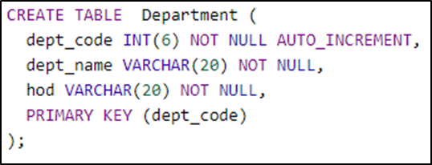

1. Create the STUDENT table using the code below and clicking the “**Build Schema**” button. Make sure you see the “**Schema Ready**” notification at the bottom of the editor. If not, have a look at your code to make sure you have not missed anything.

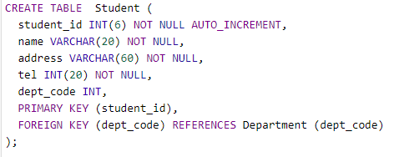

1. Now that you have created the tables, click the “**Browse**” button to see your tables. Your database schema should look like the image below:

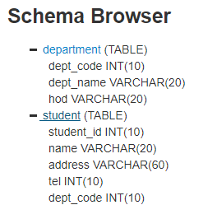

**Note:**

You need to expand the tables by clicking the “**+**” button.

When you are done, click the “**DDL Editor**” button to return to the editor window.

You have successfully created your first database schema.

## Inserting data into the tables using DDL

1. Still on the left-hand-side of the editor, enter the following code to add data to the DEPARTMENT table. Remember to click the “**Build Schema**” button when you finish typing. Make sure you see the “**Schema Ready**” notification at the bottom of the editor. If not, have a look at your code to make sure you have not missed anything.

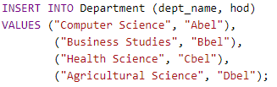

1. Enter the following code to add data to the STUDENT table. Remember to click the “**Build Schema**” button when you finish typing. Make sure you see the “**Schema Ready**” notification at the bottom of the editor. If not, have a look at your code to make sure you have not missed anything.

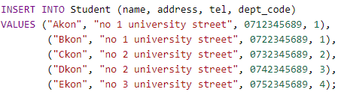

You are now ready to perform some operations on the database.

## Data manipulation using DML

1. On the right-hand-side of the editor, enter the code below and click “Run SQL” button. This should return 5 records displayed directly under the editor window.

code to select data from the student table

1. On the right-hand-side of the editor, enter the code below and click “Run SQL” button. This should return 4 records displayed directly under the editor window.

code to select data from the department table

1. On the left-hand-side of the editor, enter the code below and click “Build Schema” button. Make sure you see the “**Schema Ready**” notification at the bottom of the editor. If not, have a look at your code to make sure you have not missed anything.

code to update data on the student table

Now, re-run the query in task 2. Notice that the “hod” for “Computer Science” has changed to “Andy”.

## Questions

Using SQL statements, answer the following questions. Please run your code on SQL Fiddle to see if it works. Then copy and paste them into this document. **You will need to save this file (with your answers) and submit via the submission dropbox on Blackboard.**

1. Write a query to find all students who live at “no 2 university street”.
2. Write a statement to insert a new student data into the Student table. You can make up the student details by yourself.
3. Write a statement to delete the department whose HOD is “Dbel”
4. Write a statement to add a new column for “tel_no” into the Department table.
5. Write statement(s) to insert “tel_no” details for all departments. You can make up the telephone numbers. There are many ways of doing this so feel free to explore.

## Learning Checklist

By the end of this tutorial be sure you can do the following:

* Create a simple database.
* Insert and manipulate data in the database.

## Reading Materials

Beginning database design – Churcher ([ISBN: 978-1-59-059769-9](http://www.softouch.on.ca/kb/data/Beginning%20Database%20Design.%202E.pdf))

Data mining concepts and techniques – Han ([ISBN 978-0-12-381479-1](http://myweb.sabanciuniv.edu/rdehkharghani/files/2016/02/The-Morgan-Kaufmann-Series-in-Data-Management-Systems-Jiawei-Han-Micheline-Kamber-Jian-Pei-Data-Mining.-Concepts-and-Techniques-3rd-Edition-Morgan-Kaufmann-2011.pdf))

Sams Teach Yourself SQL in 10 minutes (ISBN 0-672-33607-3)

[W3Schools](https://www.w3schools.com/sql/default.asp) and [SQL ZOO](https://sqlzoo.net/) provides the ability to try out SQL on a simulated database

## Answers

Please supply answers to questions 1 – 5 here. This is part of the portfolio to be submitted at the end of the course.

## Question 1 Answers

Provide answers here

SELECT * FROM Student WHERE address = "no 2 university street";

## Question 2 Answers

Provide answers here

**on the left pane (building the schema):**

INSERT INTO Student (name, address, tel, dept_code)

VALUES ("Fkon", "no 3 university street", 751254678, 4)

**on the right pane (query-ing the data to check):**

SELECT * FROM Student;

## Question 3 Answers

Provide answers here

Because of the issue of Foreign Key dependency, I changed the student who belongs to this department to another department, so:

UPDATE Student

SET dept_code = 3

WHERE name = "Ekon"

then I can delete:

DELETE FROM Department WHERE hod = "Dbel";

## Question 4 Answers

Provide answers here

ALTER TABLE Department

ADD tel_no INT(20) NOT NULL;

## Question 5 Answers

Provide answers here

INSERT INTO Department (tel_no)

VALUES (078564786),

(078564785),

(078564784)