**Objective Questions**

1. In analysing the hospital dataset with Power BI, ensure data cleaning to address inconsistencies and missing values before further analysis.

* **There are missing values in the patient satisfaction rating column**
* **These null values were handled by replacing them with the mean satisfaction rating from the non-null columns.**

1. **Assess the Average Waiting Time:** Analyse the patient wait time to identify the average duration a patient spends before receiving care.

**Reference:**

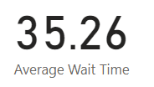

**Insights:**

* **An average patient has to spend 35 minutes before receiving care.**

1. **Visits by Department Referral:** Calculate the total number of visits to each department based on referrals to understand which departments are most frequently visited.

**Reference:**

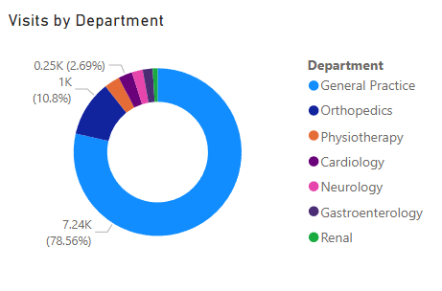

**Insights:**

* **General Practice department has the greatest number of visits.**
* **Renal Department is experiencing the least number of patient visits.**
* **Other departments only contribute to 20% of total visits.**

1. **Patient Visits by Age Group:** Segregate patient visits according to different age groups to see which demographics utilize healthcare services the most.

**Reference:**

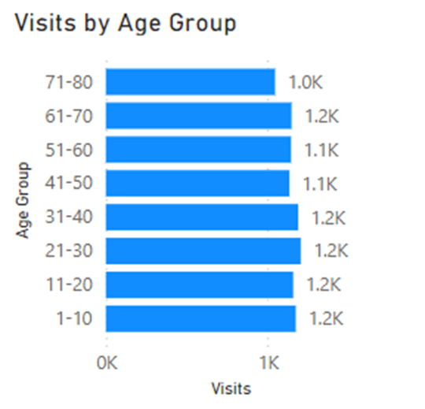

**Insights:**

* **The number of patient visits is evenly distributed among the age groups.**
* **This shows that the hospital has to have its model based on all age groups.**

1. Were there any Null values in the data? What would be the best way to handle these Null values and which approach have you opted for?

**Reference:**

* **All the null patient satisfaction scores were replaced with the mean patient satisfaction score from the non-null values i.e. 5**

**Insights:**

* **Most of the patients have been assigned the mean satisfaction score.**
* **The distribution for average ratings is not varied and lie in the 4.9 to 5.1 range.**

1. Is there any relation between the number of visits and the Gender of the patients?

**Reference:**

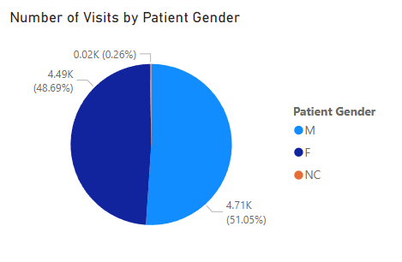

**Insights:**

* **Male patients account for a greater number of patients.**
* **The difference is not large but significant.**

1. Average Satisfaction by Demographics: Determine the relationship between patient satisfaction scores, their age groups, and racial backgrounds to pinpoint areas for improvement in patient experience.

**Reference:**

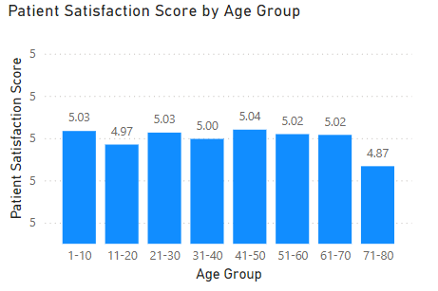

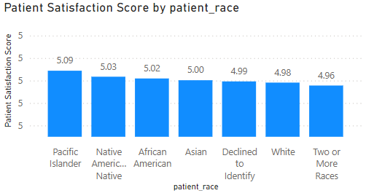

**Insights:**

* **The Age group 71-80 has the least average satisfaction scores among the patients.**
* **The range between races is not very varied for average satisfaction scores.**

1. The hospital's managing director seeks to evaluate the revenue of each department to understand how much revenue is generated by each.

**Reference:**

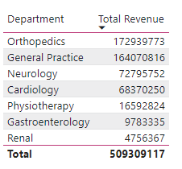

**Insights:**

* **Orthopaedics department is the largest contributor to the revenue generated.**
* **Orthopaedics and General Practice departments are significant leader in terms of revenue.**
* **Renal department has significantly lower revenue contribution.**

1. Which department is charging the highest appointment fees in general? Use an aggregation DAX function to solve this question.

**Reference:**

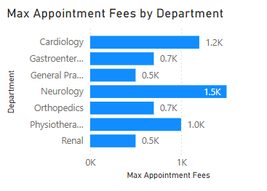

**Insights:**

* **Neurology department is charging the highest appointment fees among the departments.**
* **The difference between the highest and lowest appointment fees is 1000.**

1. Create a tabular visualization in the Report view which consists of Month-wise total visits in the hospital. Add a third column in the table that consists of the previous month’s total visits for each month’s row. Also, include a column that states whether the visits in a month are greater than that of the previous month's visits.

Reference:

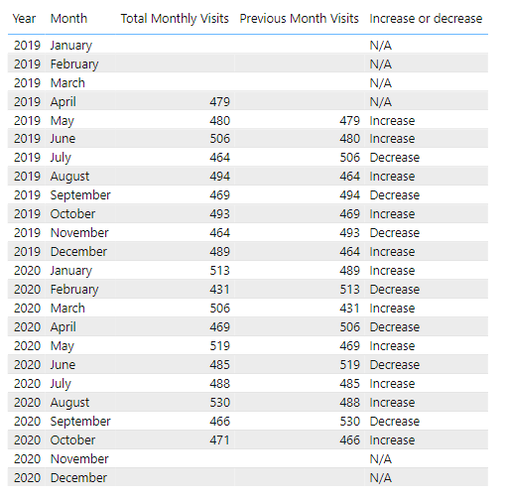

**Insights:**

* **There are no instances where the number of visits increased for 3 consecutive months.**
* **The number of visits on the whole remain unchanged.**

1. Using ‘Calculate’ and a row iteration DAX function calculate the total number of patients who have visited Dr. Smith.

**Query:**

|  |
| --- |
| **Doctor Smith Patients = CALCULATE(COUNT('Patients'[patient_id]),Patients[Doctor Name]="Dr. Smith")** |

**Reference:**

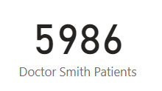

**Insights:**

* **Doctor Smith is handling 65% of patients in the hospital.**

1. Calculate the average age of the patients who visit the Orthopedics department. Will the approach used to calculate this metric be different if the requirement had been all departments’ average age?

**Query (for Orthopaedic Patients):**

|  |
| --- |
| **Orthopedics age = CALCULATE(AVERAGE('Hospital ER'[patient_age]),'Hospital ER'[department_referral]="Orthopedics")** |

**Query (for all departments):**

|  |
| --- |
| **Average age = AVERAGE('Hospital ER'[patient_age])** |

**Reference:**

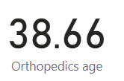

**Insights:**

* **Orthopaedic Patients mostly lie in the 30-40 age group.**

1. Were there any data format issues in the data, and if there were/are how you handle them?

**Approach Used: Replace Values**

**Reference:**

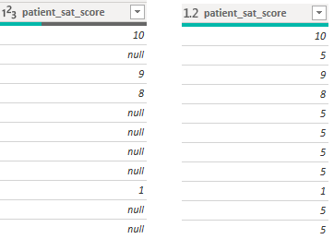

**Issues:**

* **The data had null values in the average satisfaction column for a large number of records.**

**Resolution:**

* **I replaced the null values with the mean of all non-null average satisfaction rating values.**

1. When we add a column in Power Query what’s the code that comes in M language in the formula bar? What do you know about M-query?

**Code:**

|  |
| --- |
| **Table.AddColumn(PreviousStepName, "Total", each [Quantity] * [Price])** |

* **The above code comes in the M Language when creating a conditional column in the formula bar where the column name is “Total” and the condition is “Quantity*Price”.**
* **M is a functional, case-sensitive language optimized for data transformation and manipulation. It’s particularly effective for ETL (Extract, Transform, Load) processes.**
* **M is built on functions and expressions, allowing users to define complex transformations using a series of function calls.**
* **M scripts are composed of a sequence of transformations applied to data in steps. A typical query starts with a source definition and includes multiple transformation steps.**
* **M-query is a powerful tool for data transformation in Power BI, enabling users to shape and clean data before importing it into the data model. It’s particularly useful for handling complex data preparation tasks that would be cumbersome in the Power BI model itself.**

1. Identify the top 5 doctors who generated the most revenue but had the fewest patients. (SQL)

**Reference:**



**Insights:**

* **Dr White has the highest revenue per patient.**
* **The top 3 doctors who have the most revenue per patient have a relatively similar revenue.**

1. Find the department where the average waiting time has decreased over three consecutive months. (SQL)

**Reference:**



**Insights:**

* **All the departments have months where the average waiting time has decreased over three consecutive months.**

1. Determine the ratio of male to female patients for each doctor and rank the doctors based on this ratio. (SQL)

**Reference:**



**Insights:**

* **Dr Anderson has the highest male to female ratio among their patients.**
* **Majority of the doctors have more male patients than female patients.**

1. Calculate the average satisfaction score of patients for each doctor based on their visits. (SQL)

**Reference:**



**Insights:**

* **Dr Williams has the highest average satisfaction rating among all the doctors.**
* **The average satisfaction rating is in the range 4.69 to 6.18.**

1. Find doctors who have treated patients from different races and calculate the diversity of their patient base. (SQL)

**Reference:**



**Insights:**

* **Most of the doctors have patients from all the races i.e. 7.**
* **There are 4 doctors who have less diverse patients than the other 18.**

1. Calculate the ratio of total bills generated by male patients to female patients for each department. (SQL)

**Reference:**



**Insights:**

* **Physiotherapy is the most gender-neutral department with similar number of male and female bills.**
* **Gastroenterology has significantly more female patients than male.**
* **Majority of departments have male dominated patient pool.**

1. Update the patient satisfaction score for all patients who visited the "General Practice" department and had a waiting time of more than 30 minutes. Increase their satisfaction score by 2 points, but ensure that the satisfaction score does not exceed 10. (SQL)

**Query:**

|  |
| --- |
| **update hospital**  **set patient_sat_score= least(patient_sat_score+2,10)**  **where department_referral='General Practice' and patient_waittime>30 and patient_sat_score<=8;** |

* **Here the patient score is set from the value that is least between satisfaction score+2 and 10.**
* **This ensures that the value doesn’t go above 10.**

**Subjective Questions**

1. What is the relation between patient wait time and satisfaction scores?

**Reference:**

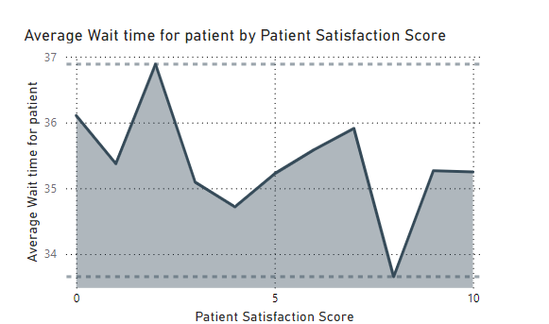

**Insights:**

* **The average wait time is in the range of 33-37 minutes.**
* **The max average wait time for patient is for satisfaction 2 while the lowest is for 8.**
* **There seems to be no relation between patient time and satisfaction scores.**

**Recommendations:**

* **Efforts to reduce patient wait time through more hospital staff.**
* **Look for other factors influencing patient satisfaction scores.**

1. How do patient demographics affect the frequency of visits to different departments?

**Reference:**

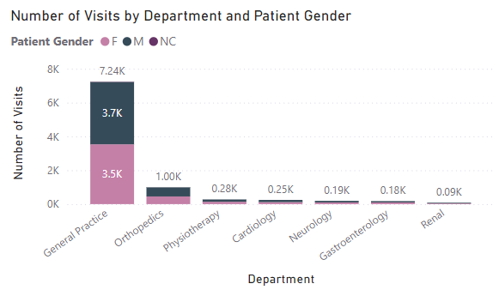

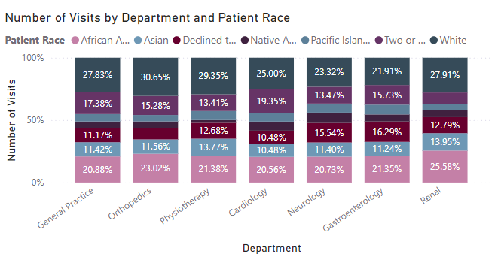

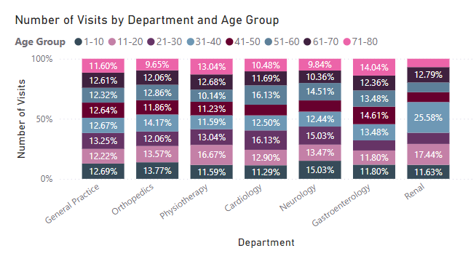

**Insights:**

* **Patient data shows that the visits are gender-neutral with similar male and female patients.**
* **White and African American constitute approximately 50% of patients in almost every department.**
* **Patients are equally distributed among their age groups in every department except Renal where age group 31-40 is in majority.**

**Recommendations:**

* **Diversity should be celebrated in hospital in order to accommodate patients from different races.**
* **Hospital should have more departments like paediatrics for focusing on health of children.**

1. Is there a noticeable trend in the volume of patient visits throughout the year?

**Reference:**

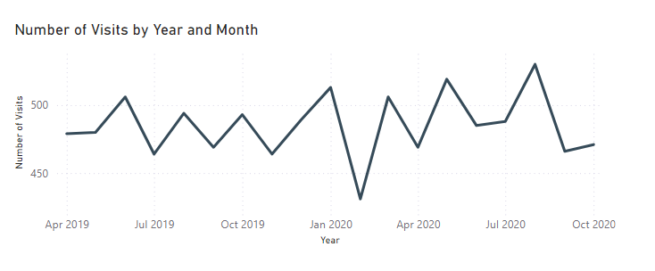

**Insights:**

* **Number of visits were least in Feb 2020.**
* **There are no 3 consecutive months where the number of visits either only increased or only decreased.**

**Recommendations:**

* **Discounts and drives should be offered seasonally to increase visits.**
* **Promotional drives and free checkups can be offered to increase patient visits.**

1. Which age groups report the highest and lowest satisfaction scores?

**Reference:**

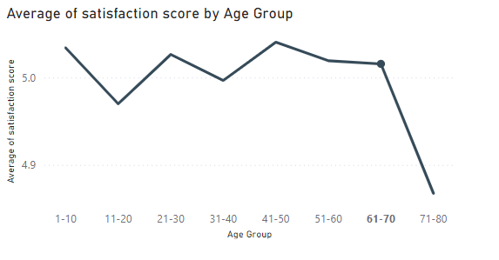

**Insights:**

* **Average Satisfaction rating of age group 71-80 is lowest among all the age groups.**
* **1-10 and 41-50 age groups have the highest average satisfaction rating**

**Recommendations:**

* **Amenities like wheelchairs and a hospital staff worker can be assigned to the senior patients.**
* **In order to improve average rating in all the age groups number of staff can be increased in order to have a more personal interaction.**

1. Say someone outside of the hospital claims that there is racial or gender-based discrimination in the hospital, how will you identify whether the claim was right or not?

**Reference:**

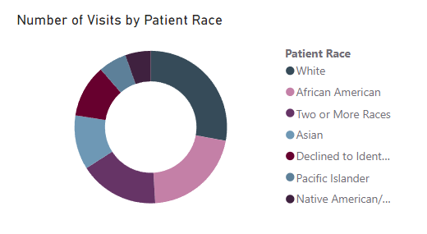

**Insights:**

* **The patient pool is highly diverse with 7 different ethnicities.**
* **Majority of patients belong to White and African American race.**

**Recommendations:**

* **Public health drives can be promoted to ethnic communication channels.**
* **Mobile clinics can be set up in areas where specific races are predominant.**

1. The hospital management intends to offer discounts to patients. How should these offers/discounts be assigned to patients, on what basis, and why?

* **Offer discounts for senior patients (age 65+) and minors, as these groups often require financial support due to retirement or limited income.**
* **A high satisfaction score can indicate loyalty. Offering discounts to patients with high satisfaction can encourage repeat visits and maintain positive relationships.**
* **Patients with lower satisfaction scores may receive a small discount as an incentive to improve their experience.**
* **Different departments may have varying patient demand and competition with other hospitals. Offering targeted discounts in departments with fewer patients (like preventive care or mental health) can drive more visits.**
* **Long wait times can negatively impact patient experience. Offering a discount as compensation to patients with higher wait times may improve satisfaction and retention.**
* **Patients with lower fees or bills could also receive smaller discounts as a gesture of goodwill and to encourage continued engagement.**

1. The hospital has a budget to hire 2-3 new doctors. They have asked for your suggestions on which departments they should hire.

**Reference:**

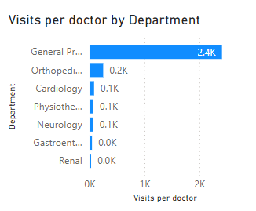

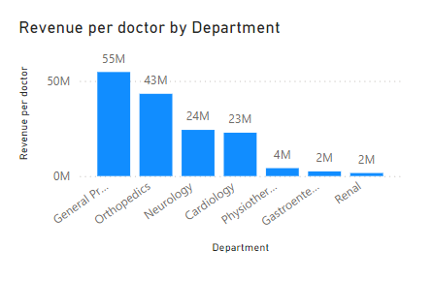

**Insights:**

* **Departments with consistently high patient volumes or significant growth trends often require additional doctors to manage patient loads effectively.**
* **High patient volume can lead to long wait times, which impact patient satisfaction and outcomes.**
* **Some departments may already have a higher patient-to-doctor ratio, making it challenging to maintain quality of care. Reducing this ratio can improve patient outcomes and doctor workload balance.**
* **High-revenue departments or those with elective procedures can justify the investment of new doctors due to their potential for positive ROI.**

**Recommendations:**

* **General Practice has the highest number of visits, new recruits should be done in this department do decrease workload and improve customer satisfaction.**
* **Orthopaedics has a small number of patients but it is very high in revenue per doctor. This fact can be used to increase revenue by increasing number of visits through referrals.**

1. Is the hospital profitable? How will you determine the profitability?

**Reference:**

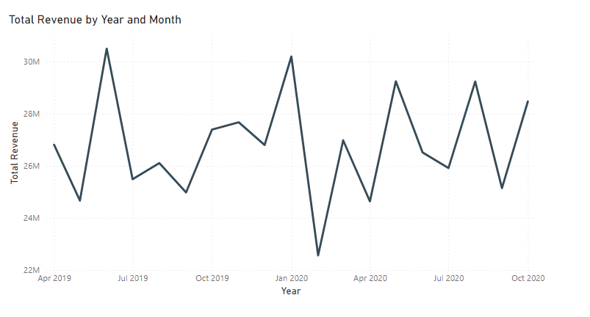

**Insights:**

* **Average monthly revenue of the hospital lies in the range of 22-30 million.**
* **The hospital is doing well in terms of revenue considering only 22 doctors are on call.**

**Recommendations:**

* **Number of doctors can be increased in order to increase number of visits by patients.**
* **Seasonal diseases can be anticipated in order to maximise productivity in that particular department.**

1. Any Department for which the waiting time is oddly large?

**Reference:**

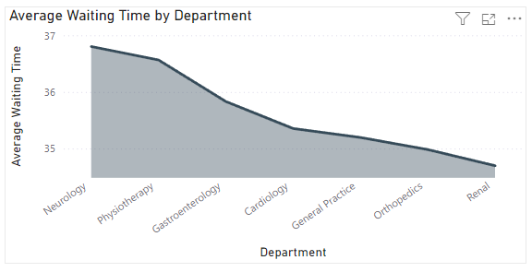

**Insights:**

* **Neurology department has the highest average waiting time among the departments.**
* **The difference between average waiting time of different departments is not that significant and the range lies in 34-37 minutes of waiting.**

1. Come up with strategies to provide discounts to the patients.

**Strategies for discounts:**

* **Seasonal Promotions:** **Provide discounts during specific times, such as back-to-school or flu season, for services like vaccinations or check-ups.**
* **Referral Discounts: Provide a discount to existing patients who refer new patients to the practice.**
* **Family Discounts: Provide discounts to patients within the same family if they visit together.**
* **Spending based discount: Discount can be given on the basis of amount spent in the hospital.**

1. Say you need to align the doctors of the “General Practice” department to work in one of the two shifts, how will you identify what will these two shifts' timings be, and how will you divide the doctors in these two shifts? And also will this 2 shift policy be helpful for the hospital?

**Reference:**

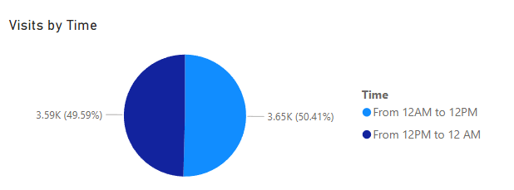

**Approach Used:**

* **Created different time slots to divide the visits in General Practice Department.**
* **Selected the most appropriate time slots based on dividing the visits equally.**

**Insights:**

* **Looking at visit times, the patient visits are symmetric around the time of noon.**
* **For General Practice, patients equally come from noon to midnight and from midnight to noon.**

**Recommendations:**

* **The two shift timings should be 12am-12pm and 12pm-12am.**
* **This timing will ensure patients have the best care possible while also ensuring the staff gets enough rest.**
* **This 2-shift policy will improve satisfaction scores as well as quality of care.**

1. What do you understand by PowerBI gateway? What are its use cases?

* A **Power BI Gateway** is a bridge that securely connects on-premises data sources to cloud-based services like Power BI, Power Automate, and Azure Analysis Services. It allows organizations to keep data on their own servers (on-premises) while enabling cloud applications to access this data for real-time analysis and reporting.

**Power BI Gateway use cases:**

* **Connecting Power BI to On-Premises Data Sources**
* **Hybrid Cloud Architectures:** **For organizations using both on-premises and cloud environments, a gateway enables seamless hybrid cloud architectures, allowing data from on-premises servers to be accessible from cloud-based applications without data migration.**
* **Scalability with Clustered Gateways: Organizations can install multiple gateways in a cluster, enhancing load balancing and reliability. This makes it possible to distribute workloads across multiple gateways, improving performance for large datasets and high-frequency queries.**
* **DirectQuery Mode for Live Reporting:** **With DirectQuery, Power BI can connect directly to on-premises data sources via the gateway, allowing real-time data access without data storage or replication. This is beneficial for data that changes frequently and requires immediate updates in reports.**

1. How would you approach this problem, if the objective and subjective questions weren't given?

**Going by the problem statement I would go through with the following steps:**

* **Analyse which departments are the biggest contributors to hospital revenue.**
* **Plotting the revenue trends throughout the year to look for seasonal changes.**
* **Analyse doctor contribution to revenue and who are the key performers.**
* **Analyse patient visits for different departments to recommend new hires to increase customer satisfaction and reduce wait times.**
* **Analyse the payment structure in order to suggest discount distribution strategies.**

1. Can you analyze and write the type of relationship between the doctor id and department, is it one-to-one?

**Reference:**

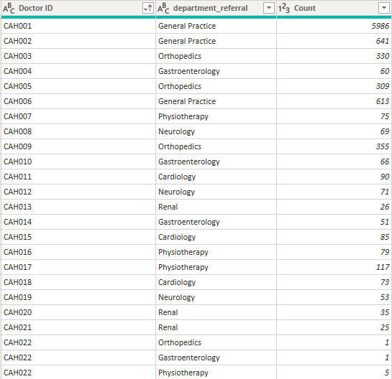

* The relationship between doctor id and department is one-to-many.
* Doctor ID CAH022 belongs to 3 different departments.

**Report**

The hospital has asked for a report with three tabs:

* Main Tab
* Doctors’ Tab
* Patients’ Tab
* **Using the Main tab in the report,** the hospital should be able to look at the overall metrics like the number of daily visits, revenue produced on that day, customer satisfaction, how busy are different departments on that day, and general waiting time on that day. This tab should have a slicer of date.
* **Using the Doctors’ Tab,** the Chief Of Staff at the hospital should be able to look at the individual doctor’s performance metrics like customer satisfaction, the number of patients he was visited by, the revenue he has generated, and his appointment fees. This tab should have a slicer of the Doctor's Name or ID.
* **Using the Patients’ Tab,** the Patient’s Care Chief at the hospital wants to look at a customer’s profile which would involve metrics like the most frequently visited department, their age, their race, their waiting time, number of visits, the total amount that they have paid to the hospital, etc. All the metrics using which they can address the patient very carefully in their visits. This tab should have a slicer of the Patient's Name or ID.

**Make sure that all the visualizations look decent and are placed in a proper order. Each tab has different POCs (Point Of Contact), so make sure you involve all the metrics that POC may look at in that tab along with those mentioned in the tab description.**

**After making the report on the Desktop ensure that it is hosted on PowerBI service and use the hosted link for submission of the dashboard and mentioning on the resume.**