WDD330 Final Web Application Proposal
Recipes With You
Overview
The Recipes With You application is designed to help users find recipes to cook in a daily basis. This addresses the common challenge of thinking about what to cook every day. Using TheMealDB API, the user will be able to search recipes by category, see its ingredients, images of the meal and the recipe for how to cook it.
Target Audience
This web application is aim for all the people who ran out of ideas for what to cook every single day. It can be used for people who love to cook and want to find new recipes to expand their repertoire.
Major functions
- Search bar:
Allow users to search for recipes by their name or main ingredient.
- Surprise me button:
A button that will take the user to a random recipe.
- Category list:
A list of categories for different types of meals.
- Bookmark button:
Add a bookmark feature using localStorage so the user can store it as a “see later” while is looking for other one.
- Favorites recipes:
A button to add a recipe to favorites using localStorage to make it easier for the user to find it.
- Personal recommendations:
A form page so the user can state their favorite main ingredient so when he enters the web application the application will render food that contains that ingredient. This will be done using localStorage
- Side bar panel:
Using CSS Animations and JS to display a side bar panel where will be a mini category and ingredient list.
- Grid or list button:
A button that will allow the user to see the recipes as a list or as cards.
- Responsive design:
It provides an easy and smooth interface across mobile and desktop.
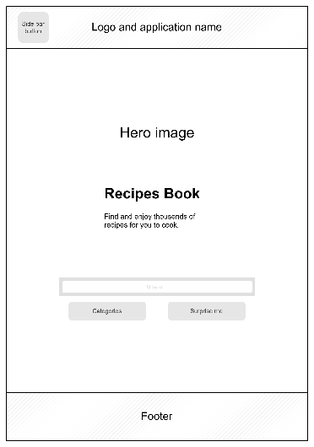
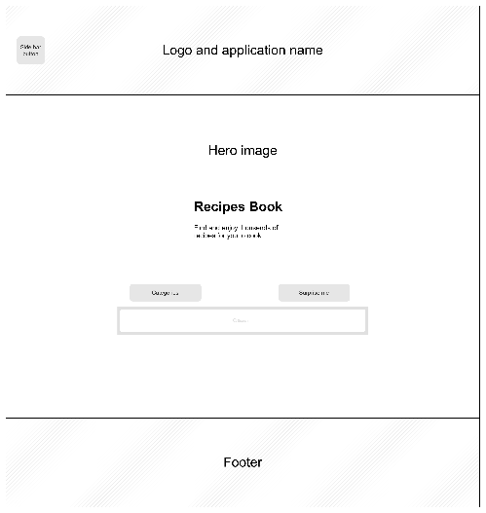
Wireframes

External Data
- TheMealDB API: recipes details (name, ingredients, images, category, etc.)
Data Storage
- Favorite meals, Bookmarks, Favorite ingredients.
Modular List
- Recipes Module:
Render the recipe detail in the recipe page.
- Storage Module:
Store and retrieve the favorites recipes of the user, the bookmark recipes to see later and the favorite ingredients.
- Search Module:
Render the side bar with the categories and the header and footer of each page dynamically.
Graphic Identity
Color:

- Primary: #C2EABA (Tea Green)
- Secondary: #C5F4E0 (Frozen Water)
- Neutral: #E6EFE0 (Mint Cream)
Typography
- Heading: Montserrat (Sans-serif)
- Body: Roboto (Sans-serif)
Icon Design
- A recipe book
Timeline (Weeks 5-7)
Week 5
- Finalize wireframes and graphic identity.
- Implement the homepage with basic CSS animations.
- Establish API connection and fetch sample data.
Week 6
- Develop search, recipe and storage modules.
- Develop responsive layouts for search and side bar.
Week 7
- Debug and refine CSS
- BP, SEO, Performance test
Project Planning
trello.com/b/Q77nIy9I/recipe-book

