**Links de Referencia y Herramientas de Cisco SCOR**

**SageIT Training - Certificarse hace la diferencia**

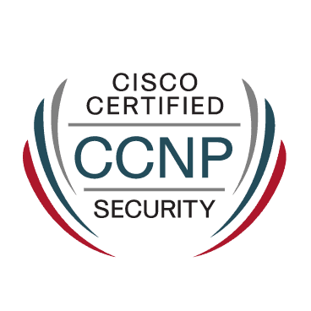

**Sesion introductoria**

Cisco Vishing:

<https://sec.cloudapps.cisco.com/security/center/resources/CRM-vishing>

Cisco Certification program

<https://learningnetwork.cisco.com/s/cisco-certification-roadmaps>

CCNP Security

<https://www.cisco.com/site/us/en/learn/training-certifications/certifications/security/ccnp-security/index.html>