RoadScan Capstone Technical Report
Road damage recognition and human reviewed repair prioritization
Feras Alyamani | Ahmed Salamah | Ahmed Alhejaili
AIEP Track A | Evidence revision 26 October 2026
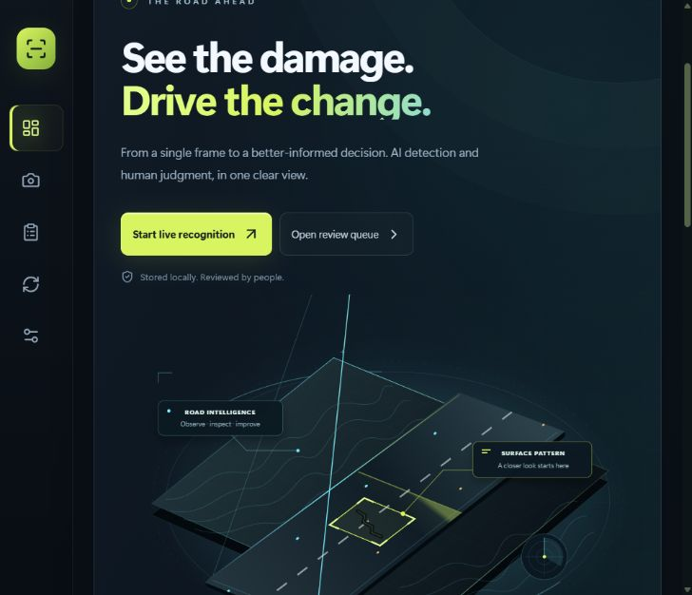
Application dashboard captured on 24 October 2026. The illustrated road is decorative, not an inference result.

Abstract
RoadScan combines road-damage detection, report review, repair-priority scoring and nearby-report comparison in a local web application. It accepts photos, camera input and video, stores the evidence with model metadata, and lets a reviewer correct predictions before an example becomes eligible for a training export. The four target damage classes are longitudinal cracking, transverse cracking, alligator cracking and potholes.
The team supplied seven new detector checkpoints, one classification baseline and experiment outputs. The strongest reported detector achieved 63.04% mAP50 and 33.01% mAP50–95 on a team-defined labeled RDD holdout. These scores have not been independently reproduced, and the supplied split audit identifies near-duplicate leakage. Current software tests pass, but local Saudi-road evaluation, real repeat-damage calibration and some submission records remain incomplete.
This report presents the implemented system, the supplied experiments and their limitations, and the evidence required before making field-performance or complete-submission claims.

1 Problem and success criteria
A road-inspection team needs to locate visible damage, decide which reports deserve attention, and avoid treating repeated observations as unrelated incidents. An image-level damage classifier alone cannot show where a defect is located; a detector supplies boxes that a reviewer can inspect and correct. RoadScan makes those predictions actionable through a persistent report and review workflow.

Users and decisions
The intended operator captures or uploads road imagery. A reviewer checks the damage class and box coordinates, then assigns an explicit report status. The system supports an inspection decision; it does not measure pavement depth, certify structural safety or autonomously schedule repairs.
Criterion | Evidence required | Current position
Recognize four damage types | Class-level held-out metrics and reviewable boxes | Software implemented; supplied metrics available
Prioritize reports | Visible 0–100 formula and sensitivity study | Formula and ±20% tools implemented; field validation pending
Find repeat observations | Real labeled pairs, GPS filtering, calibrated threshold | On-demand DINOv2 search implemented; calibration pending
Run a credible demonstration | Unseen image, correction, saved report and latency | Local application runs; panel demonstration not yet performed
Reproduce the work | Dataset manifests, run settings, code and weights | Code and weights organized; historical provenance incomplete

Scope and reading guide
Sections 2–3 describe the data and architecture. Sections 4–7 distinguish baseline and experiment evidence. Sections 8–10 explain priority scoring, user workflows and human control. Sections 11–13 cover evaluation, reproducibility and submission status. Appendices preserve a code example, evidence sources and the remaining field protocol.
Evidence labels are used consistently: team reported means received from the teammate’s results archive; locally verified means exercised in software checks; pending means the required evidence has not been obtained. A polished interface or a passing test suite is not evidence of road-damage accuracy.

2 Data card and split integrity
Field | Recorded information
Primary data | RDD road imagery; four target damage categories D00, D10, D20 and D40
Reported split | 26,869 training; 5,758 validation; 5,758 labeled holdout images
Main training extension | Approximately 14,000 additional images; roughly 41,000 total training images
Additional sources | Rome potholes, HRP4K, SVRDD Beijing and web images, as described by the team
Labels | Bounding boxes; four damage classes plus OTHER in some five-class checkpoints
Local Saudi set | Required 40–80 labeled test-only images not present in the reviewed evidence
Licenses and consent | Source-by-source manifest, redistribution terms and local consent records pending
Known quality issue | Reported near-duplicate leakage: 2.2% validation and 2.4% holdout

The approximate training total applies to the main run, not every ablation. The original image lists and split manifests were not supplied, so the counts and additional-source membership cannot be independently verified. The India-held-out experiment uses a different composition by design.

What the reported test split means
The official CRDDC 2022 challenge releases its test images without labels and evaluates submitted predictions. The labeled 5,758-image split in the supplied results is therefore described here as a team-defined RDD holdout, not a verified official challenge test score. Challenge F1 and the mAP values in this report are different metrics and must not be directly compared. [R2, R3]

Required split repair
Group all observations of the same road segment or physical damage before splitting. Review exact and near duplicates, remove cross-split overlap, and freeze a final test manifest that is never used for threshold selection or model choice. Rerun evaluation after repair and retain both the old and corrected results with their manifest hashes.
An exact-hash check in the replacement training tools catches identical files. It cannot establish that transformed frames, nearby video frames or different views of one defect are independent. The reported leakage remains a material limitation until a group-aware audit and rerun are available.

3 System architecture and data flow
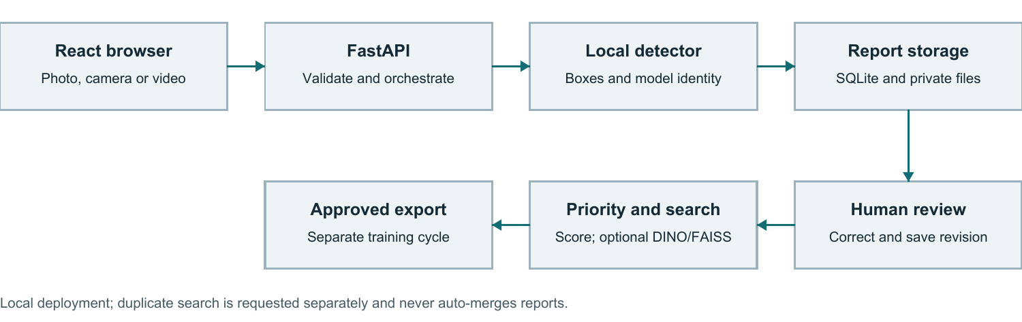
Architecture and processing flow. The browser and local API coordinate inference, persistent review and explicit downstream decisions.
React and TypeScript provide the bilingual interface. FastAPI validates requests and coordinates local inference. SQLAlchemy and SQLite store reports, status history and audit events; images, models and feature caches remain in private local storage. DINOv2 and FAISS support an optional crop-based similarity search within a GPS radius.

Processing sequence
Image or selected frame → input validation → local model inference → report and original-image coordinates → human review → priority queue and optional duplicate search. Confirmed corrections can be approved and exported for a separate training cycle; only an evaluated replacement model should be imported and activated.

Controls at the boundaries
The API validates images and annotation coordinates, protects review operations with access controls, and uses revision checks to prevent stale edits from silently overwriting newer decisions. Model imports validate checkpoint type and class mappings. Secrets and report images remain outside the shareable source package.
Deployment uses Docker and local persistent volumes. Before a live update, the stopped-service data and code are backed up, then row counts and stored files are compared after replacement. The 24 October deployment preserved 19 private reports and 6 demo reports, with their existing history and access configuration. These are preservation counts, not a field-evaluation dataset.

Architecture limits
The current deployment is a local application. Google Maps links can open recorded coordinates, but the project does not claim a hosted mapping service, drone flight integration, production fleet orchestration or validated aerial-image performance. Those capabilities require separate design and testing.

4 Models and detection results
The new team package contains seven detector checkpoints and a separate ResNet18 image-level classifier. The classifier is retained for the E1 comparison and is not presented as a box detector. Earlier models remain preserved in the inventory. Including the official pretrained DINOv2 backbone, the delivery contains 19 uniquely hashed checkpoints; this does not mean 19 RoadScan-trained detectors.
Detector and input | mAP50 | mAP50–95
YOLO26s Main 1024 | 63.04% | 33.01%
YOLO26s Size experiment 640 | 59.43% | 30.71%
YOLO26n Size experiment 640 | 55.99% | 28.03%
YOLO26s No augmentation 640 | 46.93% | 21.76%
YOLO26s Vertical flip 640 | 58.48% | 30.14%
YOLO26s Cleaned labels 640 | 60.05% | 30.73%
YOLO26s India held out 640 | 8.86% | 3.77%

Source: team-provided results. Rows except India held out use the team-labeled RDD holdout; India held out is an India-only evaluation. These values are not independently reproduced and are affected by the reported split-integrity limitation. [R4]

Metric interpretation
Average precision summarizes a precision–recall curve. mAP50 averages AP at an intersection-over-union threshold of 0.50; mAP50–95 averages stricter overlap thresholds from 0.50 to 0.95. Neither is the percentage of images correctly classified. The difference between 63.04% and 33.01% indicates that stricter box localization is substantially harder in the reported evaluation.
Main model class | AP50
D00 Longitudinal crack | 63.55%
D10 Transverse crack | 62.52%
D20 Alligator crack | 69.90%
D40 Pothole | 56.19%

The main run reports 120 epochs, best validation epoch 84 and 1024-pixel input. It is the default detailed-photo choice in the current application, while the smaller nano model is available for speed-sensitive preview. This recommendation is operational, not a claim of best performance on Saudi roads or phone/drone footage.

5 Baseline comparison and model size

E1 Classifier versus detector
The baseline asks whether each damage type is present in an image. ResNet18 supplies four image-level scores; the detector’s boxes are converted into image-presence predictions for a comparable task. The reported evaluation uses 5,758 images. Image-presence thresholds differ from the box-detection confidence thresholds used by the app.
System | Any damage F1 | Image accuracy
ResNet18 baseline | 0.893 | 0.869
Main YOLO26s | 0.929 | 0.913

Class F1 | D00 | D10 | D20 | D40
ResNet18 | 0.790 | 0.751 | 0.805 | 0.639
YOLO26s | 0.861 | 0.805 | 0.859 | 0.762

The detector is stronger on every reported class-level F1 and also provides localization for review. This supports the product choice, but the supplied image-presence protocol and preprocessing should be reproduced from a frozen manifest before treating the difference as an independently verified result.

E2 Model size and speed
640-pixel model | Reported mAP50 | Local diagnostic model time
YOLO26n | 55.99% | 57.89 ms
YOLO26s | 59.43% | 122.38 ms

The supplied same-split comparison favors the small model by 3.44 percentage points in mAP50. The local timing diagnostic favors nano for speed. The timing numbers are medians of only three warm requests on one synthetic 960×640 image with Docker limited to 2 CPUs and 4 GiB, recorded on 24 October. They exclude upload, decode, rendering and camera acquisition; they are not camera FPS or a representative benchmark.

Deployment choice
Use the main model for detailed still-image inspection and a smaller model when a responsive preview matters. Select the operating point using representative local images and end-to-end timing on the actual laptop and camera. The official brief permits a model-size or resolution study; both are not required.

6 Augmentation and country shift

E3 Augmentation ablation
YOLO26s 640 setting | mAP50 | mAP50–95
Standard augmentation | 59.43% | 30.71%
No augmentation | 46.93% | 21.76%
Vertical flip augmentation | 58.48% | 30.14%

Standard augmentation exceeds the no-augmentation run by 12.50 mAP50 points in the supplied comparison. Vertical flipping does not improve the standard run. This suggests that the chosen augmentation policy matters, while a more aggressive transformation is not automatically beneficial. The conclusion remains conditional on the reported split, run settings and common evaluation protocol.
The clean-label experiment reports slightly lower validation mAP50–95 than the original-label run, 0.3403 versus 0.3421. The main run therefore retained the original labels. The cleaned-label holdout result alone should not be used to reverse a validation-based selection decision.

E4 Held-out country
India evaluation condition | mAP50
India excluded from comparison model training | 8.86%
India included in comparison model training | 39.25%

The large reported decline when India is excluded illustrates domain shift: a model can learn damage patterns while still depending on image appearance, road context or capture conditions seen during training. The comparison motivates local validation in Saudi conditions rather than assuming global benchmark performance transfers unchanged.

Local evaluation still required
The official brief requires 40–80 team-collected and labeled local road images reserved for testing. No qualifying local set was found in the reviewed package. A separate desktop reviewed-dataset export contains only a synthetic training negative and is not a substitute. The required study needs consent/licensing records, capture conditions, labels and a frozen test manifest.
An additional United States holdout is optional; one valid held-out-country experiment plus the required local test addresses the stated E4 design. The absent local set is a blocker, while an absent second-country experiment is not.

7 Duplicate recognition and GPS

E5 Supplied experiment
Method | Reported F0.5
pHash with GPS | 0.851
ResNet50 with GPS | 0.975
DINOv2 with GPS | 0.980
DINOv2 without GPS | 0.796

The teammate’s experiment simulates repeated views and GPS. DINOv2 with GPS reports precision 0.983, hard-repeat recovery 0.951 and a new-report false-merge rate of 0.032; without GPS the reported false-merge rate is 0.137. These support testing spatial filtering, but they are not measured accuracy of the deployed replacement pipeline. Supplied E5 files do not establish a complete real-pair Recall@5 or ROC study.

Implemented replacement
The app embeds human-reviewed damage crops with the official pretrained DINOv2 ViT-S/14 backbone, compares normalized features using exact FAISS cosine search, and restricts candidates to open reports within 50 m. It excludes the query itself, resolved/duplicate reports and mismatched location sources. Cached embeddings are keyed by image content, crop and checkpoint. Search runs on demand and never merges reports automatically.
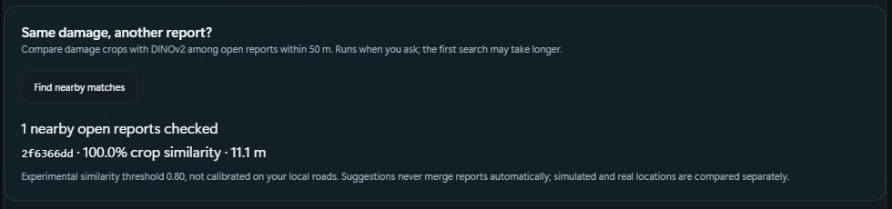
24 October synthetic software check: identical synthetic crops at simulated locations 11.1 m apart. This verifies the matching workflow, not real-road accuracy.
The replacement threshold 0.80 is experimental. It is not 80% accuracy and is deliberately separate from the teammate’s threshold 0.6529684 because crop/preprocessing equivalence has not been established. Searches are limited to 100 nearby reports and 20 boxes per report; the first search can be slower while embeddings are computed.

Calibration needed
Collect genuine same-damage and different-damage pairs, including difficult lighting, viewpoint changes and nearby but distinct defects. Select a threshold on a validation group, then measure precision, recall, F0.5, Recall@1/5 and false merges on disjoint test groups. Simulated GPS is permitted by the brief if disclosed; fabricated repeat-image evidence is not a replacement for real pairs.

8 Repair priority and sensitivity
RoadScan produces an interpretable repair-priority score, not a physical severity measurement. For a report with valid detections, the deployed formula is S = 100 × (0.40T + 0.25A + 0.20N + 0.15C). A report without boxes remains unscored, rather than being described as safe or zero risk.
Term | Definition | Weight
T Damage type | Maximum class weight: D00 .55, D10 .45, D20 .85, D40 1.00, OTHER .55 | 40%
A Relative area | Largest box area divided by image area | 25%
N Count | Minimum of box count / 5 and 1 | 20%
C Confidence | Mean model confidence or human annotation weight | 15%

Type receives the greatest weight to prioritize categories such as potholes and alligator cracking. Area and count add visible extent, while confidence or review weight affects certainty. These are design assumptions: perspective, distance and crop choice alter image area, so the score cannot infer depth or engineering urgency without calibrated measurements.
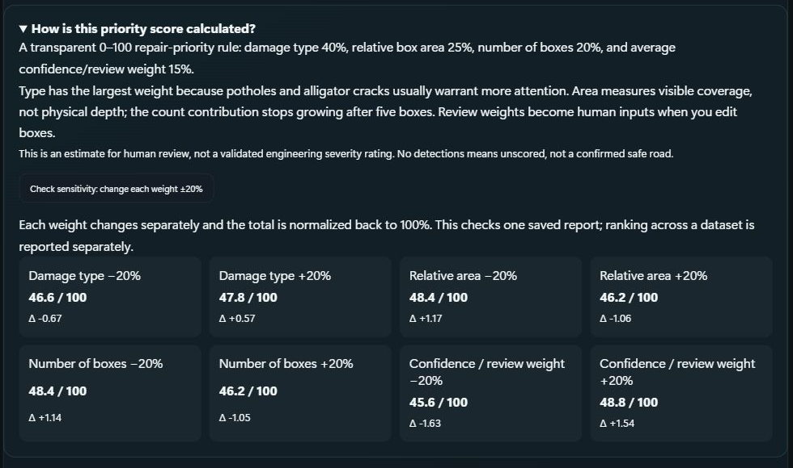
24 October sensitivity UI using a synthetic report and human annotation. Each weight changes ±20% with the full weight vector renormalized.
The new priority.py replacement also measures ranking changes and top-50 overlap across a supplied report dataset. That provides the required mechanism for dataset sensitivity, but representative-road ranking results have not yet been run. The supplied narrative described a different weighted formula with nonlinear transforms; it was not silently substituted for the working app’s formula.

9 Image camera and video workflows

Photo inspection
A photo is decoded and validated before inference. The result retains its model identity, original-image dimensions, boxes and available model timing. The reviewer can inspect class and confidence, correct the annotation and save an explicit decision. Larger supported image uploads allow high-resolution testing, while model input resizing still determines inference resolution.
The 26 October update adds a sequential batch of up to 20 photos with per-file outcomes, stop-after-current and retry controls. Fresh isolated Chrome checks saved two synthetic photos without location, rejected a corrupt PNG with HTTP 415, and exercised stop, resume and retry. Unit tests, the production build and real-model API checks passed. If saving is uncertain, check Review before submitting again to avoid duplicate reports.

Camera preview
Live recognition accepts a browser-visible camera, including a phone presented as a webcam through Iriun. The user previously confirmed that this camera connection worked. Preview analyzes frames automatically after starting; it does not require a manual photograph for each inference. Camera acquisition, browser permissions and representative latency have not been freshly tested on 26 October.

Complete video analysis
The separate complete-video workflow processes a supplied file frame by frame. This can take longer than the playback duration and should not be described as real-time inference. Live preview favors responsiveness and cannot guarantee that every camera frame is analyzed. The interface keeps these two purposes distinct.
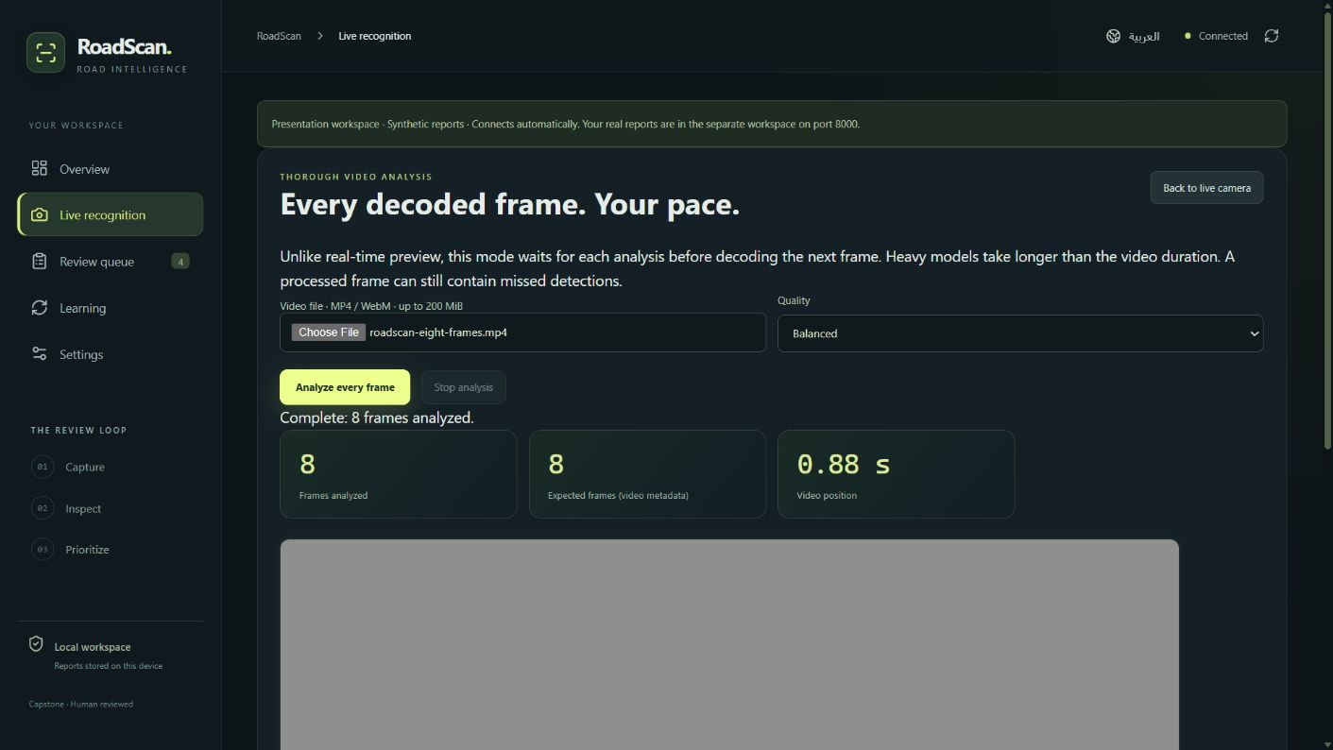
21 October software evidence for the complete-video path on an eight-frame test fixture. The fixture is not a road-accuracy benchmark.
For a drone or dashcam deployment, verify codec support, camera angle, motion blur, image scale, timestamp/GPS alignment and performance on the target device. Accepting a video file does not establish drone integration or aerial-domain accuracy.

10 Human review and model improvement
Review is the point where a person can correct a confident but wrong model. The user can change boxes or classes and select an individual model’s proposal even when other voting models disagree. Consensus is advisory and can increase computation; a minority prediction may be correct.

Public edition: owned demo review controls replace an untraced road-photo voting screenshot. The substitute illustrates the review workflow, not model predictions or ensemble accuracy.

The learning cycle
Correct the report → save a confirmed review → approve the checked example → export the reviewed dataset → train and evaluate separately → import and activate an accepted candidate. A correction does not update current model weights instantly. Approval and split/group metadata are needed to prevent accidental training on a protected evaluation set.

Model replacement
The model library supports importing a prepared model package and selecting the active detector. Checkpoint hashes bind the supplied main-model confidence profile to its exact weights. The separate ResNet18 classifier and DINOv2 feature backbone serve different tasks and must not be selected as box detectors.
The main detector’s validation-selected thresholds are D00 0.173, D10 0.166, D20 0.195 and D40 0.056 at 1024 pixels. The crack thresholds target F1 and the pothole threshold targets F2, favoring recall. OTHER is excluded from that calibrated four-class profile. Reduced live sizes have not been recalibrated, so their operating-point behavior needs separate validation.
The model-replacement workflow preserves human control, but it cannot guarantee that a new model is better merely because its filename reports a high score. Compare candidates on the same untouched local test set, record class metrics and latency, and keep a rollback checkpoint.

11 Evaluation errors and responsible use

What has and has not been evaluated
The supplied main-model AP50 is lowest for potholes, 56.19%, and the India-held-out result is much lower than the in-domain comparison. These are useful signals for choosing field checks, but they do not prove a specific visual failure category. A reviewed gallery of real false positives, missed defects and poor boxes has not been supplied.
Failure category to measure | Required example and evidence
Missed damage | Real defect with a reference box and no accepted prediction
False alarm | Marking, shadow, patch or texture predicted as damage
Class confusion | Reference class and predicted class on the same defect
Poor localization | Matched defect with visibly incorrect box extent
Repeat-match error | Same defect missed or distinct nearby defects incorrectly matched
Capture degradation | Paired examples across blur, distance, lighting and viewpoint

These are proposed audit categories, not claims that their frequencies have already been measured. Preserve representative examples with class, model hash, threshold, capture condition and reviewer rationale. Report counts and denominators rather than selecting only attractive screenshots.

Privacy fairness and misuse
Road images can contain faces, plates and location information. The app strips EXIF and keeps access controls, and the capture guidance asks users to crop or blur identifiable content. Automatic face/plate redaction is not implemented. Team collection needs documented consent or another appropriate collection basis, controlled storage and a retention decision.
Fairness risks include unequal coverage of neighborhoods, road surfaces, lighting and devices. Record these conditions and inspect performance by meaningful groups where sample sizes permit. Avoid using a low confidence score to declare a road safe, or presenting a heuristic priority as certified engineering severity. A reviewer remains responsible for interpreting the output.
The current duplicate threshold can produce false matches or miss repeats. Candidate suggestions require human inspection; the system deliberately does not perform an automatic merge.

12 Verification and reproducibility
Check | Evidence and scope
26 October final backend checks | 217 passed, 1 optional classifier test skipped because its dependency is absent
26 October final frontend checks | 24 tests passed; production Docker and TypeScript/Vite build passed
26 October runtime baseline | Private and demo health endpoints returned HTTP 200 after Docker restart
26 October isolated API check | Two synthetic photos analyzed by a real detector; invalid image rejected after model load
24 October replacement checks | Real DINOv2/FAISS synthetic matching, one synthetic ResNet epoch, detector evaluation and priority scenarios
26 October browser check | Fresh isolated Chrome: batch stop/resume/retry, human annotation validation/save, unsaved-change guard, five-screen keyboard navigation and Learning load passed. After the navigation CSS fix, English/Arabic at 320/390/640/860/1440 px had no horizontal overflow; keyboard checks passed at 390/1440 px.

Before changes, the baseline passed 216 backend and 18 frontend tests. The final checks above include the batch workflow and a fix for invalid-image rejection after model loading changed the global image opener. Tests cover software contracts; they do not establish real-road accuracy, physical camera performance, an unseen panel demonstration or the reliability of historical training runs.

Replacement research tools
priority.py exports score sensitivity and ranking changes. duplicate_finder.py exposes the current crop/GPS matcher. accuracy_report.py evaluates declared local splits, and only validation generates thresholds. The ResNet baseline supports evaluation and fine-tuning. runpod/run_all.py records a declared sequential plan and defaults to dry-run; it does not rent hardware or silently overwrite experiment outputs.
The detector trainer uses a four-class order D00, D10, D20, D40. Five-class source labels with OTHER require explicit remapping. The evaluator verifies the checkpoint’s exact class order. Full-dataset retraining and GPU execution of the replacements have not been performed; synthetic smoke tests are not new project performance results.

Repository and artifact status
The current running-source directory is not a Git repository and has no configured remotes. A shareable source snapshot and checksum manifests exist, but they do not establish a public submission URL or meaningful historical commits by each member. The team must confirm actual contribution records and the submission destination.

13 Conclusion and submission readiness
RoadScan now provides a connected local workflow for detection, human review, priority scoring, optional model voting and nearby duplicate suggestions. Its strongest demonstrated result is a working, testable application with preserved model artifacts and explicit controls around uncertain predictions. The supplied experiments provide useful comparisons, but their accuracy claims remain conditional on incomplete provenance and the reported split leakage.
Submission item | Current status | Required completion
Working application | Local runtime and test baseline pass | Rehearse unseen-input live demonstration
Report and slides | Current editable artifacts prepared | Team fact-check and final formatting review
Saudi evaluation | No qualifying set found | Collect and label 40–80 test-only road images
Duplicate study | Simulation results and working matcher | Real pairs, held-out threshold calibration and retrieval evidence
Data provenance | Partial source descriptions and run settings | Exact manifests, licenses and repaired split evaluation
Repository and contributions | Local source snapshot available | Confirm actual roles, meaningful commits and repository URL
Deadline | Team confirmed 31 October 2026 | Confirm the submission portal and required template

Contribution statement
The project team is Feras Alyamani, Ahmed Salamah and Ahmed Alhejaili. Individual responsibilities, code contributions and presentation ownership have not been confirmed. The final submission should replace this statement with an accurate member-by-member account supported by work records; roles must not be inferred from filenames or invented after the fact.

Next steps
First obtain the local test images, real repeat pairs and missing manifests. Then repair leakage, calibrate on validation data and rerun the final protected evaluation. Complete the live rehearsal and individual contribution statement, and confirm the submission portal and required template before the team-confirmed deadline of 31 October 2026. Submit after the team approves the final artifacts.
A passing software baseline is a meaningful milestone. The project is not yet verified complete against every requirement, and this report intentionally preserves the remaining gaps rather than presenting unmeasured performance as established.

Appendix A Implementation evidence and sources
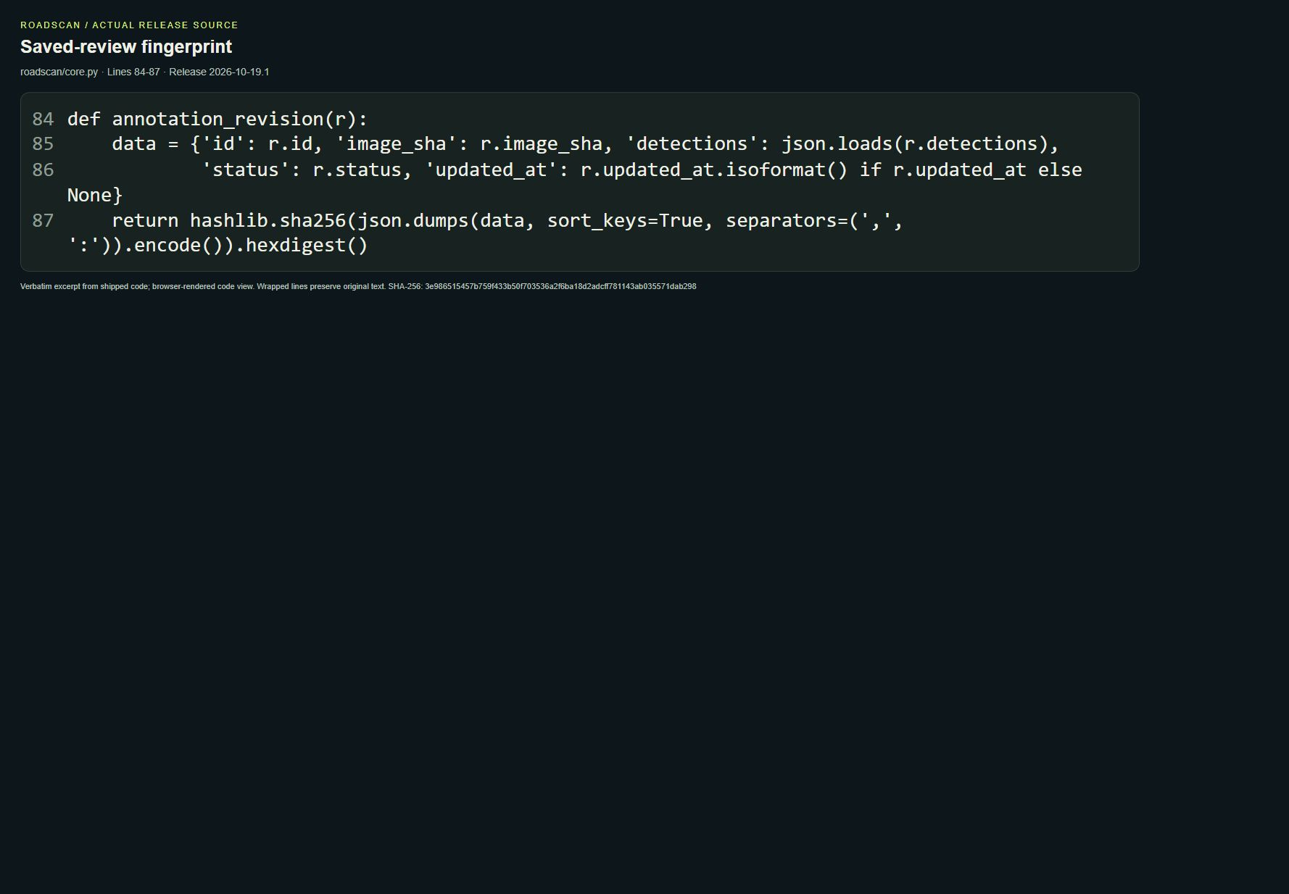
Saved code excerpt from the report-revision protection path. This screenshot is historical implementation evidence; the editable source remains authoritative.

Evidence index
[R1] OLO AIEP Projects v2, supplied project brief: Track A requirements on pp. 5–11; report, presentation and rubric on pp. 38–41; dates announced separately on p. 4. Copy: Docs/Reference/Olo-AIEP-Projects-v2.pdf.
[R2] CRDDC 2022 official data page, https://crddc2022.sekilab.global/data/ (accessed 26 October 2026): official test images lack released annotations.
[R3] CRDDC 2022 official submissions page, https://crddc2022.sekilab.global/submissions/ (accessed 26 October 2026): challenge evaluation is based on submitted predictions.
[R4] Team-supplied roadscan_results (3).zip: 203 original entries including eight weights, results.csv, E1/E5 tables, run arguments, metrics/plots, threshold data and split audit. The importable delivery package preserves original content and adds import metadata.
[R5] RoadScan-READY/Docs/Team-Models-and-Results.md, Requirements-Audit-2026-10-24.md and Replacement-Tools.md; source of the integrated model inventory and explicit implementation limits.
[R6] Archive/Submission-2026-10-26: baseline-backend.log, baseline-frontend.log, final-backend.log, final-frontend.log, release-build.log and Batch-API-Smoke-2026-10-26.json. Final-Verification/QA-RESULTS.json and mobile-navigation-results.json record fresh synthetic browser checks and responsive navigation. RoadScan-READY/Evidence retains earlier dated screenshots and deployment-preservation records.
All screenshots in this report come from the project’s existing evidence. Synthetic fixtures, decorative graphics and supplied model metrics are labeled by their actual scope; none is presented as a newly collected Saudi-road test result.

Appendix B Field evaluation and demonstration protocol

Protected local test set
- Collect 40–80 consented road photos across relevant surfaces, daylight/shadow conditions, devices and distances; exclude identifying content where possible.
- Assign a stable image ID and capture-group ID; annotate all four target classes using original-image pixel coordinates.
- Keep all views of one road segment or damage instance in one split. Freeze the local test manifest and keep it out of training, threshold tuning and model selection.
- Record model hash, software version, input size and thresholds. Report per-class precision, recall, AP50/AP50–95, aggregate metrics and a reviewed failure gallery.

Repeat damage and runtime
- Collect genuine repeated views and nearby distinct damage pairs. Separate calibration groups from final test groups; disclose real or simulated GPS.
- Calibrate the duplicate threshold on validation data. Report false merges, missed repeats, F0.5, Recall@1/5 and the threshold curve on protected test pairs.
- Measure acquisition-to-result latency and model-only time separately. Include cold/warm behavior, hardware, image resolution, sample count, median and tail latency.

Ten minute presentation sequence
Segment | Time
Problem and intended user | 1:00
System design | 1:30
Data and split limitations | 1:00
Approach and experiments | 2:00
Results and errors | 1:30
Live demonstration | 2:30
Conclusion | 0:30

Use a previously unseen image during the live demonstration, show the selected model and prediction, correct one box, save the report, explain its priority and show the learning export boundary. A screenshot sequence is not a live demonstration. A backup recording is a contingency if the live run fails, and the brief warns that it may receive reduced marks.
The supplied presentation timings total ten minutes. Prepare additional answers on leakage, the difference between mAP and image accuracy, why human review matters, and why the duplicate threshold remains experimental.

Appendix C Review experience and design evidence
This update supersedes the release and software-check counts in the preceding report. The scientific limitations and field-evaluation protocol remain unchanged.

One clear review sequence
Inspect image > Check boxes > Save decision. Direct links move focus to the right section. The decision form now precedes optional model comparison, nearby matching and training approval; any individual model can still be selected after voting.
Figure C1. Public edition: owned demo review controls replace an untraced road-photo example. This illustrative substitute does not provide detection or accuracy evidence.
Figure C2. The decision is close to the evidence. Unsaved notes, status and boxes share the same protection; optional checks follow the save action.
Research informed hierarchy, selected states, keyboard focus and readable feedback: Taste Skill (MIT), UI UX Ref (MIT), Vercel Web Interface Guidelines (MIT), Anthropic Frontend Design (Apache-2.0), and VIBE DESIGN as visual reference only. No third-party code, installer, new package or external asset was added; exact links are in Design-Review-2026-10-27.md.

Appendix D Verified release and remaining limits

Validation completed for release 2026-10-27.1
Check | Observed result
Backend suite | 221 passed; 1 optional scikit-learn test skipped
Frontend tests and build | 24 passed; TypeScript/Vite build succeeded
Browser interactions | 17 checks: save protection, focus, retries, states and motion
Responsive layouts | 40 EN/AR cases + 10 final 320 px checks across five screens
Deployment preservation | 19 private + 9 demo reports; row/file/configuration hashes unchanged
Fresh demo recreation | 19 isolated lifecycle checks and 2 model-prerequisite fault tests passed
 | Accessible recovery  Arabic uses right-to-left layouts. A failed image can be retried without discarding edits; a failed workspace refresh has its own retry. Loading, disconnected and empty results are distinct.  Backend repair  Review and sensitivity checks now use the existing trusted image decoder. Missing/corrupt images return controlled errors even when the detector library patches Pillow; the review revision stays unchanged.  Figure D1. Arabic mobile decision form, captured in the isolated test workspace.

What this does not establish
No labeled Saudi field set or genuine repeat-damage pairs have been collected yet. Reported model scores are not newly reproduced accuracy; priority and similarity remain uncalibrated. Reviews create approved training examples, not live weight updates. Fresh Mac/ARM installation and physical drone testing remain unverified. The prior CPU Docker proof applies to its recorded baseline; this release was checked on the existing Windows/Docker setup.
The editable DOCX includes the same appendix text, result table and screenshots; content parity is checked, while pagination remains unverified because no reliable Word renderer was available. Full check records and screenshots are in Evidence/Design-2026-10-27; the deployment proof is Evidence/Design-Deployment-2026-10-27.json.

