Introduction

This project demonstrates how to control a motor based on GPS coordinates by converting latitude and longitude into UTM (Universal Transverse Mercator) coordinates. The system reads GPS data, compares the current position with a target location, and controls a motor based on whether the current location is within a specified range of the target coordinates.

Objective

1. Read GPS data (latitude, longitude, and altitude).

**2.** Convert the GPS coordinates (latitude and longitude) to UTM coordinates.

**3.** Compare the current UTM coordinates with a target UTM position.

**4.** Control the motor based on whether the current position is within a predefined range of the target.

Components Used

1. Arduino Board (Arduino Uno)

2. GPS Module (GY-GBS6MV2)

**3. Motor** (DC motor)

Description, Theory and Analysis

1. Circuit Components and Connections:

The circuit controls a motor based on GPS coordinates by comparing the current location with a predefined target location. The GPS data is converted into UTM (Universal Transverse Mercator) coordinates for precise calculations.

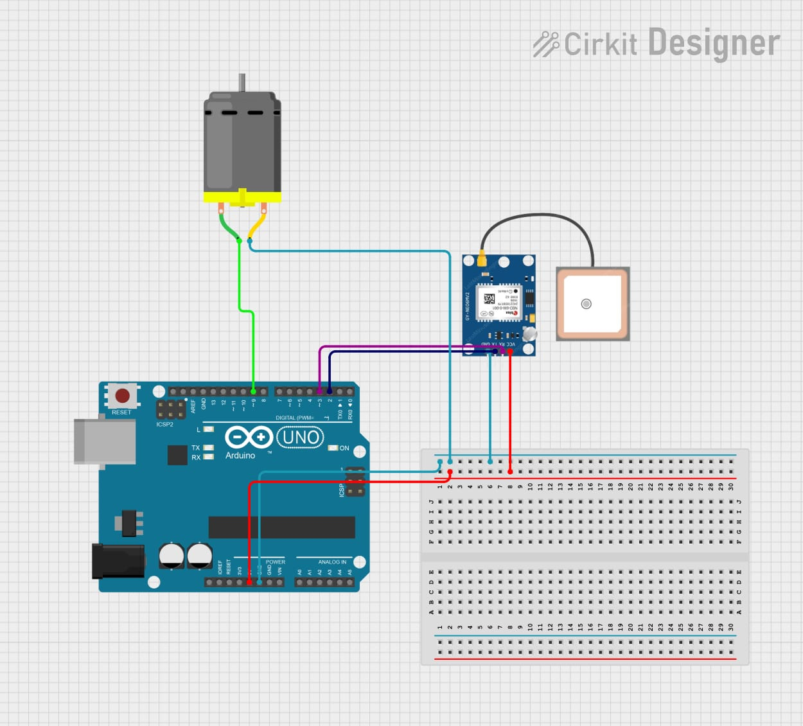

Arduino Uno:

* Acts as the main controller, reading GPS data and comparing it to the target coordinates to control the motor's state.
* The motor is controlled via the D9 digital pin.

GPS Module (GY-GBS6MV2):

* Provides geographical location data (latitude and longitude) to the Arduino through serial communication using D2 (RX) and D3 (TX) pins.
* Powered by Arduino 5V and GND pins.

DC Motor:

* The motor is connected via the D9 pin and is turned on or off based on the difference between the current and target coordinates.

**2. GPS Coordinates and UTM Conversion**:

* **GPS Coordinates (Latitude and Longitude)**: GPS coordinates are represented by latitude (North-South) and longitude (East-West). These are spherical coordinates based on a global reference system, which makes them useful for global navigation. However, for small-scale applications (like local navigation or precise distance calculation), the UTM system is often more convenient.
* **UTM (Universal Transverse Mercator)**: UTM is a global map projection system that divides the world into 60 zones, each 6° wide. In each zone, a transverse Mercator projecti
* on is applied, which helps minimize distortion of distances and areas. UTM coordinates use Easting and Northing values that correspond to locations in each zone, making them suitable for precise and localized applications.
  1. Easting: Represents the distance from the central meridian of the UTM zone.
  2. Northing: Represents the distance from the equator.

The conversion from GPS coordinates to UTM involves using the formulas based on the WGS84 ellipsoid model, which takes into account the curvature of the Earth and provides a more accurate conversion.

**3. Why UTM**

. Simplifies engineering calculations using linear coordinates in meters instead of angular degrees.

**.** Provides high accuracy for measuring distances and areas, especially in local projects.

**.** Reduces the effect of Earth's curvature by using a flat projection for each geographic zone.

. Eases location comparison and displacement calculations.

**4.**Target Input

During the setup function, the system prompts the user to input the target location's UTM coordinates (Easting and Northing) via the Serial Monitor. This is implemented to define the goal position for the GPS-based tracking system. The steps are as follows:

1. The system asks for the Target Easting:
   * The user inputs the desired Easting value.
   * The value is read and stored in the variable (targetEasting)
   * The system displays the entered value for confirmation.
2. The system then requests the Target Northing:
   * The user inputs the desired Northing value.
   * The value is read and stored in the variable (targetNorthing)
   * The entered value is displayed for confirmation.

These coordinates are stored to be used later for validating the current GPS location against the target.

**5.**Calculating Difference Between Current Location and Target

Within the loop function:

1. Obtaining Current Location:
   * The system reads GPS data (latitude and longitude) from the GPS module.
   * The latitude and longitude are converted to UTM coordinates (Easting, Northing) using the LLtoUTM() function.
2. Difference Calculation:
   * The difference between the current UTM coordinates and the target coordinates is calculated:

1. EstDifTar (difference in Easting): easting – targetEasting.

2. NorDifTar (difference in Northing): northing - targetNorthing.

These differences are used to determine proximity to the target.

**6. Motor Control Logic:**

The motor's state is controlled based on the calculated differences:

1. Proximity Check:

* + A threshold range of ±10 meters is defined for both Easting and Northing.
  + The system evaluates whether the current location is within this range:

1. isValidEasit: Checks if the Easting difference is within the range.

2. isValidNorth: Checks if the Northing difference is within the range.

2. Motor State:

* + If both ( isValidEasit ) and ( isValidNorth ) are true (current location is within range) then the motor is turned off.
  + If either difference exceeds the range (location is outside the target proximity) then The motor is turned on.

This logic ensures that the motor operates only when the current location is outside the defined proximity range, providing precise control for reaching the target position.

**Conclusion**

This project successfully demonstrates the application of GPS and UTM coordinate systems for precise motor control based on location tracking. By converting latitude and longitude into UTM coordinates, the system achieves accurate calculations to determine proximity to a target location. The integration of Arduino with the GPS module and motor highlights the feasibility of using affordable and accessible technology for precise navigation and control tasks.

The implementation of proximity-based motor logic ensures that the motor is activated only when necessary, optimizing energy usage and providing a robust mechanism for reaching the desired location. This approach simplifies engineering calculations, enhances accuracy, and reduces the impact of Earth's curvature through the UTM system.

The results validate the effectiveness of this setup for localized applications, paving the way for potential enhancements and scalability in other navigation-based projects.

References & Attachments

1. <https://en.wikipedia.org/wiki/Universal_Transverse_Mercator_coordinate_system>
2. https://en.wikipedia.org/wiki/Geographic_coordinate_system



Tafila Technical University

Faculty of Engineering

Department of Computer Engineering and Communication

**Report Name: GPS-Based Motor Control Report**

Report for Design Project – 0112582

Project Mentor:

Prof _ Abed llah Alshbatat

Prepared and written by:

Mohammad Eyal Salman



Tafila Technical University

Faculty of Engineering

Department of Computer Engineering and Communication

Report Name: Joystick with motor

Report for Design Project – 0112582

Project Mentor:

Prof _ Abed llah Alshbatat

Prepared and written by:

Feras Mustafa