Multimodal Fake News Detection
Phase 1 & Phase 2 Results

Phase 1: Binary OOC Detection
Model: FND-CLIP
Dataset: 12,000 balanced samples (NewsCLIPpings + DGM4). Split: 70/15/15.

Test Results (n = 1,800)
Metric | Value
Accuracy | 94.56%
F1 | 0.9449
AUC-ROC | 0.9874
Precision | 0.9471
Recall | 0.9428

Confusion Matrix
 | Pred Aligned | Pred OOC
True Aligned (908) | 861 | 47
True OOC (892) | 51 | 841

FND-CLIP vs LLaVA-1.5-7B (n = 1,724)
Metric | FND-CLIP | LLaVA (zero-shot) | Delta
Accuracy | 96.23% | 78.65% | +17.58
F1 | 0.9637 | 0.7914 | +0.1723
AUC-ROC | 0.9946 | 0.8716 | +0.1230

FND-CLIP Confusion
 | Pred Aligned | Pred OOC
True Aligned (824) | 796 | 28
True OOC (900) | 37 | 863

LLaVA-1.5-7B Confusion
 | Pred Aligned | Pred OOC
True Aligned (824) | 658 | 166
True OOC (900) | 202 | 698

Phase 2: 3-Class Detection
Model: FND-CLIP + DCT + ResNet with cross-attention fusion.
Dataset: 18,000 balanced samples (6,000/class: Real, Manipulated, OOC). Split: 70/15/15.

In-Distribution Test (n = 2,700)
Metric | Value
Accuracy | 86.26%
F1-macro | 0.864
AUC-ROC (macro) | 0.971

Per-Class Breakdown
Class | Precision | Recall | F1
Real | 77.0% | 87.3% | 0.818
Manipulated | 87.5% | 79.4% | 0.833
OOC | 96.1% | 92.0% | 0.940

Confusion Matrix
 | Pred Real | Pred Manip | Pred OOC
True Real (900) | 786 | 93 | 21
True Manip (900) | 172 | 715 | 13
True OOC (900) | 63 | 9 | 828
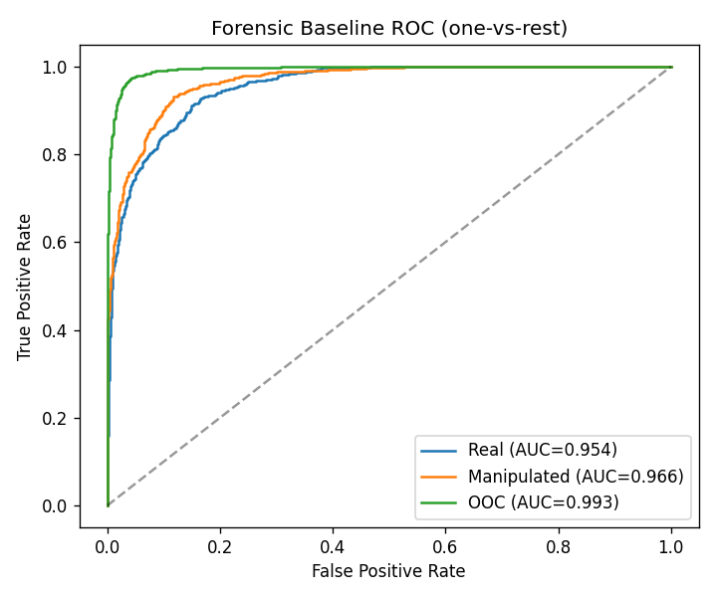
In-Distribution ROC Curves

MMFakeBench Transfer (n = 400, no fine-tuning)
Metric | Value
Accuracy | 64.25%
F1-macro | 0.308

Per-Class Breakdown
Class | Precision | Recall | F1
Real | 75.1% | 82.3% | 0.785
Manipulated | 23.3% | 10.0% | 0.140
OOC | 0% | 0% | 0.000

Confusion Matrix
 | Pred Real | Pred Manip | Pred OOC
True Real (300) | 247 | 33 | 20
True Manip (100) | 82 | 10 | 8
True OOC (0) | 0 | 0 | 0
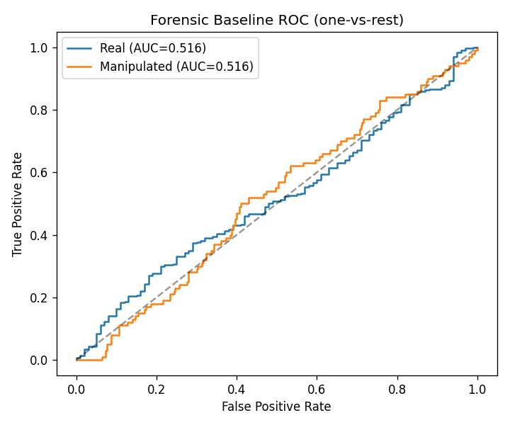
MMFakeBench Transfer ROC Curves

Leakage Detection and Fix
Initial results showed F1-macro ~0.94. The frozen FND-CLIP checkpoint had been trained on the same OOC data used in Phase 2, 84% of test OOC samples overlapped.

Split | Overlap
Phase 2 Test OOC | 757 / 900 (84%)
Phase 2 Train OOC | 2,908 / 4,200 (69%)

Fix: rebuilt splits using only samples the checkpoint never saw. Verified 0/900 overlap. All results are leak-free.

Summary
 | Phase 1 | Phase 2
Task | Binary OOC | 3-class
Accuracy | 94.56% | 86.26%
F1 | 0.9449 | 0.864 (macro)
AUC-ROC | 0.9874 | 0.971 (macro)
Transfer | N/A | 64.25%

