Paper Title:

Newton’s forward interpolation: representation of numerical data by a polynomial curve

[Publication: Math Journal]

Definition:

Interpolation is a simple mathematical method which is used to estimate an unknown value or potential yield of a security or asset by using related known values. Interpolation is achieved by using other established values that are located in sequence with the unknown value.

Newton's forward difference formula is a finite difference identity giving an interpolated value between tabulated points in terms of the first value and the powers of the forward difference. When the interpolating point lies closer to the beginning of the interval then the Newton's forward formula is used.

**Necessity:**

Newton's forward & background difference interpolation which is also known as Newton Gregory technique can be used:

* To derive numerical schemes for solving initial or boundary-value problems.
* To find approximate values of the function at intermediate points.
* To turn complicated functions into much simpler ones.
* To predict unknown values for any geographic point data, such as elevation, rainfall, chemical concentrations, noise levels, and so on.

**Working Methods Shown Using an Example**:

In the following table, use the Newton-Gregory Forward Interpolation formula to find (a) f(2.4) (b) f(8.7).   
  
x 2 4 6 8 10   
f(x) 9.68 10.96 12.32 13.76 15.28

Solution: Form a difference table and note that all differences > 2 are zero.   
  
x y=f(x) ∆y ∆2 y   
  
2 9.68   
 1.28   
4 10.96 0.08   
 1.36   
6 12.32 0.08   
 1.44   
8 13.76 0.08   
 1.52   
10 15.28

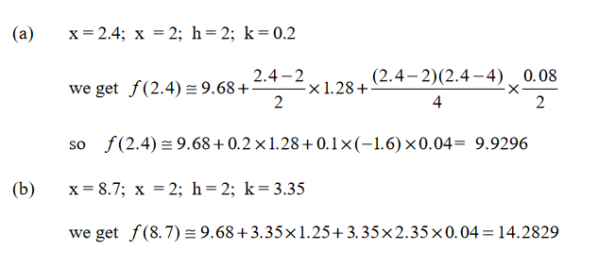

**Limitations:**

* The intervals always needs to be equal.
* Only works on the beginning point values.
* Not precise.
* Works best on limited data

**FutureWork:**