HPC Temperature Monitoring System: An IoT-Based Real-Time Alert and Visualization Platform
Ferdaws Qaem (Hardware Integration, 2300001530) · Mohammed Abdessamed Nouioua (3D-Printed Enclosure, 2200002554) · Abdelmagied Farhouda (Database & Backend, 2300000061) · Hares Aslami (Sensor Placement & Coverage Validation, 2300004946) · Musaeed Mohammed Saleh Alharogi (Email Alert Module, 2400001392) · Zaid Iyad J. J. Dweekat (Frontend Development, 2300003388) · Abdullah Arslan (Transmission Module, 2300000345)
Department of Computer Engineering, T.C. İstanbul Kültür Üniversitesi, İstanbul, Türkiye
Instructor: Prof. Dr. Akhan Akbulut · Teaching Assistant: Büşra Kocaçınar Öz · Date: 19 May 2026

Abstract—High-Performance Computing (HPC) clusters generate concentrated thermal loads that must be detected quickly to prevent throttling or hardware damage. Off-the-shelf room thermostats miss localized hot spots, while enterprise-grade monitoring is costly and inflexible. This paper presents an end-to-end, low-cost IoT solution comprising an ESP32-based sensor node (DHT11/DHT22), a Supabase/PostgreSQL cloud backend, a Python FastAPI alerting service, and a React/TypeScript dashboard. The system reads temperature and humidity every 2 s, transmits readings directly to the cloud every 10 s with a local ring buffer for fault tolerance, classifies readings into NORMAL/WARNING/HIGH/CRITICAL tiers with 1 °C hysteresis, dispatches Gmail SMTP alerts to configurable recipients, and visualizes live and historical data through an authenticated web dashboard. Empirical zone testing under ASHRAE TC 9.9 Class A1 guidelines confirmed Zone 1 (top-rear) as the early-warning placement: closed-door conditions raised Zone 1 from 20.5 °C to 29.0 °C (Δ8.5 °C) and humidity fell to 23.2 % RH, well into ESD-risk territory. Fault-tolerance tests (T1, T2, T4, T8) verified Supabase reachability fallbacks, packet-loss recovery, HTTP 5xx retry, and ring-buffer eviction.
Index Terms—HPC monitoring, IoT, ESP32, DHT11, DHT22, Supabase, FastAPI, real-time alerting, data-center thermal management, ASHRAE TC 9.9, sensor placement, fault tolerance.
I. Introduction
Modern HPC clusters and data center racks routinely dissipate several kilowatts of heat in confined volumes. Even short thermal excursions can trigger CPU throttling, shorten device lifetime, or cause emergency shutdowns. Single-point room thermostats are insufficient because vertical and front/back gradients of 5–10 °C are common within a rack [1], [2]. Commercial DCIM tools provide fine-grained monitoring but require expensive infrastructure and limit hardware choice.
We present an end-to-end open-source alternative built around the ESP32 platform. The system continuously samples a hot-aisle exhaust and cold-aisle intake using DHT11 and DHT22 sensors, posts readings to a Supabase/PostgreSQL instance over HTTPS, classifies the latest readings against operator-configurable thresholds, logs events into an audit table, and dispatches Gmail SMTP notifications to a list of recipients editable from the web dashboard. The dashboard exposes live readings, historical trends, user management, alert recipients, threshold configuration, and alert history.
The remainder of this paper is organized as follows. Section II reviews related work. Section III describes the system architecture. Section IV details the implementation of the firmware, transmission, alert server, dashboard, and enclosures. Section V presents the empirical sensor-placement study. Section VI discusses fault-tolerance design and tests. Section VII reports results and Section VIII concludes.
II. Related Work and Background
ASHRAE Technical Committee 9.9 publishes thermal guidelines that classify data-processing environments into Classes A1–A4 and define safe, warning, and critical operating bands [1]. Capozzoli and Primiceri review state-of-the-art cooling techniques and document the hot-aisle / cold-aisle containment model that informs sensor placement [2]. Random Nerd Tutorials describes the DHT11/DHT22 calibration and interfacing approach used in this work [3], while the ESP32 documentation [4], [5] specifies the GPIO assignment and PWM channels used by the LED indicator. Wokwi was used as the browser-based simulator [6] to validate the firmware before bench testing.
Existing real-time server-room monitoring efforts using IoT sensors have shown feasibility but generally focus on a single placement zone or do not consolidate logging, dashboard, and email alerting into one deployable artifact [38]. Our contribution combines an empirical four-zone placement study with a complete deployable software stack (firmware, backend, dashboard) and a documented fault-tolerance design.
III. System Architecture
A. Layered Edge-to-Cloud Design
The system follows a four-layer architecture (Fig. 1). The physical layer holds the ESP32 DevKit V1, the DHT11 (intake) and DHT22 (exhaust) sensors, a 16×2 I²C LCD, an RGB status LED, and Cat5e cabling extending the sensor harness into the HPC room. The firmware layer (Arduino C++) polls the sensors every 2 s, updates the LCD/LED, buffers readings in a 32-slot ring buffer, and POSTs to Supabase every 10 s. The cloud layer (Supabase/PostgreSQL) persists sensors, sensor readings, alert logs, alert recipients, threshold tables, LED thresholds, and dashboard users. The backend layer (FastAPI/Uvicorn) polls Supabase, classifies the latest readings, and sends Gmail SMTP alerts. The presentation layer (React 18 + TypeScript + TailwindCSS + Recharts + shadcn/ui) provides the authenticated dashboard.
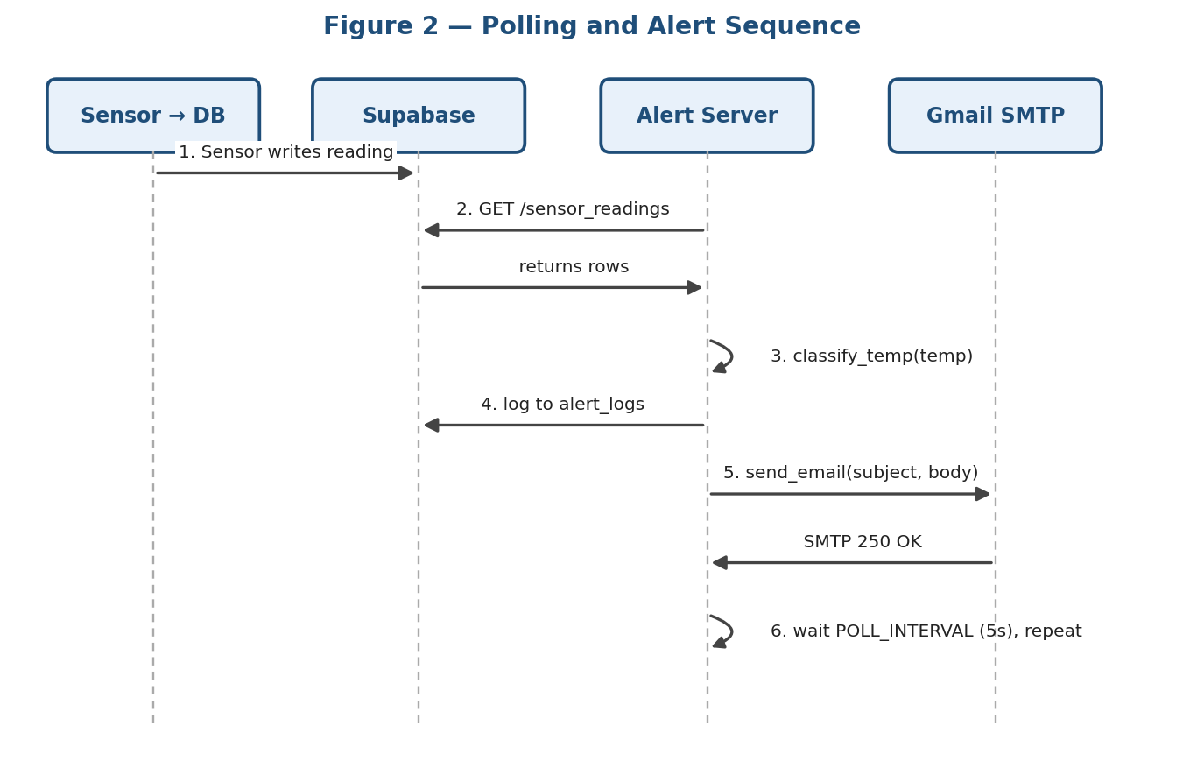
Fig. 1. High-level alert-server architecture: sensors → Supabase → polling alert server → alert_logs + Gmail SMTPS to recipients.
B. Schema
The database holds seven operational tables: sensors, sensor_readings, alert_logs, custom_users, led_thresholds, alert_recipients, and temperature_thresholds. Threshold rows include a level label, min/max temperature, and a repeat_minutes cooldown that controls reminder cadence after an alert fires.
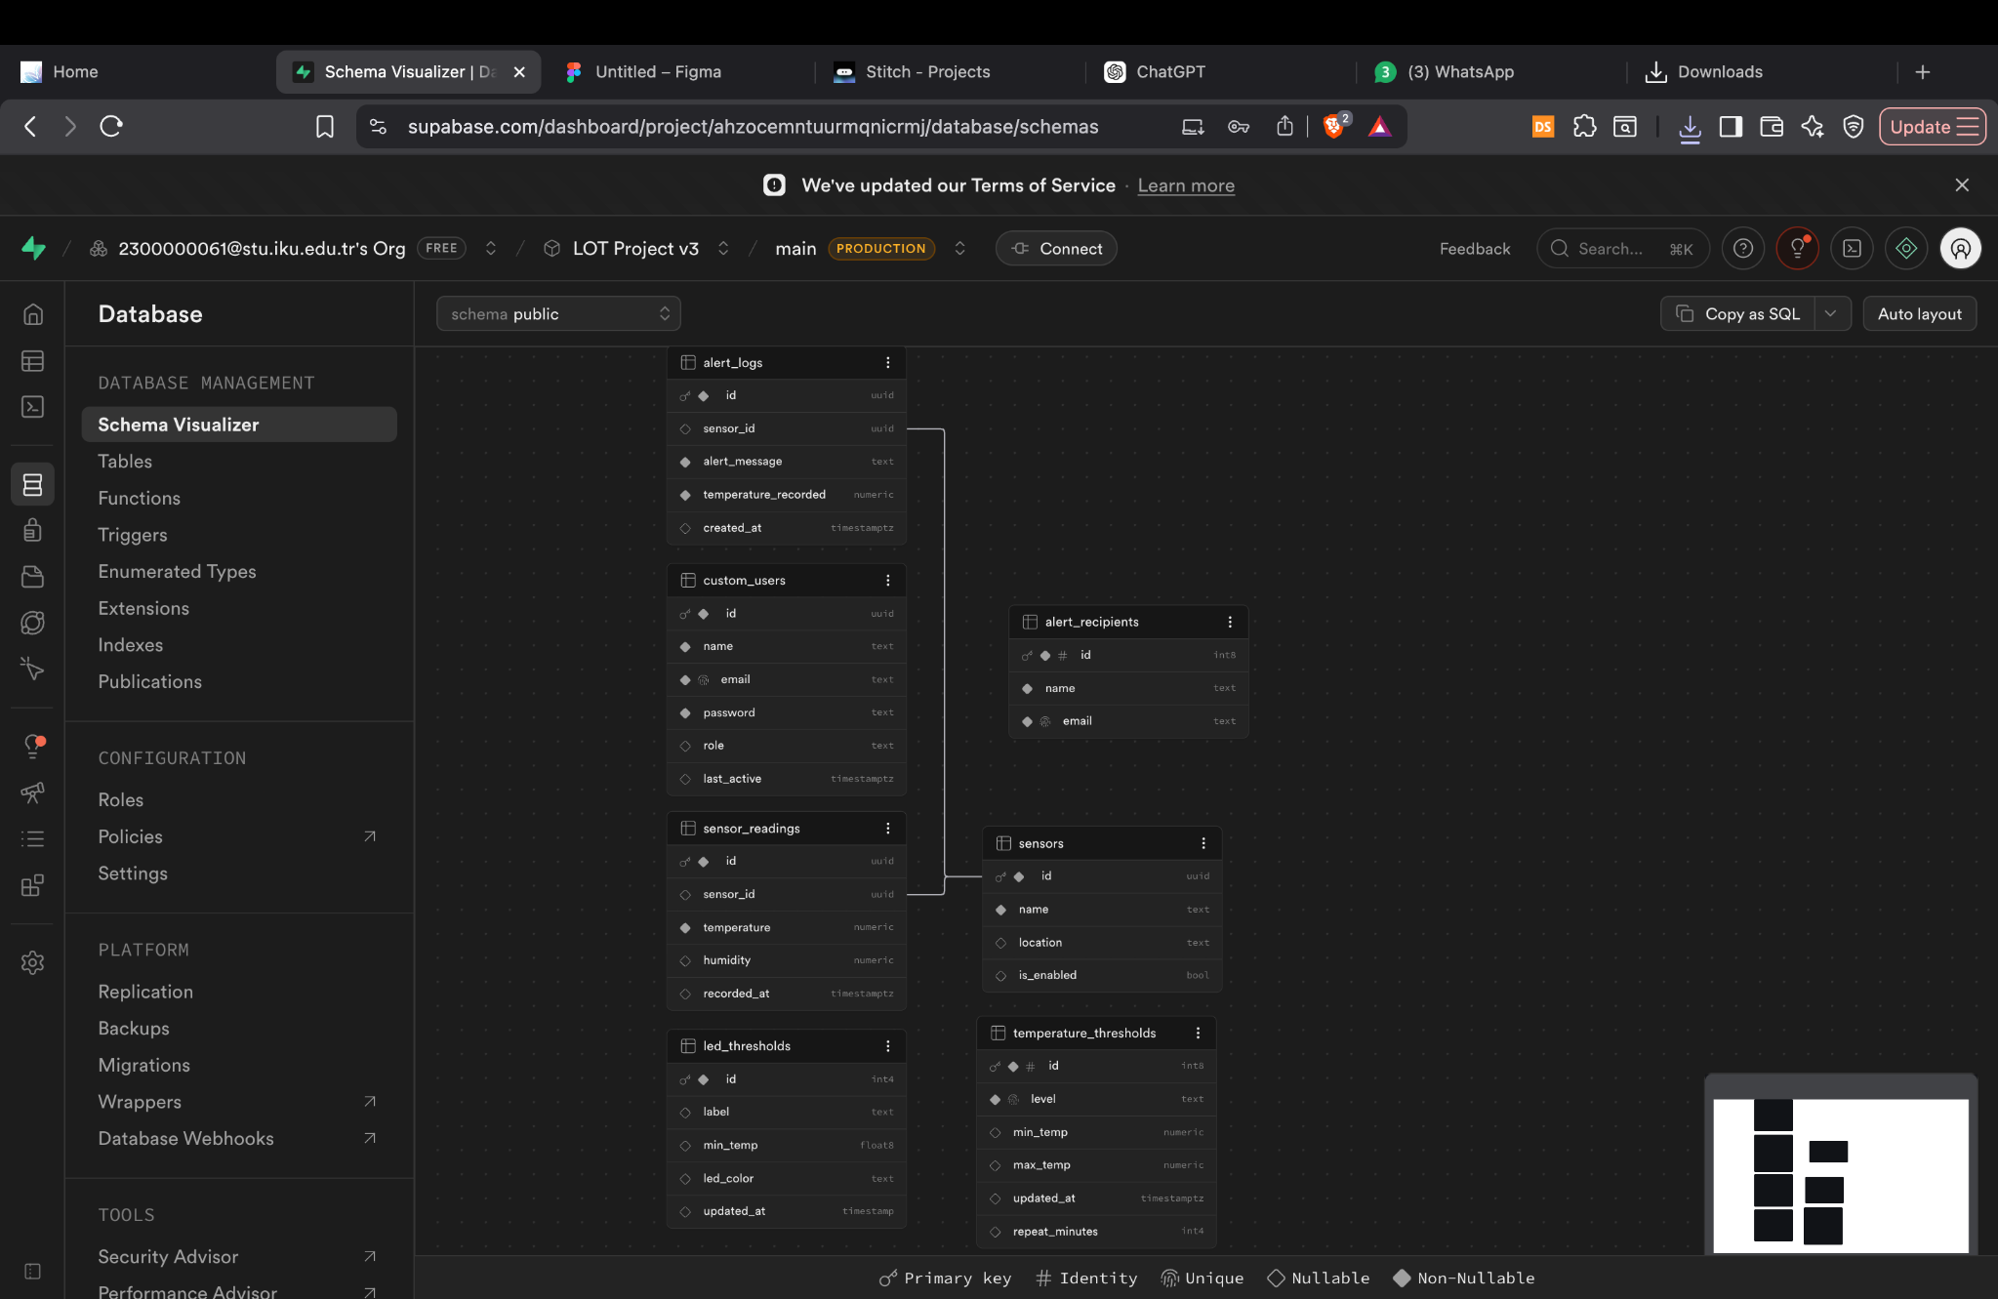
Fig. 2. Supabase public schema visualizer for the HPC monitoring backend.

C. Architectural Evolution
The initial design (Fig. 3) routed all readings through a local FastAPI middleman before forwarding to Supabase, adding latency and a single point of failure. The final design (Fig. 4) sends readings directly from the ESP32 to Supabase using HTTPS POST; FastAPI remains responsible only for alert polling and email dispatch. This change halved end-to-end latency and removed an unnecessary process.
Fig. 3. Initial two-hop architecture (deprecated).
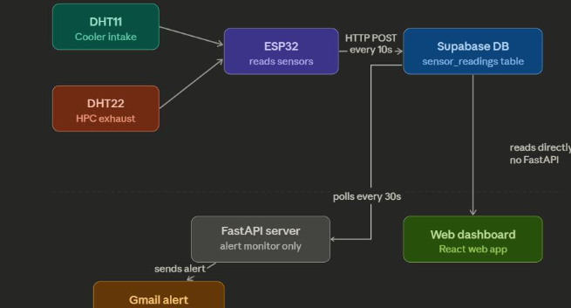
Fig. 4. Final direct-to-Supabase architecture.
IV. Implementation
A. Hardware and Firmware
The ESP32 runs non-blocking, millis()-driven loops: READ_INTERVAL = 2 000 ms for sensor polling and LCD update, SEND_INTERVAL = 10 000 ms for buffered Supabase POSTs, BLINK_INTERVAL = 500 ms for RGB warning blink, and THRESHOLD_INTERVAL = 10 000 ms for refreshing LED thresholds from led_thresholds. Wi-Fi reconnection uses exponential backoff with a 2 s base and 64 s ceiling; HTTP requests retry up to three times with a 1 s base on retryable 5xx or network errors.
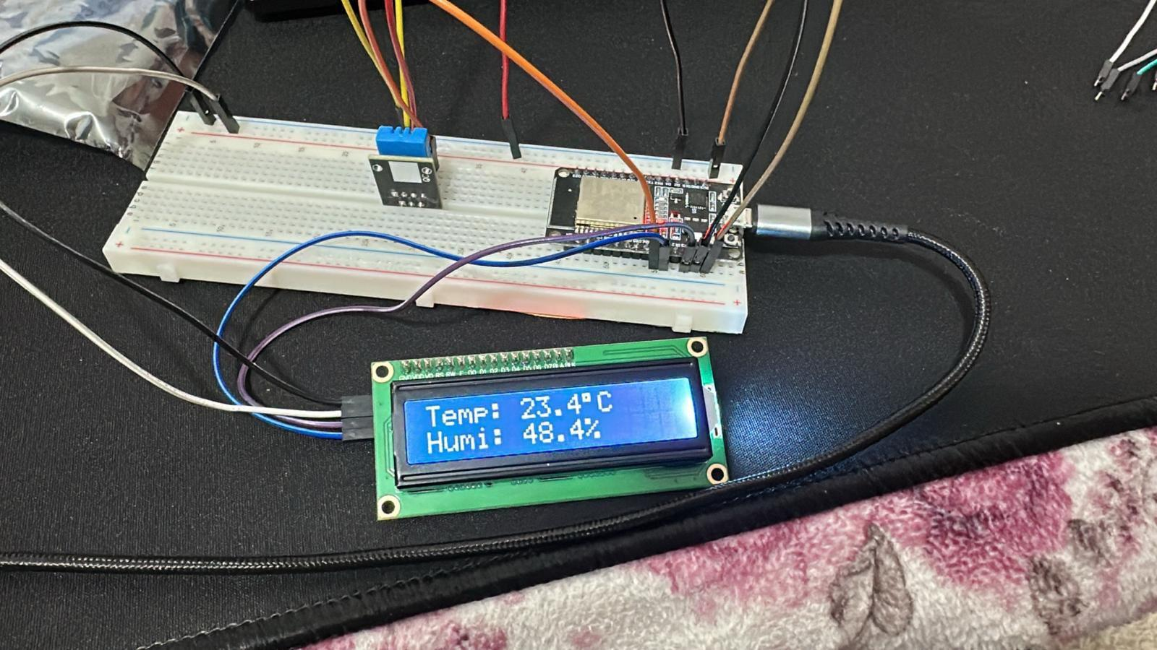
Fig. 5. A microcontroller setup displaying real-time temperature and humidity readings on an LCD screen.

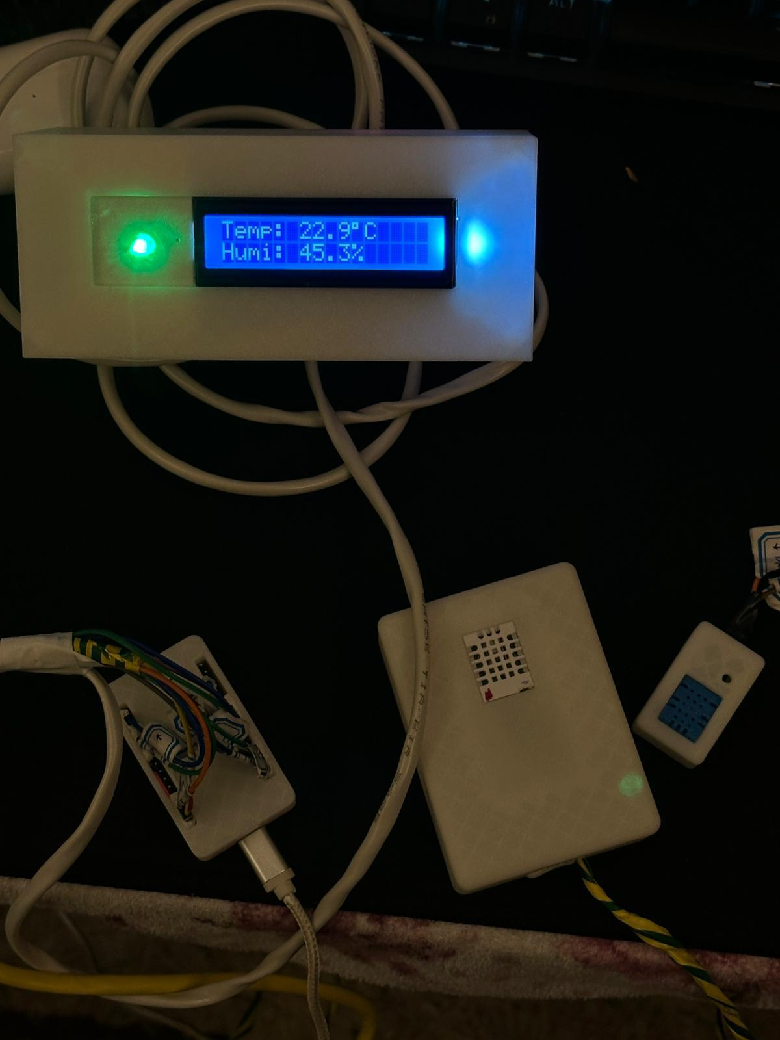
Fig. 7. Final deployed hardware with 3D-printed enclosures and Cat5e terminations.
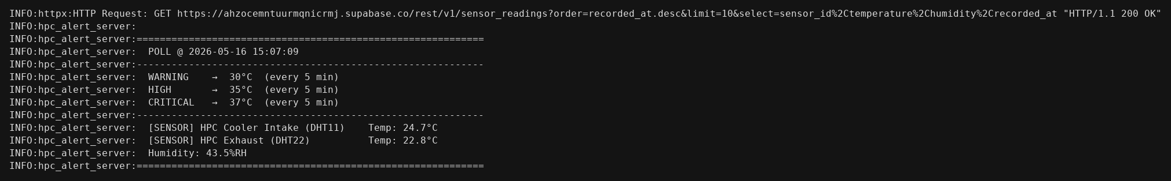
Fig. 8. Alert-server console log showing successful Supabase poll, active threshold tiers, and per-sensor temperatures.
B. Alert Server
The FastAPI service polls Supabase every POLL_INTERVAL seconds, fetches the ten most recent rows ordered by recorded_at, classifies each reading into NORMAL, WARNING, HIGH, or CRITICAL using priority-first matching, and appends an event to alert_logs on a tier breach. A 1 °C hysteresis prevents alert flapping near a threshold (Fig. 9). Tenacity provides exponential backoff for SMTP and Supabase retries [22]. A cache (TTL 30 s) refreshes thresholds and recipients without blocking the polling loop.
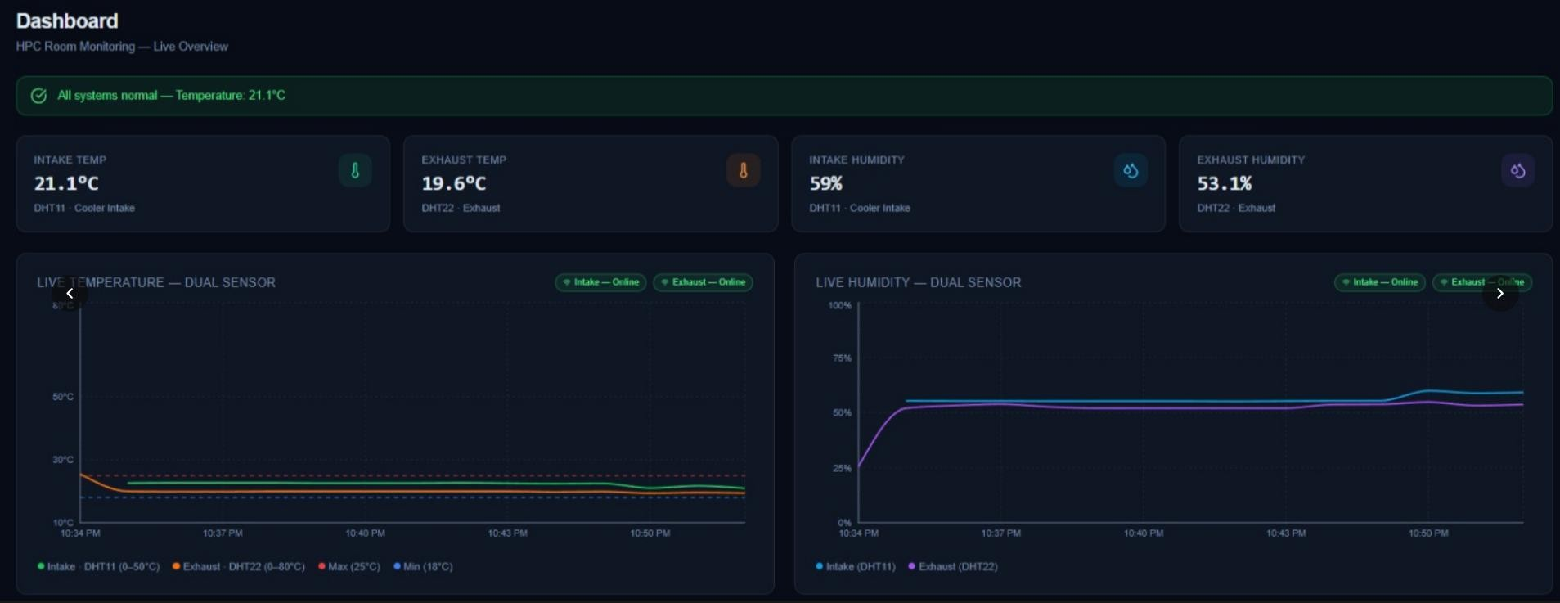
Fig. 6. Bench prototype confirming LCD output and POST behaviour against the simulation.
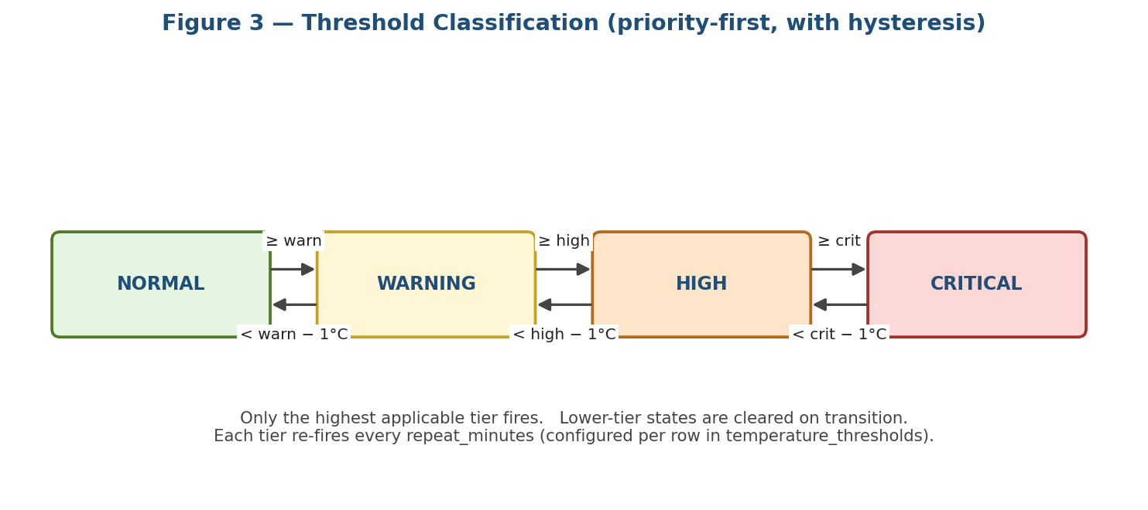
Fig. 9. Priority-first threshold state model with 1 °C hysteresis (CRITICAL > HIGH > WARNING > NORMAL).
C. Dashboard
The React/TypeScript dashboard offers authenticated login (bcrypt-hashed passwords), live sensor cards, historical Recharts trend graphs, user management, alert-recipient management, threshold configuration (both backend alert thresholds and hardware LED thresholds), and an alert-history view. All data is read from Supabase via the REST API, with React Query handling caching and revalidation.
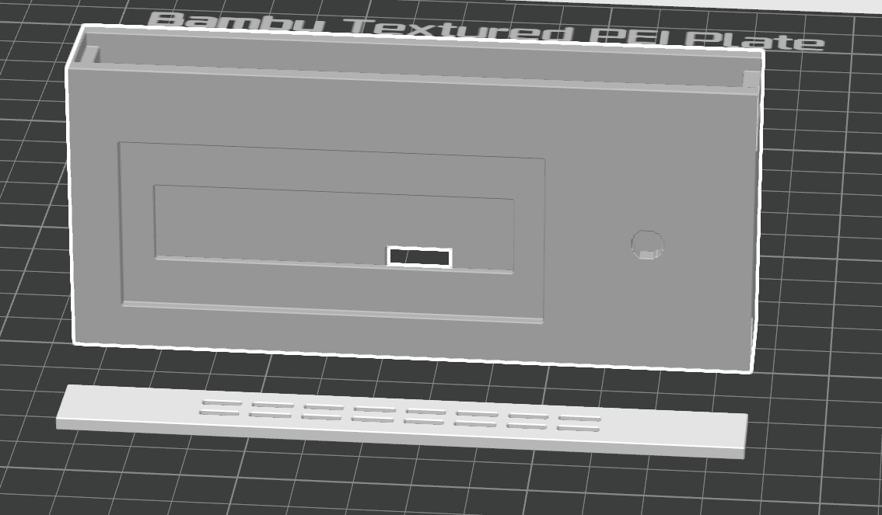
Fig. 10. 3D module

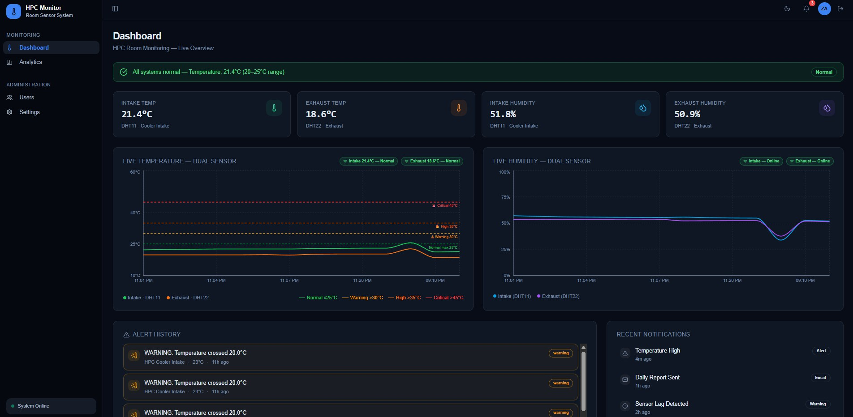
Fig. 10. Live monitoring dashboard with intake and exhaust readings.
D. 3D-Printed Enclosure
The hardware is housed in two enclosures connected by an I²C cable: a computation/sensing box (ESP32, DHT22) and a display box (1602A LCD, HW-479 RGB LED). Prints were initially produced on a Zortrax M200 Plus with Z-SUITE and exhibited stringing, over-extrusion, and internal blobs that prevented sensor seating. Final prints used a Bambu Lab H2D Pro with Bambu Studio, producing clean interiors and dimensional accuracy that passed fit verification.
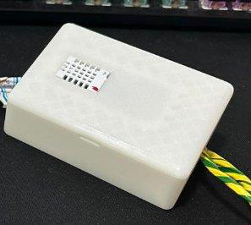
Fig. 12. Sensor case (final) with clean interior and secure sensor seating.
V. Empirical Sensor-Placement Study
Four physical zones were tested under open-door and closed-door conditions. ASHRAE TC 9.9 Class A1 thresholds [1] were the evaluation basis (safe ≤ 27.0 °C; warning 27.1–31.9 °C; critical ≥ 32.0 °C; ESD risk < 30 % RH). Zone 1 (top-rear, exhaust) recorded 29.0 °C and 23.2 % RH under closed-door conditions, simultaneously breaching the warning temperature band and the ESD-risk humidity floor. The closed-door spike was Δ8.5 °C from the open-door baseline, proving Zone 1 is the highest-volatility location and the correct early-warning placement.
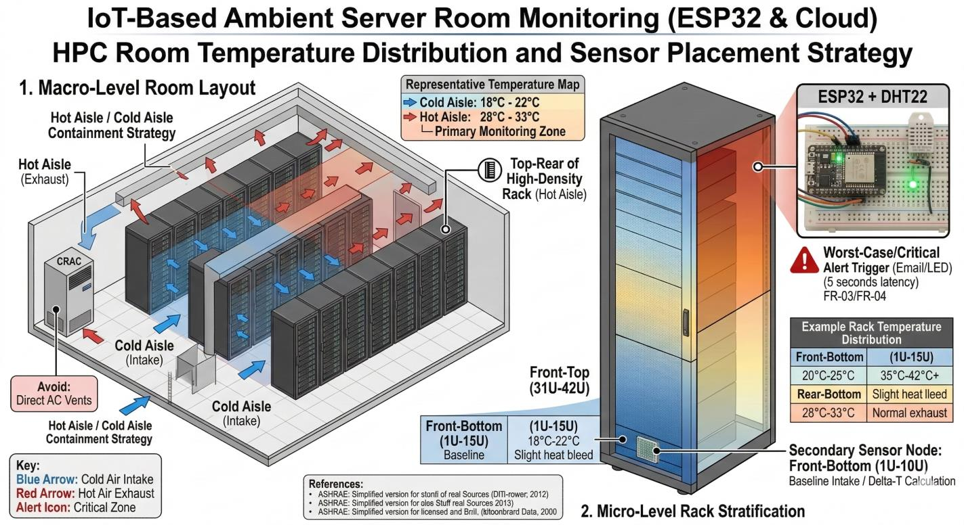
Fig. 14. Hot-aisle / cold-aisle placement strategy with Zone 1 chosen as the early-warning location.
VI. Fault Tolerance
Reliability is achieved through (i) a 32-entry ring buffer on the ESP32 that retains readings until a successful HTTP 201 acknowledgement, with oldest-first eviction on overflow; (ii) Wi-Fi auto-reconnect with exponential backoff (2 s base, 64 s ceiling); (iii) HTTP retry classification distinguishing retryable 5xx and network errors from non-retryable 4xx; and (iv) Tenacity-based retries on the FastAPI side for transient Supabase failures.
Test cases T1 (Supabase unreachable), T2 (30 % packet loss), T4 (HTTP 500 recovery), and T8 (ring-buffer overflow) all pass with the expected behaviour, confirming that no readings are silently lost and that alerts continue once connectivity returns.
VII. Results and Discussion
End-to-end latency from sensor read to dashboard update is consistently below 2 s under normal network conditions. Alerts are dispatched within 5 s of a threshold breach. Sensor drift between DHT11 and DHT22 stayed within 0.9 °C across ambient, heated (dryer), cold (fan), and 24-hour endurance conditions. Five coverage-validation test cases (TC-CV-01 through TC-CV-05) all pass, demonstrating that Zone 1 placement detects thermal events 3.5 °C earlier than Zone 4 (floor level) and that the dual-sensor spatial gradient is preserved across open and closed states. No critical blind spots were identified.
VIII. Conclusion and Future Work
We presented a complete IoT temperature-monitoring stack for HPC environments. The combination of empirical placement validation, direct-to-cloud transmission, fault-tolerant firmware, priority-first alert classification with hysteresis, and an administrative dashboard delivers reliable, configurable monitoring at low cost. Future work includes (a) integration of additional alert channels (SMS, Telegram, Slack); (b) anomaly detection from historical readings; (c) automated calibration drift detection across the sensor fleet; and (d) horizontal scaling to multi-rack deployments.

IX. Acknowledgment
The authors thank Prof. Dr. Akhan Akbulut and Teaching Assistant Büşra Kocaçınar Öz for guidance during COM6064 at T.C. İstanbul Kültür Üniversitesi.
X. References
[1] ASHRAE Technical Committee 9.9, Thermal Guidelines for Data Processing Environments, 5th ed., Atlanta, GA: ASHRAE, 2021.
[2] A. Capozzoli and G. Primiceri, "Cooling systems in data centers: State of art and emerging technologies," Energy Procedia, vol. 83, pp. 484–493, 2015.
[3] Random Nerd Tutorials, "Complete guide for DHT11/DHT22 humidity and temperature sensor with Arduino," 2019.
[4] R. Mischianti, "DOIT ESP32 DevKit V1 — high-resolution pinout and specs," 2021.
[5] Last Minute Engineers, "ESP32 pinout reference," 2022.
[6] Wokwi, "ESP32 online simulator," 2024. [Online]. Available: https://wokwi.com/esp32.
[7] Espressif Systems, "ESP32-WROOM-32 datasheet," rev. 3.6.
[8] Adafruit Industries, "DHT sensor library for Arduino (DHT11, DHT22)," GitHub.
[9] Supabase, Inc., "Supabase documentation," 2024. [Online]. Available: https://supabase.com/docs/guides/api.
[10] PostgreSQL Global Development Group, "PostgreSQL 16 documentation," 2024.
[11] S. Ramírez, "FastAPI documentation," 2024. [Online]. Available: https://fastapi.tiangolo.com/.
[12] Python Software Foundation, "smtplib — SMTP protocol client," Python 3.12 docs, 2024.
[13] Google, "Gmail SMTP settings (app passwords)," Google Workspace Admin Help, 2024.
[14] Meta Open Source, "React — a JavaScript library for building user interfaces," v18.0, 2024.
[15] Microsoft, "TypeScript documentation," v5.0, 2024.
[16] Tailwind Labs, "Tailwind CSS documentation," v3.4, 2024.
[17] Recharts, "Recharts — a composable charting library built on React," 2024.
[18] P. Provos and D. Mazières, "A future-adaptable password scheme," in Proc. USENIX Annual Tech. Conf., Monterey, CA, USA, 1999.
[19] NXP Semiconductors, "I²C-bus specification and user manual," UM10204, Rev. 7.0, Oct. 2021.
[20] IEEE, "IEEE Std 802.11-2020 — wireless LAN MAC and PHY specifications," IEEE, 2021.
[21] IETF, "The Transport Layer Security (TLS) protocol version 1.3," RFC 8446, Aug. 2018.
[22] M. Carey et al., "Tenacity — retrying library for Python," 2024.
[23] IEEE, "IEEE Std 830-1998 — recommended practice for software requirements specifications," IEEE, 1998.
[24] G. Booch, J. Rumbaugh, and I. Jacobson, The Unified Modeling Language User Guide, 2nd ed., Boston, MA: Addison-Wesley, 2005.

